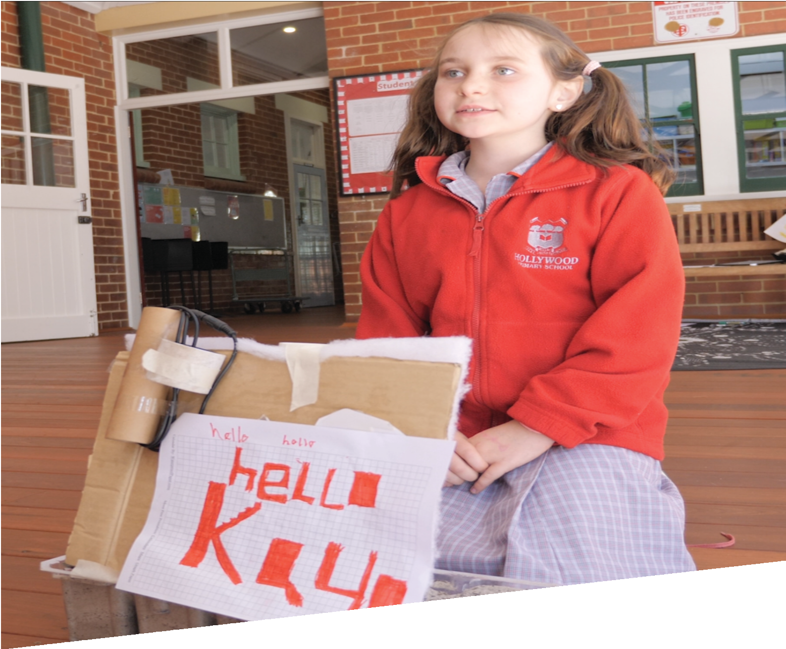

CURRICULUM RESOURCE MODULE
Cryptic code
YEAR 2

Acknowledgements

The STEM Learning Project respectfully acknowledges the Traditional Custodians of the lands upon which our students and teachers live, learn and educate.

The STEM Learning Project is funded by the Western Australian Department of Education (the Department) and implemented by a consortium in STEM education comprising the Educational Computing Association of WA, the Mathematical Association of WA, the Science Teachers Association of WA and Scitech. We acknowledge and thank the teachers and schools who are the co-creators of these resources.

Copyright and intellectual property

The copyright and intellectual property of this module remain the property of the Department.

Any Western Australian Curriculum content in this resource is used with the permission of the School Curriculum and Standards Authority (the Authority); this permission does not constitute Authority endorsement of the resource. The Authority accepts no liability for any errors or damages arising from reliance on its content.

The Western Australian Curriculum content may be freely copied, or communicated on an intranet, for non-commercial purposes in educational institutions, provided that the Authority is acknowledged as the copyright owner. Copying or communication for any other purpose can be done only within the terms of the Copyright Act 1968 or with prior written permission of the Authority. Any Australian Curriculum content in the Western Australian Curriculum is used by the Authority under the terms of the Creative Commons Attribution-NonCommercial 3.0 Australia licence. Any content on the www.scsa.wa.edu.au domain that has been derived from the Australian Curriculum may be used under the terms of Creative Commons Attribution-NonCommercial 3.0 Australia licence.

Appendix 2: General capabilities continuums is adapted from ACARA, © Australian Curriculum, Assessment and Reporting Authority (ACARA) 2009 to present, unless otherwise indicated. This material was downloaded from the ACARA website (www.acara.edu.au) (Website) (accessed December 2015) and was not modified. The material is licensed under CC BY 4.0 (https://creativecommons.org/licenses/by/4.0/). ACARA does not endorse any product that uses ACARA material or make any representations as to the quality of such products. Any product that uses material published on this website should not be taken to be affiliated with ACARA or have the sponsorship or approval of ACARA. It is up to each person to make their own assessment of the product.

This resource includes references and examples of iOS, Android and other apps. The Department does not endorse or recommend any commercial products and simply provides these as examples for teachers.

The Department is committed to providing quality information to its customers. Whilst every effort has been made to ensure accuracy, currency and reliability of the information within these documents, the Department accepts no responsibility for errors, omissions or amendments made since the time of publishing. Confirmation of information may be sought from the Department or the originating bodies providing the information. The Department has no control over the content of material published on websites to which users are referred in this resource. It is the responsibility of the internet user to make their own decision as to the relevancy, accuracy, currency and reliability of information found on those sites.

This resource contains various images from iStock used under license.
Attributions: Explain Everything, Keynote, Microsoft Excel and PowerPoint, Scratch Jr., Book Creator, Minecraft, Bloxels, Geoboard, Numbers, Padlet, eBook, iMovie, Seesaw, Popplet, Class Dojo, Edmodo, Evernote, Cool tools for schools.

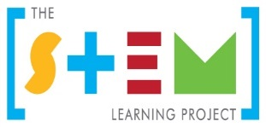
Table of contents

The STEM Learning Project 2
Overview 3
Activity sequence and purpose 7
Background 8
Activity 1: Mixing colours, words and hands 12
Activity 2: Grids and coding 21
Activity 3: Sign design 29
Activity 4: Bilingual jingle 36
Appendix 1: Links to the Western Australian Curriculum 40
Appendix 1B: Mathematics proficiency strands 42
Appendix 2: General capabilities continuums 43
Appendix 3: Materials list 46
Appendix 4: Design process guide 47
Appendix 5: Reflective journal 48
Appendix 6: Student activity sheet 1.0: Journal checklist 49
Appendix 7: Teacher resource sheet 1.1: Cooperative learning – Roles 50
Appendix 8: Teacher resource sheet 1.2: Cooperative learning – Think, Pair, Share 51
Appendix 9: Student activity sheet 1.3: I see, I think, I wonder 52
Appendix 10: Student activity sheet 2.1: Coding grids 53
Appendix 11: Teacher resource sheet 3.1: Bilingual sign example 54
Appendix 12: Teacher resource sheet 3.2: Construction skills 55
Appendix 13: Student activity sheet 3.3: Design review 59
Appendix 14: Teacher resource sheet 4.1: Evaluation 60
Appendix 15: Teacher resource sheet 4.2: 3 – 2 – 1 Reflection 61

The STEM Learning Project
The aim of the STEM Learning Project is to generate students’ interest, enjoyment and engagement with STEM (Science, Technology, Engineering and Mathematics) and to encourage their ongoing participation in STEM both at school and in subsequent careers. The curriculum resources will support teachers to implement and extend the Western Australian Curriculum across Kindergarten to Year 12 and develop the general capabilities.
Why STEM?
A quality STEM education will develop the knowledge and intellectual skills to drive the innovation required to address global economic, social and environmental challenges.
STEM capability is the key to navigating the employment landscape changed by globalisation and digital disruption. Routine manual and cognitive jobs are in decline whilst non-routine cognitive jobs are growing strongly in Australia. Seventy-five per cent of the jobs in the emerging economy will require critical and creative thinking and problem solving, supported by skills of collaboration, teamwork and literacy in mathematics, science and technology. This is what we call STEM capability. The vision is to respond to the challenges of today and tomorrow by preparing students for a world that requires multidisciplinary STEM thinking and capability.
The approach
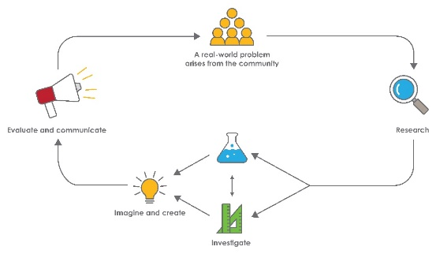
STEM capabilities are developed when students are challenged to solve open-ended, real-world problems that engage students in the processes of the STEM disciplines.

Year 2 – Cryptic code
STEM Consortium

Overview
This module acknowledges that Aboriginal and Torres Strait Islander peoples have worked scientifically for millennia and continue to contribute to contemporary science. It provides opportunities for all students to engage in respect and recognition of the world's oldest continuous living cultures.
Students will understand that identities and cultures have been, and still are, a source of strength and resilience for Aboriginal and Torres Strait Islander peoples against the historic and contemporary impacts of colonisation.
STEM learning can deepen students’ knowledge and understanding of Australia and the First Australians and Science, Mathematics and Technologies can contribute to the Aboriginal and Torres Strait Islander Histories and Cultures cross-curriculum priority of the Western Australian Curriculum. This priority addresses two distinct needs:
- That Aboriginal and Torres Strait Islander students can see themselves, their identities and their cultures reflected in the curriculum of each of the STEM learning areas can fully participate in the curriculum and can build their self-esteem
- That all students engage in reconciliation, respect and recognition of the world’s oldest continuous living cultures.
As students engage in this module, they have opportunities to:
- Learn Aboriginal words equivalent to common English words
- Investigate mixing materials to make an ochre-like paint
- Use and become familiar with alpha-numeric grids as a template for coding an image on paper and with digital technologies
- Design and create bilingual signs for public places
- Use modern technology to effectively raise awareness of a traditional Aboriginal language.
What is the context?
Aboriginal languages were spoken in Australia for thousands of years before the arrival of the English language with the colonial settlers. There were hundreds of Aboriginal languages spoken in Australia and many are still spoken to this day. Bilingual signs could increase awareness of common words and phrases of the Aboriginal language/s of the local area and show respect for first languages.
What is the problem?
How can we make a bilingual sign?
How does this module support integration of the STEM disciplines?
In addition to providing a context in which students can develop outcomes for the Early Years Learning Framework, this module gives students the opportunity to develop skills in the STEM learning areas.
Science
Students use Science understandings (ACSSU031) and Science inquiry skills (ACSIS037, ACSIS038, ACSIS041) to investigate combining materials to make paint. They question, predict, investigate, explore and compare observations about mixtures and the materials from which they are made.
Technology
Students engage with design processes from the Technologies curriculum to make bilingual signs. At this age, students are beginning to develop their design skills by conceptualising algorithms as a sequence of steps for carrying out instructions. As they identify steps in a process to create an image designed onto arrays – with and without digital technologies – students develop emerging coding capability. Working collaboratively (WATPPS11, WATPPS12 WATPPS15), students use information and communication technology skills to communicate design ideas when describing or drawing their construction process. They use equipment safely (WATPPS13) and evaluate the materials used to produce their design solutions (WATPPS14).
Students identify the interconnectedness between technologies and identity, people, culture and country/place. They explore, understand and analyse how these connections guide Aboriginal and Torres Strait Islander people in sustaining environments, histories, cultures and identities by creating appropriate and sustainable solutions. They understand that people design and produce familiar products, services and environments to meet local and community needs (ACTDEK001).
The Design process guide is included as a resource to help teachers understand the complete design process as developed in the Technologies curriculum.
Mathematics
Students measure, compare and order shapes according to chosen attributes using appropriate uniform, informal units (ACMMG037). They also interpret simple maps to identify the relative positions of key features (ACMMG044) and identify and describe half and quarter turns (ACMMG046) Students become familiar with alphanumeric grid reference points to code cells required to complete an image of a word.

General capabilities
There are opportunities for the development of general capabilities and cross-curriculum priorities as students engage with Cryptic code. In this module, students:
- Develop critical thinking skills as they research the problem and its context (Activity 1); investigate parameters impacting on the problem (Activity 2); imagine and develop solutions (Activity 3); and evaluate and communicate their solutions to an audience (Activity 4).
- Utilise creative thinking as they generate possible design solutions; and critical thinking, numeracy skills and ethical understanding as they choose between alternative approaches to solving the problem of raising awareness of Aboriginal languages.
- Utilise personal and social capability as they develop socially cohesive and effective working teams; collaborate in generating solutions; adopt group roles; and reflect on their group work capabilities through self and peer evaluation.
- Utilise a range of literacies and information and communication technology (ICT) capabilities as they collate records of work completed throughout the module in a journal; represent and communicate their solutions to an audience using digital technologies in Activity 4.
What are the pedagogical principles of the STEM learning modules?
The STEM Learning Project modules develop STEM capabilities by challenging students to solve real-world problems set in authentic contexts. The problems engage students in the STEM disciplines and provide opportunities for developing higher order thinking and reasoning, and the general capabilities of creativity, critical thinking, communication and collaboration.
The design of the modules is based on four pedagogical principles:
- Problem-based learning
All modules are designed around students solving an open-ended, real-world problem. This is supported through a four-phase instructional model: research the problem and its context; investigate the parameters impacting on the problem; design and develop solutions to the problem; and evaluate and communicate solutions to an authentic audience.
- Developing higher order thinking
Opportunities are created for higher order thinking and reasoning through questioning and discourse that elicits students' thinking, prompts and scaffolds explanations, and requires students to justify their claims. Opportunities for making reasoning visible through discourse are highlighted in the modules with the icon shown here.

- Collaborative learning
This provides opportunities for students to develop teamwork and leadership skills, challenge each other’s ideas, and co-construct explanations and solutions. Information that can support teachers with aspects of collaborative learning is included in the resource sheets.
- Reflective practice
Recording observations, ideas and one’s reflections on the learning experiences in some form of journal fosters deeper engagement and metacognitive awareness of what is being learnt. Information that can support teachers with journaling is included in the resource sheets.
These pedagogical principles can be explored further in the STEM Learning Project online professional learning modules located in Connect Resources.

Activity sequence and purpose
Mixing colours, words and hands
Students research the local Aboriginal language and culture. They learn how traditional paints and rock art were made by some Aboriginal groups and replicate the process.

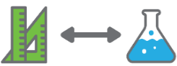 | Grids and coding  Students investigate a grid reference system to use as a basis for coding images using digital technologies concepts. Students investigate colour mixtures and paint a coded image.
Design a sign
Students use digital grids to create images. They design a bilingual sign for a public place incorporating their coded and/or digital images. Digital or non-digital technologies are used to facilitate construction.
Bilingual jingle
Students use digital technology to tell the story of their sign-making process. They explore and use the various options such as camera, text, sound, graphics and drawing within an application.

Background
Expected learning | At the completion of this module students will be able to:  - Identify and understand one or more words from a local Aboriginal language and its English translation.  - Describe how different materials can be combined for a purpose.  - Use an alpha-numeric grid to locate cells and use the grid references to create a code.  - Order objects according to size.  - Plan, predict and test different mixtures to create coloured paints.  - Explain that different materials can be combined for a purpose.  - Uses digital grids and information and communication technology (ICT) to create images.  - Design a bilingual sign for public display.  - Choose appropriate materials and use these to make a sign.  - Use ICT to present information about their bilingual sign and the design process.  - Evaluate the quality of a product in relation to its purpose.
Vocabulary | The following vocabulary list contains terms that need to be understood, either before the module commences or developed as they are used.  Aboriginal, pigment, rock art, mixture, stencil, array, grid, cell, code, coding, bilingual, language.  Examples of equivalent Aboriginal language words for common English words:  English Walmajarri  hand marla  English Ngarluma  hand mara  hello! wayiba!  English Wajarri  hand mara  English Kalgoorlie Goldfields languages (collective)  hand mara  English Noongar  hello kaya  star djinda  hut miya  fire karla  emu wetj  swan maali  hand maar  now yeyi  up yira  sit nyin  five maar  A map of Australian Aboriginal languages can be found on the Australian Institute of Aboriginal and Torres Strait Islander Studies website at  aiatsis.gov.au/explore/articles/aiatsis-map-indigenous-australia.  To get in touch with a local language group, contact an active language centre or program in your region if one is available. See the First Languages Australia website at www.firstlanguages.org.au.
Timing | There is no prescribed duration for this module. The module is designed to be flexible enough for teachers to adapt. Activities do not equate to lessons; one activity may require more than one lesson to implement.
Consumable materials | A Materials list is provided for this module. The list outlines materials outside of normal classroom equipment that will be needed to complete the activities.
Safety notes | There are potential hazards inherent in these activities and with the equipment being used, and a plan to mitigate any risks will be required.  Potential hazards specific to this module include but are not limited to:  - Possible exposure to cyber bullying, privacy violations and uninvited solicitations when using the internet  - Using spray bottles and mixing paints.
Assessment | The STEM modules have been developed to provide students with learning experiences to solve authentic real-world problems using science, technology, engineering and mathematics capabilities.  While working through the module, the following assessment opportunities will arise:  - Measuring, comparing and ordering objects according to a chosen attribute using informal units of measurement.  - Predicting, planning and testing mixtures of colours to create desired coloured paints and evaluating predictions.  - Applying code to construct an image.  - Working collaboratively to organise information.  - Using ICT to create an image on a digital grid.  Appendix 1 indicates how the activities are linked to the Western Australian Curriculum.  Evidence of learning from journaling, presentations and anecdotal notes from this module can contribute towards the larger body of evidence gathered throughout a teaching period and can be used to make on-balance judgements about the quality of learning demonstrated by the students in the science, technologies and mathematics learning areas.  Students can further develop their general capabilities including Information and communication technology (ICT) capability, Critical and creative thinking and Personal and social capability. Continuums for these are included in the General capabilities continuums but are not intended to be for assessment purposes.
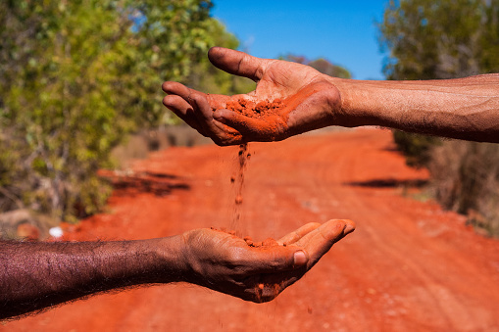
istockphoto.com

Activity 1: Mixing colours, words and hands
Activity focus | Students research the local Aboriginal language and culture. They learn how traditional paints and rock art were made by some Aboriginal groups and replicate the process.
Background information | Aboriginal rock art in Western Australia provides insight and stories about cultures dating back to at least 65,000 years. It is commonly believed rock art depicting a hand was made by spraying pigment out of the artist’s mouth onto the hand placed on the rock.  Over 250 Indigenous Australian language groups covered the continent at the time of European settlement in 1788. Government policies of the past banned or discouraged Aboriginal people from speaking their languages. The languages were oral, and when they were not permitted to be spoken, they became dormant.  In recent years they have been documented. Some Aboriginal languages are now taught in Western Australian schools by local Aboriginal language speakers.  Teaching and raising awareness of these languages to all Australians can help develop inclusive classrooms and communities.  For more information, see the following listed in Digital resources:  - SYNERGIES: Walking Together - Belonging to Country  - Indigenous Australian Languages
Instructional procedures | Establish and maintain collaborative and respectful relationships with Aboriginal students, parents and families in the school and draw on the strengths they bring to your classroom. Refer to the Aboriginal Cultural Standards Framework when engaging with Aboriginal families and the local community to ensure approaches are culturally responsive, see det.wa.edu.au/aboriginaleducation/theme/carnelian/detcms/navigation/aboriginal-education/  Student observations from the lesson should be recorded as annotations in the class reflective journal, along with copies of photos. An alternative is to record using a digital platform, see Reflective journal for more information.  It is recommended that students work in small groups for the activities. Mixed groups encourage peer tutoring and collaboration in problem solving. Collaboration is an important STEM capability. There are many solutions to this problem and negotiation is encouraged. See Teacher resource sheet 1.1: Cooperative learning – Roles.  Students will need to capture their learning journey through photos or short videos as they work through Activities 1 to 3. They will be used to create the presentations in Activity 4.  Trial a mixture of food colouring and water to find a suitable dilution that will be strong enough to contrast with white paper. Lighter and darker food colours can require different ratios.  Bloom’s question stems could be used to scaffold questioning and encourage higher order thinking and reasoning.  Remember /knowledge What is…? How would you show…? Where did you…? Which one…?  Understand/ comprehend How would you explain…? How are these alike? Different? What is the pattern in the graph/table? Which does not belong?  Apply/ application Predict what would happen if…? Why does … work? Using what you have learnt, how could you…?  Analyse/ analysis What could have caused…? What are the positive and interesting…? Explain why it is not possible for…? How would you order…? How can you use your data in your conclusion about…?  Evaluate How well does the prototype meet the design criteria? How would you improve…?  Create/ synthesise How could you show the relationships between…? How would you design an X to do Y?  Wilson (2006)
Expected learning | Students will be able to:  - Identify and understand a small number of words from a local Aboriginal language.  - Understand how different materials can be combined for a purpose (Science).
Equipment required | For the class:  Interactive whiteboard  A range of food colours  Mixing containers, spoons, liquid droppers  Spray bottles  Paper towel
For the students:
1 cm grid paper
Student activity sheet 1.3: I see, I think, I wonder
Preparation | It is important to note that the local Aboriginal language/s may not include direct translations of some common English words.  Invite Aboriginal families and local Elders to work collaboratively to develop a list of words in the local Aboriginal language that can be used for bilingual signs. Consult with a local Aboriginal language and cultural centres and/or land council where available.  Refer to additional website links in the Digital resources.
Activity parts | Part 1: What is ochre?  Ask the students if they know any other words or phrases people might use for the word hello. Working in small groups students make a simple drawing of two people meeting and annotate the drawing with as many greeting words or phrases they know (eg hi, hello, good morning, kaya, bonjour, g’day, how are you).  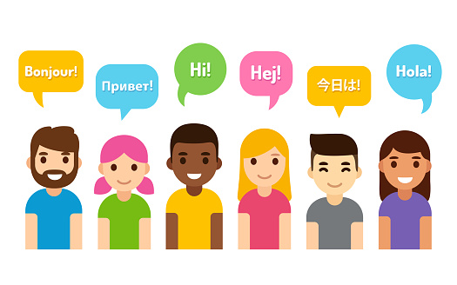  This activity provides an opportunity to engage students in sign language. Students can learn how to sign a few words on the Auslan website (see Digital resources).  istockphoto.com  Write a local Aboriginal word on the whiteboard and show where the language comes from and the name of the language on the Indigenous Australian Languages map on the Australian Institute of Aboriginal and Torres Strait Islander Studies website (see Digital resources).  To further engage the students, view the Ochre and the Indigenous Culture video (see Digital resources), explaining that it comes from a Queensland Aboriginal group (Gubbi Gubbi, near Brisbane) where they may do things differently to Aboriginal groups in your area.  After watching the video use the following questions to stimulate discussion, recording responses as a class using a method such as a mind map, brainstorm, Padlet or similar:  - What is ochre?  - Where does ochre powder come from?  - Why did he call it magic?  - How did it make him invisible?  - Why would they want to be invisible to animals?  - What would you do if you could be invisible?  Students could discuss the last question using a think-pair-share strategy. See Teacher resource sheet 1.1: Cooperative learning roles and Teacher resource sheet 1.2: Cooperative learning: Think-pair-share.  Alternatively, show students the Western Australian based video, SYNERGIES: Walking Together - Belonging to Country (see Digital resources). This film celebrates the remarkable similarities between Nyungar knowledge and Western science. It takes the audience through a 300 million year journey, featuring Nyungar Elder Dr Noel Nannup and Professor Stephen D. Hopper, as they walk the Swan River from its source to the ocean.
Part 2: Aboriginal art
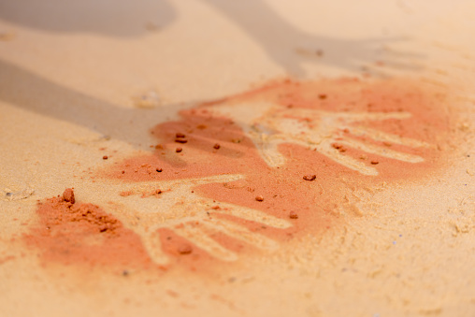
Display the image below. Ask students to think-pair-share their own ideas about how these hand paintings were made and record ideas using Student activity sheet 1.3: I see, I think, I wonder.
gettyimages.com.au
Explain to students that hand paintings like this were used thousands of years ago by Aboriginal people. Show students the video. What do hands represent in Aboriginal Art? to introduce them to how Aboriginal people use symbols to communicate (see Digital resources).
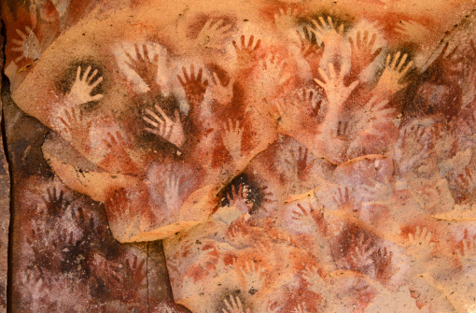
The image below shows traditional indigenous cave paintings.
gettyimages.com.au
Part 3: Mixing, making and painting
Explain to students that they will be creating their own hand paintings.
Model mixing ingredients to make paint. To approximately 500 mL of water, add about 10 drops of food colouring. Add it to the middle of the water so it can start spreading outwards.
Ask students to describe how the colour moves in the water.
Stir it slowly while intermittently asking students:
- What’s happening?
- How is the coloured liquid behaving in the clear liquid?
Add four teaspoons of cornflour, mixing as it is added. Ask:
- What changes can you see happening to the mixture as I add the cornflour?
- What do you think will happen if I don’t add enough cornflour? Too much?
Working in small groups, students make their own batches of paint. Model the following to students, explaining they will complete the task afterward in their groups:
- Transfer paint to a spray bottle, making sure it is mixed just before pouring so any cornflour is not left behind.
- Write name on the graph paper.
- Against an outside wall, one person holds their graph paper to the wall with their handheld on top. A partner sprays the paint from a greater distance at first, moving slowly closer until only a fine spray reaches the paper. Too close and the liquid will run and drip down under the hand.
- Have paper towel on hand to soak up any extra liquid.
- Rest the painting somewhere to dry. Once dry, students label their painting with the local Aboriginal word for hand.
Note: A regular spray bottle will spray a cornflour and water mixture. Flush the spray nozzle with plain water after painting.
Part 4: Which is bigger?
Measure and compare two handprints, one of an adult’s hand and one of a child’s hand.
Pose the question:
- Which handprint is bigger?
Students use direct comparison by overlaying the two handprints, like a ‘high-five’, to start their investigation to say which they think is bigger. Allow students to consider as many attributes of the handprints as they can that could be compared. Prompt student thinking by asking:
- What do we mean by ‘big’?
- Which attribute did you measure?
Identify and list the attributes the students used in their direct comparison. For example, the length of the handprint, the width of the handprint and the area of the handprint. Ask them how we can be sure which one is bigger and by how much?
Show students a range of items in a ‘messy box’ such as counters, buttons, rice, small blocks, square tiles etc. Ask students to use objects from the box to measure the same attribute for both handprints. Observe students’ ability to choose an appropriate unit, repeat a uniform unit and attend to gaps and overlaps. Ask students to describe the attribute measured, justify their choice of unit and say which handprint was bigger and by how much.
For example, “I used the cubes to measure the width of each handprint. I made sure each cube was the same size and that there were no gaps between them. I placed them in a straight line from the left of the handprint to the right. My handprint is 8 cubes wide and the adult handprint is 11 cubes wide. The adult handprint is bigger. It is 3 cubes wider than mine.”
“I used counters to measure the area of the handprints. I could fit 12 counters on my handprint and 20 counters on the adult’s handprint. The adult handprint is bigger by 8 counters. I think I will try using square tiles as my unit next time so that there are no gaps between the units.”

Part 5: Reflection and journaling
As a class, discuss the communicative function of rock art and language.
- How did Aboriginal people make hand stencil rock art?
- What other images were painted or carved onto rocks?
- Why did Aboriginal people make these pictures?
- Other than pictures, what else do we use to share stories?
Explain that, we use signs to communicate information (eg road signs, safety warnings, street name signs) and these are made using modern materials and technologies. In some countries, like New Zealand, street signs are written in two languages. In Australia we could have signs in both English and the local Aboriginal language to help more people be aware of and learn Aboriginal languages.
Ask the students to reflect on the following questions:
- How can we use modern materials and technologies to make bilingual signs?
- How were your paintings similar or different to traditional Aboriginal methods of painting?
Record student observations and photos of their activity in the class reflective journal. See Reflective journal for more information.
Resource sheets | Reflective journal  Teacher resource sheet 1.1: Cooperative learning roles  Teacher resource sheet 1.2: Cooperative learning: Think-pair-share.  Student activity sheet 1.3: I see, I think, I wonder
Digital resources | Auslan Signbank Dictionary, Hello (Auslan, 2014)  www.auslan.org.au/dictionary/words/hello-1.html
Ochre and the Indigenous Culture (Paul Nicholas, 2014)
youtu.be/bCLCBwprEEk
What do hands represent in Aboriginal Art? (Queensland Rural Medical Education Limited, 2013)
youtu.be/YZQfpBlfg8I
How to make chalk paint (wikiHow)
www.wikihow.com/Make-Chalk-Paint
Aboriginal language resources/links
Map of Indigenous Australia (Australian Institute of Aboriginal and Torres Strait Islander Studies, 2019)
aiatsis.gov.au/explore/articles/aiatsis-map-indigenous-australia
Wangka Maya Pilbara Aboriginal Language Centre - Aboriginal Languages of the Pilbara
www.wangkamaya.org.au/pilbara-languages/aboriginal-languages-of-the-pilbara
Kaartdijin Noongar-Noongar Knowledge – Noongar dictionary
www.noongarculture.org.au/noongar-dictionary-by-rose-whitehurst/
City of Greater Geraldton - Aboriginal Culture
www.cgg.wa.gov.au/live/my-community/aboriginal.aspx
Our Languages - Kimberley Aboriginal Languages Map
ourlanguages.org.au/kimberley-aboriginal-languages-map/
Goldfields Land and Sea Council
http://www.glsc.com.au/contact
Twinkl has a range of resources to support the teaching and learning of Aboriginal language, histories and culture:
www.twinkl.com.au
Literary resources | A range of picture book resources to support the teaching and learning of Aboriginal language, histories and culture can be found at:  https://www.teaching.com.au/catalogue/mta/mta-indigenous-cb

Activity 2: Grids and coding
Activity focus | Students use a grid reference system to locate cells on a grid and use them as a basis for coding images using digital technologies concepts. Students investigate colour mixtures and paint a coded image.
Background information | Images on digital screens can be created using pixels. Grids provide a template to create a pixelated image and an opportunity to use coding. Students will develop familiarity with a grid reference system, plus make connections between traditional and modern art forms.  The focus on coding at this year level is on designing a sequence of steps. Students build their computational thinking skills as they practise communicating ideas using codes and symbols. By ‘programming’ one another to draw pictures, students will begin to understand the difficulty of translating thoughts into programs and how easily information can be misinterpreted. In this activity, students practise instructing each other to locate specific cells on an alpha-numeric grid and move around the grid to create the letters of a word.  At Year 2, digital technologies learning is at the pre-programming stage and there is no requirement to learn programming language. However, students should begin to learn some basic computational skills such as determining the steps and decisions required to solve simple problems.  By drawing through ‘programming’, students begin to understand the difficulty in translating into programs, and how easily information can be misinterpreted.
Instructional procedures | In this activity, students are learning to use an alpha-numeric labelling system to locate cells on a simple grid and describe location and direction to move on the grid. It is important that students understand that the numbers and letters are used to label the columns and rows of the grid to describe the cells or spaces between the grid line. They are used in a different way to grid coordinates found on maps.  When reading grid references, state the horizontal reference then the vertical reference (eg the face is at (C, 1), not at (1, C)).  A B C  1 ☺  2  3  Some Digital Technologies concepts can be taught using unplugged activities. Basic board games are good for teaching basic programming skills to early learners. Students may also benefit from class activities such as Graph Paper Programming see Digital Resources  Students should be introduced to the words ‘algorithm’ and ‘programming’. An algorithm is a list of steps you can follow to finish a task. Programming is the process of creating a set of instructions that tell a computer how to perform a task.  Some students may be ready to learn to use a simple visual programming language specifically designed for young children. An app that enables students to drag and drop programming blocks can be used to create some simple animations.  Students will need to capture their learning journey through photos or short videos as they work through this activity. These will be used in the presentations in Activity 4.
Expected learning | Students will be able to:  - Plan, predict and test different mixtures to create coloured paints (Science).  - Explain that different materials can be combined for a purpose (Technologies).
Equipment required | For the class:  Interactive whiteboard with a coding array template Student activity sheet 2.1: Coding grids displayed  A range of food colours  Cornflour or cornstarch  Mixing containers, spoons, liquid droppers (per small group)  Paper towel  Paintbrushes
For the students:
8 counters per student pairs
Graph paper
Coding grid template Student activity sheet 2.1: Coding grids one per student
Blank paper
Science journals
Preparation | Prepare a classroom display of a shortlist of local Aboriginal words. A range of resources to support the teaching and learning of Aboriginal language, histories, and culture, including word wall templates, can be found on the Twinkl website at www.twinkl.com.au.
Part 1: Moving on a physical grid
Create a 4 x 4 grid made from 16 carpet squares or drawn in chalk on a playground surface. Have some simple pathways drawn on cards for students to follow. Invite one student to take a card and call out the instructions for another student to follow on the grid. Encourage students to give precise instructions using directional and positional language of half / quarter turns, left and right, forwards and backwards. For example, start on the bottom left square facing the top the grid. Move one square forward. Make a quarter turn to your right. Move forward 2 squares. Make a quarter turn to your left. Move forward 2 squares. Swap roles to give all students experience with both giving instructions and moving on the grid. As students become familiar with this activity, label the rows and columns with letters and numbers. Repeat the activity using grid references in oral instructions. Ask students:
- Is there more than one way to get from one point to another?
- How does using a grid reference help to give clear instructions?

Part 2: Moving on a grid
Model the use of an alpha-numeric 4 x 4 grid on the whiteboard. Help students make connections between the physical grid and the two dimensional representation on the whiteboard by asking one student to stand on a square of the carpet grid and another student saying the grid reference and marking the appropriate spot on the whiteboard grid. Have one student walk a simple path on the carpet square grid. Teacher models the drawing of the pathway on the whiteboard, clearly indicating the start and finish points using grid references. List the step by step instructions alongside the grid.
Working in pairs, have one student move along a simple pathway on the carpet/playground grid. The other student draws the path on an alpha-numeric 4x4 paper grid, indicating the start and finish position using alpha-numeric grid references. Working together, the two students write the step by step instructions to get from start to finish alongside the drawn path. Swap with another pair of students to ‘test’ the written instructions by getting them to walk the pathway described.
- Did your instructions clearly describe how to get to the finish point?
- What language did you need to use?
- What challenges did you come across?
- How could you improve your communication?

Part 3: Using alpha-numeric grid references to identify cells to write words

Students use grid references to locate cells on a larger grid to create letter of words. Students use a blank Student activity sheet 2.1: Coding grids template to colour in each cell as the teacher calls out the grid references.
(B, 4) (B, 5) (B, 6) (B, 7) (B, 8) (C, 6) (D, 4) (D, 5) (D, 6) (D, 7) (D, 8)
(F, 4) (F, 5) (F, 6) (F, 7) (F, 8) (G, 4) (G, 6) (G, 8)
Explain that now the first two letters have been completed (see image below), the remaining letters can be communicated. This is an opportunity to establish coding terms, for example, home (starting square), pen up (move without colouring in the square), pen down (move and colour in the square/s). Communicate the instructions for the next letter to the students:
Go to (I, 4), pen down, go down four more squares, go right one square, pen up.
Challenge students to guess the word and work in pairs to come up with instructions to complete the word. When they have done this, the groups of two can join to create groups of four and see if they can follow each other’s instructions.
After the activity, ask students:
- What were your challenges?
- Could you communicate the information?
- Did the other group follow your instructions?
- Did you need to make some changes to your instructions?
- Could you follow the other group’s instructions? Why/why not?

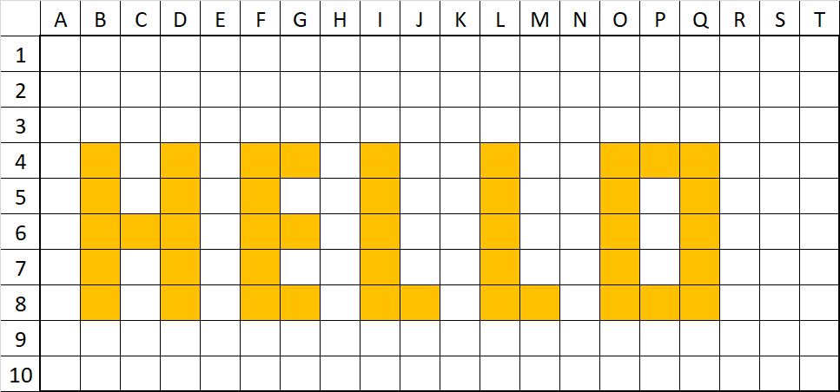
The following is a different approach to the activity and makes use of grid references and computational language using the ‘repeat’ instruction:
(B, 4) (B, 5) (B, 6) (B, 7) (B, 8) (C, 6) (D, 4) (D, 5) (D, 6) (D, 7) (D, 8)
(G, 4) (G, 6) (G, 8) (J, 8) (M, 8) (P, 4) (P, 8)
Find (F, 8)
Colour it in and colour in the four squares above it
Find (I, 8) and repeat
Find (L, 8) and repeat
Find (O, 8) and repeat
Find (Q, 8) and repeat

The learning processes can be differentiated in this activity by allowing students to apply either:
- One of the first two approaches, or,
- For an extension, introduce loops (ie F, F, F, F = 4F) which means repeat command F, four times.
Additional learning opportunity
Students can make and play the game Battleships. Battleship games introduce grid references in a hands-on way, helping students to understand the relationship between rows and columns, as well as the relationship between an actual object or a sequence of events and how they are represented on a grid.
Addition resources and activities such as this can offer a great way to reinforce or expand the activities: https://code.org/curriculum/course2/1/Teacher for elaboration.
Part 4: Make your code
Students choose a local Aboriginal word to write onto a blank coding grid. On a separate sheet of paper, students create the code to represent their word. Challenge students to think about using coding language and the repeat function. Explain to students that this type of thinking is known as algorithmic thinking and is a very useful skill to develop.
Students partner up to play a barrier game.
Barrier games are played between two or more people where a barrier is placed between the players who convey information to each other. The games are designed to facilitate communication and develop expressive (speaking) and receptive (understanding) language.
As an alternative to the barrier game, students can swap their code with their partners to transfer onto a blank coding array.
This barrier game demonstrates how Battleships can be modified to a find-and-sink word game. Examples are available on the Twinkl website at www.twinkl.com.au.

Part 5: Paint your coded word
Explain to students they will investigate how to create ochre colour paint. The responses from this activity should be recorded in the students’ science journals.
Pose the investigation question:
- What colours should we mix to produce an ochre colour?
Provide each group with a paper cup, eye droppers, access to several bottles of various food colours and a bucket of water.
Support the small groups of students to conduct their investigation:
- To approximately 200 mL of water in the paper cup, add roughly five drops of one food colouring. Add it to the middle of the water body so it can start spreading outwards.
- Predict what will happen after adding roughly five drops of a different colour, then add them.
- Observe what happens, mix intermittently. Add more colour drops if needed.
- Groups choose a colour they would like to make, then the two food colourings they predict will make it.
- Repeat the steps above to test their prediction.
- Allow a few varied colour mix tests.
- Add two teaspoons of cornflour, mixing as adding, and paint the blank cells around the coded Aboriginal word from Part 4.
Discuss the students’ observations and help them evaluate their predictions, distinguishing between the original colours and the mixture:
- Which colour did you want to make?
- What did you predict would make that colour?
- What happened when you mixed the two colours?
- What colour was the mixture?
- Was your prediction correct?
- What changes did you observe to the mixture as the cornflour was added? After it was added? Why do you think we needed to use cornflour in the mixture?

Part 6: Reflection and journaling
Ask students to think-pair-share (see Teacher resource sheet 1.3: Cooperative learning - Think-pair-share) the following questions and record their reflections in their science journal:
- How can we use grid reference codes?
- We mixed colours today. Can you think of some other mixtures?
- Why do we make mixtures?
Resource sheets | Teacher resource sheet 1.3: Cooperative learning - Think-pair-share  Student activity sheet 2.1: Coding grids
Digital resources | Aboriginal resources  Twinkl website: www.twinkl.com.au
Battleship resources
Twinkl website: www.twinkl.com.au

Activity 3: Sign design
Activity focus | Students use digital grids to create images. They design a bilingual sign for a public place incorporating their coded and/or digital images. Digital or non-digital technologies are used to facilitate construction.
Background information | Well-made signs posted in public places send a message every time a person passes by, see Teacher resource sheet 3.1: Bilingual sign example.  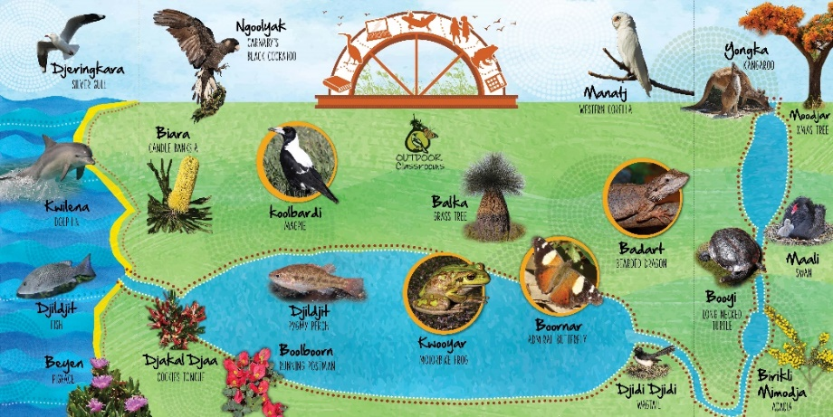  Department of Education  If a sign’s text is short, its meaning is immediately processed and understood, like a sight word for an early reader, or a well-known brand name on an advertising billboard. Therefore, a bilingual sign in a Western Australian school will quickly portray meaning to non-native speakers. Students’ STEM skills will contribute to the quality of the signs.  The Design process is a series of steps that guides the development of a solution to a problem. The core steps in the process are the same whether applied in different contexts such as engineering or software design. These steps are:  - Define the problem: What is the need?  - Research and gather information.  - Analysis: Imagine: Brainstorm ideas.  - Ideation: Plan: Pick the best idea, how will it work? Draw a diagram, identify materials or tools required?  - Development/ production: Create: Build the solution and test it.  - Evaluation: Improve: What works, what doesn’t, what could work better? Repeat the cycle.  Negotiation, critical thinking and reasoning skills will be displayed by the students as they work on their designs. Problem solving in collaborative situations is a STEM capability that students need to develop. Allowing students to negotiate amongst themselves will encourage the improvement of this skill.
Instructional procedures | Students will need assistance with cutting and joining skills. Parent or buddy class support may need to be arranged. Refer to Teacher resource sheet 3.2: Construction skills for tips on joining and binding items.  A gif could be made to showcase an example of the sign in the school’s online newsletter or webpage. The Giphy website at giphy.com/create/gifmaker can be a useful resource.  Students need to capture their learning journey through photos or short videos to use in their presentation in  Activity 4.
Expected learning | Students will be able to:  - Uses grids and digital technologies to create images (Technologies).  - Design a bilingual sign for public display (Technologies).  - Choose appropriate materials and use these to make a sign (Technologies).
Equipment required | For the class:  Interactive whiteboard  Hole-punch, laminator and laminating pouches  Teacher resource sheet 3.2: Construction skills
For the students:
Devices with appropriate applications
Coat-hangers, wire, string, cardboard, boxes, glue
A range of construction materials as listed in the
Materials list
Preparation | Ensure one or more of the following digital applications is available on all student devices:  - Microsoft Excel  - Numbers  - Keynote  - Geoboard  - Bloxels (to purchase - a physical tool with an app)  - Minecraft – Students can share their worlds with one another and screenshot and print their block-based signs  Dedicate time, if necessary, to become familiar with the applications prior to the activity.
Activity parts | Part 1: Digital pixels  Model how to use and colour cells (squares) of a grid in a digital application. An example has been provided below. See Digital resources for an extended list.  The images below show how this might appear in several applications.  Colour cells in excel.  Add rows and columns in Numbers.  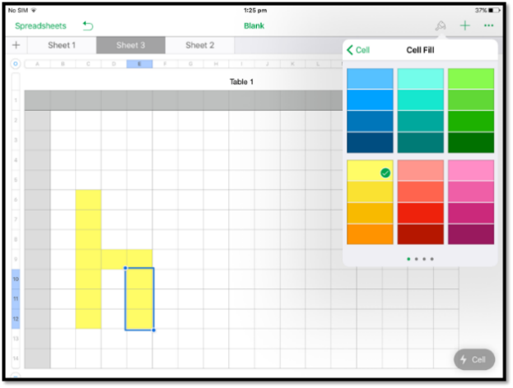  Create shapes in Geoboard  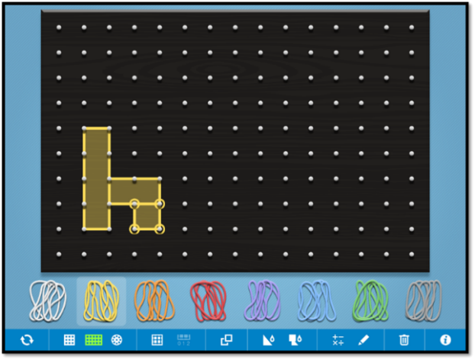  Allow students time to explore creative options and become familiar with the application of choice.  Students create a digital version of their words from  Activity 2. They will need to print out this image to use in their sign. Colour and size should be considered before printing.
Part 2: Design ideas
Explain to students that they will be making bilingual signs to be placed around the school to inform and educate the school community.
Student groups develop a set of design criteria for their sign. Drawing on knowledge from Activity 2, students consider visibility, design and durability of materials.
Ask students:
- How can we make a bilingual sign?
Using a think-pair-share cooperative strategy, students generate ideas and then discuss these ideas with the class. As students discuss ideas, record them somewhere visible to all using a format of choice (ie a brainstorm).
As a class, look at some photos of existing signs and discuss their meaning. Searching for ‘bilingual signs New Zealand’ or ‘bilingual signs Inuktitut’ will provide many examples. Question students about their size, shape, colour, symbols or language used.
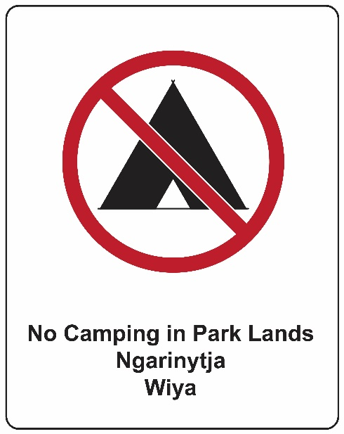
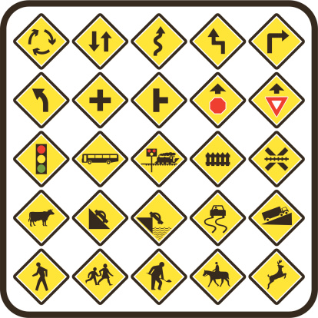
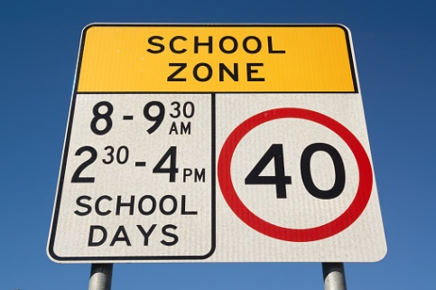
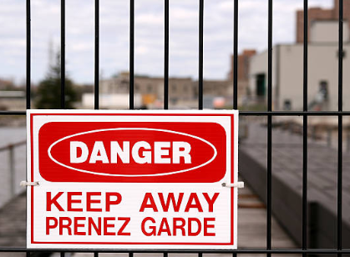
gettyimages.com.au
STEM Consortium
Students discuss and develop a design sketch for their sign.
With teacher support, students follow the design process (see Design process guide) to ideate their design.
Part 3: Materials
Explain to students that they will be working to design and build a sign showing a word in both English and the local Aboriginal language.
Working together, students ideate their design idea. Remind students how to correctly label their diagrams. Have the material names displayed somewhere central so students can access new vocabulary.
Some design ideas could include:
- Printed digital images glued onto cardboard and hung from classroom hanging wires.
- Coded and painted images laminated and hung.
- Parts of cardboard boxes with built-in folds that can act as wind-driven rotating signs hanging from a string.
- A cardboard roll hung from the cross bar of a coat hanger, with images glued onto either side of the roll. Fan blades can be cut into the ends to be wind driven.
- A digital program, such as Scratch Jr, that facilitates a looping function could be displayed using digital devices and made available to the school community (eg in the school’s reception).
Part 4: Build it
Demonstrate some basic construction skills such as hole punching and tying simple knots. Teacher resource sheet 3.2: Construction skills can be printed and placed at stations around the room to stimulate student thinking and help them solve construction problems. Demonstrate each station explaining the method and safety elements.
An option could be to establish a teacher-run shopfront where students could request materials according to their designs. Materials could be limited with students required to trade and explain why they require different materials.
During construction time, the teacher should model the design process by assessing the quality of something, critique it, disassemble it and redesign it. Encourage students to do the same. The design process steps of ideation, development, and production are specifically followed in this activity. Students are encouraged to build resilience and embrace the design cycle as they seek to improve initial design ideas.
Part 5: Review, reflection and journaling
Discuss the features of the students’ signs and evaluate their suitability. Students record their reflections in their science journals. The template Teacher resource sheet 3.3: Design review can also be used for reflection.
Prompt student thinking with questioning:
- How does your sign help people see both words?
- Which part of the sign helps both words be seen?
- Will your sign last outside in the rain, wind or sun?
- Will people want to read your sign? Why?
- What worked? Because…
- What didn’t work? Why?
- Do you have any further recommendations for developing your idea?
Resource sheets | Materials list  Design process guide  Teacher resource sheet 3.1: Bilingual sign example.  Teacher resource sheet 3.2: Construction skills  Teacher resource sheet 3.3: Design review
Digital resources | Microsoft Excel  products.office.com/en-au/excel
Numbers
www.apple.com/au/numbers/
Keynote
www.apple.com/au/keynote/
Geoboard app
www.mathlearningcenter.org/resources/apps/geoboard
Bloxels
edu.bloxelsbuilder.com/
Minecraft
minecraft.net/en-us/
Scratch Jr
itunes.apple.com/us/app/scratchjr/id895485086

Activity 4: Bilingual jingle
Activity focus | Students use digital technology to tell the story of their sign-making process. They explore and use the various options such as camera, text, sound, graphics and drawing within an application.
Background information | Communicating the value of their project will help students celebrate their work. Making a digital presentation to an external audience will also draw attention to their signs.  Students will need support to prepare and deliver their presentation. This could be scaffolded into three phases: deciding on the content of the presentation; selecting appropriate media and preparing the posters or slides, and delivering the presentation. It is suggested that presentations are group-based and that each student has a role and responsibility to support collaborative work. This will provide an opportunity to develop leadership and collaboration skills associated with the general capability of Personal and social capability. See Teacher resource sheet 1.1: Cooperative learning – Roles.  This activity provides opportunities for cross-curriculum assessment of literacy, listening and speaking. Depending on students’ prior knowledge or abilities, time may need to be dedicated to developing oral presentation skills.  Presentation options include creating a comic strip, eBook, poster in Pages, Keynote or PowerPoint, or simple iMovie (or similar), which can then be shared through a digital platform such as Connect, Seesaw or Class Dojo, added to a class blog, or shared on the interactive whiteboard. Students may require explicit instruction when using these applications.  To enable the completion of the design process, students should be given time to make improvements to their work based on the feedback received from the presentations. This could be in groups or as a private reflection in learning journals. Time should be taken to discuss how to give constructive feedback and how to take feedback positively.  There is the opportunity for teachers to monitor students’ development of the general capability of Personal and social capability using Teacher resource sheet 4.1: Evaluation.
Expected learning | Students will be able to:  - Evaluate the quality of a product in relation to its purpose (Technologies).  - Use digital technologies to present information about their bilingual sign and its design process (Technologies).
Equipment required | For the class:  Devices loaded with digital applications for their presentations. See Digital resources.
For the students:
Student activity sheet 1.0: Journal checklist
Preparation | Devices will need to be charged and loaded with appropriate applications.  Presentations will need to be scheduled.  Consider the length of the presentations. Two minutes is a good length for speaking, with two minutes for questions and two minutes change groups.  Invite members of the community to join the audience for the presentations.  Prepare copies of the following teacher resources:  Teacher resource sheet 4.1: Evaluation  Teacher resource sheet 4.2: 3-2-1 Reflection
Activity parts | Part 1: Gallery walk  Students participate in a gallery walk and verbally evaluate one another’s signs.  Facilitate a class discussion about the signs the students have seen in their neighbourhood or at a shopping centre.  Encourage students to imagine how they would make their sign if they had endless materials and options. Students discuss how their sign could be improved including the types of materials, construction processes, sign location, colours or graphics.
Part 2: Presentation content
Students decide on and write the content of the presentation.
Presentations should focus on the objects the students have made, the purpose of their sign and their choice of materials as outlined in their design plan. Students should also share what they have learnt as they have worked through the activities. Students should justify any changes made during the construction process.
Remind students of all aspects of the STEM project which have led to the sign making and to solve the problem:
How can we use modern materials and technologies to make bilingual signs?
Use questions to prompt student thinking such as:
- How are your spray bottle paintings like traditional Aboriginal art?
- How did you make coloured paints?
- How did you use arrays to code words?
- Which Aboriginal language did you choose? Why?
- Which Aboriginal word did you choose? What does it mean?
- Why did you make your sign that way?
- What attracts passers-by to your sign?
- What will passers-by learn from your sign?
Encourage students to make an engaging presentation.
Note: Students photographing their signs and video recording each other talking about the process are good starting points.
Part 2: Choosing media
Introduce the options students will have for creating their presentations. See Digital resources for suggestions. Demonstrate how to use the applications. For example, the Book creator iPad app has options for photos, camera, pen, text, sound and shapes.
It may be helpful to organise a buddy class to work with the students while they are creating their presentations.
Part 4: Public display
Hang the signs in the school and notify the school community. Encourage students to draw attention to them at break times.
Part 5: Spread the word
Students share their presentations with their peers and, where possible, an audience beyond the classroom. The work may be shared with parents via Connect, a portal, class blog or other digital platform.
Student reflections can be recorded using Teacher resource sheet 4.1: 3 – 2 – 1 Reflection.
Students complete Student activity sheet 1.0: Journal checklist.
Resource sheets | Student activity sheet 1.0: Journal checklist  Teacher resource sheet 1.1: Cooperative learning – Roles.  Teacher resource sheet 4.1: Evaluation  Teacher resource sheet 4.2: 3-2-1 Reflection
Digital resources | Digital programs or applications to create presentations
Explain Everything
explaineverything.com
Show Me
www.showme.com
Keynote
www.apple.com/au/keynote
Microsoft PowerPoint
www.microsoft.com
Scratch Jr.
www.scratchjr.org
Book Creator
bookcreator.com

Appendix 1: Links to the Western Australian Curriculum
The Cryptic code module provides opportunities for developing students’ knowledge and understandings in science, technologies and mathematics. The table below shows how this module aligns to the content of the Western Australian Curriculum and can be used by teachers for planning and monitoring.

CRYPTIC CODE | ACTIVITY
 | 1 | 2 | 3 | 4
SCIENCE
SCIENCE UNDERSTANDING
Chemical sciences: Different materials can be combined for a particular purpose (ACSIS031) | ● | ●
SCIENCE INQUIRY SKILLS
Questioning and predicting: Pose and respond to questions, and make predictions about familiar objects and events (ACSIS037) |  | ●
Planning and conducting: Participate in guided investigations to explore and answer questions (ACSIS038) |  | ●
Evaluating: Compare observations with those of others (ACSIS041) |  | ● |  | ●

CRYPTIC CODE | ACTIVITY
 | 1 | 2 | 3 | 4
DESIGN AND TECHNOLOGIES
KNOWLEDGE AND UNDERSTANDING
Technologies and society: People design and produce familiar products, services and environments to meet local and community needs (ACTDEK001) |  |  | ●
PROCESSES AND PRODUCTION SKILLS
Producing and implementing: Use components and given equipment to safely make solutions (WATPPS13) |  |  | ●
Evaluating: Use simple criteria to evaluate the success of design processes and solutions (WATPPS14) |  |  | ● | ●
Collaborating: Work independently, or collaboratively when required, to organise information and ideas to safely create and share sequenced steps for solutions (WATPPS15) | ● | ● | ● | ●
MATHEMATICS
NUMBER AND ALGEBRA
MEASUREMENT AND GEOMETRY
Using units of measurement: Compare and order several shapes and objects based on length, area, volume and capacity using appropriate uniform informal units (ACMMG037) | ●
Location and transformation: Interpret simple maps of familiar locations and identify the relative positions of key features (ACMMG044)  Identify and describe half and quarter turns (ACMMG046) |  | ●
Science elaborations with links to Aboriginal and Torres Strait Islander Histories and Cultures can be found at www.australiancurriculum.edu.au/f-10-curriculum/cross-curriculum-priorities/aboriginal-and-torres-strait-islander-histories-and-cultures/

Appendix 1B: Mathematics proficiency strands
Key ideas
In Mathematics, the key ideas are the proficiency strands of understanding, fluency, problem-solving and reasoning. The proficiency strands describe the actions in which students can engage when learning and using the content. While not all proficiency strands apply to every content description, they indicate the breadth of mathematical actions that teachers can emphasise.
Understanding
Students build a robust knowledge of adaptable and transferable mathematical concepts. They make connections between related concepts and progressively apply the familiar to develop new ideas. They develop an understanding of the relationship between the ‘why’ and the ‘how’ of mathematics. Students build understanding when they connect related ideas, when they represent concepts in different ways, when they identify commonalities and differences between aspects of content, when they describe their thinking mathematically and when they interpret mathematical information.
Fluency
Students develop skills in choosing appropriate procedures; carrying out procedures flexibly, accurately, efficiently and appropriately; and recalling factual knowledge and concepts readily. Students are fluent when they calculate answers efficiently, when they recognise robust ways of answering questions, when they choose appropriate methods and approximations, when they recall definitions and regularly use facts, and when they can manipulate expressions and equations to find solutions.
Problem-solving
Students develop the ability to make choices, interpret, formulate, model and investigate problem situations, and communicate solutions effectively. Students formulate and solve problems when they use mathematics to represent unfamiliar or meaningful situations, when they design investigations and plan their approaches, when they apply their existing strategies to seek solutions, and when they verify that their answers are reasonable.
Reasoning
Students develop an increasingly sophisticated capacity for logical thought and actions, such as analysing, proving, evaluating, explaining, inferring, justifying and generalising. Students are reasoning mathematically when they explain their thinking, when they deduce and justify strategies used and conclusions reached, when they adapt the known to the unknown, when they transfer learning from one context to another, when they prove that something is true or false, and when they compare and contrast related ideas and explain their choices.

Source: www.australiancurriculum.edu.au/f-10-curriculum/mathematics/key-ideas/?searchTerm=key+ideas#dimension-content

Appendix 2: General capabilities continuums
The general capabilities continuums shown here are designed to enable teachers to understand the progression students should make with reference to each of the elements. There is no intention for them to be used for assessment.
Information and communication technology (ICT) capability learning continuum
Sub-element | Typically by the end of Year 2 | Typically by the end of Year 4 | Typically by the end of Year 6
Create with ICT  Generate ideas, plans and processes | use ICT to prepare simple plans to find solutions or answers to questions | use ICT to generate ideas and plan solutions | use ICT effectively to record ideas, represent thinking and plan solutions
Create with ICT  Generate solutions to challenges and learning area tasks | experiment with ICT as a creative tool to generate simple solutions, modifications or data representations for particular audiences or purposes | create and modify simple digital solutions, creative outputs or data representation/ transformation for particular purposes | independently or collaboratively create and modify digital solutions, creative outputs or data representation/transformation for particular audiences and purposes
Communicating with ICT  Collaborate, share and exchange | use purposefully selected ICT tools safely to share and exchange information with appropriate local audiences | use appropriate ICT tools safely to share and exchange information with appropriate known audiences | select and use appropriate ICT tools safely to share and exchange information and to safely collaborate with others

Critical and creative thinking learning continuum
Sub-element | Typically by the end of Year 2 | Typically by the end of Year 4 | Typically by the end of Year 6
Inquiring – identifying, exploring and organising information and ideas  Organise and process information | organise information based on similar or relevant ideas from several sources | collect, compare and categorise facts and opinions found in a widening range of sources | analyse, condense and combine relevant information from multiple sources
Generating ideas, possibilities and actions  Imagine possibilities and connect ideas | build on what they know to create ideas and possibilities in ways that are new to them | expand on known ideas to create new and imaginative combinations | combine ideas in a variety of ways and from a range of sources to create new possibilities
Generating ideas, possibilities and actions  Seek solutions and put ideas into action | investigate options and predict possible outcomes when putting ideas into action | experiment with a range of options when seeking solutions and putting ideas into action | assess and test options to identify the most effective solution and to put ideas into action
Reflecting on thinking and processes  Transfer knowledge into new contexts | use information from a previous experience to inform a new idea | transfer and apply information in one setting to enrich another | apply knowledge gained from one context to another unrelated context and identify new meaning

Personal and social capability learning continuum
Sub-element | Typically by the end of Year 2 | Typically by the end of Year 4 | Typically by the end of Year 6
Social management  Work collaboratively | identify cooperative behaviours in a range of group activities | describe characteristics of cooperative behaviour and identify evidence of these in group activities | contribute to groups and teams, suggesting improvements in methods used for group investigations and projects
Social management  Negotiate and resolve conflict | practise solving simple interpersonal problems, recognising there are many ways to solve conflict | identify a range of conflict resolution strategies to negotiate positive outcomes to problems | identify causes and effects of conflict, and practise different strategies to diffuse or resolve conflict situations
Social management  Develop leadership skills | discuss ways in which they can take responsibility for their own actions | discuss the concept of leadership and identify situations where it is appropriate to adopt this role | initiate or help to organise group activities that address a common need
Further information about general capabilities is available at:
k10outline.scsa.wa.edu.au/home/p-10-curriculum/general-capabilities-over/general-capabilities-overview/general-capabilities-in-the-australian-curriculum

Appendix 3: Materials list

The following materials are required to complete this module:
- A range of food colours
- Cornflour or corn-starch
- Spray bottles (one per group)
- 1 x clear glass mixing container
- Mixing container, spoon, liquid dropper (per group)
- Paper towel
- Paint brushes
- Graph paper
- Rocks and chalk for the additional learning experience activity
- Coat-hangers
- Wire
- String
- Cardboard boxes
- Hole punch
- A range of reusable materials for construction of signs

Appendix 4: Design process guide
Safe production of the final design or multiple copies of the final design.
Fine tuning the production process, such as division of labour for batch or mass production.
Use of intended materials and appropriate tools to safely make the solution to the design problem.
Reflection on the process taken and the success of the design.
Evaluation can lead to further development or improvement of the design and can be a final stage of the design process before a conclusion is reached.
Could be formal or informal and verbal or written.
Ideation
Development
Development of the design ideas. Improvements, refinements, adding detail, making it better.
Activities such as detailed drawings, modelling, prototyping, market research, gaining feedback from intended user, further research – if needed – to solve an issue with the design, testing different tools or equipment, trialling production processes, measuring or working out dimensions, testing of prototypes and further refinement.
Idea generation – turning ideas into tangible forms so they can be organised, ordered and communicated to others.
Activities such as brainstorming, mind mapping, sketching, drawing diagrams and plans, collecting colour samples and/or material samples and talking through these ideas can help to generate more creative ideas.
Using the SCAMPER model can assist with this: www.mindtools.com/pages/article/newCT_02.htm
www.designorate.com/a-guide-to-the-scamper-technique-for- creative-thinking
Analysis
Finding useful and helpful information about the design problem.
Gathering information, conducting surveys, finding examples of existing solutions, testing properties of materials, practical testing.
Understanding the meaning of the research findings.
Analysing what the information means, summarising the surveys, judging the value of existing solutions, understanding test results.
Research
Production
Evaluation

Appendix 5: Reflective journal
When students reflect on learning and analyse their own ideas and feelings, they self-evaluate, thereby improving their metacognitive skills. When students self-monitor or reflects, the most powerful learning happens.
istockphoto.com
Journaling may take the form of a written or digital journal, a portfolio or a digital portfolio. Early childhood classrooms may use a class reflective floor book with pictures of the learning experience and scribed conversations.
Teachers can model the journaling process by thinking aloud and showing students how they can express learning and thoughts in a variety of ways including diagrams, pictures and writing.
Journals are a useful tool that gives teachers additional insight into how students value their own learning and progress, as well as demonstrating their individual achievements.
The following links provide background information and useful apps for journaling.
Kidblog – digital portfolios and blogging
kidblog.org/home
Edmodo – for consolidating and storing class notes and learning materials
www.edmodo.com
Explain Everything™ – a screen casting, video and presentation tool all in one
explaineverything.com/
Popplet – allows you to jot down your ideas and then sort them visually
Popplet.com
Seesaw – for capturing work completed by students in class, using a device’s camera function
web.seesaw.me
Connect – the Department of Education’s integrated, online environment
connect.det.wa.edu.au
Evernote (a digital portfolio app)
evernote.com
Digital portfolios for students (Cool tools for school)
cooltoolsforschool.wordpress.com/digital-student-portfolios

Appendix 6: Student activity sheet 1.0: Journal checklist
As an ongoing part of this module, you have been keeping a journal of your work.
Before submitting your journal to your teacher please ensure you have included the following information.
- Tick each box once complete and included.
- Write N/A for items that were not required in this module.
istockphoto.com

Your name and group member's names or photographs
An explanation of the problem you are solving
Your notes from Activity 1
Your notes from Activity 2
Your notes from Activity 3
Your notes from Activity 4
Student activity sheet 1.3: I see, I think, I wonder
Student activity sheet 2.1: Coding grids
Student activity sheet 3.2: Design review
Student activity sheet 1.0: Journal checklist

Appendix 7: Teacher resource sheet 1.1: Cooperative learning – Roles
Cooperative learning frameworks create opportunities for groups of students to work together, generally to a single purpose.
As well as having the potential to increase learning for all students involved, using these frameworks can help students develop personal and social capability.
When students are working in groups, positive interdependence can be fostered by assigning roles to group members.
istockphoto.com
These roles could include:
- Working roles such as Reader, Writer, Summariser, Time-keeper
- Social roles such as Encourager, Observer, Noise monitor, Energiser.
Teachers using the Primary Connections roles of Director, Manager and Speaker for their science teaching may find it effective to also use these roles for STEM learning.
Further to this, specific roles can be delineated for specific activities that the group is completing.
It can help students if some background to the purpose of group roles is made clear to them before they start, but at no time should the roles get in the way of the learning. Teachers should decide when or where roles are appropriate to given tasks.
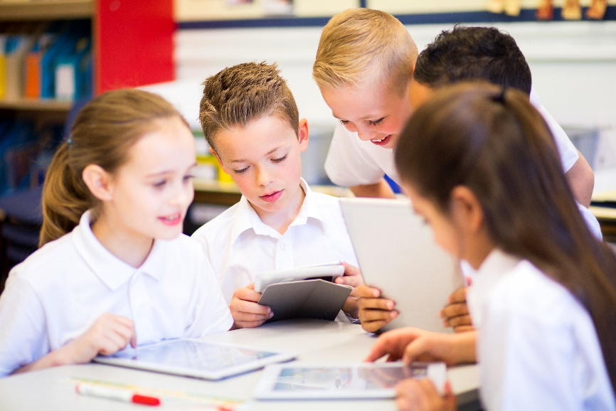
istockphoto.com

Appendix 8: Teacher resource sheet 1.2: Cooperative learning – Think, Pair, Share
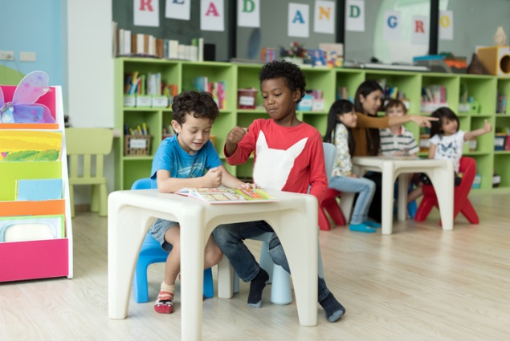
Cooperative learning frameworks create opportunities for groups of students to work together, generally to a single purpose.
As well as having the potential to increase learning for all students involved, using these frameworks can help students develop personal and social capability.
In the 'think' stage, each student thinks silently about a question asked by the teacher.
istockphoto.com
In the 'pair' stage, students discuss their thoughts and answers to the question in pairs.
In the 'share' stage, the students share their answer, their partner's answer or what they decided together. This sharing may be with other pairs or with the whole class. It is important also to let students 'pass'. This is a key element of making the strategy safe for students.
Think-pair-share increases student participation and provides an environment for higher levels of thinking and questioning.
istockphoto.com

Appendix 9: Student activity sheet 1.3: I see, I think, I wonder

What do you see when you look at this image?
What are you thinking about as you look at this image?
What are your wonderings (questions)?
gettyimages.com.au

Appendix 10: Student activity sheet 2.1: Coding grids

Coding grid
 | A | B | C | D | E | F | G | H | I | J | K | L | M | N | O | P | Q | R | S | T
1
2
3
4
5
6
7
8
9
10

Coding grid
 | A | B | C | D | E | F | G | H | I | J | K | L | M | N | O | P | Q | R | S | T
1
2
3
4
5
6
7
8
9
10

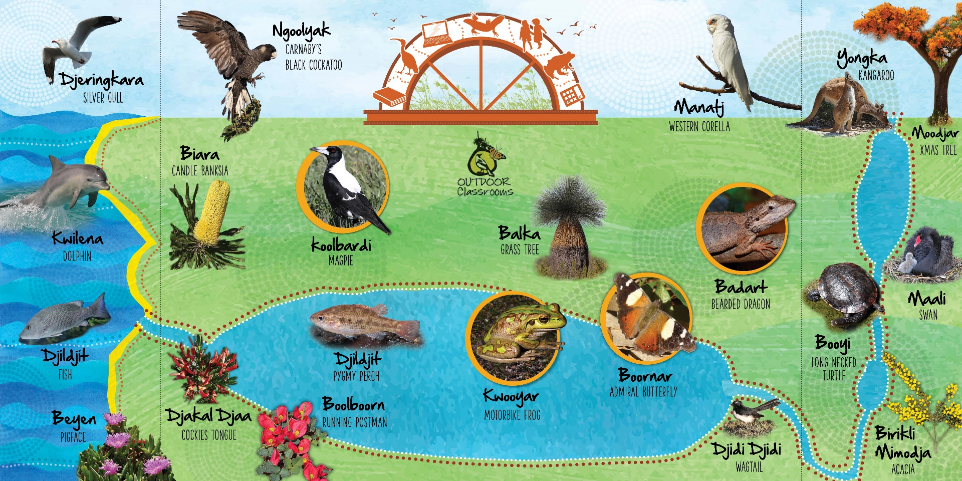
Appendix 11: Teacher resource sheet 3.1: Bilingual sign example
Department of Education

Appendix 12: Teacher resource sheet 3.2: Construction skills
Links to the Western Australian Curriculum

Technologies | Design and Technologies | Processes and production skills | Creating solutions by: Producing and implementing | Use given components and equipment to safely make solutions.
Construction skills help students to generate and produce solutions for real-world problems. This resource develops students' skills in design and technologies.
This resource can be used as a visual stimulus to prompt students to develop solutions to design problems. The cards can be printed out to create stations.
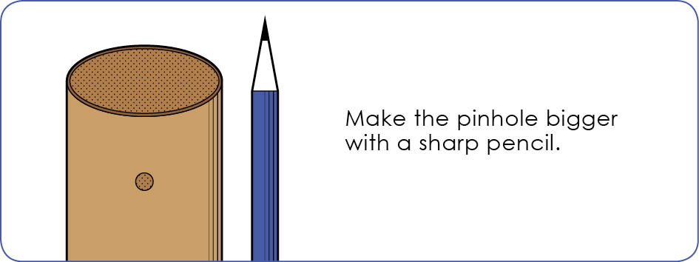
Poke a hole with a pin.
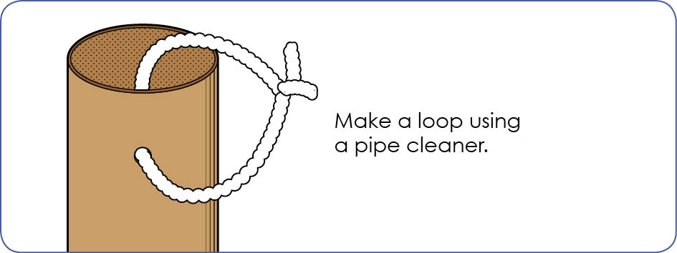

STEM Consortium

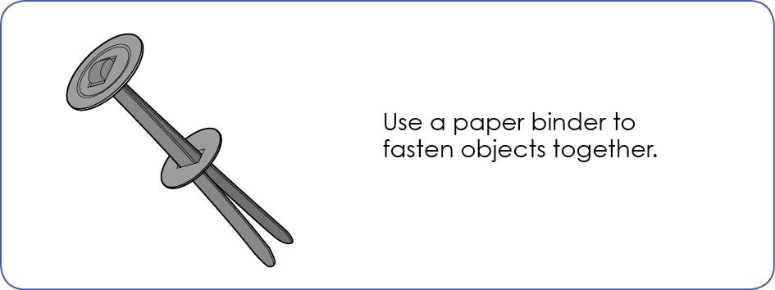

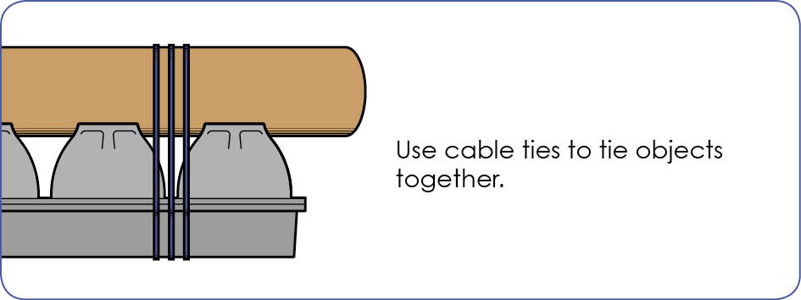

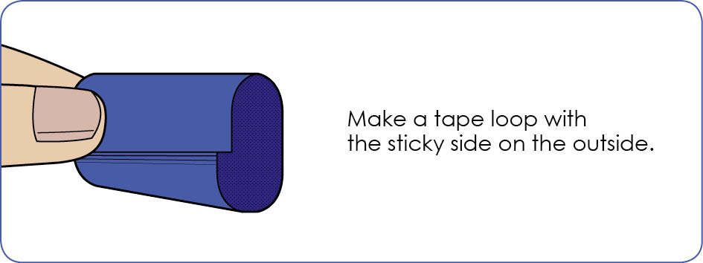
STEM Consortium

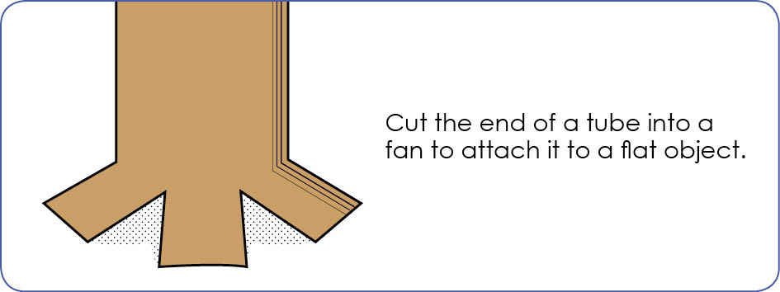

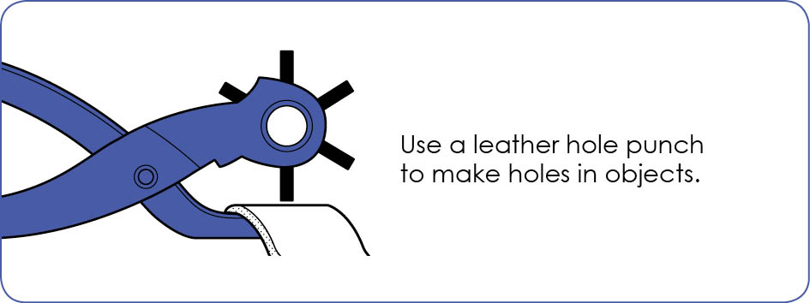

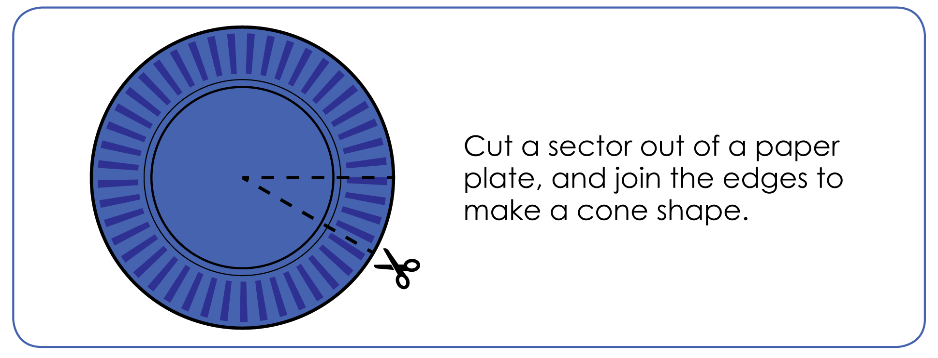
STEM Consortium

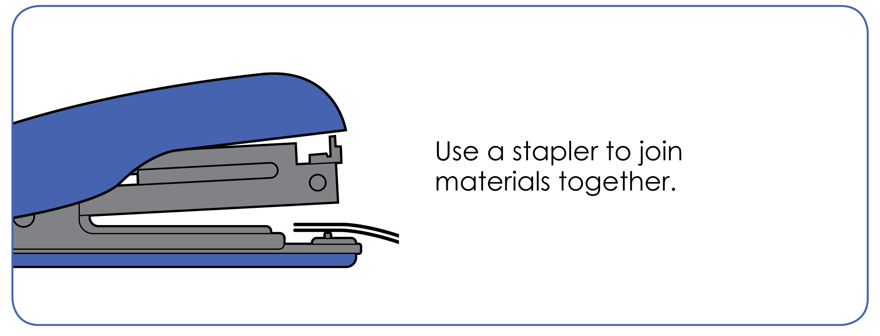

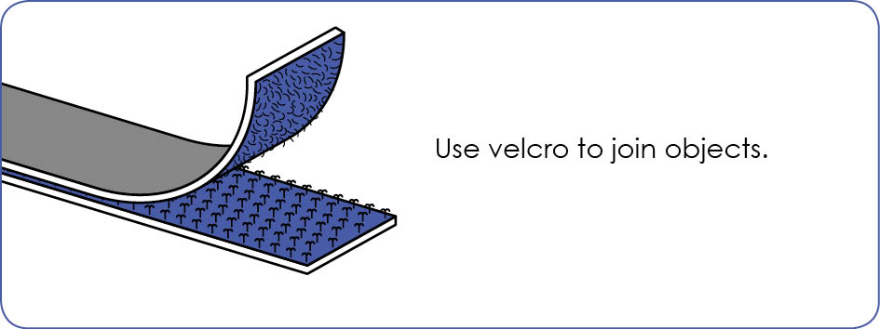

STEM Consortium

Appendix 13: Student activity sheet 3.3: Design review
Things I would keep the same _________________________________________________________________________________________________________________________________________________________________________________________________________________________
Things I would change
________________________________________________________________________________________________________________________________________________________________________________________________________________________________________________________
Photograph or drawing

Appendix 14: Teacher resource sheet 4.1: Evaluation
Key:  - Satisfactory/Usually  - Very good/Consistently  - Excellent/Independently | Student name
Remains focused on tasks presented
Completes set tasks to best of their ability
Works independently without disrupting others
Manages time effectively
Cooperates effectively within the group
Contributes to group discussions
Shows respect and consideration for others
Uses appropriate conflict resolution skills
Actively seeks and uses feedback

Appendix 15: Teacher resource sheet 4.2: 3 – 2 – 1 Reflection
Name | 3 things I learnt | 2 things I found interesting | 1 thing I found difficult

Notes
________________________________________________________________________________________________________________________________________________________________________________________________________________________________________________________________________________________________________________________________________________________________________________________________________________________________________________________________________________________________________________________________________________________________________________________________________________________________________________________________________________________________________________________________________________________________________________________________________________________________________________________________________________________________________________________________________________________________________________________________________________________________________________________________________________________________________________________________________________________________________________________________________________________________________________________________________________________________________________________________________________________________________________________________________________________________________________________________________________________________________________________________________________________________________________________________________________________________

