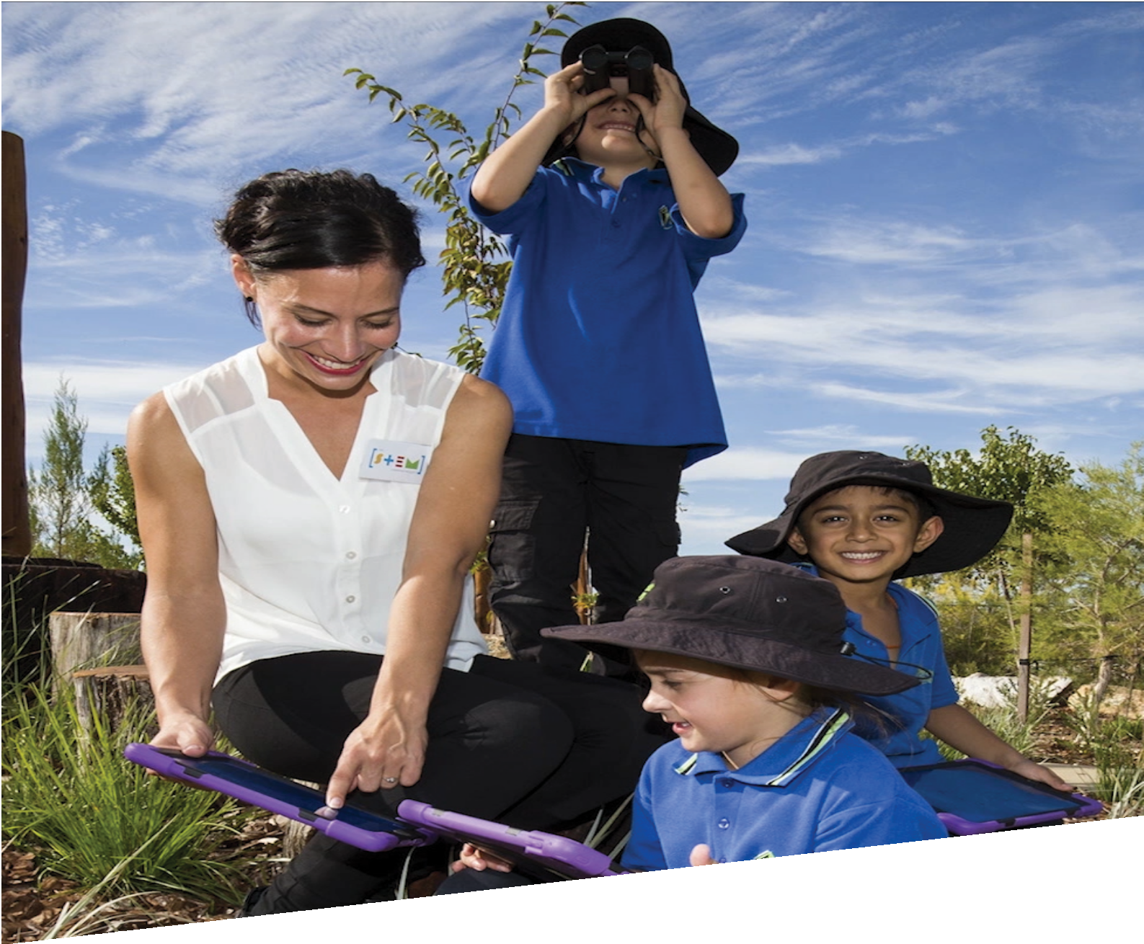

CURRICULUM RESOURCE MODULE
Every bird needs a home
YEAR 2
Acknowledgements
The STEM Learning Project respectfully acknowledges the Traditional Custodians of the lands upon which our students and teachers live, learn and educate.

The STEM Learning Project is funded by the Western Australian Department of Education (the Department) and implemented by a consortium in STEM education comprising the Educational Computing Association of Western Australia, the Mathematical Association of Western Australia, the Science Teachers Association of Western Australia and Scitech. We acknowledge and thank the teachers and schools who are the co-creators of these resources.

Copyright and intellectual property
The copyright and intellectual property of this module remain the property of the Department.

Any Western Australian Curriculum content in this resource is used with the permission of the School Curriculum and Standards Authority (the Authority); this permission does not constitute Authority endorsement of the resource. The Authority accepts no liability for any errors or damages arising from reliance on its content.

The Western Australian Curriculum content may be freely copied, or communicated on an intranet, for non-commercial purposes in educational institutions, provided that the Authority is acknowledged as the copyright owner. Copying or communication for any other purpose can be done only within the terms of the Copyright Act 1968 or with prior written permission of the Authority. Any Australian Curriculum content in the Western Australian Curriculum is used by the Authority under the terms of the Creative Commons Attribution NonCommercial 3.0 Australia licence. Any content on the www.scsa.wa.edu.au domain that has been derived from the Australian Curriculum may be used under the terms of Creative Commons Attribution-NonCommercial 3.0 Australia licence.

Appendix 2: General capabilities continuums are adapted from ACARA, © Australian Curriculum, Assessment and Reporting Authority (ACARA) 2009 to present, unless otherwise indicated. This material was downloaded from the ACARA website (www.acara.edu.au) (accessed December 2015) and was not modified. The material is licensed under CC BY 4.0 (https://creativecommons.org/licenses/by/4.0/). ACARA does not endorse any product that uses ACARA material or make any representations as to the quality of such products. Any product that uses material published on this website should not be taken to be affiliated with ACARA or have the sponsorship or approval of ACARA. It is up to each person to make their own assessment of the product.

This resource includes references and examples of iOS, Android and other apps. The Department does not endorse or recommend any commercial products and simply provides these as examples for teachers.

The Department is committed to providing quality information to its customers. Whilst every effort has been made to ensure accuracy, currency and reliability of the information within these documents, the Department accepts no responsibility for errors, omissions or amendments made since the time of publishing. Confirmation of information may be sought from the Department or the originating bodies providing the information. The Department has no control over the content of material published on websites to which users are referred in this resource. It is the responsibility of the internet user to make their own decision as to the relevancy, accuracy, currency and reliability of information found on those sites.

Attributions: Keynote, Comic Maker HD, iBooks Author, Book Creator, Comic Life, iMovie, Pages, Seesaw Digital Portfolio, Class Dojo, Explain Everything.

Table of contents

The STEM Learning Project 2
Overview 3
Activity sequence and purpose 7
Background 8
Activity 1: A place to nest 10
Activity 2: Investigate bird habitat around the school 15
Activity 3: Create bird friendly habitat 25
Activity 4: Present designs 30
Appendix 1A: Links to the Western Australian Curriculum 35
Appendix 1B: Mathematics proficiency strands 37
Appendix 2: General capabilities continuums 38
Appendix 3: Materials list 41
Appendix 4: Design process guide 42
Appendix 5: Reflective journal 42
Appendix 6: Student activity sheet 1.0: Journal checklist 44
Appendix 7: Teacher resource sheet 1.1: Cooperative learning – Roles 45
Appendix 8: Teacher resource sheet 1.4: Cooperative learning – Think, Pair, Share 46
Appendix 9: Teacher resource sheet 1.5: Sample parent letter 47
Appendix 10: Student activity sheet 2.1: Bird hunt 48
Appendix 11: Teacher resource sheet 3.1: Construction skills 49
Appendix 12: Student activity sheet 4.1: Design review 53
Appendix 13: Teacher resource sheet 4.2: Evaluation 54

The STEM Learning Project
The aim of the STEM Learning Project is to generate students’ interest, enjoyment and engagement with STEM (Science, Technology, Engineering and Mathematics) and to encourage their ongoing participation in STEM both at school and in subsequent careers. The curriculum resources will support teachers to implement and extend the Western Australian Curriculum and develop the general capabilities across Kindergarten to Year 12.
Why STEM?
A quality STEM education will develop the knowledge and intellectual skills to drive the innovation required to address global economic, social and environmental challenges.
STEM capability is the key to navigating the employment landscape changed by globalisation and digital disruption. Routine manual and cognitive jobs are in decline whilst non-routine cognitive jobs are growing strongly in Australia. Seventy-five per cent of the jobs in the emerging economy will require critical and creative thinking and problem solving, supported by skills of collaboration, teamwork and literacy in mathematics, science and technology. This is what we call STEM capability. The vision is to respond to the challenges of today and tomorrow by preparing students for a world that requires multidisciplinary STEM thinking and capability.
The approach
STEM capabilities are developed when students are challenged to solve open-ended, real-world problems that engage students in the processes of the STEM disciplines.
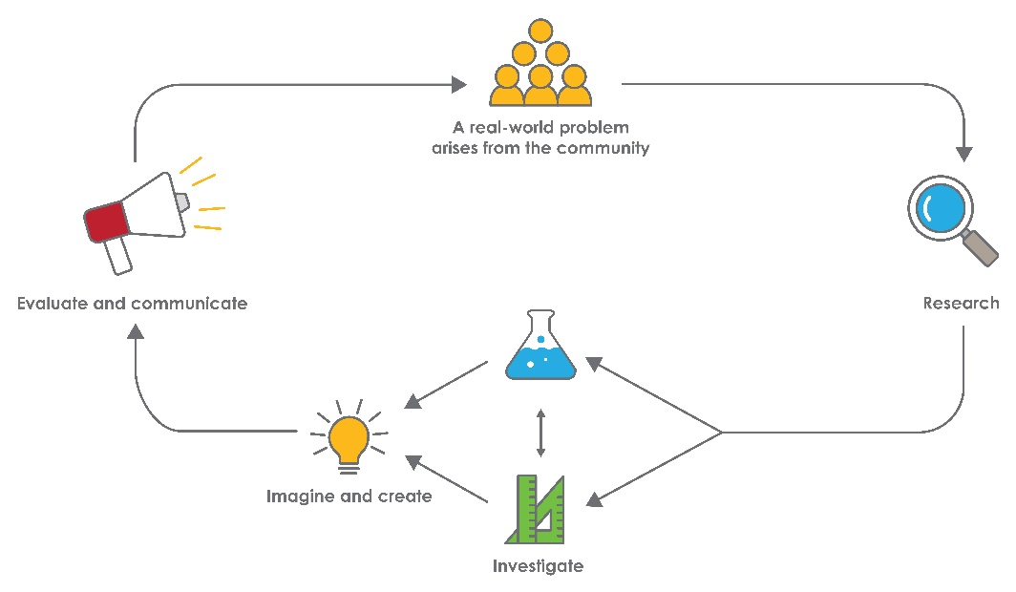
Year 2 – Every bird needs a home

Overview
In this module, students learn how habitat loss affects biodiversity. Birds have been selected as a study species because they are good indicators of overall environmental health and are easy to observe.
Students undertake field work and investigate the problem within the context of their school. Using a collaborative learning approach and problem-solving skills, students design a bird habitat to increase bird numbers.
What is the context?
Human activities, have resulted in Australia having one of the highest rates of animal extinction in the world. These activities include:
- habitat change through agricultural development
- urban and industrial development
- exploitation of natural resources
- pollution of soil, water and air
- overharvesting resources which reduces both population sizes and genetic diversity
- the introduction of exotic species which damage land and water resources, bring disease, compete with native plants and animals for food and shelter, and which may be predators.
Currently over 200 Australian bird species are considered threatened. Restoring impacted habitats is an essential part of maintaining biodiversity.
What is the problem?
How can we encourage more birds to visit, live and breed at our school?
How does this module support integration of the STEM disciplines?
Science
Students develop Science understandings when investigating resources birds need to survive (ACSSU030: Living things grow, change and have offspring similar to themselves, ACSHE038: Participate in guided investigations to explore and answer questions).
Technology
Students incorporate Design and Technologies (ACTDEK001: People design and produce familiar products, services and environments to meet local and community needs) as they imagine, plan, create and evaluate their habitat
design. Students document their design process and use Digital Technologies to present their data (ACTDIP003: Present data using a variety of digital tools, WATPPS12: Develop, communicate and discuss design ideas through describing, drawing and/or modelling, WATPPS15: Work independently, or collaboratively when required, to organise information and ideas to safely create and share sequenced steps for solutions, WATPPS14: Use simple criteria to evaluate the success of design processes and solutions and WATPPS13: Use components and given equipment to safely make solutions).
The Design process guide is included as a resource to provide assistance to teachers in understanding the complete design process as developed in the Technologies curriculum.
Mathematics
Students use Mathematical skills during fieldwork when counting birds at the school and tallying and graphing data (ACMSP050: Create displays of data using lists, table and picture graphs and interpret them, ACMSP048: Identify a question of interest based on one categorical variable. Gather data relevant to the question and ACMSP049: Collect, check and classify data). They interpret a simple map of the school and identify the relative positions of key features (ACMMG044: Interpret simple maps of familiar locations and identify the relative positions of key features). When exploring top view maps, they describe and draw two-dimensional shapes (ACMMG042: Describe and draw two-dimensional shapes, with and without digital technologies). They solve simple addition problems using a range of efficient mental strategies when combining class data (ACMNA030: Solve simple addition and subtraction problems using a range of efficient mental and written strategies).

General capabilities
Tasks throughout the module encourage Personal and social capabilities. Students are encouraged to work collaboratively, give and receive peer feedback, and are given the opportunity to respond to feedback.
Information and communication technology (ICT) general capabilities are addressed in Activities 2, 3 and 4 as students use digital technologies to record data, design a bird habitat, and present their design to a wider audience.
There is an opportunity for literacy activities through verbal cooperative strategies such as Think – Pair – Share (see Teacher resource sheet 1.4: Cooperative learning – Think, Pair, Share).
There are opportunities for the development of general capabilities and cross-curriculum priorities as students engage with the module. In this module, students:
- Develop problem solving skills as they research the problem and its context (Activity1); investigate parameters impacting on the problem (Activity 2); imagine and develop solutions (Activity 3); and evaluate and communicate their solutions to an audience (Activity 4).
- Utilise creative thinking as they generate possible design solutions; and critical thinking, numeracy skills and ethical understanding as they choose between alternative approaches to solving the problem.
- Utilise a range of literacies and information and communication technologies (ICT) capabilities as they collate records of work completed throughout the module in a journal; represent and communicate their solutions to an audience using digital technologies in Activity 4.
- Utilise a range of literacies and ICT capabilities as they make records of their work; and represent and communicate their solutions to an audience using digital technologies in Activity 4.

What are the pedagogical principles of the STEM learning modules?
The STEM Learning Project modules develop STEM capabilities by challenging students to solve real-world problems set in authentic contexts. The problems engage students in the STEM disciplines and provide opportunities for developing higher order thinking and reasoning, and the general capabilities of creativity, critical thinking, communication and collaboration.
The design of the modules is based on four pedagogical principles:
- Problem-based learning
This is an underlying part of all modules with every module based around solving an initial problem. It is supported through a four-phase instructional model: research the problem and its context; investigate the parameters impacting on the problem; design and develop solutions to the problem; and evaluate and communicate solutions to an authentic audience.
- Developing higher order thinking
Opportunities are created for higher order thinking and reasoning through questioning and discourse that elicits students' thinking, prompts and scaffolds explanations, and requires students to justify their claims. Opportunities for making reasoning visible through discourse are highlighted in the modules with the icon shown here.
- Collaborative learning
This provides opportunities for students to develop teamwork and leadership skills, challenge each other’s ideas, and co-construct explanations and solutions. Information that can support teachers with aspects of collaborative learning is included in the resource sheets.
- Reflective practice
Recording observations, ideas and one’s reflections on the learning experiences in some form of journal fosters deeper engagement and metacognitive awareness of what is being learnt. Information that can support teachers with Journaling is included in the resource sheets.
These pedagogical principles can be explored further in the STEM Learning Project online professional learning modules located in Connect Resources.
Additional learning opportunity
A visit to a local habitat such as wetlands, local parks or wildlife centres could enhance student understanding of the importance of habitat i.e., Herdsman Wildlife Centre, Canning Eco-Education Centre or Piney Lakes Environmental Education Centre.

Activity sequence and purpose

A place to nest

Students research the resources birds need to survive and learn about the life cycle of birds. They are introduced to the idea that habitat loss threatens birds and that generally birds are good indicators of overall environmental health. Students are engaged with the problem of habitat loss and the impact it has on birds in their local area.
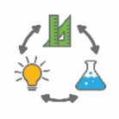 | Investigate bird habitat  Students investigate habitat around their school by participating in field work. They identify and record species of birds and compare the type and number of birds in different locations. They consider bird habitat features with an emphasis on shelter, feeding and nesting opportunities and consider what might be limited at their school.
Create bird friendly habitat
Students reflect on their learning about the requirements of birds and use this knowledge to consider how birds could be encouraged to visit the school. Students work collaboratively to design a bird friendly habitat to encourage local bird species to visit and breed.
Present designs
Students present and justify their design solutions to an authentic audience such as their peers and invited guests and evaluate and reflect on the process. Presentations are developed and recorded using technology and are shared with the wider school community.

Background
Expected learning | Students will:  - Describe how birds grow and change through different stages of their life, identifying some similarities between parent and offspring.  - Participate in guided investigations to explore and answer questions about the habitat requirements of birds and the prevalence of birds at their school.  - Collect, organise, classify and represent data from bird observations.  - Analyse bird data from two locations and identify the differences between locations.  - Design and communicate habitat improvements for birds using annotated drawings or modelling.  - Use a chosen form of digital technology to record a reflection of the design process.  - Work collaboratively to generate options for creating bird friendly habitat.  - Draw a map of the school (or park) representing habitat and bird data.
Vocabulary | The following vocabulary list contains terms that need to be understood, either before the module commences or developed as they are used:  adult, chick, data, development, egg, embryo, environment, habitat, hatching, hatchling, life cycle, species, survey, table, tally, urban
Timing | There is no prescribed duration for this module. The module is designed to be flexible enough for teachers to adapt. Activities do not equate to lessons; one activity may require more than one lesson to implement.
Safety notes | There are potential hazards inherent in these activities and with the equipment being used, and a plan to mitigate any risks will be required.  Potential hazards specific to this module include but are not limited to:  - Possible exposure to cyber bullying, privacy violations and uninvited solicitations when using the internet  - Caution is required to ensure students are not exposed to hazards when undertaking observations outside the classroom.
Assessment | The STEM modules have been developed to provide students with learning experiences to solve authentic real-world problems using science, technology, engineering and mathematics capabilities. Appendix 1 indicates how the activities are linked to the Western Australian Curriculum.  Evidence of learning from Journaling, presentations and anecdotal notes from this module can contribute towards the larger body of evidence gathered throughout a teaching period and can be used to make on-balance judgements about the quality of learning demonstrated by the students in the science, technologies and mathematics learning areas.  Students can further develop the general capabilities within Information and communication technology (ICT) capability, Critical and creative thinking and Personal and social capability. Continuums for these are included in the General capabilities continuums but are not intended to be for assessment purposes.

Activity 1: A place to nest
Activity focus |  | Students research the resources birds need to survive and learn about the life cycle of birds. They are introduced to the idea that habitat loss threatens birds and that generally birds are good indicators of overall environmental health. Students are engaged with the problem of habitat loss and the impact it has on birds in their local area.
Background information |  | Habitat loss threatens species  Many conservation issues impact species worldwide, however, habitat loss is a significant threat to the variety of life on Earth. Globally, the loss of habitat is identified as the main threat to 85% of all species classified as Threatened and Endangered (International Union for Conservation of Nature, Red List, 2017). In Australia, almost every type of natural habitat is threatened by clearing, land developments or other human activities.  Birds as environmental health indicators  It can be difficult and expensive to measure the health of an environment. Scientists often use a group of animals that are representative of what is happening in an area to act as indicators of environmental health.  Birds are often considered to be outstanding indicators of the health of the overall environment. Birds inhabit almost every conceivable habitat, they are responsive to a wide variety of environmental changes and can reflect diversity and trends in other animals and plants with which they coexist.  www.birdlife.org.au/conservation/science/threats-to-birds  Australia’s birds  A threatened species is one where the population is in decline and at risk of becoming extinct. Australia has one of the highest extinction rates in the world and birds are threatened. Since European settlement, 21 species of Australian birds, have become extinct, 16 are critically endangered, 50 are endangered and 67 are vulnerable. To find out more about threatened bird species in Australia go to www.birdlife.org.au/projects/threatened-bird-network/threatened-birds (Birdlife Australia, 2017)  What birds need  Most bird species build nests in the habitat in which they live. Different species require different resources. Nests are constructed from a variety of natural materials (grass, sticks, mud) and non-natural materials (paper, plastic, yarn). Nests are diverse, with species nesting on branches, inside tree hollows, in open-cupped nests on the ground and even under roof eaves. Fertilised eggs are kept in nests which provide a safe place for young birds to develop.  Birds need sources of water and food. Some birds are ground feeders, feeding on insects, grasses, nuts or seeds. Others feed on the nectar from flowers while some feed on animals such as fish or amphibians. Shelter from weather and predators is also required. Thick understory vegetation provides valuable protection from predators such as cats and larger birds.
Instructional procedures |  | It is recommended that students work in small groups of three to four for all activities. Mixed ability groups encourage peer tutoring and collaboration in problem solving. Collaboration is an important STEM capability see Teacher resource sheet 1.1: Cooperative learning – Roles. Student thinking from the activity should be recorded in a reflective journal. Depending on the needs of the class, this can be a collaborative process in one class journal, or students can work individually on their reflective journals. The journal can be either digital or physical. See Reflective journal for more support.
Expected learning |  | Students will be able to:  - Describe how birds grow and change through different stages of their life, identifying some similarities between parent and offspring (Science).
Equipment required |  | For the class:  Interactive whiteboard or large poster paper
For the students: Optional in Part 2:
Bird life cycle images, scissors, glue and pencils
A device loaded with Explain Everything, Seesaw, Popplet, Pages or a similar app (see Digital resources)
Preparation |  | Set up to watch The Best Nest video.  Preload the Parrot Life Cycle Game onto a computer linked to an interactive whiteboard or projector.  If students are cutting and pasting the bird life cycle, print images.  If using devices, ensure they are charged and have internet access.  Create a template for the Birds in our school brainstorm on poster paper or an interactive whiteboard.  A sample parent letter is provided, Teacher resource sheet 1.5: Sample parent letter. These letters can be used to inform the parent community of the STEM learning students’ will be undertaking.
Activity parts |  | Part 1: Habitat changes  Students consider the implications of habitat loss for birds. They watch the video The Best Nest by P.D. Eastman (see Digital resources) as a stimulus for discussion and share ideas through a collaborative learning strategy such as think–pair–share (see Teacher resource sheet 1.4: Cooperative learning – Think, Pair, Share).  Questioning can be used to stimulate student thinking and discussion:  - What do you think was here before our school was built?  - Where do you think the birds moved to after their habitat was destroyed? Where would they nest or find shelter?  - Where do you think they had to go to find food or water?
Part 2: Bird nesting requirements and life cycle
Use The Best Nest video to explain that birds need certain resources to survive and reproduce, such as shelter and access to food and water.
Introduce students to the bird life cycle. As a class, review the stages of the bird life cycle using the web interactive Parrot Life Cycle Game (see Digital resources).
Students sequence the stages of the bird life cycle, drawing their own life cycle diagram or cutting and pasting images (see Digital resources). An app such as Popplet or Pages can be used as a digital option.
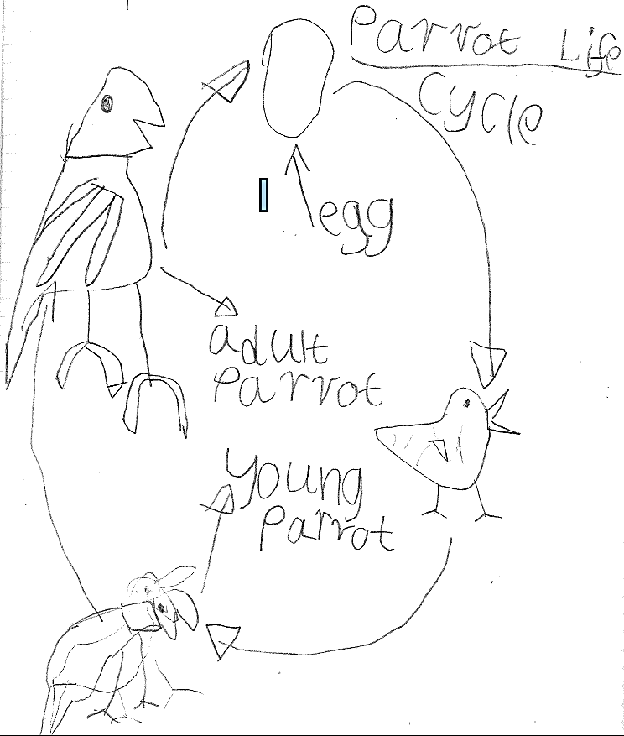
A student work sample illustrating the parrot life cycle.
A digital alternative is included in Digital resources.
Part 3: Birds in our school brainstorm

Through a class discussion, explore factors that impact the number of birds living and breeding in areas of the school. The brainstorm will need to be saved as it is revisited in Activity 2. Prompt questions could include:
- What do you think a bird would need to nest here at school?
- Where do you think a bird would live? Why?
- Where might a bird sleep?
- What would a bird drink?
- What would a bird eat?
- How would a bird avoid or escape predators?

Part 4: Reflective journal
Students write or draw what they have learnt in their reflective journal (individual or class). They express ideas about how changes in habitat might have affected bird species and numbers around their school.
They should add a question they have about birds in their community.
Resource sheets | Teacher resource sheet 1.4: Cooperative learning – Think, Pair, Share
Digital resources |  | The Best Nest by P.D. Eastman (Patrick Albert, 2013)  www.youtube.com/watch?v=7f6TsHA0kTM
Parrot Life Cycle Game (Sheppard Software)
www.sheppardsoftware.com/scienceforkids/life_cycle/bird_lifecycle.htm
The life cycle of a bird (printable)(Scholastic Ltd, 2017)
education.scholastic.co.uk/resources/27504
IUCN (International Union for Conservation of Nature) Red List of Threatened Species, 2017
www.iucnredlist.org

Pages
itunes.apple.com/au/app/pages/id361309726?mt=8
Seesaw Digital Portfolio
web.seesaw.me
Popplet
popplet.com
Explain Everything
explaineverything.com
CSIRO mathematicians and scientists in schools program
A national volunteer program that facilitates partnerships between schools and industry to bring real STEM into the classroom.
www.csiro.au/en/Education/Programs/STEM-Professionals-in-Schools

Activity 2: Investigate bird habitat around the school
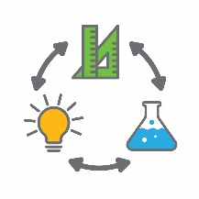  Activity focus | Students investigate habitat around their school by participating in field work. They identify and record species of birds and compare the type and number of birds in different locations. They consider bird habitat features with an emphasis on shelter, feeding and nesting opportunities and consider what might be limited at their school.
Background information | All birds require access to food, water, protection from predators and weather, a site to nest and access to nesting materials. These features are normally provided within the complex structure of a natural environment. Different habitat features suit different species of birds, although habitat variety and a good understory is key for all species.  In the built environment, there is a need to retain natural spaces and gardens for birds. Collectively, many smaller areas of habitat have the potential to support breeding populations of birds.
Instructional procedures | During the bird hunt, students may use devices or digital cameras to capture images.  The Birdlife Australia website (www.birdlife.org.au) can provide help with identifying birds. A printed handout with common local bird species may also assist students with the identification process while on their bird hunt.
Expected learning | Students will be able to:  - Participate in guided investigations to explore and answer questions about the habitat requirements of birds and the prevalence of birds at their school (Science).  - Collect, organise, classify and represent data from bird observations using a table and tallies (Mathematics).  - Use a range of mental strategies for addition.  - Analyse data to determine the most frequently occurring birds and identify where they were found (Mathematics).  - Interpret and draw a map of the school (or park) representing habitat and bird data (Mathematics).
Equipment required | For the students:  Clipboards for bird hunt checklist, pencils  Two Student activity sheet 2.1: Bird hunt per group  Device to record photos and videos of birds (optional)  Device with mind mapping software such as Popplet or Simple Mind (optional)
Preparation | Identify two sites where the bird hunts will take place. One should occur in an area changed by humans and the other in an area with natural features.
Activity parts | Part 1: Predicting where birds might be found  Students engage in a whole class discussion to identify where they think birds will most likely be found around the school.  Use questioning to drive discussion and encourage deeper thinking using ‘why’ and ‘because’ to develop reasoning.  - What do birds need to survive? Why?  - Where do they eat, drink, sleep, nest and stay safe? Why?  - Where do you think most birds will be found around our school? Because . . .
Part 2: Let’s take a look!
Working in small groups, students participate in a bird hunt to identify and record birds in the school grounds.
One investigation should occur in an area modified by humans such as the school basketball courts or near classrooms. The other should focus on an area where there are more natural features such as a garden or bushland.
To promote higher order thinking, ask:
- Why were two different areas suggested?
- Where do you think most birds will be found?
- How could using numbers help us find out?
- Why would we need to spend the same amount of time in each area observing and counting the birds?
Encourage students to discover that counting how many birds are in each area during a given amount of time is a ‘fair’ way to decide which is visited by the most birds.
Discuss how to record their count. If necessary, introduce the idea of a tally. Show the students different ways that tally marks could be made and ask them to count each group according to how the marks are grouped, for example:
Count by ‘ones’
Count by ‘twos’
Count by ‘fives’
Ask:
- What makes the last row of tally marks easiest to count?
- How can you be sure there are five in each group without having to count them?
- Are there any other ways you can look at the five marks and know there are five? (e.g. two and two and one more, three and two, four and one)
Before students go on their ‘bird hunt’, provide opportunities for them to practice recording data using the standard tally marks. For example, counting students from other classes as they go out to lunch; counting cars that go past the school, counting students who have a sandwich for lunch.
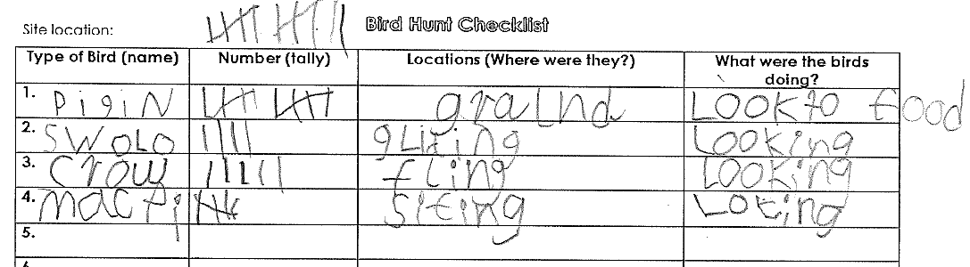
Students can record data on the Student activity sheet 2.1: Bird hunt as hard copy or digital. See sample below.

Alternatively, create a suitable table as a class activity.
When collecting data, one student could use technology to record photos and videos of birds while the other completes the checklist. Digital records of the species sighted will assist in

identification in the classroom. Remind students to move slowly and quietly to avoid scaring birds away.
Part 3: Review collected data
Students return to class and interpret their data sets. Combine each groups’ data to show the type and number of birds counted in the selected areas of the school.
Ask students to count their tally marks and write the number of each type of bird they saw on a sticky note.
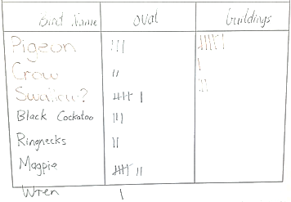
List the names of the birds they saw on the whiteboard and have students place their sticky notes next to the appropriate bird and area. Invite students to look at the numbers of birds shown on the sticky notes and find combinations that are easy to add together without having to count.
Move the sticky notes around, circle combinations, replace with the sums and accumulate the totals, as illustrated below. Encourage students to develop mental strategies other than ‘counting on’ by modelling new strategies, such as using partitioning, doubles, compatibles, bridging tens.
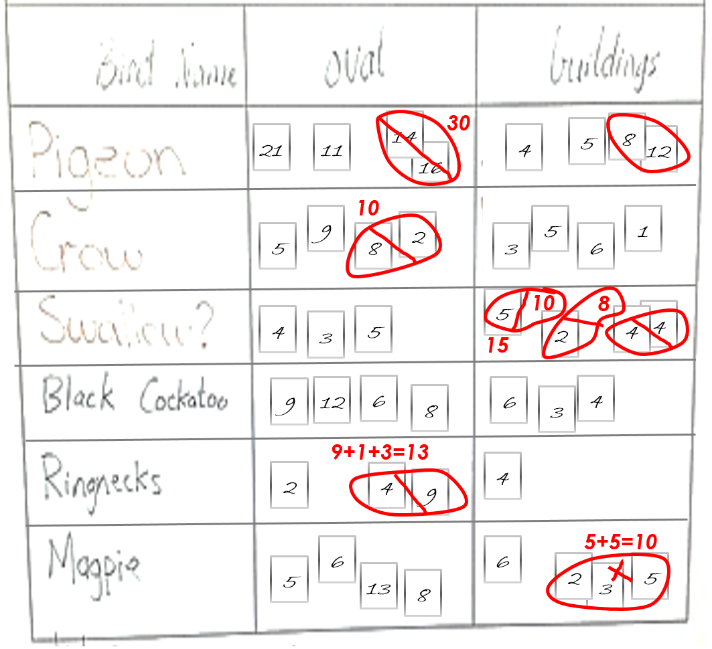
When completed, remove or erase all but the final count in each cell. Explain that we have now ‘summarised’ our data by combining the data that the different groups collected.
As a class compare the results.
Sample questions to stimulate discussion include:
- How many birds were seen in the set time?
- How many different types of birds were there?
- What is the difference in bird numbers between the two areas? What does this show?
- Do you think the time of day would affect the bird count? Why?
- Why did we spend the same time in each location?
- Why did we collect data in this way? Do you think this is the best way? Can you think of another way?
- Would our findings be useful if we had different numbers of students at each location?
- What would happen if no birds lived in our area?
- Can you recall seeing birds in other places?
Part 4: Represent data
Use the data to expand on the class brainstorm from
Activity 1, adding a section for each place the bird hunts occurred. If using technology, the class mind map could be made on the interactive whiteboard using apps such as Popplet or Simple Mind. Ask students:
- Can you see how many birds visit our school each day from this table? Why? Why not?
- How might our data be different if we repeated our bird hunt at different times of the day or on different days?
- What can our results tell us about where birds prefer to spend their time?
- How does the table help us to see at a glance what type of bird species are most common?
As an optional extension, enter the data into a spreadsheet and create a column graph, ensuring the numbers are shown on each bar. This can assist students to begin to interpret column or bar graphs in a familiar context.
Part 5: Mapping bird habitat
In groups, students create a map showing the two sites where the bird hunts occurred.
Students at this age do not yet fully understand that a map is a top view and that not all objects are represented in a map. Students will need scaffolding and support with this activity.
A helpful way to begin developing a ‘birds eye’ view is to ask students to pretend there is no roof on the classroom and a little bird flew over. Ask them to draw what they would see of the classroom if they were the bird. This activity will indicate which students are able to at least draw the top view of some pieces of furniture. Most students will draw different ground level views or a mixture of both. They will not yet be able to interpret or draw a top view map of the school.
A next step would be to have groups of students use blocks or similar to construct small clusters of buildings on the floor (not representing anything in particular). Take photos of each group’s construction from above. Print or project the photos in black and white (so colour does not provide clues) and ask students to match the photos with the various group’s buildings. Students can be encouraged to walk around and look down on the top of the buildings to help them compare what they see to the photos. Encourage students to talk
about the top view two-dimensional shapes and the arrangements they can see.
From Google Maps obtain a top view image of the school and project it on an interactive white board (or print and enlarge). Talk about what they see. Ask, for example:
- Which part of the buildings can you see?
- What is blocking the view of some of the buildings?
- Imagine what you would see if all the trees were cut down?
- What shapes would you be able to see?
- Can you find where our classroom is on the map?
- Where on the plan do you eat your lunch, play, go to music/art etc.
Download the map onto tablets or as hard copies and provide a copy for each pair of students. Take the students for a walk around the school and help them follow their route on the map. Stop every few minutes and have students point to various features in the real world and then point to the same places on the map. They will need help to match the orientation of the buildings represented on the map to the real buildings.
Students work in groups to create their own maps of the school buildings and pathways, allowing them to refer to the Google map to assist them. Challenge them to draw and number the classrooms, pretending there are no roofs on the buildings. Ask, for example:
- Is there enough room to walk between the buildings on your map?
- Should the classrooms be smaller or larger than the basketball court?
- Why isn’t there enough room on your plan for all the buildings? What could you do to fix it?
Adding to their maps, students draw or list the bird data collected and add detail such as habitat features of the two sites.
See Student work samples of mapping activity.
Part 6: Reflection
Students record and reflect on new knowledge using words and/or pictures.
Resource sheets | Student activity sheet 2.1: Bird hunt
Digital resources |  | Find a bird (Birdlife Australia, 2017)  www.birdlife.org.au/all-about-birds/australias-birds/find-a-bird
Popplet
popplet.com
Simple Mind
simplemind.eu
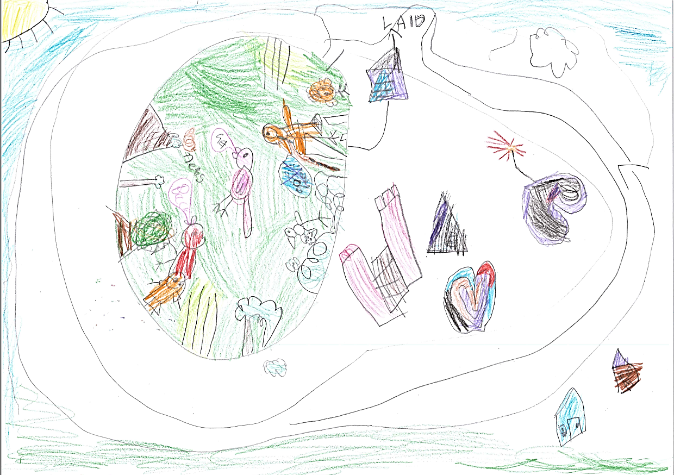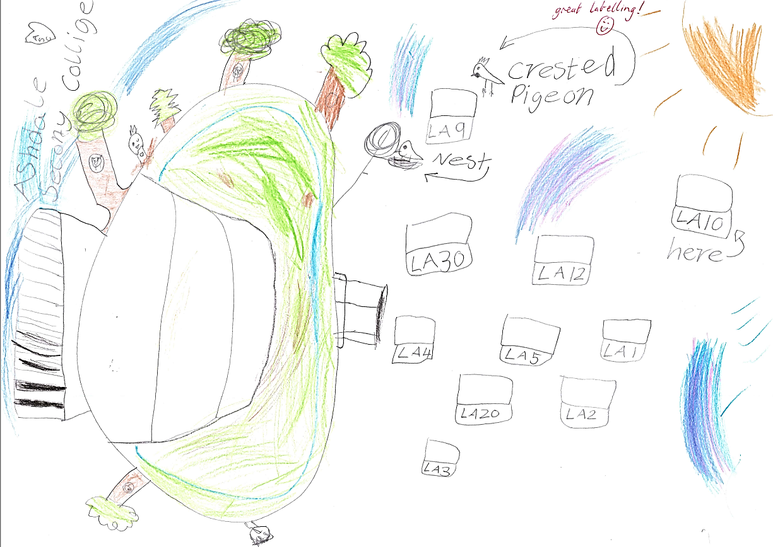Student work samples of mapping activity
Students engaging in the investigation process

Activity 3: Create bird friendly habitat
Activity focus | Students reflect on their learning about the requirements of birds and use this knowledge to consider how birds could be encouraged to visit the school. Students work collaboratively to design a bird friendly habitat to encourage local bird species to visit and breed.
Background information | Creating places for birds  Creating habitat for wildlife in built-up areas is an effective way to increase biodiversity.  The open spaces of schools have potential to provide habitat for local birds. In general, bird numbers increase when habitat is diverse, so having a mix of trees, shrubs, grasses and ground cover is ideal. Native vegetation is best for birds as it provides a supply of natural food.  Bird friendly habitat should be free from predators such as domestic pets. All birds need water, so a bird bath or pond can encourage birds to visit an area.  Some birds rely on tree hollows to breed but these are becoming scarce. It can take over 100 years for a tree to form a natural hollow and in built-up areas trees are often removed before a hollow can form. Man-made nest boxes are an excellent substitute for a nest hollow.
Instructional procedures | Students continue to work in small groups to identify ways to increase bird numbers at the school. Part of the STEM philosophy is for students to work collaboratively to solve problems. There are many solutions to this problem and negotiation is encouraged. See Teacher resource sheet 1.1: Cooperative learning – Roles.  Once imagined, planning is required to identify the materials, fabrication techniques and processes needed for construction. A labelled diagram can clarify how each component relates to others and the various specifications of materials required. A labelled diagram can also guide the construction process. The final product can be either a prototype or a digital representation.  The teacher guides students through the design process as they participate in this activity, see Design process guide.  During construction, new insights may emerge which can initiate revisions. Further improvements are often made to the design following feedback on the prototype.  Refer to Teacher resource sheet 3.1: Construction skills for tips on joining and binding items.  Encourage students to take photographs of the design process. These can be presented as an eBook, comic strip or movie (see Activity 3 and 4 Digital resources for technology options). Students can use this to share the design process with their peers or a wider audience in Activity 4.  Student thinking from the lesson should be recorded as annotations in their class reflective journal, along with copies of photos that have been taken.
Expected learning | Students will be able to:  - Work collaboratively to generate options for creating bird friendly habitat (Technologies).
Equipment required | For the class:  Access to the internet  Cameras  Pre-collected materials, glue, scissors and paint (optional)
Preparation | Download The Magnificent Tree by Nick Bland (see digital resources) to reduce streaming issues when viewing.  This activity offers an opportunity to invite members of the community such as local senior high school students, Men’s Shed members or wildlife centre employees to assist students with their designs.  Pre-collected items from families, and supplies for building including tape, scissors, blades and cutting mats, glue sticks, PVA glue, paintbrushes, hot glue etc.
Activity parts | Part 1: Class brainstorm  Students watch the reading of The Magnificent Tree by Nick Bland to stimulate thinking about bird habitat.  Reflect on Activity 2 and list the habitat features where the highest number of bird sightings occurred at school.  Encourage students to think about how they could redevelop an area of the school to be more suitable for birds.  Students may suggest:  - Landscaping – Design a bird friendly garden with a diversity of plants of many heights and densities with upper, middle and lower layers, and a mix of native plants that flower in different seasons.  - Shelter – Design a solution using vegetation or other materials to encourage birds to roost and nest, providing protection from weather and predators.  - Water – Design a predator-proof bird bath, pond or other water feature.  - Nesting material – Design a vessel to store or create nest material. A variety of materials are needed to bind nests together, for nest lining and for camouflage.  - Nest box – Use nest boxes as a substitute for tree nest hollows. Different species require boxes of different size and shape. Fallen branches, rotting logs and old stumps may also be used for nesting.
Part 2: Group decision making
Working collaboratively, students decide on a design to attract birds to the school, recording ideas as notes or pictures.
Students pitch their decision to the class and describe how they believe it will encourage more birds to visit.
Part 3: Habitat design
Students design their bird friendly habitat, annotating their illustration. This can be an individual or collaborative process.
Additional learning opportunity:
When students are designing their plan have them use uniform units (ie pop sticks or straws) to measure out their design and record on their representations (eg the length, width and height of a bird feeder).
For a technology option, students can create their design and use an app such as Explain Everything. Students draw and annotate their design on paper, then use the app to record the image and create a voice over explaining their thinking.
Part 4: Build it!
Working in small groups, students build a model of their design. Students decide how to build their model and the materials they need. Options will vary based on the chosen solution to the problem. For example, some students may decide to create a bird friendly garden and a model could be made from cardboard. Others may create a nest box which could be made from plastic materials. Modelling options could include three-dimensional printing, woodwork, clay or using recyclable materials.
Part 5: Making it real
Students choose one design to implement at the school. This might be selected through a class vote and a recommendation taken to the school’s Parents and Citizens Association for funding and installations. For example, students could choose a bird bath or nest box to place in the school yard, or if students voted to create a garden, native plants may be purchased and planted.
Students could write letters of advocacy to the local paper, informing community members how they can enhance bird habitat in their gardens.
Part 6: Reflection
In their reflective journals, students record something that went well with their design and something they would do differently. They explain how their design would meet the needs of bird habitat in their school.
Resource sheets |  | Teacher resource sheet 1.1: Cooperative learning – Roles  Teacher resource sheet 3.1: Construction skills
Digital resources | The Magnificent Tree by Nick Bland for Sammy Boy (Jemma Flanagan, 2016)  www.youtube.com/watch?v=sF-CkAtpNPg
Creating places for birds (Birds in Backyards, 2017)
www.birdsinbackyards.net/places
Explain Everything
explaineverything.com
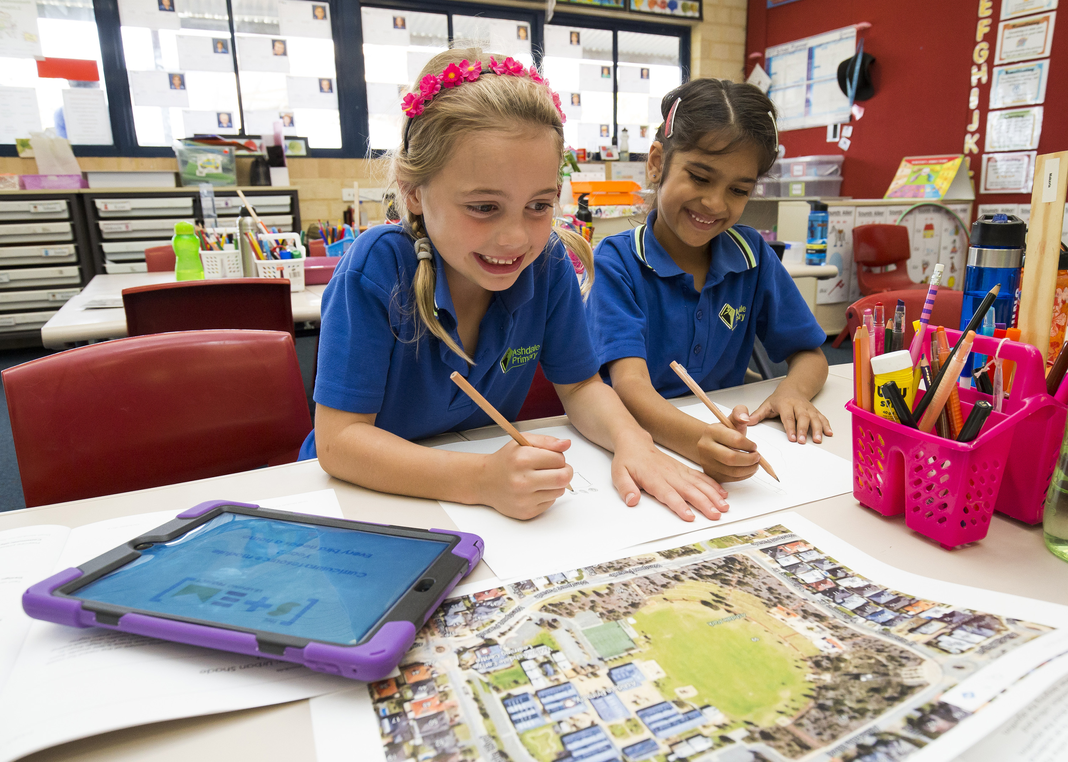

Students engaging in the design process

Activity 4: Present designs
Activity focus | Students present and justify their design solutions to an authentic audience such as their peers and invited guests and evaluate and reflect on the process. Presentations are developed and recorded using technology and are shared with the wider school community.
Instructional procedures | This activity provides opportunities for cross-curricula assessment of literacy, listening and speaking. Depending on student's prior knowledge or ability, time may need to be dedicated to developing oral presentation skills.  Presentation options include creating a comic strip, eBook, poster in Pages, Keynote or PowerPoint or simple iMovie (or similar), which can then be shared through a digital platform such as Connect, Seesaw or Class Dojo, added to a class blog, or shared on the interactive whiteboard. Students may require explicit instruction in the use of these apps.  If Information and Communication Technology (ICT) is not accessible, students could share their project using a traditional poster or recount.  To enable the completion of the design process students should be given time to make improvements to their work based on feedback received from the presentations. This could be in groups or as a private reflection in learning journals. Time should be taken to discuss how to give constructive feedback and how to accept feedback positively.  There is the opportunity to evaluate students’ development of the general capability of Personal and social capability using Teacher resource sheet 4.2: Evaluation.
Expected learning | Students will be able to:  - Design and communicate habitat improvements for birds using annotated drawings or modelling (Technologies).  - Use a chosen form of information communication technology to record a reflection of the design process.
Equipment required | For the students:  Two sticky notes per student, device with appropriate software  Media for presentations  Student activity sheet 4.1: Design review
Preparation | The presentations provide a rich opportunity for assessing the students' understanding of the science and technology principles and processes, as well as literacies associated with speaking and listening. Inviting a visitor with an interest in aviculture will increase students’ engagement and learning from the task.  Preparing the presentations  Students will need support and scaffolding to prepare their presentation. Presentations could be prepared in groups of three to four students. To scaffold cooperative group work, each member of the group could have a role and responsibility. For example, one could be the Content Director, one the Media Director and a third the Presentation Director. All students would contribute to deciding on the content, preparing the media and giving the presentation whilst one student has overall responsibility for managing that phase of the task. See Teacher resource sheet 1.1: Cooperative learning – Roles for more information.
Activity parts | Part 1: Gallery walk  Students participate in a gallery walk to view the completed habitat designs. Provide students with sticky notes of two different colours and encourage them to leave one note highlighting a strength for up to three designs and another offering an idea for improvement.
Part 2: Deciding on content
Groups of three to four students are recommended for this activity. To scaffold cooperative group work, each member of the group could have a role and responsibility. See Teacher resource sheet 1.1: Cooperative learning – Roles
All students would contribute to all three phases of deciding on content, preparing the media presentation and delivering the presentation. One student may have overall responsibility for managing each phase of the task.
Part 3: Digital presentation
Students work collaboratively to communicate their design journey using ICT.
Students decide on the media to be used for their presentation. Options include:
- Talk using the model or poster.
- Speak to slides which include photos of the model.
- Digital platforms such as; comic strips, eBook, poster in Pages, Keynote or PowerPoint or simple iMovie (or similar), which can then be shared through a digital platform such as Connect, Seesaw or Class Dojo, or added to a class blog.
Use these questions to stimulate reflection and discussion:
- What have you designed?
- Why did you choose that design?
- How will your design attract birds?
- What did not work according to your plan? How did you change things to make it work?
- What would you do differently the next time?
Part 4: Sharing the design
Students share their digital reflections in the classroom and more broadly using a chosen forum (eg Connect, Seesaw, Class Dojo or a class blog).
If possible, invite a local scientist who works with birds (eg from a rescue centre or wildlife park) to view the reflections. Parents could also be invited to view the digital reflections. This presents an opportunity to develop community partnerships.
Part 5: Reflection
Students self-evaluate and reflect on what they like about their designs and what they would change. Students may like to use Student activity sheet 4.1: Design review when reflecting on designs.
Students complete the Journal checklist and finalise their reflective journals with:
- three things they have learnt
- two things they found difficult
- a question they still wonder about.

Resource sheets | Student activity sheet 4.1: Design review  Teacher resource sheet 4.2: Evaluation
Digital resources | Keynote  itunes.apple.com/au/app/keynote/id361285480?mt=8
Comic Maker HD
itunes.apple.com/au/app/comic-maker-hd/id649271605?mt=8
iBooks Author
www.apple.com/au/ibooks-author
Book Creator
itunes.apple.com/au/app/book-creator-for-ipad-create/id442378070?mt=8
Comic Life
itunes.apple.com/us/app/comic-life/id432537882?mt=8&ign-mpt=uo%3D4
iMovie
itunes.apple.com/au/app/imovie/id377298193?mt=8
Pages
itunes.apple.com/au/app/pages/id361309726?mt=8
Seesaw Digital Portfolio
web.seesaw.me
Class Dojo
www.classdojo.com
Explain Everything
explaineverything.com

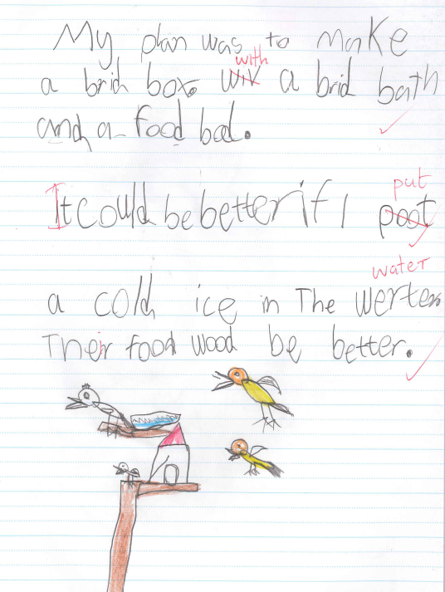
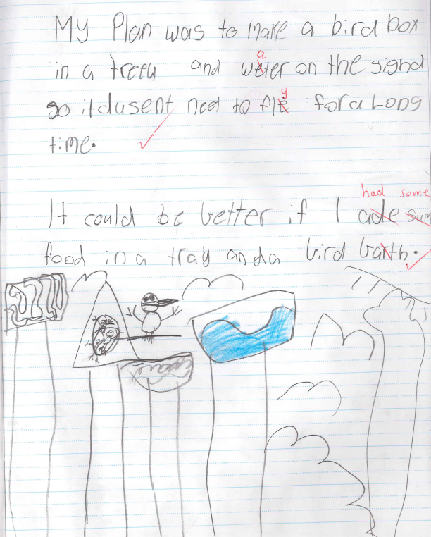
Student work samples showing design solutions and reflections.

Appendix 1A: Links to the Western Australian Curriculum
The Every bird needs a home module provides opportunities for developing students’ knowledge and understandings in science, technologies and mathematics. The table below shows how this module aligns to the content of the Western Australian Curriculum and can be used by teachers for planning and monitoring.
EVERY BIRD NEEDS A HOME  Links to the Western Australian Curriculum | ACTIVITY
 | 1 | 2 | 3 | 4
SCIENCE
SCIENCE UNDERSTANDING
Biological sciences: Living things grow, change and have offspring similar to themselves (ACSSU030) | ●
SCIENCE INQUIRY SKILLS
Questioning and predicting: Participate in guided investigations to explore and answer questions (ACSIS038) |  | ●
DESIGN AND TECHNOLOGIES
PROCESS AND PRODUCTION SKILLS
Designing: Develop, communicate and discuss design ideas through describing, drawing and/or modelling (WATPPS12) |  |  | ●
Collaborating and managing: Work independently, or collaboratively when required, to organise information and ideas to safely create and share sequenced steps for solutions (WATPPS15) |  |  | ●
Producing and implementing: Use components and given equipment to safely make solutions (WATPPS13) |  |  | ●
Evaluating: Use simple criteria to evaluate the success of design processes and solutions (WATPPS14) |  |  |  | ●

EVERY BIRD NEEDS A HOME | ACTIVITY
Links to the Western Australian Curriculum | 1 | 2 | 3 | 4
MATHEMATICS
MEASUREMENT AND GEOMETRY
Shape: Describe and draw two-dimensional shapes, with and without digital technologies (ACMMG042) |  | ●
Location and transformation: Interpret simple maps of familiar locations and identify the relative positions of key features (ACMMG044) |  | ●
PROBABILITY AND STATISTICS
Data representation and interpretation: Identify a question of interest based on one categorical variable. Gather data relevant to the question (ACMSP048) |  | ●
Data representation and interpretation: Collect, check and classify data (ACMSP049) |  | ●
Data representation and interpretation: Create displays of data using lists, table and picture graphs and interpret them (ACMSP050) |  | ●
NUMBER AND ALGEBRA
Number and Place Value: Solve simple addition and subtraction problems using a range of efficient mental and written strategies (ACMNA030) |  | ●
Further information about assessment and reporting in the Western Australian Curriculum can be found at: https://k10outline.scsa.wa.edu.au/home
curriculum-browser/technologies/technologies-overview/ways-of-assessing

Appendix 1B: Mathematics proficiency strands
Key ideas
In Mathematics, the key ideas are the proficiency strands of understanding, fluency, problem-solving and reasoning. The proficiency strands describe the actions in which students can engage when learning and using the content. While not all proficiency strands apply to every content description, they indicate the breadth of mathematical actions that teachers can emphasise.
Understanding
Students build a robust knowledge of adaptable and transferable mathematical concepts. They make connections between related concepts and progressively apply the familiar to develop new ideas. They develop an understanding of the relationship between the ‘why’ and the ‘how’ of mathematics. Students build understanding when they connect related ideas, when they represent concepts in different ways, when they identify commonalities and differences between aspects of content, when they describe their thinking mathematically and when they interpret mathematical information.
Fluency
Students develop skills in choosing appropriate procedures; carrying out procedures flexibly, accurately, efficiently and appropriately; and recalling factual knowledge and concepts readily. Students are fluent when they calculate answers efficiently, when they recognise robust ways of answering questions, when they choose appropriate methods and approximations, when they recall definitions and regularly use facts, and when they can manipulate expressions and equations to find solutions.
Problem-solving
Students develop the ability to make choices, interpret, formulate, model and investigate problem situations, and communicate solutions effectively. Students formulate and solve problems when they use mathematics to represent unfamiliar or meaningful situations, when they design investigations and plan their approaches, when they apply their existing strategies to seek solutions, and when they verify that their answers are reasonable.
Reasoning
Students develop an increasingly sophisticated capacity for logical thought and actions, such as analysing, proving, evaluating, explaining, inferring, justifying and generalising. Students are reasoning mathematically when they explain their thinking, when they deduce and justify strategies used and conclusions reached, when they adapt the known to the unknown, when they transfer learning from one context to another, when they prove that something is true or false, and when they compare and contrast related ideas and explain their choices.

Source:
www.australiancurriculum.edu.au/f-10-curriculum/mathematics/key-ideas/?searchTerm=key+ideas#dimension-content

Appendix 2: General capabilities continuums
The General capabilities continuums shown here are designed to enable teachers to understand the progression students should make with reference to each of the elements. There is no intention for them to be used for assessment.
Personal and social capability learning continuum
Sub-element | Typically by the end of Year 2 | Typically by the end of Year 4 | Typically by the end of Year 6
Social management  Work collaboratively | identify cooperative behaviours in a range of group activities | describe characteristics of cooperative behaviour and identify evidence of these in group activities | contribute to groups and teams, suggesting improvements in methods used for group investigations and projects
Social management  Negotiate and resolve conflict | practise solving simple interpersonal problems, recognising there are many ways to solve conflict | identify a range of conflict resolution strategies to negotiate positive outcomes to problems | identify causes and effects of conflict, and practise different strategies to diffuse or resolve conflict situations
Social management  Develop leadership skills | discuss ways in which they can take responsibility for their own actions | discuss the concept of leadership and identify situations where it is appropriate to adopt this role | initiate or help to organise group activities that address a common need

Critical and creative thinking learning continuum
Sub-element | Typically by the end of Year 2 | Typically by the end of Year 4 | Typically by the end of Year 6
Inquiring – identifying, exploring and organising information and ideas  Organise and process information | organise information based on similar or relevant ideas from several sources | collect, compare and categorise facts and opinions found in a widening range of sources | analyse, condense and combine relevant information from multiple sources
Generating ideas, possibilities and actions  Imagine possibilities and connect ideas | build on what they know to create ideas and possibilities in ways that are new to them | expand on known ideas to create new and imaginative combinations | combine ideas in a variety of ways and from a range of sources to create new possibilities
Generating ideas, possibilities and actions  Seek solutions and put ideas into action | investigate options and predict possible outcomes when putting ideas into action | experiment with a range of options when seeking solutions and putting ideas into action | assess and test options to identify the most effective solution and to put ideas into action
Reflecting on thinking and processes  Transfer knowledge into new contexts | use information from a previous experience to inform a new idea | transfer and apply information in one setting to enrich another | apply knowledge gained from one context to another unrelated context and identify new meaning

Information and communication technology (ICT) capability learning continuum
Sub-element | Typically by the end of Year 2 | Typically by the end of Year 4 | Typically by the end of Year 6
Create with ICT  Generate ideas, plans and processes | use ICT to prepare simple plans to find solutions or answers to questions | use ICT to generate ideas and plan solutions | use ICT effectively to record ideas, represent thinking and plan solutions
Create with ICT  Generate solutions to challenges and learning area tasks | experiment with ICT as a creative tool to generate simple solutions, modifications or data representations for particular audiences or purposes | create and modify simple digital solutions, creative outputs or data representation/ transformation for particular purposes | independently or collaboratively create and modify digital solutions, creative outputs or data representation/transformation for particular audiences and purposes
Communicating with ICT  Collaborate, share and exchange | use purposefully selected ICT tools safely to share and exchange information with appropriate local audiences | use appropriate ICT tools safely to share and exchange information with appropriate known audiences | select and use appropriate ICT tools safely to share and exchange information and to safely collaborate with others
Further information about general capabilities is available at:
k10outline.scsa.wa.edu.au/home/p-10-curriculum/general-capabilities-over/general-capabilities-overview/general-capabilities-in-the-australian-curriculum

Appendix 3: Materials list
The following materials are required to complete this module.
A range of recyclable items, including:
- newspaper
- cans
- plastic bottles
- ice-cream containers
- yoghurt containers
- shoe boxes
- plastic wrapping
- boxes
- foil
- fabric scraps
- egg cartons
- bottle caps.

A selection of cutting and construction tools such as:
- tape
- scissors
- cutting mats
- glue sticks
- PVA glue
- paint brushes
- tacks
- cable ties
- string.

Appendix 4: Design process guide

Appendix 5: Reflective journal
Safe production of the final design or multiple copies of the final design.
Fine tuning the production process, such as division of labour for batch or mass production.
Use of intended materials and appropriate tools to safely make the solution to the design problem.
Reflection on the process taken and the success of the design.
Evaluation can lead to further development or improvement of the design and can be a final stage of the design process before a conclusion is reached.
Could be formal or informal and verbal or written.
Ideation
Development
Development of the design ideas. Improvements, refinements, adding detail, making it better.
Activities such as detailed drawings, modelling, prototyping, market research, gaining feedback from intended user, further research – if needed – to solve an issue with the design, testing different tools or equipment, trialling production processes, measuring or working out dimensions, testing of prototypes and further refinement.
Idea generation – turning ideas into tangible forms so they can be organised, ordered and communicated to others.
Activities such as brainstorming, mind mapping, sketching, drawing diagrams and plans, collecting colour samples and/or material samples and talking through these ideas can help to generate more creative ideas.
Using the SCAMPER model can assist with this: www.mindtools.com/pages/article/newCT_02.htm
www.designorate.com/a-guide-to-the-scamper-technique-for- creative-thinking
Analysis
Finding useful and helpful information about the design problem.
Gathering information, conducting surveys, finding examples of existing solutions, testing properties of materials, practical testing.
Understanding the meaning of the research findings.
Analysing what the information means, summarising the surveys, judging the value of existing solutions, understanding test results.
Research
Production
Evaluation
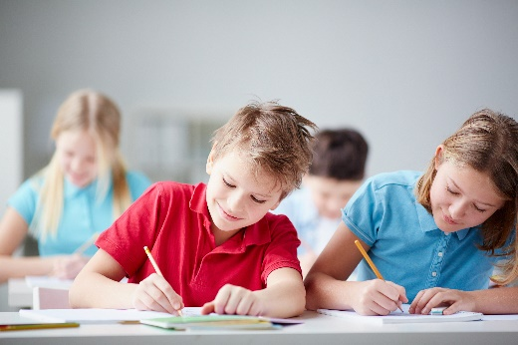
When students reflect on learning and analyse their own ideas and feelings, they self-evaluate, thereby improving their metacognitive skills. When students self-monitor or reflect, the most powerful learning happens.
Journaling may take the form of a written or digital journal, a portfolio or a digital portfolio. Early childhood classrooms may use a class reflective floor book with pictures of the learning experience and scribed conversations.
Teachers can model the Journaling process by thinking aloud and showing students how they can express learning and thoughts in a variety of ways including diagrams, pictures and writing.
Journals are a useful tool that gives teachers additional insight into how students value their own learning and progress, as well as demonstrating their individual achievements.
The following links provide background information and useful apps for Journaling.
Kidblog – digital portfolios and blogging
kidblog.org/home
Edmodo – for consolidating and storing class notes and learning materials
www.edmodo.com/
Explain Everything™ – a screen casting, video and presentation tool all in one
explaineverything.com
Popplet – allows you to jot down your ideas and then sort them visually
Popplet.com
Seesaw – for capturing work completed by students in class, using a device’s camera function
web.seesaw.me
Connect – the Department of Education’s integrated, online environment
connect.det.wa.edu.au
Evernote (a digital portfolio app)
evernote.com
Digital portfolios for students (Cool tools for school)
cooltoolsforschool.wordpress.com/digital-student-portfolios

Appendix 6: Student activity sheet 1.0: Journal checklist
As an ongoing part of this module, you have been keeping a journal of your work.
Before submitting your journal to your teacher please ensure you have included the following information.
- Tick each box once complete and included.
- Write N/A for items that were not required in this module.

Your name and group member's names or photographs
An explanation of the problem you are solving
Your notes from Activity 1
Your notes from Activity 2
Your notes from Activity 3
Your notes from Activity 4
Student activity sheet 2.1 Bird hunt
Student activity sheet 4.1: Design review
Student activity sheet 1.0: Journal checklist

Appendix 7: Teacher resource sheet 1.1: Cooperative learning – Roles
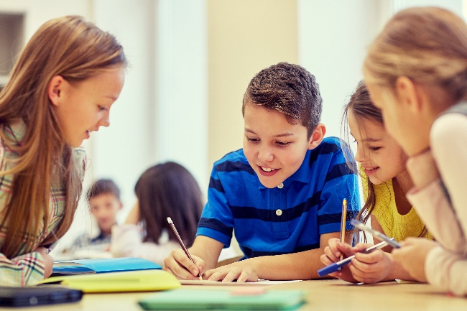
Cooperative learning frameworks create opportunities for groups of students to work together, generally to a single purpose.
As well as having the potential to increase learning for all students involved, using these frameworks can help students develop personal and social capability.
When students are working in groups, positive interdependence can be fostered by assigning roles to group members.
These roles could include:
- working roles such as Reader, Writer, Summariser, Time-keeper.
- social roles such as Encourager, Observer, Noise monitor, Energiser.
Teachers using the Primary Connections roles of Director, Manager and Speaker for their science teaching may find it effective to also use these roles for STEM learning.
Further to this, specific roles can be delineated for specific activities that the group is completing.
It can help students if some background to the purpose of group roles is made clear to them before they start, but at no time should the roles get in the way of the learning. Teachers should decide when or where roles are appropriate to given tasks.

Appendix 8: Teacher resource sheet 1.4: Cooperative learning – Think, Pair, Share
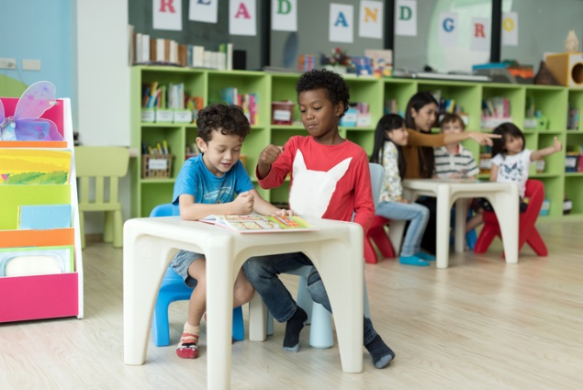
This resource sheet provides a brief outline of a cooperative learning strategy known as 'think – pair – share'.
Cooperative learning frameworks create opportunities for groups of students to work together, generally to a single purpose.
As well as having the potential to increase learning for all students involved, using these frameworks can help students develop personal and social capability.
In the 'think' stage, each student thinks silently about a question asked by the teacher.
In the 'pair' stage, students discuss their thoughts and answers to the question in pairs.
In the 'share' stage, the students share their answer, their partners answer or what they decided together. This sharing may be with other pairs or with the whole class. It is important also to let students 'pass'. This is a key element of making the strategy safe for students.
Think – pair – share increases student participation and provides an environment for higher levels of thinking and questioning.

Appendix 9: Teacher resource sheet 1.5: Sample parent letter
(School details and letterhead)
(Date)

Dear Parents/Caregivers,

RE: ITEMS COLLECTION FOR EVERY BIRD NEEDS A HOME STEM PROJECT

This term, our class is undertaking a STEM (Science, Technology, Engineering and Mathematics) project called Every bird needs a home. This project will involve students creating or improving bird habitat that will encourage more bird species to visit our school.
This project develops students’ ability to design, create and problem-solve. To enable students to create their design solutions, I would appreciate if you could collect items suitable for construction from your home. Please do not include any glass containers or toilet rolls.
We will be starting the project on (date), and would like the items to be delivered to the classroom before then.
We may require adult assistance during the construction phase so please let me know if you are available to help.

Thank you in advance,

(Classroom teacher)

Appendix 10: Student activity sheet 2.1: Bird hunt
Date: ___________________ Site location: ___________________ Group member names: _______________________________
Type of bird (name) | Number (tally) | Locations (where were they?)
1.
2.
3.
4.
5.
6.
7.
8.
9.
10.
Total number of birds seen: ___________________________
Most common bird: ___________________________________ Least common bird: __________________________________
Location with the most birds: ___________________________ Location with the least birds: ___________________________

Appendix 11: Teacher resource sheet 3.1: Construction skills
Construction skills help students to generate and produce solutions for real-world problems. This resource develops students' skills in design and technologies.
This resource can be used as a visual stimulus to prompt students to develop solutions to design problems. The cards can be printed out to create stations.

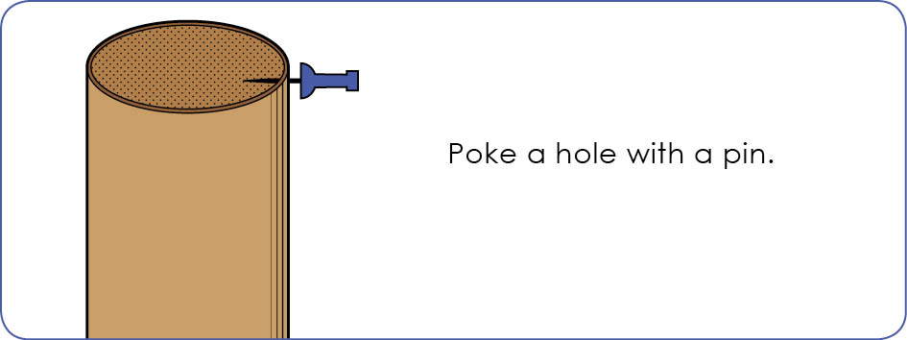

Poke a hole with a pin.
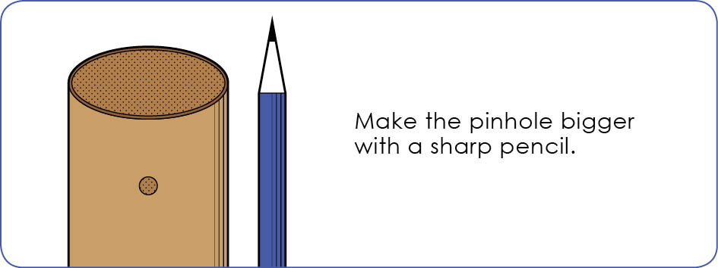

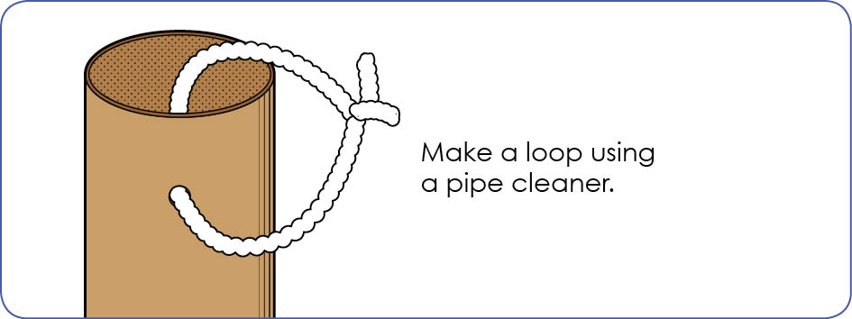

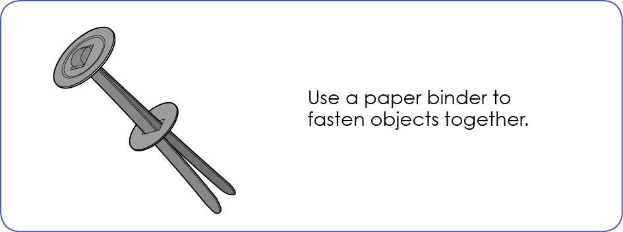

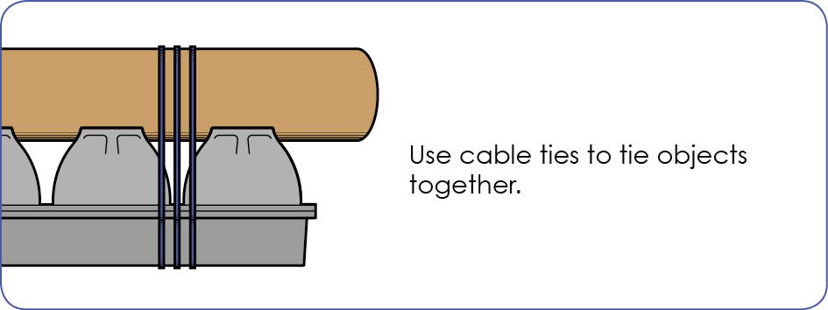
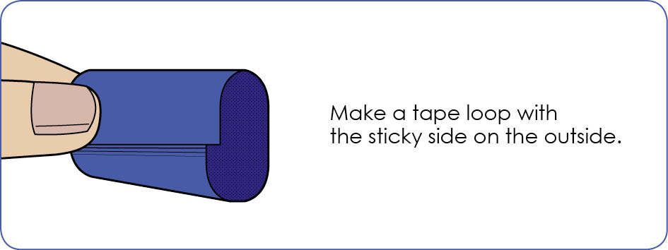

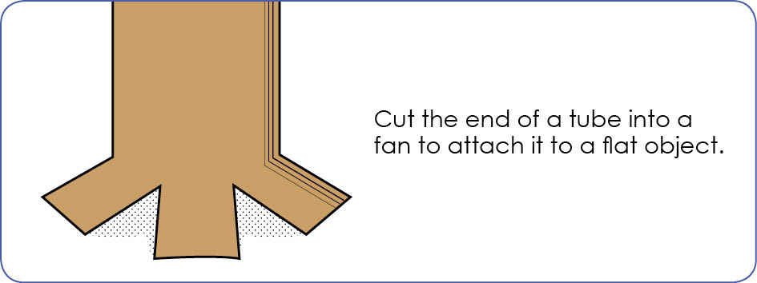

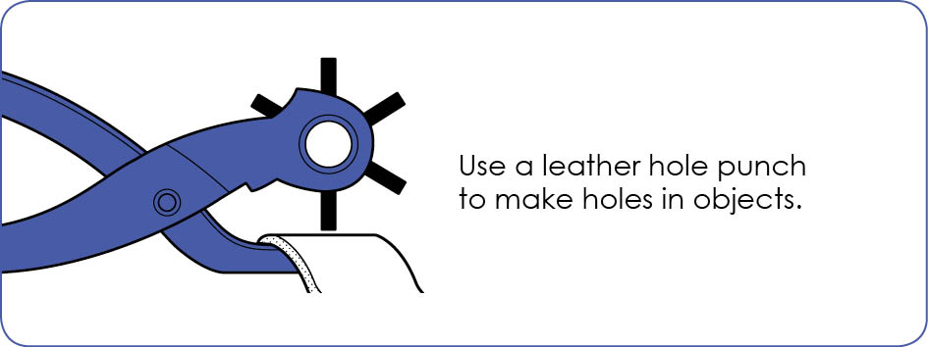
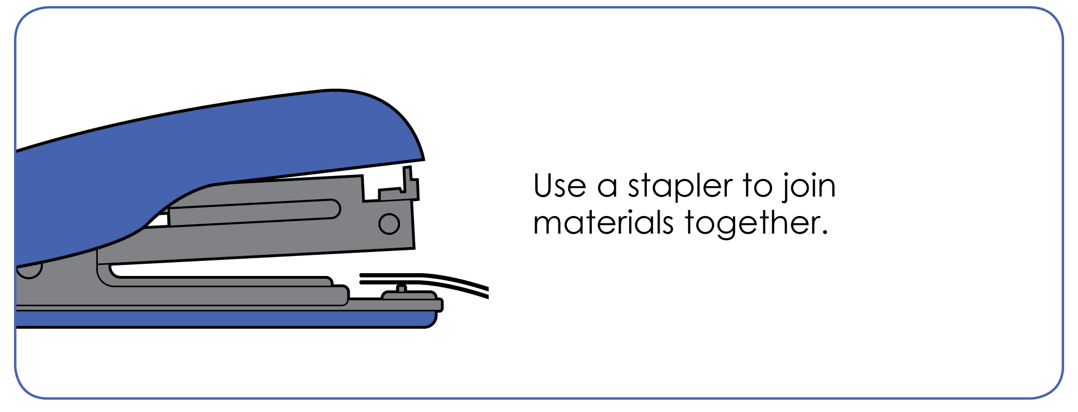

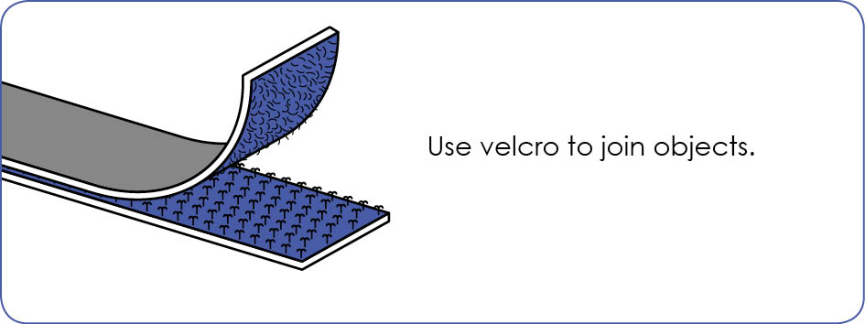

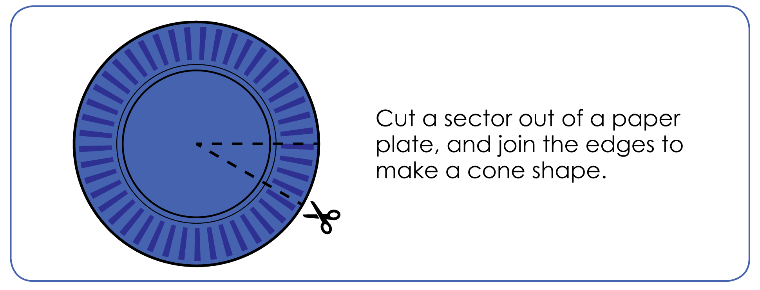

Appendix 12: Student activity sheet 4.1: Design review
Things I would keep the same _________________________________________________________________________________________________________________________________________________________________________________________________________________________
Things I would change
________________________________________________________________________________________________________________________________________________________________________________________________________________________________________________________
Photograph or drawing

Appendix 13: Teacher resource sheet 4.2: Evaluation
Key:  - Sometimes  - Consistently  - Independently and consistently | Student name
Remains focused on tasks presented
Completes set tasks to best of their ability
Works independently without disrupting others
Manages time effectively
Cooperates effectively within the group
Contributes to group discussions
Shows respect and consideration for others
Uses appropriate conflict resolution skills
Actively seeks and uses feedback

Notes
_______________________________________________________________________________________________________________________________________________________________________________________________________________________________________________________________________________________________________________________________________________________________________________________________________________________________________________________________________________________________________________________________________________________________________________________________________________________________________________________________________________________________________________________________________________________________________________________________________________________________________________________________________________________________________________________________________________________________________________________________________________________________________________________________________________________________________________________________________________________________________________________________________________________________________________________________________________________________________________________________________________________________________________________________________________________________________________________________________________________________________________________________________________________________________________________________________________________________

Notes
_______________________________________________________________________________________________________________________________________________________________________________________________________________________________________________________________________________________________________________________________________________________________________________________________________________________________________________________________________________________________________________________________________________________________________________________________________________________________________________________________________________________________________________________________________________________________________________________________________________________________________________________________________________________________________________________________________________________________________________________________________________________________________________________________________________________________________________________________________________________________________________________________________________________________________________________________________________________________________________________________________________________________________________________________________________________________________________________________________________________________________________________________________________________________________________________________________________________________

