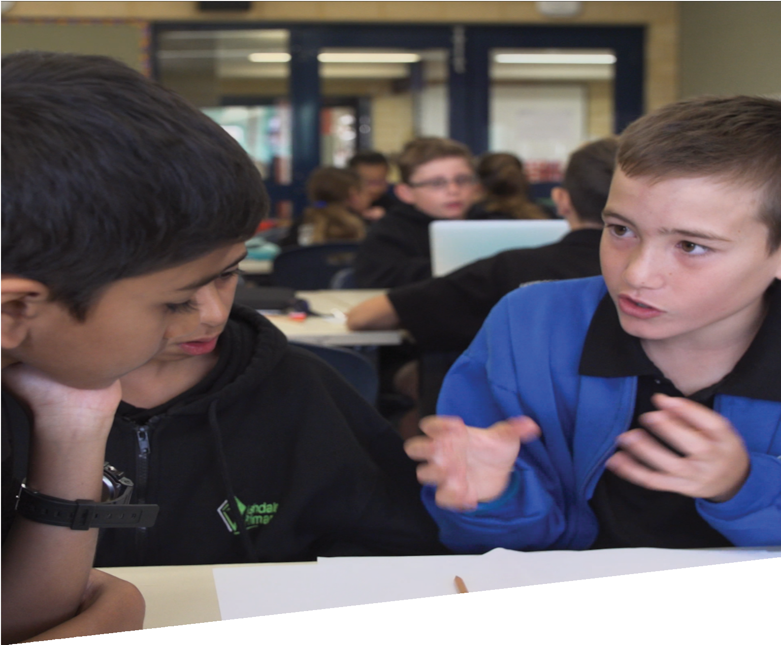

CURRICULUM RESOURCE MODULE
Living off-grid
YEAR 6
Acknowledgements
The STEM Learning Project respectfully acknowledges the Traditional Custodians of the lands upon which our students and teachers live, learn and educate.

The STEM Learning Project is funded by the Western Australian Department of Education (the Department) and implemented by a consortium in STEM education comprising the Educational Computing Association of WA, the Mathematical Association of WA, the Science Teachers Association of WA and Scitech. We acknowledge and thank the teachers and schools who are the co-creators of these resources.
Copyright and intellectual property
The copyright and intellectual property of this module remain the property of the Department.

Any Western Australian Curriculum content in this resource is used with the permission of the School Curriculum and Standards Authority (the Authority); this permission does not constitute Authority endorsement of the resource. The Authority accepts no liability for any errors or damages arising from reliance on its content.

The Western Australian Curriculum content may be freely copied, or communicated on an intranet, for non-commercial purposes in educational institutions, provided that the Authority is acknowledged as the copyright owner. Copying or communication for any other purpose can be done only within the terms of the Copyright Act 1968 or with prior written permission of the Authority. Any Australian Curriculum content in the Western Australian Curriculum is used by the Authority under the terms of the Creative Commons Attribution-NonCommercial 3.0 Australia licence. Any content on the www.scsa.wa.edu.au domain that has been derived from the Australian Curriculum may be used under the terms of Creative Commons Attribution-NonCommercial 3.0 Australia licence.

Appendix 2: General capabilities continuums is adapted from ACARA, © Australian Curriculum, Assessment and Reporting Authority (ACARA) 2009 to present, unless otherwise indicated. This material was downloaded from the ACARA website (www.acara.edu.au) (Website) (accessed December 2015) and was not modified. The material is licensed under CC BY 4.0 (https://creativecommons.org/licenses/by/4.0/). ACARA does not endorse any product that uses ACARA material or make any representations as to the quality of such products. Any product that uses material published on this website should not be taken to be affiliated with ACARA or have the sponsorship or approval of ACARA. It is up to each person to make their own assessment of the product.

This resource includes references and examples of iOS, Android and other apps. The Department does not endorse or recommend any commercial products and simply provides these as examples for teachers.

The Department is committed to providing quality information to its customers. Whilst every effort has been made to ensure accuracy, currency and reliability of the information within these documents, the Department accepts no responsibility for errors, omissions or amendments made since the time of publishing. Confirmation of information may be sought from the Department or the originating bodies providing the information. The Department has no control over the content of material published on websites to which users are referred in this resource. It is the responsibility of the internet user to make their own decision as to the relevancy, accuracy, currency and reliability of information found on those sites.

This resource contains various images from iStock used under license.
Attributions: Jaycar Electronics, Scientrific.com.au, eBook, Pages, Keynote, Microsoft PowerPoint, iMovie Seesaw, Class Dojo, Google Sheets.

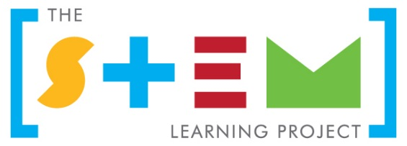
Table of contents

The STEM Learning Project 2
Overview 3
Activity sequence and purpose 5
Background 7
Activity 1: Living off-grid 10
Activity 2: Investigating living off-grid 13
Activity 3: Solar cooker design and construction 19
Activity 4: Solar cooker demonstration and testing 25
Appendix 1: Links to the Western Australian Curriculum 31
Appendix 1B: Mathematics proficiency strands 33
Appendix 2: General capabilities continuums 34
Appendix 3: Materials list 37
Appendix 4: Design process guide 39
Appendix 4B: Drawing in the design process 40
Appendix 5: Student journal 41
Appendix 6: Student activity sheet 1.0: Journal checklist 42
Appendix 7: Teacher resource sheet 1.1: Cooperative learning – Roles 43
Appendix 8: Teacher resource sheet 1.2: Cooperative learning – Jigsaw 44
Appendix 9: Teacher resource sheet 1.3: Cooperative learning – Placemat 45
Appendix 10: Teacher resource sheet 1.4: Cooperative learning – Think, Pair, Share 46
Appendix 11: Teacher resource sheet 2.1: Solar panel experiment 47
Appendix 12: Student activity sheet 2.2: Solar panel experiment 49
Appendix 13: Teacher resource sheet 2.3: Water purification experiment 53
Appendix 14: Student activity sheet 2.4: Water purification experiment 56
Appendix 15: Student activity sheet 2.5: Solar cooker testing 61
Appendix 16: Student activity sheet 4.1: Design review 66

The STEM Learning Project
The aim of the STEM Learning Project is to generate students’ interest, enjoyment and engagement with STEM (Science, Technology, Engineering and Mathematics) and to encourage their ongoing participation in STEM both at school and in subsequent careers. The curriculum resources will support teachers to implement and extend the Western Australian Curriculum across Kindergarten to Year 12 and develop the general capabilities.
Why STEM?
A quality STEM education will develop the knowledge and intellectual skills to drive the innovation required to address global economic, social and environmental challenges.
STEM capability is the key to navigating the employment landscape changed by globalisation and digital disruption. Routine manual and cognitive jobs are in decline whilst non-routine cognitive jobs are growing strongly in Australia. Seventy-five per cent of the jobs in the emerging economy will require critical and creative thinking and problem solving, supported by skills of collaboration, teamwork and literacy in mathematics, science and technology. This is what we call STEM capability. The vision is to respond to the challenges of today and tomorrow by preparing students for a world that requires multidisciplinary STEM thinking and capability.
The approach
STEM capabilities are developed when students are challenged to solve open-ended, real-world problems that engage students in the processes of the STEM disciplines.
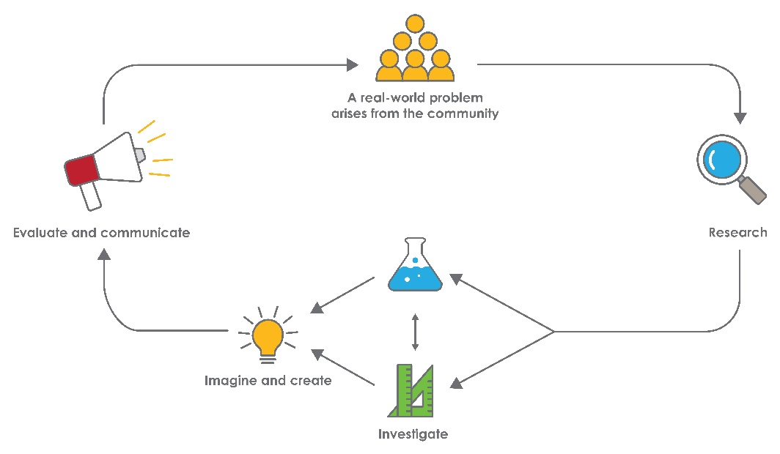
Year 6 – Living off-grid

Overview
What is the context?
In a well-developed country such as Australia it is easy to access essential services such as electricity, gas, clean drinking water and sewerage. A lack of infrastructure in developing countries makes it more difficult for people to access energy and clean water.
The purpose of this module is to engage students in creating relatively simple, environmentally sustainable solutions that will generate energy and produce clean drinking water for living off-grid. Students design and build their solutions as examples of ways to provide these essential services in a developing country, in a developed country in an emergency, camping or for when these services are not available.
The module also aims to provoke students to reflect on their impact on the environment and raise their awareness about the appeal of sustainably living
off-grid.
What is the problem?
How can we develop simple and sustainable living solutions?
How does this module support integration of the STEM disciplines?
Science
Students build science understandings as they investigate the transfer and transformation of energy and research how wind, water and solar panels can be used to generate electricity (ACSSU097). Students consider whether energy sources are sustainable. Students plan and conduct investigations (ACSIS103, ACSIS104), and collect, represent and interpret data (ACSIS107).
Technologies
Students consider the role of technology in society and ways in which people address sustainability issues when designing products (ACTDEK019). Engineering principles and systems are examined when students investigate energy within systems and create solutions while following a design process (ACTDEK023). (ACTDEK020). Digital reports are shared online (ACTDIP022).
The Design process guide is included as a resource to assist teachers in understanding the complete design process as developed in the Technologies curriculum.
Mathematics
Mathematics understandings and proficiencies are developed as students select and apply efficient mental and written strategies to solve problems involving measurements taken during their experiments (ACMNA123); represent and interpret data displays (ACMSP147) from their investigations; convert between common metric units of capacity and make connection between volume and capacity (ACMMG136 and ACMMG138) when investigating stills and designing a solar cooker and when constructing and comparing the performance of different solar cookers, they also solve problems involving length and area measurements (ACMMG137).
General capabilities
There are opportunities for the development of general capabilities and cross-curriculum priorities as students engage with Living off-grid. In this module, students:
- Develop problem solving skills as they research the problem and its context (Activity 1); investigate parameters impacting on the problem (Activity 2); imagine and develop solutions (Activity 3); and evaluate and communicate their solutions to an audience (Activity 4).
- Utilise creative thinking as they generate possible design solutions; and critical thinking, numeracy skills and ethical understanding as they choose between alternative approaches to solving the problems of living off-grid.
- Utilise personal and social capability as they develop socially cohesive and effective working teams; collaborate in generating solutions; adopt group roles; and reflect on their group work capabilities.
- Utilise a range of literacies and information and communication technology (ICT) capabilities as they collate records of work completed throughout the module in a journal and represent and communicate their solutions to an audience using digital technologies in Activity 4.
What are the pedagogical principles of the STEM learning modules?
The STEM Learning Project modules develop STEM capabilities by challenging students to solve real-world problems set in authentic contexts. The problems engage students in the STEM disciplines and provide opportunities for developing higher order thinking and reasoning, and the general capabilities of creativity, critical thinking, communication and collaboration.
The design of the modules is based on four pedagogical principles:
- Problem-based learning
This is an underlying part of all modules with every module based around solving an initial problem. It is supported through a four-phase instructional model: research the problem and its context; investigate the parameters impacting on the problem; design and develop solutions to the problem; and evaluate and communicate solutions to an authentic audience.
- Developing higher order thinking
Opportunities are created for higher order thinking and reasoning through questioning and discourse that elicits students' thinking, prompts and scaffolds explanations, and requires students to justify their claims. Opportunities for making reasoning visible through discourse are highlighted in the modules with the icon shown here.
- Collaborative learning
This provides opportunities for students to develop teamwork and leadership skills, challenge each other’s ideas, and co-construct explanations and solutions. Information that can support teachers with aspects of collaborative learning is included in the resource sheets.
- Reflective practice
Recording observations, ideas and one’s reflections on the learning experiences in some form of journal fosters deeper engagement and metacognitive awareness of what is being learnt. Information that can support teachers with journaling is included in the resource sheets.
These pedagogical principles can be explored further in the STEM Learning Project online professional learning modules located in Connect Resources.

Activity sequence and purpose
Living off-grid | Students collaboratively research off-grid living and sustainable ways to provide drinkable water and energy for heating, lighting, cooking.
Designing for living off-grid | Students conduct investigations into the effectiveness of solar panels for producing electricity and solar stills for producing drinking water.
Solar cooker design and construction | Students explore the design process and apply it to designing and making a solar cooker.
Solar cooker demonstration and testing | Students demonstrate, test and evaluate their solar cookers and compare the performance of different designs. They evaluate their results and present their solution to an audience using multimedia.

Background
Expected learning | Students will be able to:  - Define sustainability and sustainable living.  - Describe sustainable methods of electricity generation including the use of solar panels.  - Describe how energy sources can be transformed to generate electricity.  - Formulate a question, plan and conduct an investigation, collect and analyse data to measure the performance of a solar (photovoltaic) panel under different conditions.  - Formulate a question, plan and conduct an investigation, collect and analyse data to measure the performance of a solar still in producing drinking water.  - Convert units of measurement and calculate rates at which electricity and distilled water are generated.  - Compare rates of water and electricity generation to those required to meet domestic needs.  - Using scientific principles, justify the choice of materials and shapes used in the design of the solar cooker.  - Describe how energy sources can be transformed to generate electricity.  - Imagine and design a solar cooker and represent the design as an annotated diagram, including measurements of length, area, volume/capacity and angle.  - Working from their design, select appropriate materials and construction techniques to make a prototype solar cooker.  - Test and compare the effectiveness of their designs.
Vocabulary | This module uses subject-specific terminology.  The following list contains vocabulary that need to be developed, either before the module commences or as it is used:  absorb, amenities, condensation, conductor, consumption, convert, current, desalination, energy, energy transfer, energy transformation, environmental footprint, evaporation, generate, heat, insulator, molecule, multi-meter, non-renewable resources, off-grid, output, parabolic shapes, photovoltaic, prototype, radiation, rate, reflect, solar energy, solar panel, still, sustainable, temperature, utilities, voltage.
Timing | There is no prescribed duration for this module. The module is designed to be flexible enough for teachers to adapt. Activities do not equate to lessons; one activity may require more than one lesson to implement.
Materials | A Materials list is provided for this module. The list outlines materials outside of normal classroom equipment that will be needed to complete the activities.
Safety notes | There are potential hazards inherent in these activities and with the equipment being used, and a plan to mitigate any risks will be required.  Potential hazards specific to this module include but are not limited to:  - Possible exposure to cyber bullying, privacy violations and uninvited solicitations when using the internet.  - Sharp tools for cutting and joining materials.  - Heat from the cookers and hot surfaces.  - Uncooked food and associated bacteria.  - Sun exposure during outdoor activities.
Enterprise skills | The Living of grid module focuses on higher order skills with significant emphasis on expected learning from the general capabilities and consideration of what are Enterprise skills.  Enterprise skills include: problem solving, communication skills, digital literacy, teamwork, financial literacy, creativity, critical thinking and presentation skills.  Further background on this is available from the Foundation for Young Australians New Work Order research. This is a series of reports which show how disruption to the world of work has significant implications for young Australians www.fya.org.au/our-research/.  A summary report is The New Basics: Big data reveals the skills young people need for the New Work Order (Foundation for Young Australians, 2016) www.fya.org.au/wp-content/uploads/2016/04/The-New-Basics_Web_Final.pdf
Assessment | The STEM modules have been developed to provide students with learning experiences to solve authentic real-world problems using science, technology, engineering and mathematics capabilities. While working through the module, the following assessment opportunities will arise.  - Anecdotal notes of observations as students work collaboratively through the activities.  - Predictions and observations gathered through the science investigation.  - Reflections and justification of understandings when students present their learning in Activity 4.  Appendix 1 indicates how the activities are linked to the Western Australian Curriculum.  Evidence of learning from journaling, presentations and anecdotal notes can contribute towards the larger body of evidence gathered throughout a teaching period and can be used to make on-balance judgements about the quality of learning demonstrated by the students in the Science, Technologies and Mathematics learning areas.  Students can further develop the general capabilities of Information and communication technology (ICT) capability, Critical and creative thinking and Personal and social capability. Continuums for these are included in the General capabilities continuums but are not intended to be for assessment purposes.

Activity 1: Living off-grid
Activity focus | Students collaboratively research off-grid living and sustainable ways of providing energy and drinkable water.  Students record their research findings and create a reflective journal to document their thinking.
Background information | Living off-grid refers to being self-sufficient and not relying on utilities for electricity, water, gas and sewerage. Successful off-grid living solutions achieve sustainability by reducing or eliminating the use of non-renewable resources.  People in developed countries may choose to live off the grid to reduce their environmental footprint or because they live in a remote location. In developing countries, people may be forced to live off the grid as they are unable to afford, or have limited access to, utilities.  There are a variety of ways of generating off-grid electricity such as, wind generators and solar panels. There are also ways of generating heat for cooking such as burning wood or dried manure.  Living off-grid can have positive impacts such as reducing consumption of non-renewable resources. There can also be negative effects such as having to work harder to keep systems sustainable (eg growing your own food or maintaining your own energy supplies).  Understanding how a generator transforms the kinetic energy of moving wind or water into electrical energy, or how a solar panel harnesses the Sun’s energy, will help students consider design solutions. See Digital resources for more information.
Instructional procedures | This activity is intended to be student-led through individual and collaborative research, brainstorming and reflection. Prompt questions and the placemat strategy are suggested scaffolds to support student inquiry. See Teacher resource sheet 1.3: Cooperative learning – Placemat.  In Activity 4, an authentic audience such as parents, canteen staff or a chef could be invited to observe the testing of the cookers and to hear students’ explanations of their designs and how they work.
Expected learning | Students will be able to:  - Define sustainability and sustainable living (Science).  - Propose methods for generating electricity and purifying water for drinking (Science).
Equipment required | For the students:  Access to internet and library  Paper for Placemat activity  Digital devices
Preparation | Preload the webpage links in Digital resources to a common drive to ensure all students can access material to complete the research questions.
Activity parts | Part 1: What does it mean to be ‘off the grid’?  Working in groups, students research the following aspects of sustainability and use a visual display, such as a storyboard, to present their understanding to the class:  - What does ‘living off-grid’ mean?  - Why do people live off-grid?  - What makes a resource sustainable?  - What are sustainable methods of generating electricity and how do they work?  Students can use the placemat strategy, see Teacher resource sheet 1.3: Cooperative learning – Placemat when researching. See Digital Resources for suggested links for research.
Part 2: Power cut
As a class, brainstorm the impact on households, industry and neighbourhoods, of a week-long electricity outage and strategies that could be adopted in response to this. Prompt students to conceptualise their own ideas.
Students should consider that the fresh water supply, sewerage and storm water treatment and the use of electricity for power would not be available.

Suggested example: An electricity outage that affected a whole suburb for a week would stop the pumps that take sewage away to the water treatment plant, the pumps needed to pressurise the water supply, and the supply of electricity for lighting and cooking.
- What problems would be created by a power outage?
- What impact would this have on the appliances and devices you use?
- What strategies could you adopt to cope with this crisis?
- How could you generate electricity?
- How could you purify water for drinking?
Part 3: Reflection and journaling
Students review their definitions of sustainability and reflect on their dependence on utilities in their learning journals or online blogs. See Student journal for elaboration.
Resource sheets | Teacher resource sheet 1.3: Cooperative learning – Placemat
Digital resources | eSafety classroom resources (Office of the eSafety Commissioner, 2018)  esafety.gov.au/education-resources/classroom-resources
Primary Connections – Essential Energy (Australian Academy of Science, 2018)
https://www.primaryconnections.org.au/curriculum-resource/essential-energy
Richgro Bioenergy Plant, Jandakot, Western Australia (Waste Management Review, 2016)
wastemanagementreview.com.au/richgro-bioenergy-plant-jandakot-western-australia
Heat Energy: Insulators, Conductors and Solar Energy (Teachers Pay Teachers, 2016)
www.teacherspayteachers.com/Product/Heat-Energy-Insulators-Conductors-and-Solar-Energy-1681255
How Wind Turbines Generate Electricity (Andy Dunau, 2009)
youtu.be/0Kx3qj_oRCc

Activity 2: Investigating living off-grid
Activity focus | Students conduct investigations into the effectiveness of both solar panels for producing electricity and solar stills for producing drinking water.
Background information | Photovoltaic (PV) cells transform light energy into electrical energy. Materials such as silicon in a photovoltaic cell absorb photons of light and release electrons. These free electrons flow in an electric current when the solar panel is connected in an electric circuit. Solar panels generate direct current (DC) electricity like a battery. An inverter can be used to convert direct current to alternating current (AC) like the electricity supplied from a power station. The electrical output from a set of 10 solar panels can be as high as 3000 watts (3 kW). This is enough to boil a kettle and run a toaster at the same time.  One-way fresh water can be obtained from salty water is through evaporation and condensation. Sunlight can provide energy to water molecules, so they move faster and escape from the surface of the liquid to become water vapour (a gas), leaving the salt molecules behind. The molecules of water can then move freely. If the water vapour in the air reaches a cold surface, the water molecules move more slowly, form tiny droplets and join to form pure water suitable for drinking. We see these droplets on cold windows as condensation.
Expected learning | Students will be able to:  - Describe how energy sources can be transformed to generate electricity (Science).  - Formulate a question, plan and conduct an investigation, collect and analyse data to measure the performance of a photovoltaic panel in generating electricity (Science).  - Formulate a question, plan and conduct an investigation, collect and analyse data to measure the performance of a solar still in producing drinking water (Science and Mathematics).  - measure time and liquid volume and, with support, calculate rates in units of capacity and time. (Mathematics).  - Relate volume and capacity units and convert between the two kinds of units (Mathematics).  - Use multiplication and division on whole numbers of measurements to calculate and compare the rates at which electricity and water are generated in their experiments to the rates required for domestic purposes (Mathematics).
Equipment required | For the class:  Teacher resource sheet 2.3: Water purification experiment  Teacher resource sheet 2.1: Solar panel experiment. Kits will need to be sourced.
For the students:
Student activity sheet 2.4: Water purification experiment
Student activity sheet 2.2: Solar panel experiment
Preparation | Teachers should familiarise themselves with the experiments and supply the materials detailed in the resource sheets.  The links in the Digital resources can be used to develop student understandings about energy.  Source small solar panel kits (see Digital resources).
Activity parts | Part 1: What could we do?  Students work in small groups of three or four for the following ‘thought experiments’.  Discuss whether the students have solar panels at home and how they work.  Prior to using the resource sheets for the experiments, facilitate a brainstorm on ways to provide electricity and clean drinking water following an electricity outage affecting a whole suburb for a week. This would stop the pumps that take sewage away to the water treatment plant, the pumps needed to pressurise the water supply, and the supply of electricity for lighting and cooking.  Prompt questions can include:  - How much electricity is required to power a household?  - Can all household appliances be powered by a solar panel?  - How much water would we need each day for survival?  - How could you produce enough electricity and clean water to meet your needs?  Following the brainstorm, groups work to complete the experiments that support the brainstormed solutions. Students formulate a question for investigation and plan the experiments and data collections. See Teacher resource sheet 2.1: Solar panel experiment and Student activity sheet 2.2: Solar panel experiment.  Prompt student thinking using questioning:  - How much electrical energy can be generated by a solar panel? How would we measure this?  - Where should the solar panel be placed to maximise electricity generation?  - Is the rate at which electricity is generated sufficient for our needs?  - How much drinking water can be produced by a simple solar still? How fast can it produce drinking water and will this be sufficient for our needs?  Students record their findings in their reflective journals or online blogs.  This is an excellent opportunity for students to develop and plan their own investigations on their choice of off-grid living resources. Peer facilitated, inquiry-based learning is encouraged as best practice.
Part 2: Testing a solar panel
Assemble a solar panel and take measurements with a multimeter to calculate the power output of the panel. Refer to Teacher resource sheet 2.1: Solar panel experiment and Student activity sheet 2.2: Solar panel experiment for instructions. Students will investigate factors that affect the amount of electricity generated by panels. For example: In full sun, partial shade and full shade investigate the angle at which sun rays hit the panels. Record the voltage and current readings from these and calculate the amount of electrical energy produced. Compare the electrical energy produced with that required to power domestic appliances such as a kettle. Sufficient information is provided in the student activity sheet for them to make this comparison.
Encourage students to select and construct suitable displays for their data, using their previous experiences with tables and bar graphs to choose appropriately.
Part 3: Making and testing a solar still
Teacher resource sheet 2.3: Water purification experiment and Student activity sheet 2.4: Water purification experiment explain how to set up a solar still which can be used to produce fresh drinking water from contaminated water.
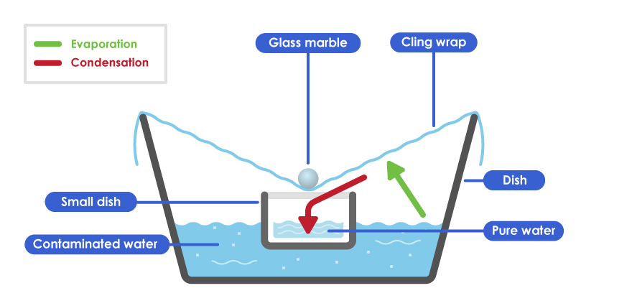
Figure 1 Solar Still
Groups of students plan their own investigations, creating two stills to determine if particular design features affect the rate of water production in each still. Have them consider which aspects of the still might affect the rate of water production; different size/shape of containers, quantities of water, time of day, position of the still and type of plastic sheeting.
When planning and conduction their small group investigations, students will need to think carefully about which of the independent variables should be kept the same, and which one they will vary to try and discover the factor that maximise clean water production (the dependent variable):
- The volume or the surface area of contaminated water
- Period of time: during the day, overnight, or both?
- Using clear, black or white plastic
- In full sun or in shade, or moving from sun to shade?
- Amount of the slope towards the collection container?
In reporting their results, students consider how the processes of evaporation and condensation of water enable the still to produce fresh water. It would be helpful to have different groups investigate different independent variables, keeping other variables consistent, to enable further comparison of data between groups. Have students research and explain why one factor might have a greater effect on the rate of water production than another.
Concepts related to rates and ratios will not be introduced until Years 7 and 8. Consequently some specific teaching will likely be required to assist students to understand that a ‘rate’ involves a relationship between two different kinds of measurements, in this case liquid volume and time. Students will need to measure the quantity of water collected in millilitres and the total time the experiment was conducted in minutes to enable them to complete the work sheet provided. From this information, students can derive the rate of water production in millilitres per minute, and then calculate answers to further questions from that rate. Discuss and support students in this process by working through the following questions and determining the required operations:
- How can we use our measurements to work out the average rate of water produced each minute?
- How can that help us compare different stills?
- What calculation should we apply to our mL/m rate to convert it to a rate of L/hr (Litres per hour)?
- What calculation should be applied to a rate given in L/hr, given for a commercial still, so we could compare it to our rate in mL/m?
- Could your measurements be used to work out how many minutes it would take to produce 1 litre of water in your still, i.e. a rate given in minutes per litre (m/L)?
- What would your rates of mL/m and L/h be if given in cubic centimetres (cm³) of water?
Use this opportunity to relate liquid volume capacity units of millilitres and litres to solid volume units of cubic centimetres and cubic decimetres (i.e.1000 cm3). Emphasise that both kinds of units measure identical quantities; that 1 millilitre (mL) has the same volume (i.e. takes up the same amount of space) as 1 cubic centimetre (cm3) and are interchangeable units. Relate to engine capcity in vehicles e.g. a 3000 cc (cubic cm) engine is the same as a 3 Litre engine, and the inside volume or capacity of refrigerators and freezers are sometimes given in cubic metres and sometimes in litres.
Part 4: Reviewing the data
Review the results from the two experiments and consider the size of solar panels and stills that would be needed to supply useful quantities of electricity and water. Discussion questions could include:
- In which location did the solar panel work best? Why?
- How do solar panels work? Where does the electrical energy come from and transfer to?
- What are the energy transformations taking place when solar panels power an appliance?
- How is the light from the sun transformed in a solar panel to generate electricity?
- How much electrical energy was produced? Was this enough to boil a kettle?
- How could you increase the power output of a solar panel?
- How did the solar still make drinking water?
- What happened to the contaminants?
- How much clean water could your still make in an hour? Is this enough to supply drinking water to sustain you?
- How could you design a still that would produce a greater quantity of water?
- Is there an energy transformation happening in a solar still?
Discuss the principles of solar panels converting light energy to electrical energy and the concepts of evaporation and condensation with the students.
Part 5: Journaling
Students document their thinking and reflections on the activities in their journals or online blogs.
Resource sheets | Teacher resource sheet 2.1: Solar panel experiment  Student activity sheet 2.2: Solar panel experiment  Teacher resource sheet 2.3: Water purification experiment  Student activity sheet 2.4: Water purification experiment
Digital resources | Energy Resources: What power can you get from a solar panel - practical activity (Education Services Australia, 2017)  www.scootle.edu.au/ec/viewing/R12284/pdf/stelr_06b.pdf
Putting STEM into Science - Innovative STEM teaching resources (STELR, 2016)
www.stelr.org.au
Solar Energy – Electricity (STELR, 2016)
www.stelr.org.au/solar-cells
How do Photovoltaics Work? (NASA Science, 2008)
https://science.nasa.gov/science-news/science-at-nasa/2002/solarcells

Activity 3: Solar cooker design and construction
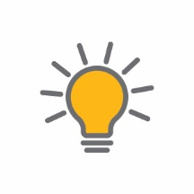  Activity focus | Students explore the design process and apply it to designing and making a solar cooker.
Background information | The focus of this activity is to design a solar cooker. It is important to note that there is scope for students to design and build other off-grid solutions (ie solar phone chargers) while maintaining the structure of the activity.  Solar cookers involve the transfer and transformation of energy.  Light emitted by the Sun transfers a lot of energy. When it strikes a solid or liquid, most of this energy causes the molecules in that matter to vibrate and this generates heat. In this way, light energy is transformed into heat energy.  Dark surfaces get very hot in sunlight because they absorb light energy, while light and shiny surfaces reflect light. Dark coloured cooking pots work best in a solar cooker because they absorb light energy and convert it to heat energy.  In designing their solar cookers students are attempting to maximise the efficiency of their cookers. There are three main designs: box, panel and parabolic cookers. See Solar Cooker Comparisons: Solar Cookers, Solar Ovens, Solar Grills, and More (SolSource, 2018)  http://www.oneearthdesigns.org/solar-oven-solar-cooker/  Parabolic designs involve using reflective materials formed into shapes that reflect and focus the light energy onto the cooking pot.  Box cookers are insulated boxes that capture the light that shines into it. The glass or plastic top creates a kind of greenhouse effect trapping heat and increasing the temperature in the box. One or more reflective surfaces are attached to the insides of the box to reflect sunlight onto the cooking pot.  Panel type solar cookers consist of several reflecting panels. The focus of the panels is the pan. To prevent the pan from losing its heat, the pan is put in a transparent and heat resistant plastic bag.  The different materials used to construct a solar cooker need to have a range of properties that enable reflection and absorption of light and heat energy where appropriate as well as the conduction and insulation of heat energy where necessary. The sides of the cooker need to be made of reflective material (eg aluminium foil) and the cooking pot needs to be made of a material that absorbs heat (ie dark colour) and conducts heat to the food (ie metal). The outer surfaces of the cooker could be covered with an insulating material (eg cardboard) to stop heat being lost to the air.  Solar cookers can be very efficient, transforming up to 80% of light energy into heat energy. They can generate high temperatures which could pose a safety risk.
Instructional procedures | To better manage the design and construction of solar cookers the following constraints are suggested:  - It must be constructed from low or no cost material readily available or repurposed from the household.  - It must be of simple design and size that is able to be constructed within the classroom with basic hand tools.  - The final design must be discussed with the teacher before the production phase to ensure the project has the best chance of being successful.  - Additional resources identified by students must be able to be acquired in a timely manner.  To better manage available resources, solar cookers could be designed and built by groups of three or four students using assigned roles.  The design process needs to consider the shape of the cooker, the materials to be used for each part of the cooker, and how each part will be cut to shape and joined to other parts.  For comparison of performance in Activity 4, it would be ideal if there is at least one variation in the types of design. A key component of students’ reflection is to discuss whether the elements of design (shape, size and material properties) were a factor in the performance.  The Design process guide outlines how the design process is cyclic and often involves evaluating and redesigning.  Redesigning can be a formal process, or it can be performed ‘on the run’ during any stage of the process.
Expected learning | Students will be able to:  - Justify the choice of materials and shapes used in the design of a solar cooker using scientific principles (Science and Mathematics).  - Imagine, design and represent a design for a solar cooker as an annotated diagram (Technologies).  - Use their design, select appropriate materials and construction techniques to construct a solar cooker (Technologies).  - Describe how energy sources can be transferred and/or transformed to generate electricity (Science)  - Measure lengths, area and volume during construction of their ovens and to compare features and capacity in their designs (Mathematics).
Equipment required | For the students:  A range of household materials including but not limited to:  - cardboard boxes in a variety of sizes and styles  - aluminium foil  - cooking pots (eg aluminium cans painted black on the outside)  - newspaper  - tools such as scissors, tape, glue, stapler
Preparation | Teachers should familiarise themselves with the Design process guide.
Activity parts | Part 1: Overview of the design process and parameters  Review the design process with students, referring to the Design process guide. A parent helper could provide valuable support to students with constructing the cookers.  Research  Students research and review designs for solar cookers. This research should include developing an explanation of how solar cookers work. Key processes to be incorporated in the explanation should include light energy, reflection, heat energy and conduction. Students research how size can affect the efficiency of ovens. Dimensions, area, and/or volume/capacity will need to be considered. Refer to Digital resources for further information and review the links to determine which will be useful for your students.  Establishing a project plan  This step involves forming groups, assigning group roles, revealing the materials available, and prescribing the time for designing and constructing. See Teacher resource sheet 1.1: Cooperative learning – Roles.
Part 2: Designing the solar cooker
Students work in groups to imagine and create their design and then represent their design as an annotated drawing.
Key design decisions relate to the shape of the cooker, the materials to be used for each part, and how each part will be cut to shape and joined to other parts. Determining appropriate measurements of lengths, dimensions, area, volume/capacity and angles will greatly affect the success of their cooker in relation to the size of their cooking pot and their solar heating panel and should be included in their designs.
The drawing needs to include annotations that justify the choice of measurements and materials for each part of the cooker.
The final group design is to be discussed with the teacher prior to moving to the production phase. This encourages justification of design choices, embedding the design process and allowing opportunity for changes to be made prior to moving to the next phase.
Part 3: Construction
Provide enough time for students to construct their cooker providing coaching on construction techniques and prompting reflection by asking:
- What measurements have you made before you begin cutting the materials?
- Which measurement will you need to reconsider?
- How do you know your cooking pot won’t fit in?
- Why are you using that material?
- Why are you joining materials that way?
- Have you thought about which parts will get hot?
- How do you know those parts will hold together when they get hot?
- What are you struggling with? How will you fix that problem?
Part 4: Review progress and journaling
Ask student groups to reflect on the construction phase:
- What went well?
- What was difficult?
- How did you fix that?
Students record their reflections in their journals or on their blogs.
Resource sheets | Teacher resource sheet 1.1: Cooperative learning – Roles
Digital resources | Finding the Focal Point (WGBH Educational Foundation)  www.pbs.org/wgbh/nova/education/activities/3406_solar_03.html
Parabolic Solar Shoebox Cooker – Math You Can See! (Almost Unschoolers, 2015)
almostunschoolers.blogspot.com.au/2015/05/parabolic-solar-shoebox-cooker-math-you.html?_sm_au_=iqV5qZMmj2fHfHJB
Science Projects on Solar Cooking an Egg by the Sun (Sciencing, 2017)
classroom.synonym.com/science-projects-solar-cooking-egg-sun-23697.html

Solar cooker design ideas
Solar Cooker Comparisons: Solar Cookers, Solar Ovens, Solar Grills, and More (SolSource, 2018)
http://www.oneearthdesigns.org/solar-oven-solar-cooker/
6 Homemade Solar Oven Projects for Kids (Sunshine On My Shoulder, 2018)
https://www.sunshineonmyshoulder.com/6-homemade-solar-oven-projects-for-kids/
Make Sun S’mores! (NASA Climate Kids, 2017)
https://climatekids.nasa.gov/smores/
How to build a solar oven (Home Science Tools, 2018)
https://www.homesciencetools.com/article/how-to-build-a-solar-oven-project/

Activity 4: Solar cooker demonstration and testing
Activity focus | Students demonstrate, test and evaluate their solar cookers and compare the performance of different solar cooker designs. Students share their learning journey with an authentic audience.
Background information | When comparing the performance of the solar cookers the testing should be fair. Fair testing may include ensuring cookers are tested at the same time of day and are exposed to the same environmental conditions. It may also include ensuring that measurements are taken with the same procedures and instruments.
Instructional procedures | This activity provides an opportunity for students to compare the efficiency of their solar cookers and to demonstrate their effectiveness to an authentic audience. Parents, canteen staff or a chef could be invited to hear students’ explanations of their designs and how they work.  The presentations provide a rich opportunity for assessing students’ understanding of the science, technology and mathematics principles and processes as well as cross-curriculum assessment of literacy, speaking and listening.  Students continue to work in their groups. They will need support and scaffolding to help them prepare for their presentation. Students may need information about effective presentation skills such as voice clarity, projection, volume, pitch and tone. Time constraints should be set for presentations and all students should have an opportunity to speak.  To scaffold cooperative group work, each member of the group could have a role and responsibility. For example, one could be the content director, one the media director and a third the presentation director. See Teacher resource sheet 1.1: Cooperative learning – Roles.  Presentation options include creating a comic strip, eBook, poster in Pages, Keynote or PowerPoint or simple iMovie (or similar), which can then be shared through a digital platform such as Connect, Seesaw or Class Dojo, added to a class blog, or shared on the interactive whiteboard.  Students may require explicit instruction in the use of these apps.  To enable the completion of the design process students should be given time to make improvements to their work based on feedback received from the presentations. This could be provided in groups or as a private reflection in learning journals. Time should be taken to discuss how to give constructive feedback and how to take feedback positively.  Year 6 students will have had prior experience of planning an investigation involving fair testing and could be guided through the investigation planning template Student activity sheet 2.5: Solar cooker testing.  Possible methods of testing the efficiency of the cookers include:  - The increase in temperature of 100 mL of water at  15-minute intervals  - The time taken for 10 g of popcorn to pop  - The time taken for food to visibly change eg a gram of butter to melt.
Expected learning | Students will be able to:  - Test and compare the effectiveness of their designs, evaluate the results and make judgments on the effectiveness of their design based on performance data (Science).  - Use digital devices and apps to prepare and give a presentation on the design and efficiency of their solar cooker and share their report online (Technologies).
Equipment required | For the class:  Materials to construct solar cookers as identified in the design process  Scissors, glue, string  An infrared thermometer or a cooking thermometer  Multimedia specific to students’ presentation requirements
For the students:
Timing devices
Appropriate food for placing in the solar cookers
Digital devices loaded with appropriate apps for multimedia presentations
Student activity sheet 4.1: Design review
Preparation | Plan to conduct the testing of solar cookers on a bright sunny day. Source suitable thermometers.  Source appropriate food.  Aluminium soft drink cans cut off to form a short ‘cup’ shape about 5 cm high would be suitable cooking pots. A parent may be able to do this. Ensure the cut surfaces are free from sharp edges.  Ensure technology and media are available.  It is assumed that presentations will be made after the session in which students test and compare their solar cookers. It is assumed that presentations will be made by groups, which means the presentations may have to be scheduled across two separate sessions.  It is recommended that presentations be five minutes plus two minutes for questions and two minutes swap over between groups (ie nine to ten minutes per group).  Consider how students will present their findings. One student might introduce the presentation, another might give the presentation, and a third might answer any questions.  Information on developing presentation skills and teacher resources for scaffolding student learning can be sourced from the Phys.org article in the Digital resources section.
Activity parts | Part 1: Introduction  Introduce the purpose of the activity which is to test the effectiveness of the solar cookers and demonstrate their performance to the invited guests.
Part 2: Planning a fair test of the cookers
Guide students through the planning of the fair test of the solar cookers using an investigation planning template (See Student activity sheet 2.5: Solar cooker testing). Focus on the question, the prediction, the variables to be controlled, how the performance of the solar cookers will be measured, and how the results will be recorded.
Before testing the cookers, students could investigate variances in the heat produced at different areas of the cookers using an infrared thermometer. For example, several marshmallows or chocolate dots could be spread through the cookers for students to observe and compare the rate at which each melts. Students should be given the opportunity to revise their designs before moving to Part 3.
Part 3: Students test the cookers
Students prepare their cookers and perform the tests as agreed in the planning process. Students record their results on the investigation planning template Student activity sheet 2.5: Solar cooker testing.
Part 4: Collating the results
Students decide on and prepare a table, using the interactive whiteboard or similar, into which the results from each group can be recorded. Students copy these results onto their investigation planner or record data in a collaborative document such as Google Sheets.
The results are discussed to engage students in reasoning about design features:
- Which cookers performed the best? How do you know?
- Which cookers were not successful? How do you know?
- How has mathematics been used to determine the efficiency of the cooker?
- What design features made the best cookers work well? Why? How? … Because…
- Why were some designs more effective?
- Were the tests fair? What could have been improved?
Part 5: Students complete their reports and reflections
Students complete their investigation reports by explaining the results of their cooker and comparing it with others. They explain why certain designs were effective and evaluate their investigation and design using Student activity sheet 4.1: Design review.
Part 6: Deciding on content
Students decide on the content of their presentation by asking:
- Why is there a need to develop off-grid living solutions?
- What were we trying to achieve in our solution?
- What decisions did we make as we developed our solution?
- How did our mathematics and science knowledge help us develop our ideas?
- How did technology help us develop our solution?
Part 7: Preparing media
Students decide on the media to be used for their presentation. Options include:
- Talk using the model or a poster.
- Speak to slides which include photos of the model.
Digital options include comic strips, eBook, poster in Pages, Keynote or PowerPoint or simple iMovie (or similar), which can then be shared through a digital platform such as Connect, Seesaw or Class Dojo, or added to a class blog.
Part 8: Creating and delivering presentations
Students work in their groups to prepare the presentations. Timing and speaking skills will need to be discussed as well as content for the slides (ie slides should not be text heavy).
Once students have finished, they present their work to an authentic audience.
Part 9: Completing the design
Using peer feedback, students apply changes to their design solution.
Part 10: Reflection
Students reflect on their learning journey, recording thoughts on their blogs or in their learning journals.
Resources | Student activity sheet 4.1: Design review
Digital resources | Comic Life  itunes.apple.com/us/app/comic-life/id432537882?mt=8&ign-mpt=uo%3D4 ($4.99)
Comic Maker HD
https://edshelf.com/tool/comic-maker-hd/
iBooks Author
www.apple.com/au/ibooks-author
Book Creator
bookcreator.com
iMovie
itunes.apple.com/au/app/imovie/id377298193?mt=8
Google Sheets
www.google.com.au/sheets/about/
Pages
itunes.apple.com/au/app/pages/id361309726?mt=8
Keynote
itunes.apple.com/au/app/keynote/id361285480?mt=8
Seesaw Digital Portfolio
https://web.seesaw.me/
Class Dojo
www.classdojo.com
eBook
www.ebooks.com
Scratch
www.scratch.mit.edu
splash.abc.net.au/home#!/digibook/2427023/introduction-to-scratch
Kids coached to pitch world-changing ideas (Phys.org, 2014)
phys.org/news/2014-01-kids-pitch-world-changing-ideas.html

Appendix 1: Links to the Western Australian Curriculum
The Living off-grid module provides opportunities for developing students’ knowledge and understandings in science, technologies and mathematics. The table below shows how this module aligns to the content of the Western Australian Curriculum and can be used by teachers for planning and monitoring.

LIVING OFF-GRID  Links to the Western Australian Curriculum | ACTIVITY
 | 1 | 2 | 3 | 4
SCIENCE
SCIENCE UNDERSTANDING
Physical sciences: Electrical energy can be transferred and transformed in electrical circuits and can be generated from a range of sources |  | ● | ●
SCIENCE INQUIRY SKILLS
Planning and conducting: Identify, plan and apply the elements of scientific investigations to answer questions and solve problems using equipment and materials safely and identifying potential risks |  | ●
Planning and conducting: Decide variables to be changed and measured in fair tests, and observe, measure and record data with accuracy using digital technologies as appropriate |  | ●

LIVING OFF-GRID  Links to the Western Australian Curriculum | ACTIVITY
 | 1 | 2 | 3 | 4
DESIGN AND TECHNOLOGIES
KNOWLEDGE AND UNDERSTANDING
Technologies and society: How people address competing considerations, including sustainability when designing products, services and environments for current and future use |  | ● | ●
Materials and technologies specialisations: Characteristics, properties and safe practice of a range of materials, systems, tools and equipment; and evaluate the suitability of their use |  |  | ●
PROCESSES AND PRODUCTION SKILLS
Designing: Design, modify, follow and represent both diagrammatically, and in written text, alternative solutions using a range of techniques, appropriate technical terms and technology |  |  | ●
MATHEMATICS
NUMBER AND ALGEBRA
Number and place value: Select and apply efficient mental and written strategies and appropriate digital technologies to solve problems involving all four operations with whole numbers |  | ● | ●
MEASUREMENT AND GEOMETRY
Using units of measurement: Convert between common metric units of length, mass and capacity  Using units of measurement: Solve problems involving the comparison of lengths and areas using appropriate units  Using units of measurement: Connect volume and capacity and their units of measurement |  | ●     | ●    
STATISTICS AND PROBABILITY
Data representation and interpretation: Interpret and compare a range of data displays, including side-by-side column graphs for two categorical variables |  | ●

Appendix 1B: Mathematics proficiency strands
Key ideas
In Mathematics, the key ideas are the proficiency strands of understanding, fluency, problem-solving and reasoning. The proficiency strands describe the actions in which students can engage when learning and using the content. While not all proficiency strands apply to every content description, they indicate the breadth of mathematical actions that teachers can emphasise.
Understanding
Students build a robust knowledge of adaptable and transferable mathematical concepts. They make connections between related concepts and progressively apply the familiar to develop new ideas. They develop an understanding of the relationship between the ‘why’ and the ‘how’ of mathematics. Students build understanding when they connect related ideas, when they represent concepts in different ways, when they identify commonalities and differences between aspects of content, when they describe their thinking mathematically and when they interpret mathematical information.
Fluency
Students develop skills in choosing appropriate procedures; carrying out procedures flexibly, accurately, efficiently and appropriately; and recalling factual knowledge and concepts readily. Students are fluent when they calculate answers efficiently, when they recognise robust ways of answering questions, when they choose appropriate methods and approximations, when they recall definitions and regularly use facts, and when they can manipulate expressions and equations to find solutions.
Problem-solving
Students develop the ability to make choices, interpret, formulate, model and investigate problem situations, and communicate solutions effectively. Students formulate and solve problems when they use mathematics to represent unfamiliar or meaningful situations, when they design investigations and plan their approaches, when they apply their existing strategies to seek solutions, and when they verify that their answers are reasonable.
Reasoning
Students develop an increasingly sophisticated capacity for logical thought and actions, such as analysing, proving, evaluating, explaining, inferring, justifying and generalising. Students are reasoning mathematically when they explain their thinking, when they deduce and justify strategies used and conclusions reached, when they adapt the known to the unknown, when they transfer learning from one context to another, when they prove that something is true or false, and when they compare and contrast related ideas and explain their choices.
Source:
www.australiancurriculum.edu.au/f-10-curriculum/mathematics/key-ideas/?searchTerm=key+ideas#dimension-content

Appendix 2: General capabilities continuums
The general capabilities continuums shown here are designed to enable teachers to understand the progression students should make with reference to each of the elements. There is no intention for them to be used for assessment.
ICT capability learning continuum
Sub-element | Typically by the end of Year 4 | Typically by the end of Year 6 | Typically by the end of Year 8
Create with ICT  Generate ideas, plans and processes | use ICT to generate ideas and plan solutions | use ICT effectively to record ideas, represent thinking and plan solutions | use appropriate ICT to collaboratively generate ideas and develop plans
Create with ICT  Generate solutions to challenges and learning area tasks | create and modify simple digital solutions, creative outputs or data representation/ transformation for particular purposes | independently or collaboratively create and modify digital solutions, creative outputs or data representation/ transformation for particular audiences and purposes | design and modify simple digital solutions, or multimodal creative outputs or data transformations for particular audiences and purposes following recognised conventions
Communicating with ICT  Collaborate, share and exchange | use appropriate ICT tools safely to share and exchange information with appropriate known audiences | select and use appropriate ICT tools safely to share and exchange information and to safely collaborate with others | select and use appropriate ICT tools safely to lead groups in sharing and exchanging information, and taking part in online projects or active collaborations with appropriate global audiences

Critical and creative thinking learning continuum
Sub-element | Typically by the end of Year 4 | Typically by the end of Year 6 | Typically by the end of Year 8
Inquiring – identifying, exploring and organising information and ideas  Organise and process information | organise information based on similar or relevant ideas from several sources | analyse, condense and combine relevant information from multiple sources | critically analyse information and evidence according to criteria such as validity and relevance
Generating ideas, possibilities and actions  Imagine possibilities and connect ideas | expand on known ideas to create new and imaginative combinations | combine ideas in a variety of ways and from a range of sources to create new possibilities | draw parallels between known and new ideas to create new ways of achieving goals
Generating ideas, possibilities and actions  Seek solutions and put ideas into action | experiment with a range of options when seeking solutions and putting ideas into action | assess and test options to identify the most effective solution and to put ideas into action | predict possibilities, and identify and test consequences when seeking solutions and putting ideas into action
Reflecting on thinking and processes  Transfer knowledge into new contexts | transfer and apply information in one setting to enrich another | apply knowledge gained from one context to another unrelated context and identify new meaning | justify reasons for decisions when transferring information to similar and different contexts

Personal and social capability learning continuum
Sub-element | Typically by the end of Year 4 | Typically by the end of Year 6 | Typically by the end of Year 8
Social management  Work collaboratively | describe characteristics of cooperative behaviour and identify evidence of these in group activities | contribute to groups and teams, suggesting improvements in methods used for group investigations and projects | assess the extent to which individual roles and responsibilities enhance group cohesion and the achievement of personal and group objectives
Social management  Negotiate and resolve conflict | identify a range of conflict resolution strategies to negotiate positive outcomes to problems | identify causes and effects of conflict, and practise different strategies to diffuse or resolve conflict situations | assess the appropriateness of various conflict resolution strategies in a range of social and work-related situations
Social management  Develop leadership skills | discuss the concept of leadership and identify situations where it is appropriate to adopt this role | initiate or help to organise group activities that address a common need | plan school and community projects, applying effective problem-solving and team-building strategies, and making the most of available resources to achieve goals
Further information about general capabilities is available at: https://k10outline.scsa.wa.edu.au/home/p-10-curriculum/general-capabilities-over/general-capabilities-overview/general-capabilities-in-the-australian-curriculum

Appendix 3: Materials list

You will need the following materials to complete this module:
- digital camera
- cardboard boxes in a variety of sizes and styles
- foil
- newspaper
- scissors
- tape
- glue
- stapler
- additional materials as requested by students

Water purification experiment (per group):
- Large container approximately 2L
- Second smaller container shorter than the top of the first container when it sits inside
- 2 cups of warm water contaminated with mud or food colouring
- Small weight such as a pebble, glass marble or glass bead
- Plastic food wrap
- A small graduated cup used for measuring liquid medicines in millilitres.

Solar panel experiment:
The minimum materials are to include:
- Small solar panels
Small STEM project solar panel kits required for Activity 2 may be purchased from hobby engineering stores (such as STELR online or Jaycar Electronics or Scientrific.com.au). Alternatively, high schools with solar panel kits may be willing to lend them for this experiment.
- Multimeter or separate ammeter and voltmeter
- Small testing light bulb suitable for classroom electrical experiments such as a 1.5-volt mini lamp
- Connecting leads with ‘piggy-back’ banana plugs or alligator clips

Solar cooker testing:
- Solar cookers
- Food to be heated
- Small cooking pots
- An infrared thermometer or a cooking thermometer.
- Timing devices

Appendix 4: Design process guide
Safe production of the final design or multiple copies of the final design.
Fine tuning the production process, such as division of labour for batch or mass production.
Use of intended materials and appropriate tools to safely make the solution to the design problem.
Reflection on the process taken and the success of the design.
Evaluation can lead to further development or improvement of the design and can be a final stage of the design process before a conclusion is reached.
Could be formal or informal and verbal or written.
Ideation
Development
Development of the design ideas. Improvements, refinements, adding detail, making it better.
Activities such as detailed drawings, modelling, prototyping, market research, gaining feedback from intended user, further research – if needed – to solve an issue with the design, testing different tools or equipment, trialling production processes, measuring or working out dimensions, testing of prototypes and further refinement.
Idea generation – turning ideas into tangible forms so they can be organised, ordered and communicated to others.
Activities such as brainstorming, mind mapping, sketching, drawing diagrams and plans, collecting colour samples and/or material samples and talking through these ideas can help to generate more creative ideas.
Using the SCAMPER model can assist with this: www.mindtools.com/pages/article/newCT_02.htm
www.designorate.com/a-guide-to-the-scamper-technique-for- creative-thinking
Analysis
Finding useful and helpful information about the design problem.
Gathering information, conducting surveys, finding examples of existing solutions, testing properties of materials, practical testing.
Understanding the meaning of the research findings.
Analysing what the information means, summarising the surveys, judging the value of existing solutions, understanding test results.
Research
Production
Evaluation

Appendix 4B: Drawing in the design process
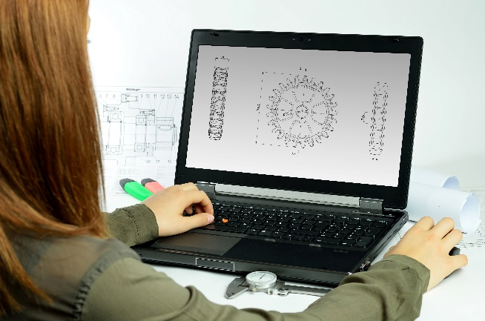
Incorporating the design process into the STEM modules will often result in the need for students to draw plans of their designs. This can be done at a simple level using hand drawn sketches or at a more technical level using computer-aided design (CAD).
By developing skills using industry standard software, students may be well-placed to explore future career pathways.
There are a number of CAD software options, two free examples are detailed below. Autodesk is a third package that is also free for educational use.
Tinkercad
- Format: Web-based app requiring internet access via a browser
- Purpose: A simple, online 3D design and 3D printing app
- Home: www.tinkercad.com
- Blog: blog.tinkercad.com
- Tutorials: www.tinkercad.com/learn
- Feature: Connects to 3D printing and laser cutting.
SketchUp
- Format: Can be downloaded and installed on devices, or used in a browser
- Purpose: Enables students to draw in 3D
- Home: www.sketchup.com 'Products' 'SketchUp Make'
- Help centre: help.sketchup.com/en
- Blog: blog.sketchup.com
- Tutorials: www.youtube.com/user/SketchUpVideo. From beginner tool tips to intermediate and advanced modelling techniques, the video tutorials help to build SketchUp skills.

Appendix 5: Student journal
When students reflect on learning and analyse their ideas and feelings, they self-evaluate, thereby improving their metacognitive skills.
These modules encourage students to self-reflect and record the stages of their learning in a journal. This journal may take the form of a written journal, a portfolio or a digital portfolio.
Using digital portfolios can help develop students’ Information and Communication Technology (ICT) capability.
Reflective practice and recording can be supported in classrooms by creating opportunities for students to think about and record their learning through notes, drawings or pictures. Teachers should encourage students to revisit earlier journal entries to help them observe the progress of their thoughts and understanding.
Journals are a useful tool that gives teachers additional insight into how students value their own learning and progress, as well as demonstrating their individual achievements.
The following links provide background information and useful apps for journaling.
Reflective journal (University of Technology Sydney)
www.uts.edu.au/sites/default/files/reflective_journal.pdf
Balancing the two faces of ePortfolios (Helen Barrett, 2009)
electronicportfolios.org/balance/Balancing.jpg
Digital portfolios for students (Cool tools for school)
cooltoolsforschool.wordpress.com/digital-student-portfolios
Kidblog – digital portfolios and blogging
kidblog.org/home
Evernote (a digital portfolio app)
evernote.com
Weebly for education (a drag and drop website builder)
education.weebly.com
Connect – the Department of Education’s integrated, online environment
connect.det.wa.edu.au

Appendix 6: Student activity sheet 1.0: Journal checklist
As an ongoing part of this module, you have been keeping a journal of your work.
Before submitting your journal to your teacher please ensure you have included the following information
- Tick each box once complete and included.
- Write N/A if items are not required

Your name and group member's names or photographs
An explanation of the problem you are solving
Your notes from Activity 1
Your notes from Activity 2
Your notes from Activity 3
Your notes from Activity 4
Student activity sheet 2.1: Solar panel experiment
Student activity sheet 2.4: Water purification investigation
Student activity sheet 2.5: Solar cooker testing
Student activity sheet 4.2: Design review
Student activity sheet 1.0: Journal checklist

Appendix 7: Teacher resource sheet 1.1: Cooperative learning – Roles
Cooperative learning frameworks create opportunities for groups of students to work together, generally to a single purpose.
As well as having the potential to increase learning for all students involved, using these frameworks can help students develop personal and social capability.
When students are working in groups, positive interdependence can be fostered by assigning roles to group members.
These roles could include:
- working roles such as Reader, Writer, Summariser, Time-keeper.
- social roles such as Encourager, Observer, Noise monitor, Energiser.
Teachers using the Primary Connections roles of Director, Manager and Speaker for their science teaching may find it effective to also use these roles for STEM learning.
Further to this, specific roles can be delineated for specific activities that the group is completing.
It can help students if some background to the purpose of group roles is made clear to them before they start, but at no time should the roles get in the way of the learning. Teachers should decide when or where roles are appropriate to given tasks.
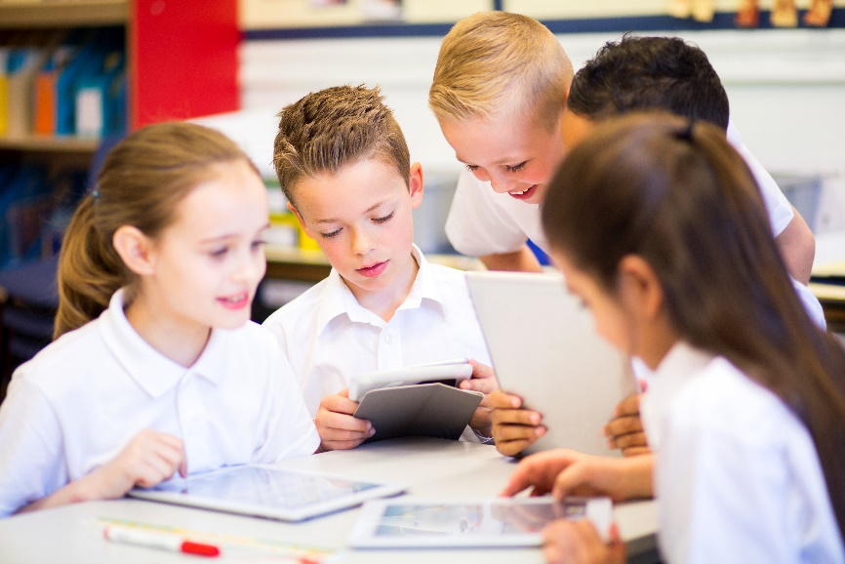

Appendix 8: Teacher resource sheet 1.2: Cooperative learning – Jigsaw
This resource sheet provides a brief outline of a collaborative learning strategy known as 'jigsaw'.
Cooperative learning frameworks create opportunities for groups of students to work together, generally for a single purpose.
As well as having the potential to increase learning for all students involved, using these frameworks can help students develop personal and social capability.
The jigsaw strategy typically has each member of the group becoming an 'expert' on one or two aspects of a topic or question being investigated. Students start in their cooperative groups, then break away to form 'expert’ groups to investigate and learn about a specific aspect of a topic. After developing a sound level of understanding, the students return to their cooperative groups and teach each other what they have learnt.
Within each expert group, issues such as how to teach the information to their group members are considered.

Step 1 | Cooperative groups  (of four students) | 1 2 3 4 |  | 1 2 3 4
Step 2 | Expert groups  (size equal to the number of groups) | 1 1 | 2 2 | 3 3 | 4 4
Step 3 | Cooperative groups  (of four students) | 1 2 3 4 |  | 1 2 3 4

Appendix 9: Teacher resource sheet 1.3: Cooperative learning – Placemat
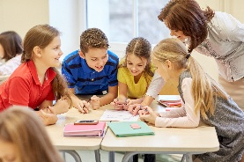
This resource sheet provides a brief outline of a cooperative learning strategy known as 'placemat'.
Cooperative learning frameworks create opportunities for groups of students to work together, generally for a single purpose.
As well as having the potential to increase learning for all students involved, using these frameworks can help students develop personal and social capability.
The placemat strategy involves students working collaboratively to record prior knowledge about a common topic and brainstorm ideas. It also allows teachers to readily see the contribution of each student. The diagram below shows a typical placemat template.

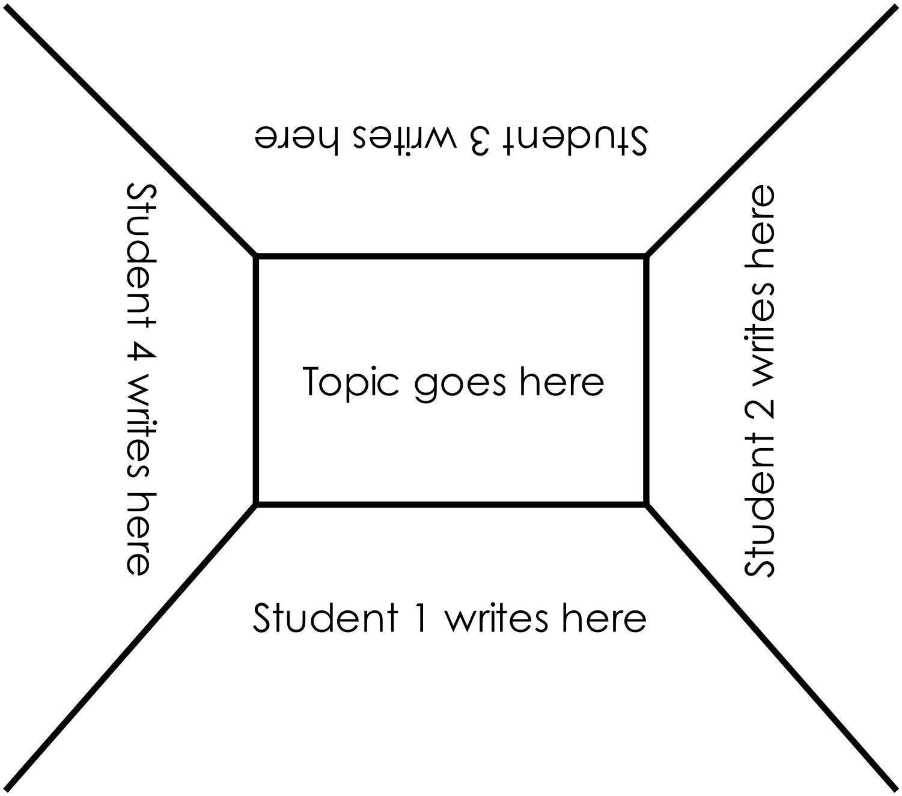

Appendix 10: Teacher resource sheet 1.4: Cooperative learning – Think, Pair, Share
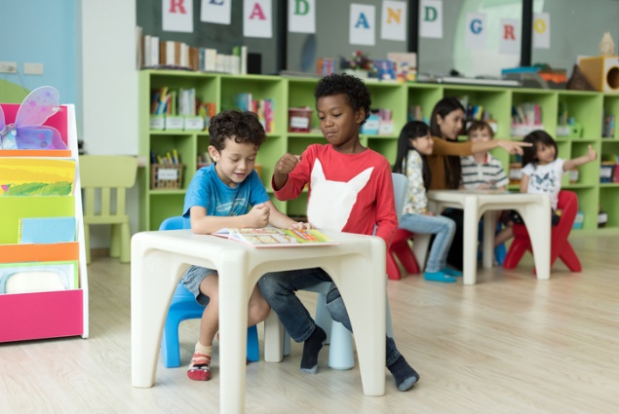
This resource sheet provides a brief outline of a cooperative learning strategy known as 'think – pair – share'.
Cooperative learning frameworks create opportunities for groups of students to work together, generally to a single purpose.
As well as having the potential to increase learning for all students involved, using these frameworks can help students develop personal and social capability.
In the 'think' stage, each student thinks silently about a question asked by the teacher.
In the 'pair' stage, students discuss their thoughts and answers to the question in pairs.
In the 'share' stage, the students share their answer, their partners answer or what they decided together. This sharing may be with other pairs or with the whole class. It is important also to let students 'pass'. This is a key element of making the strategy safe for students.
Think – pair – share increases student participation and provides an environment for higher levels of thinking and questioning.

Appendix 11: Teacher resource sheet 2.1: Solar panel experiment
Introduction:
Photovoltaic cells (solar panels) transform light energy into electrical energy. This experiment investigates the effect of light intensity on the electrical output of photovoltaic cells.
Design:
This experiment relies on measuring the current and voltage of an electric circuit powered by a solar cell and manipulating the intensity of sunlight directed at the panel.
Two 70 mm by 40 mm panels connected in series will generate approximately 1 volt and 90 milliamps. This will produce a dim glow from a 1.5-volt mini lamp. Larger solar panels or more joined together will be required to power larger lamps.
Safety notes:
- When outside, ensure students wear sun safe clothing, a hat and sunscreen.
- The light bulb may become hot.
Materials:
- Small solar panels.
- Multimeter or a separate ammeter and voltmeter.
- Small testing light bulb such as a 1.5-volt mini lamp.
- Connecting leads with ‘piggy-back’ banana plugs or alligator clips.

Procedure:
A
Ammeter
-
+
V
Voltmeter
Solar Cells
Light
+
Simplified solar cell circuit diagram

- Set up the solar cell circuit as shown above. Voltage is measured in parallel across the circuit and current is measured in series with the lightbulb. Bench top meters or a multimeter may be used.
- Place the solar panel circuit in the sunlight and record the voltage and current. If readings fluctuate, take an average or approximate.
- Light meters could also be used to measure the intensity of light on the panels.
Challenge students to identify the variables that might influence the electrical output of the solar panels. These might include the number of solar panels, whether the panels are exposed to full sun, part shade or full shade, and the angle at which the panels intercept light rays from the Sun. Engage students in identifying the variable they wish to investigate and support them in designing and conducting their investigation.

Appendix 12: Student activity sheet 2.2: Solar panel experiment
Introduction
Photovoltaic cells (solar panels) transform light energy into electrical energy. The electrical output of solar panels can be measured in volts and amps. When multiplied together the volts x amps gives the power output of the panels in watts. Electrical appliances require a certain amount of power to operate, for example, some LED light globes require 7 watts.
Purpose
The purpose of this experiment is to investigate variables that determine the electrical output of solar panels. Which variables do you think would affect the electrical output of solar panels?

Question and prediction
What is your investigation question?

What is your prediction?

Planning
What is your independent variable? _____________________________________________
What observations or measurements will you make of your independent variable?

What is your dependent variable? _______________________________________________

What measurements will you take of your dependent variable?

Which variables will you need to keep the same to make it a fair test?
_________________________________________________________________________________
_________________________________________________________________________________
In the space below draw a labelled diagram of your circuit:

For each of your tests, measure the electrical output of the solar panels in volts (voltage) and amps (current). Since current was measured in milliamps, the units for power (P) will be calculated in milliwatts (mW) and is calculated by:
Power = Voltage x Current
Record your data in a table.
Analysis and interpretation of results
What do your results show about the effect of the independent variable on the electrical output of the solar panels?

Which of your results show this?

Was your prediction correct?

Convert the maximum power achieved by your model solar panel watts (W) where
1 W = 1000 mW (milliwatts).
Show your calculations and include units:

Consider the power required to operate common household appliances. Some examples are shown below:
Appliance | Power Requirement
Laptop computer | 50 W
Dishwasher | 1200 W
LED lightbulb | 7 W
Alarm clock radio | 1 W
Electric oven | 2200 W
Charge a mobile phone | 2W

Calculate how many model solar panels are required to generate the power output required to light the LED lightbulb. Show your working and include units.

Think about an appliance you use frequently. Calculate how many model solar panels are required to generate the power needed to run this appliance. Show your working and include units.

Explain scientifically, how photovoltaic cells (solar panels) transfer and transform light energy into electrical energy to power your appliance.

Evaluation
Think about how you conducted your investigation. How could you have improved your procedure so that there was better control of variables and measurements?

Appendix 13: Teacher resource sheet 2.3: Water purification experiment
Introduction
The ability to source of drinkable water is essential for living off-grid. Sea water contains too much salt to safely drink and many sources of fresh water are muddy. Pure water can be recovered from water contaminated with salt or mud by evaporating the water using a solar still.
Note: This activity could take considerable time and will be more effective in warm-hot weather. It is recommended that muddy or coloured water is used for this investigation as the difference between the contaminated water and the pure water can be observed.
Purpose
The purpose of this experiment is to test the efficiency of a simple solar still.
Design:
The design of this solar still relies on the evaporation and condensation of water which is collected in an internal reservoir.
Materials:
- Large container approximately 2 litres.
- Two cups of warm coloured or muddy water (warm water speeds up the rate of evaporation)
- Second smaller container shorter than the top of the first container when it sits inside
- Small weight such as a pebble, glass marble or glass bead
- Plastic wrap
- A small graduated cup (eg a small cup used for measuring liquid medicine in millilitres).

Procedure
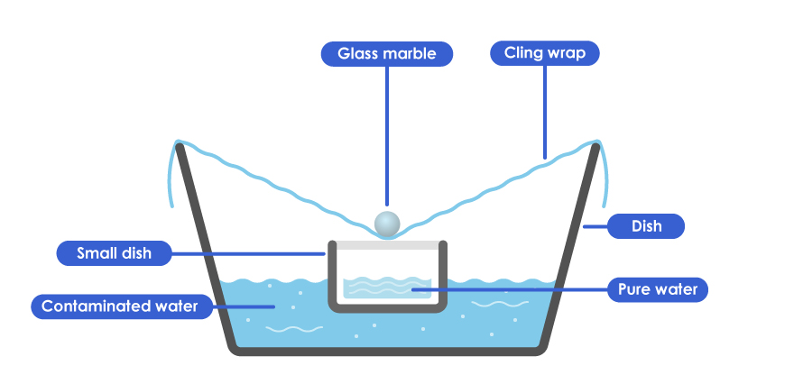

Figure 2 Illustration of a solar still
- Place 500 mL (two cups) of warm, contaminated water into the large container.
- Place the empty smaller container into the centre of the large container.
- Place plastic wrap over the larger container letting it sink a little in the centre and ensure a tight seal around the edge of the large container.
- To ensure that the water can be collected in the smaller container, place a small weight onto the plastic directly above the smaller container.
- Place your solar still in direct sunlight outside the classroom and record the time.
- When a sufficient quantity of water has collected in the small container, remove from the direct sunlight and record the time.
- Measure the volume of the water that collected in the small container using the graduated cup.
- Observe the water collected in the smaller dish.

Discussion
Using coloured arrows, illustrate the operation of the solar still by writing the words ‘evaporation’ and ‘condensation’ on the arrows.

Figure 3 Operation of the solar still

Appendix 14: Student activity sheet 2.4: Water purification experiment
Introduction
A source of water which is safe to drink is essential for those living off-grid. Sea water is too salty to drink, and sources of fresh water are often muddy. Pure drinking water can be recovered from contaminated water by evaporating and condensing the water and leaving the contaminants behind. One way of doing this is to construct a solar still.
Purpose
The purpose of this experiment is to investigate variables that determine the output of solar stills of different designs. A simple solar still can be made from two dishes and cling wrap as shown below.
Figure 4 A simple solar still

List the ways you could change the design of this solar still to make it more effective? Discuss your ideas with your group and write down one change you would like to investigate. Why is it important to only change one variable to ensure it is a fair test.

You will conduct an investigation, designing and creating two solar stills, making one aspect of the design (an independent variable) different between your two stills, to determine if that variable has an effect on the amount of purified water produced over time (the dependent variable).

Question and prediction
What is your investigation question? (How does a change in your chosen independent variable affect the dependent variable?)

What is your hypothesis? (If…then…because…)

Planning
What is your independent variable? (What you will change)

What is your dependent variable? (What you will measure)
_________________________________________________________________________________

Which of the other independent variables will you need to keep the same to make it a fair test?
____________________________________________________________________________
____________________________________________________________________________

What measurements will you need to take to compare the dependent variable: (Why is the amount of water alone not enough to work out the rate of production?)

Conducting
List a simple step by step procedure describing what you will do:

Draw a diagram to show how the two stills differ.

Observations from the investigation. Record your data here in a table

Analysis and interpretation of results
Was your prediction supported? Can you use numbers to show this?
____________________________________________________________________________
____________________________________________________________________________

Calculate the average rate of water produced by each solar still in millilitres per minute (mL/m). (What calculations are needed?)

Convert the rate of water produced by each solar still from mL/m to litres per hour (L/hr) (What calculations are needed?)

Calculate the amount of water each still could produce in10 hours (give the amounts in millilitres and in litres).

How long would it take your stills to produce one cubic metre (m³) of water.

How does your water production compare to commercial water purifiers?
(Note: some different commercial purifiers can produce from 500 L/hr up to 42m³/hr)

Do you think either of your solar stills could produce enough purified water for one person for one day? How could you increase your stills production to provide that amount of water in a day?

If you were in the bush on a hot day and your car broke down, how could collect water that is safe to drink? What would you need to carry with you (other than extra water!) to ensure you would always be able to use solar energy to produce water in the bush.

Evaluation
How fair was your comparison of the two solar stills?

How could you improve the design of your investigation?

Appendix 15: Student activity sheet 2.5: Solar cooker testing
Introduction
Solar cookers use energy from the Sun to heat and cook food. In this activity you will test the performance of the solar cooker you have built and compare it to others.
Safety notes
- Wear sun safe clothing including a hat and sunscreen if collecting data in the sun.
- The cooker, and the food in it, get very hot and care must be taken to avoid burns.
- Ensure the cooker is in an open area away from dry grass or other flammable materials.
Materials
- Two solar cookers
- Food to be heated
- An infrared thermometer or a cooking thermometer
Design of the two solar cookers
Draw labelled diagrams of the two solar cookers in the space below.

How do the cookers differ?

Question and prediction
What are you going to investigate? (Write this as a question)

What do you predict will happen? Why?

Planning
You will be comparing the performance of two solar cookers and need to ensure that the comparison is fair.

What will you keep the same to make the comparison fair?

What food will be heated in the cookers? _____________________________________

What observations of the food will you make?

How will you measure the heating of the food and how often will you do this?

Conducting
Record your measurements in a table:

Analysis and interpretation of results

In what units did you measure temperature? ________

Draw a graph to show the temperature measurements of the two solar cookers.

What does the graph show?

Was your prediction correct? Explain.

Why do you think the cookers produced different results?

What are some advantages and disadvantages of using a solar cooker?
Advantages:

Disadvantages:

Do you think it would be appropriate to cook all types of food with a solar cooker? Explain:

Was your prediction correct? Explain.

Evaluation
List any errors you may have made in your investigation?

Explain in detail two ways you could have improved your investigation?

Appendix 16: Student activity sheet 4.1: Design review
Things I would keep the same with reasons why _________________________________________________________________________________________________________________________________________________________________________________________________________________________
Things I would change with reasons why
________________________________________________________________________________________________________________________________________________________________________________________________________________________________________________________
Photograph or drawing

Notes
________________________________________________________________________________________________________________________________________________________________________________________________________________________________________________________________________________________________________________________________________________________________________________________________________________________________________________________________________________________________________________________________________________________________________________________________________________________________________________________________________________________________________________________________________________________________________________________________________________________________________________________________________________________________________________________________________________________________________________________________________________________________________________________________________________________________________________________________________________________________________________________________________________________________________________________________________________________________________________________________________________________________________________________________________________________________________________________________________________________________________________________________________________________________________________________________________________________________

