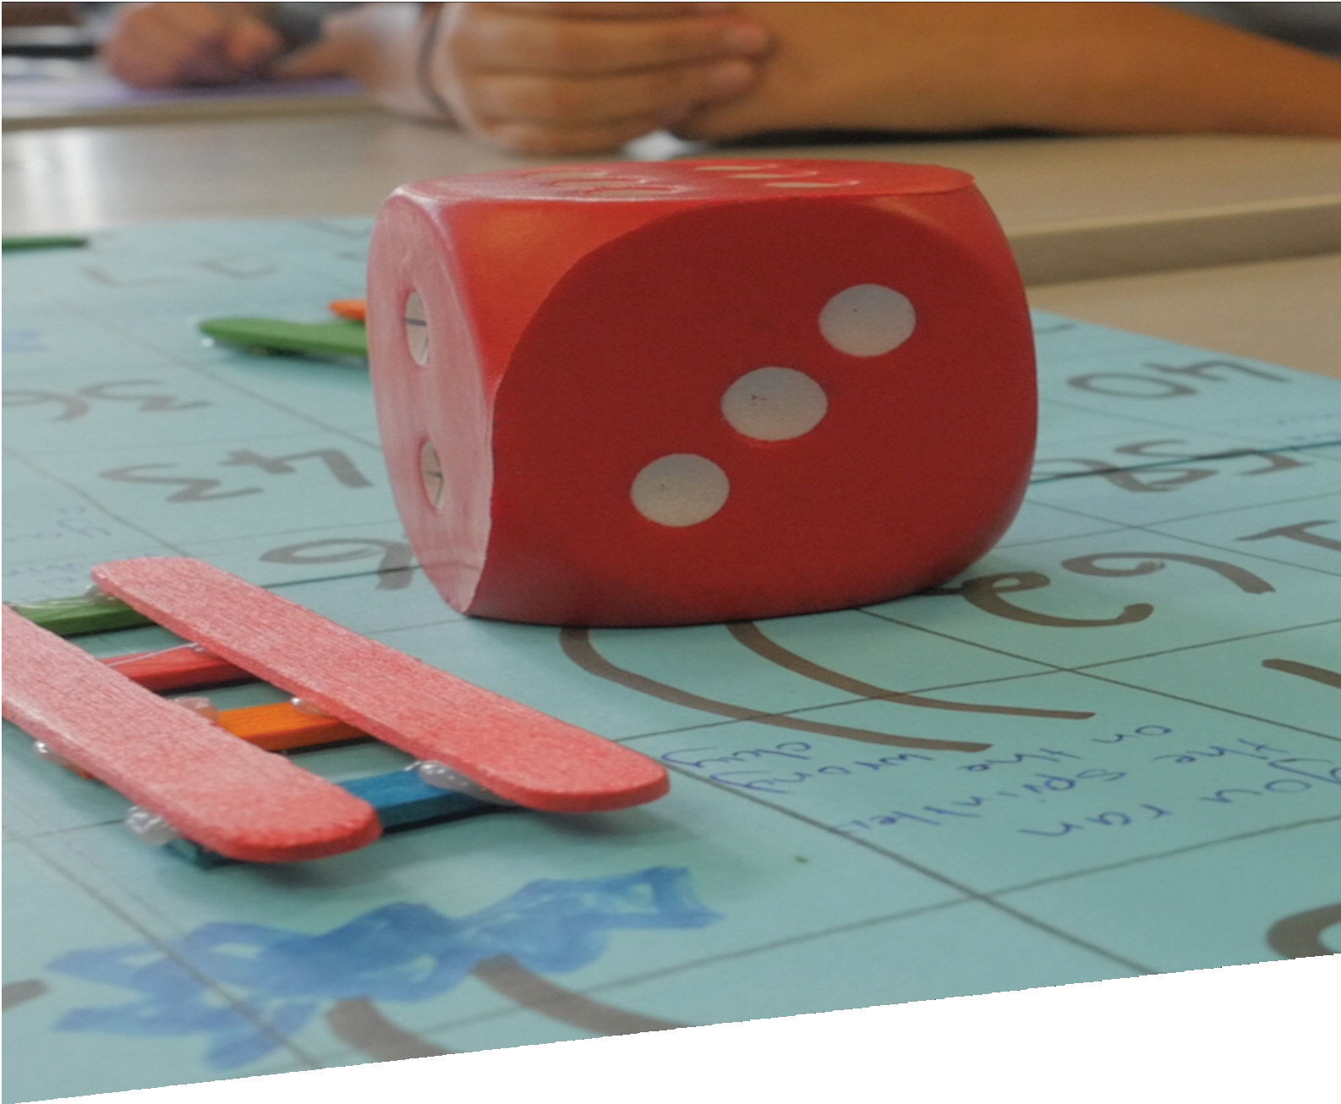

CURRICULUM RESOURCE MODULE
Water games
YEAR 7
Acknowledgements
The STEM Learning Project is funded by the Western Australian Department of Education (the Department) and implemented by a consortium in STEM education comprising the Educational Computing Association of Western Australia, the Mathematical Association of Western Australia, the Science Teachers Association of Western Australia and Scitech.
We acknowledge and thank the teachers and schools who are the co-creators of these resources and also the support of Water Corporation whose assistance in reviewing the module and providing data has been gratefully received.
Copyright and intellectual property
The copyright and intellectual property of this module remain the property of the Department.
Any Western Australian Curriculum content in this resource is used with the permission of the School Curriculum and Standards Authority (the Authority); this permission does not constitute Authority endorsement of the resource. The Authority accepts no liability for any errors or damages arising from reliance on its content.
The Western Australian Curriculum content may be freely copied, or communicated on an intranet, for non-commercial purposes in educational institutions, provided that the Authority is acknowledged as the copyright owner. Copying or communication for any other purpose can be done only within the terms of the Copyright Act 1968 or with prior written permission of the Authority. Any Australian Curriculum content in the Western Australian Curriculum is used by the Authority under the terms of the Creative Commons Attribution NonCommercial 3.0 Australia licence.
Any content on the www.scsa.wa.edu.au domain that has been derived from the Australian Curriculum may be used under the terms of Creative Commons Attribution-NonCommercial 3.0 Australia licence.
Appendix 2: General capabilities continuums are adapted from ACARA, © Australian Curriculum, Assessment and Reporting Authority (ACARA) 2009 to present, unless otherwise indicated. This material was downloaded from the ACARA website (www.acara.edu.au) (accessed December 2015) and was not modified. The material is licensed under CC BY 4.0 (https://creativecommons.org/licenses/by/4.0/). ACARA does not endorse any product that uses ACARA material or make any representations as to the quality of such products. Any product that uses material published on this website should not be taken to be affiliated with ACARA or have the sponsorship or approval of ACARA. It is up to each person to make their own assessment of the product.
This resource includes references and examples of iOS, Android and other apps. The Department does not endorse or recommend any commercial products and simply provides these as examples for teachers.
The Department is committed to providing quality information to its customers. Whilst every effort has been made to ensure accuracy, currency and reliability of the information within these documents, the Department accepts no responsibility for errors, omissions or amendments made since the time of publishing. Confirmation of information may be sought from the Department or the originating bodies providing the information. The Department has no control over the content of material published on websites to which users are referred in this resource. It is the responsibility of the internet user to make their own decision as to the relevancy, accuracy, currency and reliability of information found on those sites.
Attributions: GRID-Arendal, Google Drive, Adobe Spark, Water Corporation, Waterwise, Asana, Carva, Wunderlist, Todoist, Google Tasks, Google Forms, Survey Monkey, SurveyGizmo, Microsoft Excel, Padlet, Popplet, Uno, Minecraft.

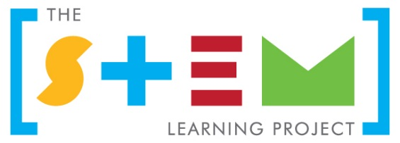
Table of contents
The STEM Learning Project 2
Overview 3
Activity sequence and purpose 6
Background 7
Activity 1: H₂O – No! 10
Activity 2: Your water footprint 18
Activity 3: A solution that works 29
Activity 4: Communicate and ruminate 37
Appendix 1A: Links to the Western Australian Curriculum 42
Appendix 1B: Mathematics proficiency strands 45
Appendix 2: General capabilities continuums 46
Appendix 3: Materials list 49
Appendix 4: Design process guide 51
Appendix 4B: Drawing in the design process 52
Appendix 5: Student journal 53
Appendix 6: Student activity sheet 1.0: Journal checklist 54
Appendix 7: Teacher resource sheet 1.1: Cooperative learning – Roles 55
Appendix 8: Teacher resource sheet 1.2: Cooperative learning – Jigsaw 56
Appendix 9: Teacher resource sheet 1.3: Cooperative learning – Placemat 57
Appendix 10: Teacher resource sheet 1.4: Cooperative learning – Think, Pair, Share 58
Appendix 11: Teacher resource sheet 1.5: Game mechanics 59
Appendix 12: Student activity sheet 2.1: Unit conversions 60
Appendix 13: Student activity sheet 2.2: Olympic swimming pools 61
Appendix 14: Teacher resource sheet 2.3: Infographics 62
Appendix 15: Student activity sheet 2.4: The water cycle 64
Appendix 16: Student activity sheet 2.5: Perth’s water sources 65
Appendix 17: Teacher resource sheet 2.6: Purifying contaminated water 68
Appendix 17A: Student activity sheet 2.6: Purifying contaminated water 69
Appendix 18: Teacher resource sheet 2.7: Recovering pure water from a mixture 71
Appendix 19: Teacher resource sheet 2.8: Investigation extension 73
Appendix 20: Student activity sheet 3.1: Prototype troubleshooting 75
Appendix 21: Alternative Activity 4A: Student showcase 79
Appendix 22: Student activity sheet 4.1: Peer evaluation 87
Appendix 23: Student activity sheet 4.2: Self-evaluation 88

The STEM Learning Project
The aim of the STEM Learning Project is to generate students’ interest, enjoyment and engagement with STEM (Science, Technology, Engineering and Mathematics) and to encourage their ongoing participation in STEM both at school and in subsequent careers. The curriculum resources will support teachers to implement and extend the Western Australian Curriculum and develop the general capabilities across Kindergarten to Year 12.
Why STEM?
A quality STEM education will develop the knowledge and intellectual skills to drive the innovation required to address global economic, social and environmental challenges.
STEM capability is the key to navigating the employment landscape changed by globalisation and digital disruption. Routine manual and cognitive jobs are in decline whilst non-routine cognitive jobs are growing strongly in Australia. Seventy-five per cent of the jobs in the emerging economy will require critical and creative thinking and problem solving, supported by skills of collaboration, teamwork and literacy in mathematics, science and technology. This is what we call STEM capability. The vision is to respond to the challenges of today and tomorrow by preparing students for a world that requires multidisciplinary STEM thinking and capability.
The approach
STEM capabilities are developed when students are challenged to solve open-ended, real-world problems that engage students in the processes of the STEM disciplines.
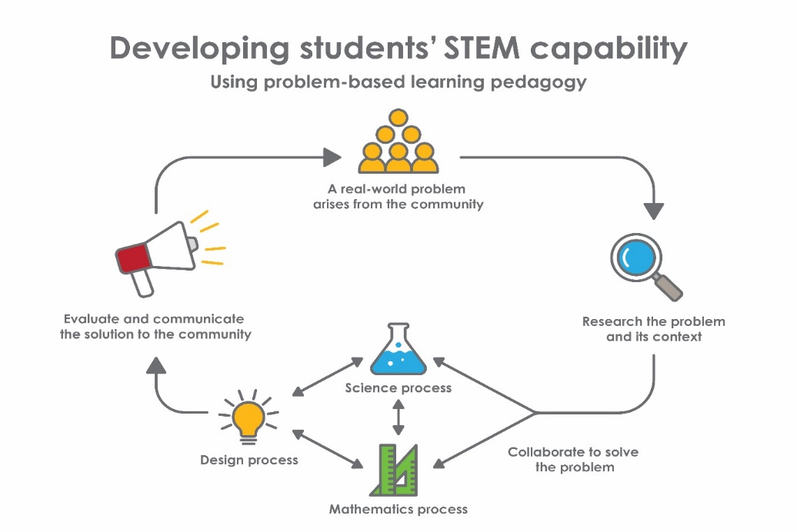
Year 7 – The water games

Overview
The growing global population combined with dwindling supplies of clean water is challenging the future sustainability of water. Demand continues to outstrip supply which places many communities at risk.
In Western Australia, 'A long term, sustained focus on using less water is central to living with less rainfall and becoming climate resilient. Our goal is to reduce water use by 15% by 2030' (Water Corporation, 2017).
GRID-Arendal, a centre collaborating with the United Nations Environment Programme (UNEP), suggests that with the predicted population growth mankind may be moving 'toward a world of thirst' by 2050 if we keep consuming water at the same rate. The water games module engages students through the recognition that this issue affects their future. It provides students the opportunity to lead change now, so they can develop a sustainable future.
What is the context?
The world is changing and technology is leading to innovations in how we think, create and solve problems for future generations. Students will represent a team of scientists, mathematicians, engineers and researchers who have been contracted to produce an effective water saving strategy.
What is the problem?
Current water saving strategies and campaigns from Water Corporation are having an effect, but the risk of demand outstripping supply still remains. What gamification process can be designed that will change people's habits towards water saving and result in reducing demand?
How does this module support integration of the STEM disciplines?
Using science, technology and mathematics to address a real-world problem, students draw on prior knowledge and learn new principles to collaboratively produce a solution.
Science
Students develop an understanding of water being an important resource that cycles through the environment (ACSSU222). Students will understand that despite water being considered a renewable resource (ACSSU116), there are challenges in ensuring an adequate supply of drinking water. In order to reuse water, usable water needs to be separated from mixtures, including solutions, using a range of techniques (ACSSU113).
Technologies
Students use the design process from the Technologies curriculum to investigate, define, design, produce, implement and evaluate a gamification solution to increase water savings. Student groups collaborate and manage the project with guidance from the teacher.
Students develop success criteria for their project and use this to interpret which project ideas have a better chance of success.
Students present their solution by communicating their design ideas, plans and processes to an audience using digital technologies and multimodal representations including an infographic (ACTDIP026).
The Design process guide is included as a resource to provide assistance to teachers in understanding the complete design process as developed in the technologies syllabus.
Mathematics
Students use mathematics to achieve an understanding of their water footprint. They collect class data using a website, converting their footprint from US gallons to litres (ACMNA156, ACMNA173). Students calculate the mean, median, mode, range of the student data, and use this to generate insights for their project ideas (ACMSP171) and make displays (ACMSP172). Summing all the data, they visualise the large numbers by converting them to Olympic-sized swimming pool units by calculating the volumes of rectangular prisms (ACMMG160, ACMNA154, ACMNA156, ACMNA173). Students analyse data on Perth's water sources and calculate the percentage provided by each source (ACMSP169, ACMNA157, ACMNA158).
General capabilities
There are opportunities for the development of general capabilities and cross-curriculum priorities as students engage with The water games. In this module, students:
- Develop critical and creative thinking skills as they research the problem and its context (Activity1); investigate parameters impacting on the problem (Activity 2); imagine and develop solutions (Activity 3); and evaluate and communicate their solutions to an audience (Activity 4).
- Utilise creative thinking as they generate possible design solutions; and critical thinking, numeracy skills and ethical understanding as they choose between alternative approaches to solving the problem.
- Utilise personal and social capability as they collaborate in generating solutions; adopt group roles; and reflect on their group work capabilities.
- Utilise a range of literacies and information and communication technology (ICT) capabilities as they collate records of work completed throughout the module in a journal; represent and communicate their solutions to an audience using digital technologies in Activity 4.
- Communicate and, using evidence, justify their group’s design to a broader audience.
There are also significant opportunities for students to develop enterprise skills.
What are the pedagogical principles of the STEM learning modules?
The STEM Learning Project modules develop STEM capabilities by challenging students to solve real-world problems set in authentic contexts. The problems engage students in the STEM disciplines and provide opportunities for developing higher order thinking and reasoning, and the general capabilities of creativity, critical thinking, communication and collaboration.
The design of the modules is based on four pedagogical principles:
- Problem-based learning
This is an underlying part of all modules with every module based around solving an initial problem. It is supported through a four-phase instructional model: research the problem and its context; investigate the parameters impacting on the problem; design and develop solutions to the problem; and evaluate and communicate solutions to an authentic audience.
- Developing higher order thinking
Opportunities are created for higher order thinking and reasoning through questioning and discourse that elicits students' thinking, prompts and scaffolds explanations and requires students to justify their claims. Opportunities for making reasoning visible through discourse are highlighted in the modules with the icon shown here.
- Collaborative learning
This provides opportunities for students to develop teamwork and leadership skills, challenge each other’s ideas, and co-construct explanations and solutions. Information that can support teachers with aspects of collaborative learning is included in the resource sheets.
- Reflective practice
Recording observations, ideas and one’s reflections on the learning experiences in some form of journal fosters deeper engagement and metacognitive awareness of what is being learnt. Information that can support teachers with Journaling is included in the resource sheets.
These pedagogical principles can be explored further in the STEM Learning Project online professional learning modules located in Connect Resources.

Activity sequence and purpose
H₂O – No! | Students’ interest in water saving is captured and they are challenged to devise effective water saving strategies.
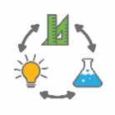  Your water footprint | Students collect data on their personal water footprint and scale this to see how decisions made by individuals impact on the sustainability of water supply.  Students develop an understanding of the water cycle, water resources and water purifying techniques.
A solution that works | Students design a gamification solution that motivates people to use a water saving strategy.
Communicate and ruminate | Students create a digital representation of their solution and present it to peers and invited guests. Opportunities are provided for self and peer evaluation of both the solutions and the group work collaborations.

Background
Expected learning | Students will be able to:  - Explain why conserving safe drinking water is both a local and global problem.  - Identify potential techniques that could be used to more effectively engage the community with water saving strategies.  - Use the water cycle to illustrate and explain how water is a renewable resource.  - Explain the processes that enable water to be cycled through the environment and the sources from which we draw water for human consumption.  - Construct an infographic to represent water source data and show changes in patterns of use.  - Explain how filtration can be used to remove particulate matter from water and distillation can be used to recover water from a solution.  - Collate, analyse and interpret data collected on water footprints and represent findings using appropriate measures of central tendency.  - Analyse water source and usage data using fractions, decimals and percentages.  - Analyse and interpret secondary sources of data regarding sources of water.  - Calculate volumes of water contained in rectangular prisms.  - Imagine, create, design and evaluate a gamification solution to the problem of motivating people to use a water saving strategy.  - Develop success criteria that can be used to guide the design and evaluation of a gamification solution.  - Contribute and collaborate effectively in program planning, implementation and management.  - Create solutions involving game mechanics that motivate users.  - Explain why there is a need to conserve water and give a rationale for their project.  - Communicate their solution to an audience and justify their design choices.  - Use defined success criteria to evaluate the effectiveness of their solution.  - Reflect on the design process and determine what worked well and what could be improved.
Enterprise skills | As students work in teams to develop solutions that will engage the community in water saving measures there are opportunities for the development of enterprise skills.  Enterprise skills include: problem solving, communication skills, digital literacy, teamwork, financial literacy, creativity, critical thinking and presentation skills.  Further background on this is available from the Foundation for Young Australians’ report The New Basics: Big data reveals the skills young people need for the New Work Order (Foundation for Young Australians, 2016) www.fya.org.au/wp-content/uploads/2016/04/The-New-Basics_Web_Final.pdf
Vocabulary | The following vocabulary list contains some terms that need to be understood, either before the module commences or developed as they are used:  aquifer, artesian, condensation, contaminated, evaporation, desalination, game mechanics, gamification, greywater, hypothesis, infiltration, potable, precipitation, protozoa, reverse osmosis, sustainability, transpiration, turbid, virtual water usage, wastewater, water footprint.
Timing | There is no prescribed duration for this module. The module is designed to be flexible enough for teachers to adapt. Activities do not equate to lessons; one activity may require more than one lesson to implement.
Consumable materials | A Materials list is provided for this module. The list outlines materials outside of normal classroom equipment that will be needed to complete the activities.
Safety notes | There are potential hazards inherent in these activities and with the equipment being used, and a plan to mitigate any risks will be required.  Potential hazards specific to this module include but are not limited to:  - Consumption of contaminated water
Assessment | The STEM modules have been developed to provide learning experiences in which students solve authentic real-world problems using science, technology, engineering and mathematics capabilities. While working through the module, assessment opportunities will arise as outlined below.  - Students participate in gathering data, interpreting data, making calculations and constructing data representations and reports which provide opportunities for individual assessments.  - Some tasks are completed as collaborative activities and these can provide opportunities for formative assessment.  Appendix 1 indicates how the activities are linked to the Western Australian Curriculum.  Students will also have opportunities to further develop the general capabilities of Information and communication technology capability, Critical and creative thinking and Personal and social capability. Continuums for these are included in the General capabilities continuums but are not intended to be for assessment purposes.

Activity 1: H₂O – No!
Activity focus | This activity is designed to capture students’ interest in the global issue of water saving as an issue which requires a local response. Students develop understandings about water sources and the need to conserve water resources.
Background information | Water is our most important natural resource and is necessary to sustain life. Water makes up most of our body tissues and we need to drink water to replace that lost through excretion, sweating and breathing. It is a vital resource that cycles through the environment, evaporating from oceans, lakes and rivers. As water vapour rises through the atmosphere it cools, condenses and falls back to the earth as rain. Some rain percolates through the soil into the water table and the remaining rain water runs into dams or into rivers and back to the ocean. In Western Australia, our main sources of water are groundwater, water derived from the sea by desalination and water collected in dams. Rainfall has declined significantly in the south west of the state and so there has been reduced run-off into dams. Therefore, we have had to rely more heavily on groundwater and desalination. Reduced rainfall has resulted in reduced recharge of aquifers such as the Gnangara Mound so that it has become necessary to inject treated waste water into the aquifers to recharge them.  Providing adequate supplies of safe drinking water is a major challenge for developing countries and is Goal 6 in The Global Goals for Sustainable Development and Goal 7C in the United Nations Millennium Development Goals. These goals set ambitious targets to reduce, reuse and recycle water. In Western Australia, Water Corporation promotes many water saving strategies which are outlined on its website at www.watercorporation.com.au .  In this module, students consider gamification techniques as one method to motivate the general population to make water saving a habit. Gamification is the application of game-design elements and game principles in non-game contexts to help people understand and engage with issues. For further information on game mechanics see Teacher resource sheet 1.5: Game mechanics.
Instructional procedures | Activity 1 sets the scene for the entire module. The basis of the challenge set before the students is that although people know that water needs to be saved, our community is still not reducing its water consumption to a level that is sustainable. To have a sustainable future, communities need to ensure they conserve water resources and encourage individual action for this global issue. Therefore, the idea presented to the students is that if we could make water saving fun, more people would participate.  Students will work in groups of three or four and will look at gamification techniques as one method to motivate the general population into making water saving a habit. The idea is that gamification is included in the students' final solution.  Reflection questions have been used throughout the module to capture not only students’ thoughts on the topic, but also to have them think about how they are collaborating in their groups. By reflecting on their group’s progress, students can evaluate and re-think how their group might work better in the next stage of the process.
Expected learning | Students will be able to:  - Explain why conserving safe drinking water is both a local and global problem (Science).  - Identify potential approaches that could be used to more effectively engage the community with water saving practices (Technologies).
Equipment required | For the class:  Internet access (or can be done without)  Butcher’s paper and marker pens  Poster putty to attach butcher’s paper to walls
For the students:
Devices (computers, tablets)
Preparation | Part 1:  - Print out posters for The Global Goals for Sustainable Development – Goal 6 and United Nations Millennium Development Goals – Goal 7C (see Digital resources).  Part 2:  - Make available a projection of Water Corporation's website or student access to devices for browsing.  Part 3:  - Prepare to show the National Geographic video Why Care about Water? (see Digital resources.)  Part 4:  - Prepare the timer so it is ready to start.  - Prepare an app, device or other means to capture the ideas brainstormed by the class.  - Print out placemat activity sheets (one per group).  - Provide butcher’s paper to capture ideas.  Part 5:  - Make available, a website providing information about and demonstrations of showing gamification methods (eg Gamified UK).  - Produce a poster or printed list of the game mechanics (see Digital resources).  Part 6:  - Provide butcher’s paper to capture ideas.
Activity parts | Part 1: Introduction to the module  Outline to students the structure of the learning experience:  - They will be working in groups of three or four.  - They will be given a challenge and required to create a solution.  - Their solution might just save the world!  Set the scene. Read out the following script to students (add or change as desired).  Weather records indicate that the south west of Western Australia is receiving far less rainfall than in previous years. This means that run-off into dams has declined. On top of this an increase in population and hence increased demand, met from other sources, has meant that dams now supply only 5% of drinking water for Perth when they once supplied 95%. We need to save drinkable water in order to have a sustainable future.  Many water saving strategies exist such as sprinkler days, shorter showers, fix the drip and not leaving the tap running. Yet we still continue to use more water than in previous years. So why aren’t we saving more water?  Challenge students to find an answer. In groups, students need to find a way to make water saving happen by devising a gamification method that motivates people to employ water saving strategies.  Share with students Goal 6 in The Global Goals for Sustainable Development and Goal 7C of the United Nations Millennium Development Goals.  The Global Goals for Sustainable Development  www.globalgoals.org  United Nations Millennium Development Goals  www.un.org/millenniumgoals
Part 2: Water saving targets
Review the information on Water Corporation's website under the tab 'Save water' at
www.watercorporation.com.au
Talk through the targets. Focus on the targets that relate specifically to this topic.
- Do you think we will meet these targets? Why? Why not?
- What is stopping us from meeting these targets?
It is recommended that each group comes up with their own group name to initiate some team-building. Teams may also wish to create their own logo.
Students answer the following questions and record in their learning journal:
- What excites you about this challenge?
- What worries you about this challenge?
- What capabilities you can bring to the group? Why?
- What will be your biggest challenge working in a group?
Further information can be found in Teacher resource sheets 1.1 – 1.4 on Cooperative learning.

Part 3: Why don't we save more water?
Students watch the National Geographic video Why Care About Water? Discuss the video with the class.
The video should provoke students to want to saving water.
Class debrief questions can include:
- How do you feel now after watching the video?
- What does the narrator mean by ‘water is a global issue, but it is also a very local issue’?
- How might you motivate people to use water saving strategies on a global scale eg. An app that is used by people from all around the world.
Part 4: Brainstorm
Instruct students: As a class, we will list some useful water saving strategies. We will add to the list throughout the module. Your group task is to design a motivation technique for one or more of these strategies that the public will use.
The Placemat teaching strategy can be used to ensure each student is accountable for listing ideas. See Teacher resource sheet 1.3: Cooperative learning – Placemat.
Team roles could be allocated for this task. For example:
- A writer – to write down all ideas generated by the team and to ensure no ideas are negated by other team members.
- A time-keeper – to ensure the team meets the time deadline by reminding the team how much time they have left.
- An encourager – when the team is running low on ideas, the encourager selects individuals to generate new ideas.
- A director – ensures the team remains on task.
More information on group roles is provided in Teacher resource sheet 1.1: Cooperative learning – Roles.
Challenge students to list as many water saving strategies as they can in five minutes. A timer, such as Bomb Timer (see Digital resources), can be used to encourage students to participate in the task. These ideas could be existing water saving strategies or completely new ideas.

When the five minutes is finished, gather all the ideas together on a whiteboard or in a digital app such as Padlet or Popplet displayed through a projector for the class.
Allow time for each group to decide which two strategies might be most effective and which two strategies might be least effective, and be able to explain why. Ask each group to elect a speaker to present their group’s ideas to the class. Capture the ideas with a photo or save in the app for future use.
Group debrief questions can include:
- How well did you work together as a group today?
- In your group, what worked well?
- What could have been improved?
- How will you work differently next time?
These questions can be used after any group task to focus on effective collaboration, group work and leadership which helps develop skills required for jobs of the future.
Part 5: Motivating a strategy – Gamification
Introduce the students to the concepts of gamification and game mechanics.
The techniques of gamification can be used to motivate people to change their behaviour. In this problem, it is to encourage the use of a water saving strategy. This means using elements of game mechanics to leverage people’s natural desires for competition, achievement, status, altruism, community collaboration and more. A motivating game could be developed into an app for phones or other devices.
Teacher resource sheet 1.5: Game mechanics provides advice and a link to more information on game mechanics. This needs to be reviewed with the class to develop an understanding of gamification. The list of game mechanics could be displayed in the classroom or provided to each student or group.
A class activity involving research and discussion to find current real-world examples of the various gamification techniques would also help develop students' understanding.

Later, in Activity 3, students will use aspects of gamification to motivate people to use an existing or new water saving strategy.
Part 6: Capturing ideas
At this stage of the project, it is good for groups to start capturing their insights and any useful information they have discovered through their learning. This will help students to ideate solutions for their project.
Using butcher’s paper, groups capture their ideas about new and existing water saving strategies they could promote, and about the gamification techniques they might use to promote water saving strategies. Information captured from the previous parts of this activity can be used to help prompt the students.
Ensure students are respectful of ideas generated by other students; no idea is a bad idea. Encourage students to write down ideas from all group members. Remind students that there are many possible solutions to the water saving problem.
At this stage, it is important students do not prematurely decide on a solution to the problem. The aim is for students to be able to capture a range of ideas and later choose the solution that is going to be the most effective.
Ideas could involve:
- Promoting inventions that reduce, reuse or recycle water.
- Motivating the use of an existing water-saving strategy that has been revamped.
- Developing an app or device that encourages water saving.
- Running a competition that encourages individuals to compete to save water.
The butcher’s paper should be readily available so the group can add more ideas as they generate them.
Resource sheets | Teacher resource sheet 1.1: Cooperative learning – Roles  Teacher resource sheet 1.3: Cooperative learning – Placemat  Teacher resource sheet 1.5: Game mechanics
Digital resources | Virtual tours of Water Corporation treatment plants (Water Corporation, 2017)  www.watercorporation.com.au/home/education/school-talks-and-excursions/virtual-tours
Poster: The Global Goals for Sustainable Development (The Global Goals for sustainable development, 2017)
www.globalgoals.org
Poster: United Nations Millennium Development Goals (United Nations, 2015)
www.un.org/millenniumgoals
Why Care About Water? (National Geographic, 2010)
www.youtube.com/watch?v=Fvkzjt3b-dU&feature=youtu.be
Bomb Timer (Online Stopwatch)
An online stopwatch (mute tab to avoid loud blast)
www.online-stopwatch.com/bomb-countdown/full-screen
Padlet
padlet.com
Popplet
popplet.com
52 Gamification mechanics and elements (Gamified UK, 2017)
www.gamified.uk/user-types/gamification-mechanics-elements

Activity 2: Your water footprint
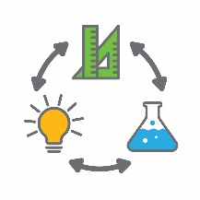  Activity focus | In this activity students gather data about their own water footprint to better understand how much water they use. Analysis of the water cycle and water source data helps students understand how the demand for water is met. Filtration and distillation are investigated as ways of purifying contaminated water and methods of recycling waste water are also considered.
Background information | The topic of water has a strong link to the Humanities and Social Sciences curriculum. Teachers might like to investigate some cross-curricula activities with the Humanities and Social Sciences learning area to coincide with this project.  It is important to note that the Perth desalination plants are now producing roughly one-half of the city’s fresh water requirement. However, this source of fresh water has a large capital expenditure and ongoing need for energy. Generating this energy from coal or gas means the plants have an environmental cost that needs to be considered in their overall sustainability equation.  There are opportunities for developing mathematical competencies related to recording data in spreadsheets, scaling-up quantities, conversion from imperial to metric units, calculating volumes of rectangular prisms and calculating percentages.  Students should be spending most of the time in their groups so they can discuss ideas with their team members and capture their insights. Cross-collaboration between groups can be facilitated to share ideas around the class.  Activity 2 is not yet the time for choosing a solution to the problem of reducing water consumption. However, teachers should encourage students to be capturing their insights throughout this activity to prepare them for Activity 3 where they will eventually select, design and implement a gamification solution that motivates people to use a water saving strategy.
Expected learning | Students will be able to:  1. Use the water cycle to illustrate and explain how water is a renewable resource (Science).  2. Explain the processes involved in the cycling of water through the environment and the sources from which we draw water for human consumption (Science).  3. Construct an infographic to represent data about water sources and to show changes in patterns of use (Science and Technologies).  4. Explain how filtration can be used to remove particulate matter from water and distillation can be used to recover water from a solution (Science).  5. Collate, analyse and interpret data collected on water footprints and represent findings using appropriate measures of central tendency (Mathematics).  6. Analyse water source and usage data using fractions, decimals and percentages (Mathematics).  7. Analyse and interpret secondary sources of data regarding sources of water (Mathematics).  8. Calculate volumes of water contained in rectangular prisms (Mathematics).
Equipment required | For the class:  Access to a spreadsheet program such as Microsoft Office 365 Excel or Google Sheets  Teacher device with access to a projector (or seek alternative options for these activities)  See Materials list for the equipment and materials needed for each part of the activity
For the students:
Access to a collaborative spreadsheet program such as Microsoft Office 365 Excel or Google Sheets
Access to a presentation tool such as Microsoft Office 365, PowerPoint or Google Slides (or a paper-based alternative)
Butcher’s paper and marker pens
Preparation | See Resource sheets and Digital resources for links to the documents and videos used in this activity.  Part 1:  - Print or provide digital access to Student activity sheet 2.1: Unit conversions.  - Teachers unfamiliar with spreadsheets might like to access tutorials online. There are many available at this link:  www.thoughtco.com/free-spreadsheet-tutorials-3123959  - Prepare the Water Footprint – Class Template spreadsheet as a template for the class to input their data.  Part 2:  - Make a copy of the completed spreadsheet.  - Print or provide digital access to Student activity sheet 2.2: Olympic swimming pools.  - Infographics apps such as Canva and Adobe Spark require students to have an account. These are free, but will need to be established by the teacher.  Part 3:  - Print or provide digital access to Student activity sheet 2.4: The water cycle  - Prepare to watch the chosen water cycle video.  Part 4:  - Print or provide digital access to Student activity sheet 2.5: Perth’s water sources.  Part 5:  - Prepare to watch Water Corporation’s video Our water sources – WA's wastewater system.  Part 6:  - Print or provide digital access to Student activity sheet 2.6: Purifying contaminated water.  - Source equipment and materials required for the filtering tests (see Materials list).  - Source equipment and materials required for the students to design and make their own water filters (if chosen).  Part 7:  - Source equipment and materials required for the option chosen.  - Prepare to watch Water Corporation School Talks – Desalination.  Part 8:  - Prepare to watch the videos Water conservation tips – How to conserve water at home and 7 Weird Ways to Save Water.  - Prepare to use an app to capture ideas from students.
Activity parts | Part 1: Calculating personal water footprint  Students calculate their personal water footprint using the online water footprint calculator:  Water Footprint Calculator (GRACE Communications Foundation, 2016) www.watercalculator.org  To complete their calculation, students need to select a USA state. Students should select California as it has a climate similar to Western Australia.  Once students have calculated their water footprint the following should be explored through class discussion:  - How their score compares to the US national average.  - Whether this average would be the mean, median or mode.  - Areas of high or low water usage in their results.  - The tips that are listed next to each topic.  - Virtual Water Usage (this might be a new concept that needs further explanation).  - The link in the bottom left hand corner to Compare Yourself to Other Countries.  This calculator gives an answer in US gallons, providing an opportunity to explore non-metric measurements and conversion to the students. This can be consolidated with Student activity sheet 2.1: Unit conversions. Students are not likely to be familiar with the difference between US gallons and litres. They should participate in a range of activities that provide opportunities for them to handle and compare the volumes and capacities of both units.  The Water footprint - Class templates (see Digital resources) are provided as a shared worksheet for entering data in US gallons. It will automatically convert these values to litres per day and per year. The templates are embedded in Appendix 20, but a full version is available in the STEM Learning Project Connect community.  Students add their values into this shared class spreadsheet and all work in the same document initially to collect the class data.  The following prompt questions can be explored with the students:  - What did you learn about the water usage of your class?  - Where are the biggest areas for improvement as a class?  - Thinking about your project, in what area could your solution have the biggest effect? For example, agriculture.  - Has this prompted your thinking about ideas for your solution to the problem of motivating people to use a water saving strategy? Add any new ideas to your list.
Part 2: Create a visual representation of class water footprint
Students interpret the water footprint of their class by converting the usage values to Olympic size swimming pool units.
Students calculate the volume of an Olympic swimming pool using the dimensions: 50 m × 25 m × 2.5 m; and that one cubic metre is equivalent to one thousand litres (1 m³ = 1000 L = 1 kL). Using this information, students calculate how many Olympic swimming pools the class water footprint would fill.
This work can be scaffolded using Student activity sheet 2.2: Olympic swimming pools.
This data can be displayed in an infographic using an app such as Canva or Adobe Spark (see Teacher resource sheet 2.3: Infographics).
Students print their infographics and include them in their journal. Students critique and provide feedback on each other’s work.
Prompt questions can include:
- Looking at the infographic, what does this tell you about the class’ water usage?
- Where could the class make the greatest water savings?
- What might this information look like for your school? For your community? State? Country? The world?
- What are the per capita water usage figures for some other countries?
- How does this revelation make you feel?
- Has this prompted any new ideas for your solution? Add them to your list.
Students to choose the best infographic from the class and display it in the classroom.
Part 3: The water cycle
Now that students have gathered data about the ways in which they use water and the amounts used, it is timely to consider the water cycle.
Students unfamiliar with the water cycle should participate in a range of activities that enable them to investigate evaporation, condensation, precipitation and saturation. Activities such as the ‘water cycle in a jar’ will also help to develop their understanding.
Review the water cycle using one of the following videos:
The water cycle - Water Corporation
www.watercorporation.com.au/extras/WCWC/multiscreen.html
The Water Cycle – National Science Foundation
www.youtube.com/watch?v=al-do-HGuIk
Water Cycle Song – Have Fun Teaching
www.youtube.com/watch?v=TWb4KlM2vts
Learn about The Water Cycle – Turtlediary
www.youtube.com/watch?v=6-rVAeGrMsg
Students complete Student activity sheet 2.4: The water cycle to review the processes by which water cycles through the environment.
Part 4: Water sources
Perth’s demand for water has increased with its rise in population. At the same time, the impact of climate change on rainfall in the south west of Western Australia has reduced the amount of water flowing into dams and the amount of water percolating through the soil into underground aquifers. Desalination of sea water is required to compensate for the reduced availability of water from dams and ground water.

Students complete Student activity sheet 2.5: Perth's water sources to develop their understanding of the varying sources of our water supply and to practise calculating percentage change.
Part 5: How do we recycle wastewater?
Recycling of wastewater is another strategy that has been adopted to provide additional water supplies. Students watch the video Our water sources – WA's wastewater system from Water Corporation.
www.watercorporation.com.au/water-supply/our-water-sources/recycled-water
Additional learning opportunity:
Water Corporation's website includes the following statements:
- We are committed to recycling 30% of wastewater by 2030.
- Over the last 10 years, we have increased the total volume of recycled water by almost 70% across WA.
Prompt the class with:
- What do these statistics mean?
- How could we use them?
- What information would we need to know first?
Have students find answers to the following questions:
- How many litres of wastewater will WA be recycling in 2030?
- How many litres of wastewater were we recycling 10 years ago?
Run this as an individual activity but encourage students to work through the process collaboratively.
Getting the correct answer is not as important as the mathematical process and thinking about how to find the answers to the questions. Give clues, such as directing the focus to the correct values to be used in the calculation, to scaffold the process as required, but not too soon. The problem should be ‘uncomfortably challenging’.
Part 6: Purifying contaminated water by filtration
Many natural sources of water are contaminated by particulates and dissolved solutes. Particulates can be removed by filtration.
Teachers read Teacher resource sheet 2.6: Purifying contaminated water describing the experiments students will complete. Then allow students to complete Student activity sheet 2.6: Purifying contaminated water which gives them an opportunity to test different filtering media and to investigate the impact of pore size on the effectiveness of a filter.
Alternatively, challenge students to design and make their own water filters. See Materials list for details on this and materials needed.
Students include a report of this work in their journals.
Part 7: Purifying contaminated water by distillation
Dissolved contaminants can be removed from water by distillation. Simple solar stills have been designed for use in developing countries and for emergencies when people are stranded in the bush. Fundamental to the operation of a still are the processes of evaporation and condensation.
Choose one or more of the following to complete with the students:
- Option 1: Demonstrate the Liebig condenser. See Teacher resource sheet 2.7: Recovering pure water from a mixture.
- Option 2: Challenge students to build a solar still. For example, see the Science Buddies – Solar-Powered Water Desalination experiment (see Digital resources).
- Option 3: Introduce this experiment as a challenge where students research, design and possibly build a home water still. Students could look at the 'Make It Your Own' tab on Science Buddies website.
- Option 4: Watch the Water corporation video on Desalination (see Digital resources).
Students include a report in their journals.
Part 8: Water saving ideas
As a class watch the video Water conservation tips – How to conserve water at home and discuss the water saving strategies shown. Add these to the brainstorm from Activity 1.
www.youtube.com/watch?v=4MDLpVHY8LE
Water saving does not need to be boring. As a class, watch the video 7 Weird Ways to Save Water.
www.youtube.com/watch?v=KX4RulbNdVw
Use this to inspire students to start thinking about ideas for their solution.
Use the following questions to prompt discussion on the likely popularity of these different water saving strategies:
- Which idea do you think has the potential to save the most water? Why?
- Which idea do you think would be the most appealing to people? Why?
- Which idea do you think would be the least appealing to people? Why?
- How could you change one unappealing idea to make it fun/engaging/exciting? For example, each time you washed your clothes in the shower, you pressed a button that adds up the water you have saved. Maybe this data could be saved to compete against your friends or people from around the world.
Write and capture the ideas on the whiteboard or on a digital app for current and future use.
Resource sheets | Student activity sheet 2.1: Unit conversions  Student activity sheet 2.2: Olympic swimming pools  Teacher resource sheet 2.3: Infographics  Student activity sheet 2.4: The water cycle  Student activity sheet 2.5: Perth's water sources  Teacher resource sheet 2.6: Purifying contaminated water  Student activity sheet 2.6: Purifying contaminated water  Teacher resource sheet 2.7: Recovering pure water from a mixture  Teacher resource sheet 2.8: Investigation extension  Teacher resource sheet 2.9: Water footprint – Class Templates
Digital resources | Water Footprint Calculator (GRACE Communications Foundation, 2016)  www.watercalculator.org
Free Spreadsheet Tutorials (Ted French, 2016)
www.thoughtco.com/free-spreadsheet-tutorials-3123959
 | Water Footprint – Class Template in the STEM Learning Project Connect community
 | Water Footprint – Class Template on Google Docs https://docs.google.com/spreadsheets/d/1s5F1Cc35dJmKF69Q4mLBTiM-eE4AdCDlIumlczehJBc/edit#gid=0
Wastewater (Water Corporation, 2017)
www.watercorporation.com.au/home/education/incursions-and-excursions/our-incursions/wastewater
What are biosolids? (Water Corporation, 2017)
www.watercorporation.com.au/home/education/teaching-resources/find-a-lesson-plan/lesson-plan/what-are-biosolids
The water cycle – Do you know where our water comes from? (Water Corporation, 2017)
www.watercorporation.com.au/extras/WCWC/multiscreen.html
The Water Cycle (National Science Foundation, 2013)
www.youtube.com/watch?v=al-do-HGuIk
Water Cycle Song (Have Fun Teaching, 2015)
A nerdy but catchy song
www.youtube.com/watch?v=TWb4KlM2vts
The Water Cycle Lesson - Learn about The Water Cycle (Turtlediary, 2012)
www.youtube.com/watch?v=6-rVAeGrMsg
Bomb Timer (Online Stopwatch)
An online stopwatch (mute tab to avoid loud blast)
www.online-stopwatch.com/bomb-countdown/full-screen
Our water sources – WA's wastewater system (Water Corporation, 2017)
www.watercorporation.com.au/water-supply/our-water-sources/recycled-water
Designing, making and testing a water filter (Australian Science Innovations, 2013)
scienceweb.asta.edu.au/verve/_resources/asta_5-1-3_ew_mixing_yr7_v1-3.doc
Desalination (Water Corporation, 2017)
www.watercorporation.com.au/home/education/school-talks-and-excursions/school-talks/desalination
Solar Powered Water Desalination (Science Buddies, 2017)
www.sciencebuddies.org/science-fair-projects/project_ideas/EnvEng_p022.shtml#summary
Water conservation tips – How to conserve water at home (Howdini, 2009)
www.youtube.com/watch?v=4MDLpVHY8LE
7 Weird Ways to Save Water (Youth Radio, 2014)
www.youtube.com/watch?v=KX4RulbNdVw

Activity 3: A solution that works
Activity focus | The focus of this activity is to draw on what students have learnt about water use, water saving strategies and gamification to produce a workable solution that can be used to motivate people to implement a water saving strategy.
Background information | This activity focuses heavily on the design process as described in the Western Australian Curriculum: Technologies curriculum. It is important to understand that the process is more significant than the final product and the reflection process plays a key role in the development of ideas into a solution. See the Design process guide for further information.  Students work in their groups from here on. Encourage the sharing of knowledge and ideas between groups; however, each group should be making their own unique solution. It does not matter if groups choose the same type of solution because the way they deliver it can be different.  Each group may progress through these steps at different paces. They may have to ‘go back to the drawing board’ on a few occasions to improve their design. The teacher should decide how this is facilitated. The teacher may go through the process with the class once, and then students can go back to each stage of their own accord. Or, the material can be made available to them in an online classroom management app or website and have students access it at their own pace. This can be achieved through Connect Content.  Students may choose a project management methodology or the teacher may choose one for the class (eg Waterfall model and Agile methodology in Digital resources). It is worthwhile making students aware of the different methodologies available so they can approach the task in an appropriate manner. Ideally students should make quick 'prototype' solutions that can be re-thought through each iteration, so the Agile methodology approach may be most suitable for this project.  Reflection is key to the design process. Ensure students are using their journal to reflect on the process.  Students may find Student activity sheet 3.1: Prototype troubleshooting a useful resource to direct their reflection.  Encourage students to reflect on at least one part of their journey towards the final solution.  For example, students could choose to reflect on a different part of the journey each day, such as:  - Individual effort – How do you think you contributed to the group today?  - Feelings towards the project – Do you feel you have the basis of a solution?  - Group participation and collaboration – List one good thing about the group's participation and collaboration, and one thing that could be improved.  - Challenges met – What issues caused problems or roadblocks for you?  - Project solution – Where are you at in terms of a solution?
Expected learning | Students will be able to:  - Make design decisions about a gamification solution considering a range of success criteria (Technologies).  - Imagine, create, design and evaluate a gamification solution to the problem of motivating people to use a water saving strategy (Technologies).  - Identify success criteria that can be used to guide the design and evaluation of a solution (Technologies).  - Contribute and collaborate effectively in the planning, implementation and management of a project (Technologies).  - Create solutions involving game mechanics that motivate users through their application (Technologies).
Equipment required | For the class:  Projection device with internet access
For the students:
One-to-one or one per group devices with internet access
Preparation | Part 1:  - Print copies of the brainstorm ideas initiated in Activity 1, Part 4.  Part 2:  - Print the list of water saving strategies.  - Print the list of game mechanics.  - Devise a method of randomly matching items from the two lists dependent on the option chosen.  Part 3:  - Provide access to a collaborative spreadsheet app.  Part 4:  - Provide materials to plan and design their solutions.  - Research on the internet a range of design brief templates for ideas students could include in their design.  Part 5:  - Plan for a break in the classroom schedule at this time to allow for the implementation and evaluation to occur. Perhaps two weeks on this part may be appropriate.  Part 6:  - Ensure students can access the rating system they created in Part 3.
Activity parts | Part 1: Review the current ideas on solutions  In Activity 1 students began to formulate solutions to the problem. These ideas should have been added to or developed as the groups progressed through Activity 2.  At this point, teachers need to review the ideas generated and encourage students to consider the range of water saving strategies and problems investigated.
Part 2: Selecting the strategy and game mechanic
Each group narrows down the strategy and game mechanic they will use to motivate water saving using:
- The list of water saving strategies that was first generated in Activity 1, Part 4.
- The list of gamification ideas from the Gamified UK website www.gamified.uk/user-types/gamification-mechanics-elements/
See Teacher resource sheet 1.5: Game mechanics for further information.
Once groups are assigned their strategy and game mechanic they can develop their solution based around them.
For example, using the strategy 'half-flush on the toilet' with the game mechanic 'points' might generate a solution of positive points for a half-flush, negative points for a full-flush, and bonus points for 'if it's yellow let it mellow'. Any solution ideas should be captured on the group’s butcher’s paper. Students should think of a number of solution ideas in the given timeframe before selecting a final choice to develop.
A further period of brainstorming should take place so groups can consider many solutions based around their strategy and game mechanic. The Placemat strategy (see Teacher resource 1.3: Cooperative learning – Placemat) would be a great way to encourage accountability. Using another sheet of butcher’s paper, groups should brainstorm possible ideas.
At this stage, students should not go into detail about the possible solutions and instead focus on getting down as many different ideas as possible.
To get the 'juices flowing', the teacher may want to walk students through all the activities that have been completed so far and ask pondering questions such as 'How might you use this in your solution? What could you take away from this idea? Solutions must reduce, reuse, recycle or in some other way help conserve water.
Once groups have completed their brainstorming they should look at the ideas of other groups and ask:
- What are we missing?
- What could we take from what other groups have done?
- Where are the missed opportunities?
- Can we combine two ideas?
Part 3: Compare solutions and choose development idea
In this part each group may start with a number of possible solutions. They need to determine what will make a solution successful, and hence which solution is their best.
As a class discuss which criteria might determine a successful solution. Capture these in a tool like Padlet or Popplet. These might include, but will not be limited to:
- engagement/fun level
- how much water could be saved
- speed to market
- ease to develop.
Students choose which criteria they will use to rate their solutions, develop a rating system to compare and contrast the solutions, and then choose which one they will develop.
Students prepare their rating system in a collaborative spreadsheet app such as Google docs or Office 365. Each criterion chosen is placed in a row and each solution in a column.
The ’possible score’ column will determine how much weighting each criterion will be allocated. In the example below, water saving is worth twice as much as engagement level and speed to market.
Students need to choose how much weight they apply to each criterion depending on what they think will make a successful solution.
Teachers may need to question students' assumptions and guide them. Groups then allocate points out of a possible score for each criterion of each project idea.
Criteria | Possible score | Solution 1 | Solution 2 | Solution 3
Engagement level | 5 | 3 | 4 | 3
Water saving | 10 | 8 | 9 | 6
Speed to market | 5 | 2 | 3 | 5
Total | 20 | 13 | 16 | 14
Percentage total | 100 | 65 | 80 | 70
Students use the SUM function to calculate the total score for each solution, and a spreadsheet formula to calculate the percentage as a total of the overall score. This might be an opportunity to teach students about relative and absolute referencing when autofilling.
More information on spreadsheet techniques is available at:
www.gcflearnfree.org/excel2013/relative-and-absolute-cell-references/1/
The solution with the highest score should be chosen as the ‘best’ idea for the group. The focus for the students is to go through the process of thinking about what will make the project successful. If, after applying their criteria, they feel a need to change the weightings, this can be done.
Part 4: Plan and design your solution
Groups need to create a detailed design of their solution. Ask the question 'What questions must we ask (and later answer) to determine that our solution has been well designed?' Use Padlet or Popplet to capture these ideas which will likely match those in 52 Gamification mechanics and elements (see Digital resources).
Some questions they could ask include:
- What will our solution do?
- What gamification concepts have we employed?
- What will our design look like?
- What materials or equipment might we require?
- How will we explain our solution to other people?
- What will a successful solution look like?
- Is this the best plan for our solution? How could we make it better?
- How can we calculate how much water will be saved/recycled/reused?
- How will we determine the cost?
Groups need to document their solution and record it in their journal. Notes should include materials required, methods used, design elements and principles, how the user will interact with the solution and more.
Ensure students build success criteria into their designs. How will they know if they are successful at the end? Success criteria should be easy to quantify and should only have a 'success' or 'not a success' rating.
Are the success criteria ANDed together (all have to happen) or ORed together (only one has to happen) for the project to be a success? Or is 2 out of 3 a success? These success criteria are required later in the module.

Part 5: Implement the solutions
Allocate time for students to implement and evaluate their solutions and reflect and refine them. A small trial initially may be useful. At this point it may be worthwhile to pause the module while the solutions are implemented. Students may need a few weeks to measure success, make adjustments and re-implement.
Implementation could be with the class, the year group, the school community or local community.
Part 6: How could your solution have more impact?
Evaluation, reflection and refinement are important parts of the design process. Students go back to their statements about how their solution will have the most impact.
The following questions are a guide to what students can consider at this stage of reflection.
- How could the product be redesigned/improved to have further impact (be more engaging, conserve more water, be more aesthetically pleasing etc)?
- Is the design working?
- Do we need to discard this design altogether and start from scratch?
- Which ideas could we use in a new design?
Students choose which improvements they will implement and move back to the design phase (as in Part 4).
Resource sheets | Design process guide  Teacher resource sheet 1.3: Cooperative learning – Placemat
Digital resources | Waterfall Method (Wikipedia, 2017)  en.wikipedia.org/wiki/Waterfall_model
Agile software development (Wikipedia, 2017)
en.wikipedia.org/wiki/Agile_software_development
Understanding agile project management methods using Scrum (H. Frank Cervone, 2010)
pdfs.semanticscholar.org/a639/ae4b486e8686a27325dcbfd470b350a13cc0.pdf

A Beginners Guide To Understanding The Agile Method
linchpinseo.com/the-agile-method
52 Gamification mechanics and elements (Gamified UK, 2017)
www.gamified.uk/user-types/gamification-mechanics-elements
List of game mechanics
www.gamified.uk/user-types/gamification-mechanics-elements
List Randomizer (Random.org, 2017)
See the link for the iOS and Android apps
www.random.org/lists
Excel 2013: Relative and Absolute Cell References (GCF LearnFree.org, 2017)
For information on spreadsheet techniques
www.gcflearnfree.org/excel2013/relative-and-absolute-cell-references/1/

Activity 4: Communicate and ruminate
Activity focus | Two alternative activities are provided for Activity 4. Both are based around the Evaluate and communicate stage of the problem-solving process. Choice should be based on the desired learning, available time and expertise.
Background information | The presentation process is twofold. It is a culmination of all the hard work that has gone into the project and it is also used as the driver for students to motivate them throughout the project. The more stakeholders invited to the final presentations, the more buy-in there will be from the students throughout the process. The accountability that students have when they know they must stand next to their solution for all to see is the driving force to get the best out of them during this project.  The reflection process is as important as the design process. By looking back at the project, students have another opportunity to learn; looking back to look forward. By evaluating what worked well and what could be improved, students can consider how they might choose to approach this type of task in the future and improve on their solution. This is why the process is more important than the final product.
Instructional procedures | Student presentations should be limited to eight to ten minutes. Students can choose the information to be included in their slides, however, they should try and incorporate their various redesigns as well as demonstrate the final product. They should talk about the process they used to get to the final solution, and also about why the user will want to use their solution.
Expected learning | Students will be able to:  - Explain why there is a need to conserve water and give a rationale for their project (Science).  - Communicate their solution to an audience and justify their design choices (Technologies).  - Use defined success criteria to evaluate the effectiveness of their solution (Technologies).  - Reflect on the design process and determine what worked well and what could be improved (Technologies).
Equipment required | For the class:  Nil
For the students:
Materials to make cards or thank you letters
Preparation | Part 1:  - Provide access to a collaborative online presentation app such as Google Slides or Microsoft Office 365 PowerPoint.  Part 2:  - Ensure students have access to the success criteria they made for their own project during Activity 3, Part 3.  Part 3:  - Print or provide digital access to Student activity sheet 4.1: Peer evaluation and Student activity sheet 4.2: Self-evaluation.  Part 4:  - Print or provide digital access to Student activity sheet 1.0: Journal checklist).  Part 5:  - Provide materials to make thank you cards if this idea is used.
Activity parts | Part 1: Presentation of solutions  Students design a digital presentation using a collaborative presentation app such as Google Slides or Microsoft Office 365 PowerPoint to present their final solution to the class or other invitees.  The following guidelines have been devised to encourage students to effectively report on the solution they have designed and to present in front of their peers:  - No more than five slides following a title slide  - Four dot points per slide (maximum – encourage less)  - Four words per dot point (maximum – encourage less)  - Each group must present their slides to the class.  Other students should write down at least one question they can ask each student group. The teacher picks a few students to ask their question to the groups. If students do not know the answer they should be encouraged to say, 'I don’t know, I’ll find out' rather than fumble their way through a mistaken answer.  Students should add a link or embed their presentation in their electronic journal. Alternatively, they could print a copy and paste it into their journal.  To increase motivation, it may be worthwhile selecting the best presentation to give to a representative of Water Corporation.  Additional learning opportunity  Students complete a peer assessment to evaluate each solution.
Part 2: Project evaluation
Collect and collate evidence to determine the success of the project. Students should use the success criteria they created in Activity 3, Part 3.
Groups need to determine if their solution meets the success criteria developed in Parts 3 and 4 of Activity 3.
Students record the following in their journals:
- Did our solution meet the success criteria? If so, was the solution a success according to the success criteria that were established earlier in the module?
- To what extent was it successful?
- Why was the solution successful, or not?
- Given more time and resources what would you do differently? Why?
Part 3: Group, peer and self-assessment
Teachers can use the suggestions below or may wish to use the standard assessment tools Student activity sheet 4.1: Peer evaluation and Student activity sheet 4.2: Self-evaluation.
Group assessment
Answer the following questions about your group:
- What did your group do well during this project?
- What could your group have improved on?
- Was there a difference between how your group worked at the beginning and end of the project? How so?
- Comparing yourselves with the other groups, what score would you give your group out of 10. Why?
Peer assessment
Answer the following questions for each person in your group:
- What is this person’s greatest attribute (or attributes) to the group?
- What could this person do to better contribute to the group?
- If you were to provide a score out of 10 for this person for this project, what would you give them? Justify your answer.
- Write an affirmation for this person.
Self-assessment
Answer the following questions about yourself:
- What was the greatest capability I brought to the group?
- What could I have done better to contribute more to the group?
- If you were to give yourself a score out of 10 for this project, what would you give yourself? Justify your answer.
- Write an affirmation for yourself.
Part 4: Completion and submission of journal
Students collect and collate any additional material for their journal using Student activity sheet 1.0: Journal checklist to ensure they have submitted all items.
Part 5: Celebrating success (Optional)
Students write an entry for the school newsletter/local paper or prepare an item for the next school assembly. Take photos to include in the entry. Students write thank you notes/cards to the required people for their own work. This could be opportunity to collaborate with the students' English teachers.
Resource sheets | Student activity sheet 1.0: Journal checklist  Student activity sheet 4.1: Peer evaluation  Student activity sheet 4.2: Self-evaluation
Digital resources | Nil

Appendix 1A: Links to the Western Australian Curriculum
The Water Games module provides opportunities for developing students’ knowledge and understandings in science, technologies and mathematics. The table below shows how this module aligns to the content of the Western Australian Curriculum and can be used by teachers for planning and monitoring.
WATER GAMES  Links to the Western Australian Curriculum | ACTIVITY
 | 1 | 2 | 3 | 4
SCIENCE
SCIENCE UNDERSTANDING
Chemical sciences: Mixtures, including solutions, contain a combination of pure substances that can be separated using a range of techniques (ACSSU113) |  | ●
Earth and space sciences: Some of Earth’s resource are renewable, including water that cycles through the environment, but others are non-renewable (ACSSU116) |  | ●
Earth and space sciences: Water is an important resources that cycles through the environment (ACSSU222) |  | ●
SCIENCE INQUIRY SKILLS
Processing and analyzing data and information: Construct and use a range of representations, including graphs, keys and models to represent and analyse patterns or relationships in data using digital technologies as appropriate (ACSIS129) |  | ●

WATER GAMES  Links to the Western Australian Curriculum | ACTIVITY
 | 1 | 2 | 3 | 4
DESIGN AND TECHNOLOGIES
KNOWLEDGE AND UNDERSTANDING
Materials and technologies specialisations: Material and technology decisions and processes influence the selection and combination of materials, systems, components, tools and equipment (ACTDEK034) |  | ● | ●
PROCESS AND PRODUCTION SKILLS
Designing: Design, develop, review and communicate design ideas, plans and processes within a given context, using a range of techniques, appropriate technical terms and technology (WATPPS41) |  |  |  | ●
Evaluating: Independently apply given contextual criteria to evaluate design processes and solutions (WATPPS44) |  |  | ●
Collaborating and managing: Work independently, and collaboratively when required, to plan, develop and communicate ideas and information when using management processes (WATPPS45) |  |  |  | ●
DESIGN AND TECHNOLOGIES
PROCESS AND PRODUCTION SKILLS
Collecting, managing and analyzing data: Create information using relevant software, and create data to model objects and/or events (ACTDIP026) |  | ●
Digital implementation: Design the user experience of a digital system (ACTDIP028) |  |  | ●

WATER GAMES | ACTIVITY
Links to the Western Australian Curriculum | 1 | 2 | 3 | 4
MATHEMATICS
NUMBER AND ALGEBRA
Real Numbers: Multiply and divide fractions and decimals using efficient written strategies and digital technologies (ACMNA154) |  | ●
Real Numbers: Round decimals to a specified number of decimal places (ACMNA156) |  | ●
Real Numbers: Connect fractions, decimals and percentages and carry out simple conversions (ACMNA157 |  | ●
Real Numbers: Find percentages of quantities and express one quantity as a percentage of another, with and without digital technologies (ACMNA158) |  | ●
Real Numbers: Recognise and solve problems involving simple ratios (ACMNA173) |  | ●
MEASUREMENT AND GEOMETRY
Units of measurement: Calculate volumes of rectangular prisms (ACMMG160) |  | ●
STATISTICS AND PROBABILITY
Data representation and interpretation: Identify and investigate issues involving numerical data collected from primary and secondary sources (ACMSP169) |  | ●
Data representation and interpretation: Calculate mean, median, mode and range for sets of data. Interpret these statistics in the context of data (ACMSP171) |  | ●
Data representation and interpretation: Describe and interpret data displays using median, mean and range (ACMSP172) |  | ●
Further information about assessment and reporting in the Western Australian Curriculum can be found at: https://k10outline.scsa.wa.edu.au/home
curriculum-browser/technologies/technologies-overview/ways-of-assessing

Appendix 1B: Mathematics proficiency strands
Key ideas
In Mathematics, the key ideas are the proficiency strands of understanding, fluency, problem-solving and reasoning. The proficiency strands describe the actions in which students can engage when learning and using the content. While not all proficiency strands apply to every content description, they indicate the breadth of mathematical actions that teachers can emphasise.
Understanding
Students build a robust knowledge of adaptable and transferable mathematical concepts. They make connections between related concepts and progressively apply the familiar to develop new ideas. They develop an understanding of the relationship between the ‘why’ and the ‘how’ of mathematics. Students build understanding when they connect related ideas, when they represent concepts in different ways, when they identify commonalities and differences between aspects of content, when they describe their thinking mathematically and when they interpret mathematical information.
Fluency
Students develop skills in choosing appropriate procedures; carrying out procedures flexibly, accurately, efficiently and appropriately; and recalling factual knowledge and concepts readily. Students are fluent when they calculate answers efficiently, when they recognise robust ways of answering questions, when they choose appropriate methods and approximations, when they recall definitions and regularly use facts, and when they can manipulate expressions and equations to find solutions.
Problem-solving
Students develop the ability to make choices, interpret, formulate, model and investigate problem situations, and communicate solutions effectively. Students formulate and solve problems when they use mathematics to represent unfamiliar or meaningful situations, when they design investigations and plan their approaches, when they apply their existing strategies to seek solutions, and when they verify that their answers are reasonable.
Reasoning
Students develop an increasingly sophisticated capacity for logical thought and actions, such as analysing, proving, evaluating, explaining, inferring, justifying and generalising. Students are reasoning mathematically when they explain their thinking, when they deduce and justify strategies used and conclusions reached, when they adapt the known to the unknown, when they transfer learning from one context to another, when they prove that something is true or false, and when they compare and contrast related ideas and explain their choices.
Source:
www.australiancurriculum.edu.au/f-10-curriculum/mathematics/key-ideas/?searchTerm=key+ideas#dimension-content

Appendix 2: General capabilities continuums
The General capabilities continuums shown here are designed to enable teachers to understand the progression students should make with reference to each of the elements. There is no intention for them to be used for assessment.
Information and communication technology (ICT) capability learning continuum
Sub-element | Typically by the end of Year 6 | Typically by the end of Year 8 | Typically by the end of Year 10
Create with ICT  Generate ideas, plans and processes | use ICT effectively to record ideas, represent thinking and plan solutions | use appropriate ICT to collaboratively generate ideas and develop plans | select and use ICT to articulate ideas and concepts, and plan the development of complex solutions
Create with ICT  Generate solutions to challenges and learning area tasks | independently or collaboratively create and modify digital solutions, creative outputs or data representation/transformation for particular audiences and purposes | design and modify simple digital solutions, or multimodal creative outputs or data transformations for particular audiences and purposes following recognised conventions | design, modify and manage complex digital solutions, or multimodal creative outputs or data transformations for a range of audiences and purposes
Communicating with ICT  Collaborate, share and exchange | select and use appropriate ICT tools safely to share and exchange information and to safely collaborate with others | select and use appropriate ICT tools safely to lead groups in sharing and exchanging information, and taking part in online projects or active collaborations with appropriate global audiences | select and use a range of ICT tools efficiently and safely to share and exchange information, and to collaboratively and purposefully construct knowledge

Critical and creative thinking learning continuum
Sub-element | Typically by the end of Year 6 | Typically by the end of Year 8 | Typically by the end of Year 10
Inquiring – identifying, exploring and organising information and ideas  Organise and process information | analyse, condense and combine relevant information from multiple sources | critically analyse information and evidence according to criteria such as validity and relevance | critically analyse independently sourced information to determine bias and reliability
Generating ideas, possibilities and actions  Imagine possibilities and connect ideas | combine ideas in a variety of ways and from a range of sources to create new possibilities | draw parallels between known and new ideas to create new ways of achieving goals | create and connect complex ideas using imagery, analogies and symbolism
Generating ideas, possibilities and actions  Seek solutions and put ideas into action | assess and test options to identify the most effective solution and to put ideas into action | predict possibilities, and identify and test consequences when seeking solutions and putting ideas into action | assess risks and explain contingencies, taking account of a range of perspectives, when seeking solutions and putting complex ideas into action
Reflecting on thinking and processes  Transfer knowledge into new contexts | apply knowledge gained from one context to another unrelated context and identify new meaning | justify reasons for decisions when transferring information to similar and different contexts | identify, plan and justify the transfer of knowledge to new contexts

Personal and social capability learning continuum
Sub-element | Typically by the end of Year 6 | Typically by the end of Year 8 | Typically by the end of Year 10
Social management  Work collaboratively | contribute to groups and teams, suggesting improvements in methods used for group investigations and projects | assess the extent to which individual roles and responsibilities enhance group cohesion and the achievement of personal and group objectives | critique their ability to devise and enact strategies for working in diverse teams, drawing on the skills and contributions of team members to complete complex tasks
Social management  Negotiate and resolve conflict | identify causes and effects of conflict, and practise different strategies to diffuse or resolve conflict situations | assess the appropriateness of various conflict resolution strategies in a range of social and work-related situations | generate, apply and evaluate strategies such as active listening, mediation and negotiation to prevent and resolve interpersonal problems and conflicts
Social management  Develop leadership skills | initiate or help to organise group activities that address a common need | plan school and community projects, applying effective problem-solving and team-building strategies, and making the most of available resources to achieve goals | propose, implement and monitor strategies to address needs prioritised at local, national, regional and global levels, and communicate these widely  discuss the concept of leadership and identify situations where it is appropriate to adopt this role
Further information about general capabilities is available at:
k10outline.scsa.wa.edu.au/home/p-10-curriculum/general-capabilities-over/general-capabilities-overview/general-capabilities-in-the-australian-curriculum

Appendix 3: Materials list
The following materials are required to complete this module.

Activity 2, Part 6 – Student activity sheet 2.6: Purifying contaminated water

- retort stand
- clamp
- filter funnel
- 250 ml beaker
- plastic spoon
- 2 x 100 ml beaker
- cotton wool
- sheet of newspaper
- washed beach sand
- small pebbles/blue metal/glass beads
- contaminated water – sawdust/straw/clay

Activity 2, Part 7 – Option 1: Student activity sheet 2.7: Recovering pure water from a mixture

- safety glasses
- copper sulfate
- Liebig condenser
- anti-bumping beads
- cold water supply
- conical flask with stopper
- Bunsen burner and stand
- thermometer
- 100 ml beaker

Activity 2, Part 7 – Option 2: Solar powered water desalination experiment
- clear plastic rectangular containers with pre-drilled holes (2)
- plastic cups with pre-drilled holes (2)
- black construction paper, A4 size (3)
- white construction paper, A4 size (3)

- 25 ml graduated cylinder
- 800 ml graduated beaker
- thermometer
- modelling clay, 1 stick
- 5 ml funnels (2)
- flexible straws (2)
- steel washers, 7/16 size (2)
- rubber bands (2)
- plastic cling wrap
- tape
- salt
- water
- sunny location
- lab notebook

Activity 2 – Teacher resource sheet 2.8: Investigation extension
- Plans of the school buildings to calculate the roof surface area or a plan view from Google Earth or similar.
- Access to a CAD system for students.
- If using, access to 3D Printer.
Activity 2 Part 6: Designing, making and testing a water filter
If students choose to make their own water filter, the following notes outline the materials required for designing, making and testing a water filter.
This can be distributed to students, along with a dirty water sample.
Materials
- stocking material
- netting
- cotton wool
- sand
- gravel
- pebbles
- silk fabric
- sphagnum moss

Appendix 4: Design process guide
Safe production of the final design or multiple copies of the final design.
Fine tuning the production process, such as division of labour for batch or mass production.
Use of intended materials and appropriate tools to safely make the solution to the design problem.
Reflection on the process taken and the success of the design.
Evaluation can lead to further development or improvement of the design and can be a final stage of the design process before a conclusion is reached.
Could be formal or informal and verbal or written.
Ideation
Development
Development of the design ideas. Improvements, refinements, adding detail, making it better.
Activities such as detailed drawings, modelling, prototyping, market research, gaining feedback from intended user, further research – if needed – to solve an issue with the design, testing different tools or equipment, trialling production processes, measuring or working out dimensions, testing of prototypes and further refinement.
Idea generation – turning ideas into tangible forms so they can be organised, ordered and communicated to others.
Activities such as brainstorming, mind mapping, sketching, drawing diagrams and plans, collecting colour samples and/or material samples and talking through these ideas can help to generate more creative ideas.
Using the SCAMPER model can assist with this: www.mindtools.com/pages/article/newCT_02.htm
www.designorate.com/a-guide-to-the-scamper-technique-for- creative-thinking
Analysis
Finding useful and helpful information about the design problem.
Gathering information, conducting surveys, finding examples of existing solutions, testing properties of materials, practical testing.
Understanding the meaning of the research findings.
Analysing what the information means, summarising the surveys, judging the value of existing solutions, understanding test results.
Research
Production
Evaluation

Appendix 4B: Drawing in the design process
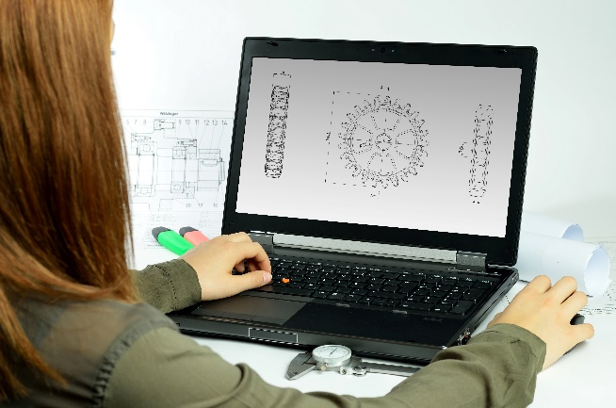
Incorporating the design process into the STEM modules will often result in the need for students to draw plans of their designs. This can be done at a simple level using hand drawn sketches or at a more technical level using computer-aided design (CAD).
By developing skills using industry standard software, students may be well-placed to explore future career pathways.
There are a number of CAD software options, two free examples are detailed below. Autodesk is a third package that is also free for educational use.
Tinkercad
- Format: Web-based app requiring internet access via a browser
- Purpose: A simple, online 3D design and 3D printing app
- Home: www.tinkercad.com
- Blog: blog.tinkercad.com
- Tutorials: www.tinkercad.com/learn
- Feature: Connects to 3D printing and laser cutting.
SketchUp
- Format: Can be downloaded and installed on devices, or used in a browser
- Purpose: Enables students to draw in 3D
- Home: www.sketchup.com 'Products' 'SketchUp for Schools'
- Help centre: help.sketchup.com/en
- Blog: blog.sketchup.com
- Tutorials: www.youtube.com/user/SketchUpVideo. From beginner tool tips to intermediate and advanced modelling techniques, the video tutorials help to build SketchUp skills.

Appendix 5: Student journal
When students reflect on learning and analyse their ideas and feelings, they self-evaluate, thereby improving their metacognitive skills.
These modules encourage students to self-reflect and record the stages of their learning in a journal. This journal may take the form of a written journal, a portfolio or a digital portfolio.
Using digital portfolios can help develop students’ Information and Communication Technology (ICT) capability.
Reflective practice and recording can be supported in classrooms by creating opportunities for students to think about and record their learning through notes, drawings or pictures. Teachers should encourage students to revisit earlier journal entries to help them observe the progress of their thoughts and understanding.
Journals are a useful tool that gives teachers additional insight into how students value their own learning and progress, as well as demonstrating their individual achievements.
The following links provide background information and useful apps for Journaling.
Reflective journal (University of Technology Sydney)
www.uts.edu.au/sites/default/files/reflective_journal.pdf
Reflective writing (University of New South Wales Sydney))
student.unsw.edu.au/reflective-writing
Balancing the two faces of ePortfolios (Helen Barrett, 2009)
electronicportfolios.org/balance/Balancing.jpg
Digital portfolios for students (Cool tools for school)
cooltoolsforschool.wordpress.com/digital-student-portfolios
Kidblog – digital portfolios and blogging
kidblog.org/home
Evernote (a digital portfolio app)
evernote.com
Weebly for education (a drag and drop website builder)
education.weebly.com
Connect – the DoE portal for teachers
connect.det.wa.edu.au

Appendix 6: Student activity sheet 1.0: Journal checklist
As an ongoing part of this module, you have been keeping a journal of your work.
Before submitting your journal to your teacher please ensure you have included the following information.
- Tick each box once complete and included.
- Write N/A for items that were not required in this module.

Your name and group member's names or photographs
An explanation of the problem you are solving
Your notes from Activity 1
Your notes from Activity 2
Your notes from Activity 3
Your notes from Activity 4
Student activity sheet 2.1: Unit conversions
Student activity sheet 2.2: Olympic swimming pools
Infographic
Student activity sheet 2.4: The water cycle
Student activity sheet 2.5: Perth's water sources
Student activity sheet 2.6: Purifying contaminated water
Student activity sheet 4.1: Peer evaluation
Student activity sheet 4.2: Self-evaluation
Student activity sheet 1.0: Journal checklist

Appendix 7: Teacher resource sheet 1.1: Cooperative learning – Roles
Cooperative learning frameworks create opportunities for groups of students to work together, generally to a single purpose.
As well as having the potential to increase learning for all students involved, using these frameworks can help students develop personal and social capability.
When students are working in groups, positive interdependence can be fostered by assigning roles to group members.
These roles could include:
- working roles such as Reader, Writer, Summariser, Time-keeper.
- social roles such as Encourager, Observer, Noise monitor, Energiser.
Further to this, specific roles can be delineated for specific activities that the group is completing. It can help students if some background to the purpose of group roles is made clear to them before they start, but at no time should the roles get in the way of the learning. Teachers should decide when or where roles are appropriate to given tasks.

Appendix 8: Teacher resource sheet 1.2: Cooperative learning – Jigsaw
This resource sheet provides a brief outline of a collaborative learning strategy known as 'jigsaw'.
Cooperative learning frameworks create opportunities for groups of students to work together, generally for a single purpose.
As well as having the potential to increase learning for all students involved, using these frameworks can help students develop personal and social capability.
The jigsaw strategy typically has each member of the group becoming an 'expert' on one or two aspects of a topic or question being investigated. Students start in their cooperative groups, then break away to form 'expert’ groups to investigate and learn about a specific aspect of a topic. After developing a sound level of understanding, the students return to their cooperative groups and teach each other what they have learnt.
Within each expert group, issues such as how to teach the information to their group members are considered.

Step 1 | Cooperative groups  (of four students) | 1 2 3 4 |  | 1 2 3 4
Step 2 | Expert groups  (size equal to the number of groups) | 1 1 | 2 2 | 3 3 | 4 4
Step 3 | Cooperative groups  (of four students) | 1 2 3 4 |  | 1 2 3 4

Appendix 9: Teacher resource sheet 1.3: Cooperative learning – Placemat
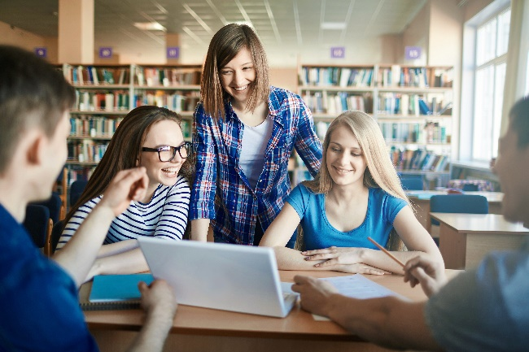
This resource sheet provides a brief outline of a cooperative learning strategy known as 'placemat'.
Cooperative learning frameworks create opportunities for groups of students to work together, generally for a single purpose.
As well as having the potential to increase learning for all students involved, using these frameworks can help students develop personal and social capability.
The placemat strategy involves students working collaboratively to record prior knowledge about a common topic and brainstorm ideas. It also allows teachers to readily see the contribution of each student. The diagram below shows a typical placemat template.
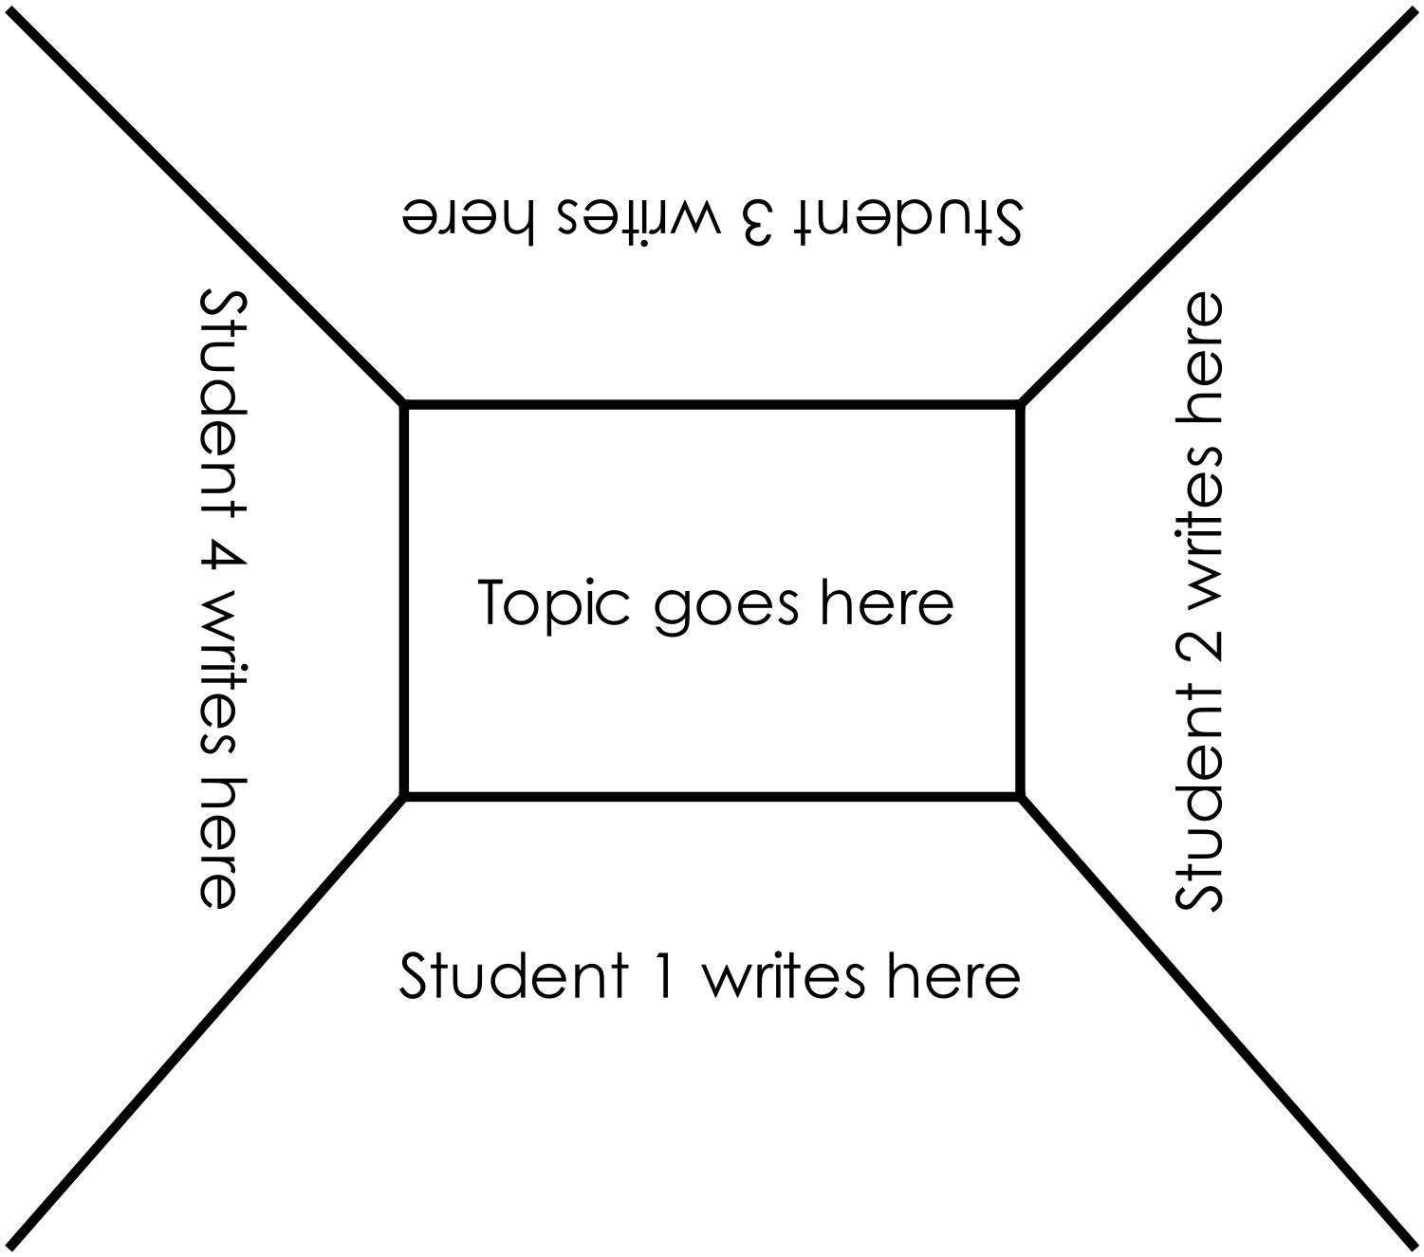

Appendix 10: Teacher resource sheet 1.4: Cooperative learning – Think, Pair, Share
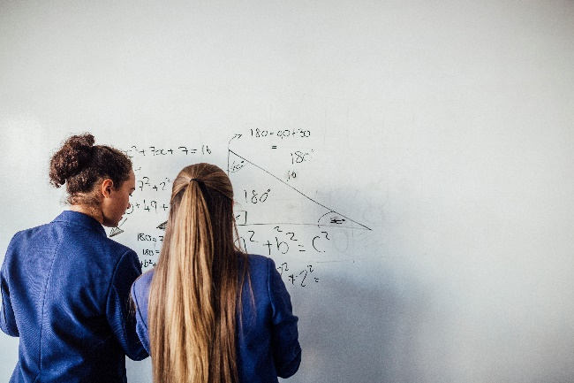
This resource sheet provides a brief outline of a cooperative learning strategy known as 'think – pair – share'.
Cooperative learning frameworks create opportunities for groups of students to work together, generally to a single purpose.
As well as having the potential to increase learning for all students involved, using these frameworks can help students develop personal and social capability.
In the 'think' stage, each student thinks silently about a question asked by the teacher.
In the 'pair' stage, students discuss their thoughts and answers to the question in pairs.
In the 'share' stage, the students share their answer, their partners answer or what they decided together. This sharing may be with other pairs or with the whole class. It is important also to let students 'pass'. This is a key element of making the strategy safe for students.
Think – pair – share increases student participation and provides an environment for higher levels of thinking and questioning.

Appendix 11: Teacher resource sheet 1.5: Game mechanics
Links to the Western Australian Curriculum
Technologies | Digital Technologies | Processes and production skills | Digital implementation| Design the user experience of a digital system (ACTDIP028)
Game mechanics
Gamification is the application of elements of game playing to other activities to encourage engagement in those activities.
Examples of what is classified as gamification include:
- Exercise apps such as Strava show progress bars towards goals, badges for achieving certain goals, and challenges to compete against others.
- Teachers award certificates to students as they complete modules.
- LinkedIn shows a percentage completion of your profile and gives you a nickname for how much you have done to encourage you to complete more.
Game mechanics are elements of games that are used to encourage players to continue playing the game. These are applied to encourage people to continue with a task. In this module students will apply game mechanics to motivate their community to use a water saving strategy.
The Gamified UK website has a long list of game mechanics that can be used to generate possible ideas for the students' projects.
www.gamified.uk/user-types/gamification-mechanics-elements
Students may need some scaffolding to understand how to apply this to their project. It may be worthwhile to start with a game that all students know (eg the card game Uno or Minecraft) and identify which game mechanics are being used. For example, like many games, Minecraft uses the Free Spirit element of Exploration to give the opportunity for players to discover what they will find.
Once students have an understanding of how game mechanics can be applied, they should find ways to use them to motivate people to engage in water saving strategies. For example, players time how long they take to shower and there is a leader board for those who can take the shortest showers. Another example might be a digital tutorial on strategies to save water; where players must complete each strategy to level up, encouraging the user to build this into habitual action. Remember, the solution does not need to be a digital solution.
This activity could also be gamified to encourage students to generate many possible ideas!

Appendix 12: Student activity sheet 2.1: Unit conversions
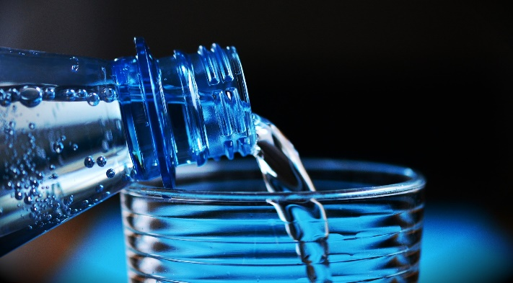
The Water Footprint Calculator is provided up by the Grace Communications Foundation to increase awareness and understanding of water usage.
www.watercalculator.org
The site is based in the United States and uses the non-metric measurement unit, the US gallon, to measure the amount of water used.
A US gallon is also different to the imperial unit gallon.
To convert US gallons to litres, the conversion rate of 1 US gallon = 3.785411784 litres can be used.
Task 1: Use the conversion rate above to convert the following amounts from US gallons to litres or kilolitres. Round your answers to two decimal places.
(a) 10 US gallons = ___________ litres
(b) 150 US gallons = ___________ litres
(c) 2 000 US gallons = ___________ litres
(d) 47 000 US gallons = ___________ kilolitres
Task 2: Use the conversion rate above to convert the following amounts from litres to US gallons. Round your answers to one decimal place.
(a) 500 L = ___________ US gallons
(b) 3 500 L = ___________ US gallons
(c) 40 kL = ___________ US gallons
(d) 3 125 kL = ___________ US gallons

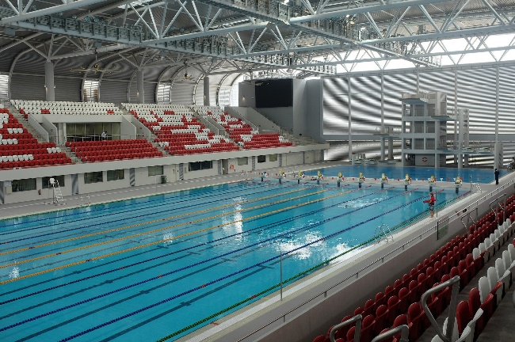
Appendix 13: Student activity sheet 2.2: Olympic swimming pools
Olympic swimming pools must be of a standard size. This size is length 50 m, width 25 m and depth a minimum of 2 m but recommended to be 3 m.
For this activity, we will use a depth of 2.5 m as this is an average of the possible depths.

Task 1: Use the dimensions given above, along with the formula for the volume of a rectangular prism, to calculate the volume of an Olympic swimming pool.
$$Volume\left(rectangular prism\right)=length ×width×height$$

Task 2: Use the relationship 1 m³ = 1 000 L = 1 kL to calculate the number of kilolitres of water required to fill an Olympic swimming pool.

Task 3: Convert the total water usage values of the class from litres into 'number of Olympic swimming pools'. Round your results accurate to one decimal place.

Appendix 14: Teacher resource sheet 2.3: Infographics
Links to the Western Australian Curriculum
Technologies | Digital Technologies | Processes and production skills | Collecting, managing and analysing data| Create information using relevant software, and create data to model objects and/or events (ACTDIP026)
Science | Science inquiry skills | Processing and analysing data and information | Construct and use a range of representations, including graphs, keys and models to represent and analyse patterns or relationships in data using digital technologies as appropriate (ACSIS129)
Science | Science inquiry skills | Processing and analysing data and information | Summarise data, from students’ own investigations and secondary sources, and use scientific understanding to identify relationships and draw conclusions based on evidence (ACSIS130)
Mathematics | Statistics and probability | Data representation and interpretation | Describe and interpret data displays using median, mean and range (ACMSP172)

Infographics simplify complex information using eye-catching imagery and digestible pieces of data. They are increasingly being used in marketing to invoke an emotional response to the information provided.
Well-designed infographics:
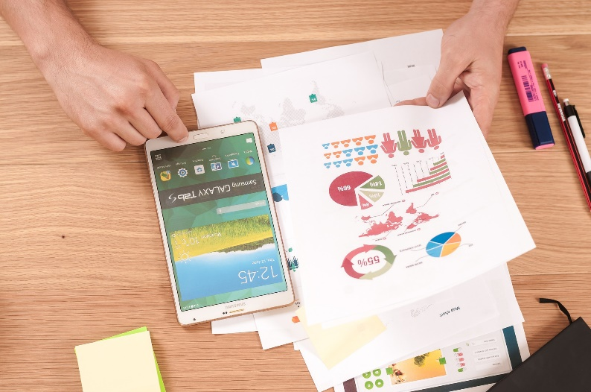
- capture lots of reliable and interesting data
- focus on a topic of interest
- present information simply
- provide visuals of the data
- provide information succinctly
- provide obvious takeaways
- cite data sources
- are promoted and shared.
There are number of free programs that can be used to create infographics. Two examples of these are Canva and Adobe Spark.

Canva
Canva is an app available through your web browser. There are a number of ready-to-use examples of good infographics that can be readily adapted by modifying the content and changing the fonts, background, images and colours. Students can also create infographics from scratch.

Adobe Spark Post
Adobe Spark Post allows students to create simple shareable posts aimed at social media. Through Adobe Spark there are three different options – Video, Post or Page. Students choose the Post option to create an infographic. Students enter the text and choose from a number of pre-existing templates. They can use the different menu options to change the layout, add pictures, change the colour palette, and more. Adobe Spark allows users to be creative and deliberately limits choices so the creations use elements and principles of design with suggestions of which colours, styles and fonts work together.

Appendix 15: Student activity sheet 2.4: The water cycle
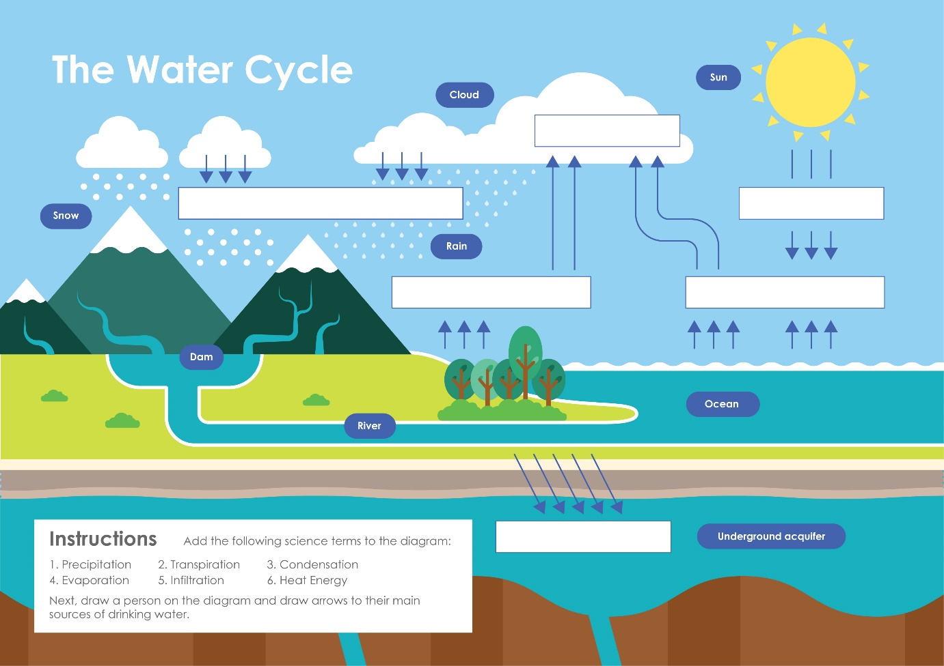
Task 1:
Add the following terms to the diagram:
1. Precipitation 2. Transpiration 3. Condensation
4. Evaporation 5. Infiltration 6. Heat Energy
Task 2:
Draw a person on the diagram and draw arrows to their main sources of drinking water.

Appendix 16: Student activity sheet 2.5: Perth’s water sources
The Bureau of Meteorology has been collecting rainfall data since the late 19th century. Using these records, it is possible to identify changes in rainfall patterns over many years.
Table 1.
Perth monthly rainfall: A comparison of the long-term average with the average for 2014 to 2016.
Month | Jan | Feb | Mar | Apr | May | June | July | Aug | Sep | Oct | Nov | Dec | Total
2014-2016 | 11 | 8 | 13 | 49 | 116 | 101 | 131 | 115 | 66 | 32 | 20 | 8 | 670
1876-2015 | 10 | 13 | 20 | 44 | 117 | 174 | 168 | 133 | 81 | 52 | 22 | 13 | 839
Source: Water Corporation website
Task 1:
Compare the rainfall data for 2014–2016 with the data for the long-term average of 1876–2015. Give two examples where the two sets of data differ.

Task 2:
What is the change in the average total rainfall between 1876–2015 and 2014–16?

Task 3:
Calculate and write this change as a percentage of the 1876–2015 total.

Perth relies on three main sources of drinking water: dams, groundwater and water from desalination plants. Analyse the data in Table 2 detailing Perth water sources over the past 20 years.
Table 2.
Volumes of water from various sources between 1995 and 2015 (Megalitres).
 | Year
Source | 1995 | 2000 | 2005 | 2010 | 2015
Dams | 132 445 | 115 150 | 107 381 | 163 100 | 20 100
Groundwater | 90 767 | 132 533 | 155 296 | 120 700 | 136 879
Desalination |  |  |  | 47 980 | 138 645
Total | 223 212 | 247 683 | 262 677 | 331 780 | 295 624
Source: Water Corporation Annual Reports
Notes:
1. Production of desalinated drinking water began in 2006, hence there are no records prior to 2010.
2. There are minor discrepancies in the way that this data is collected each year. For example, some south west dams are included in some years and not others.
Task 4:
What is the percentage increase in the volume of water used in Perth between 1995 and 2015?

Task 5:
Why do you think more water is being used in Perth in 2015 compared to 1995?

Task 6:
What percentage of water was sourced from dams in 1995 and in 2015?

Task 7:
Water Corporation's Fresh Water Thinking video (2015) explains why we now have reduced run-off into our dams as a result of long-term reductions in rainfall
www.youtube.com/watch?annotation_id=annotation_2101379235&feature=iv&src_vid=QvtrlZ8XcLc&v=xm9O-TVo4KU
Why have dams supplied less water to Perth in recent years?

Task 8:
What percentage of total water consumption was provided by desalination in 2015?

Task 9:
Find out why desalination was introduced in Western Australia?

Task 10:
Find out why Water Corporation is now recharging underground aquifers with treated wastewater?

Appendix 17: Teacher resource sheet 2.6: Purifying contaminated water
Links to the Western Australian Curriculum
Science | Science understandings | Chemical sciences | Mixtures, including solutions, contain a combination of pure substances that can be separated using a range of techniques (ACSSU113)

Teacher notes
Student activity sheet 2.6 develops concepts relating to methods of separating mixtures and is set in the context of purifying contaminated water.
Each group of students will need a retort stand and clamps suitable to support a filter funnel (preferably plastic), a 250 mL beaker of contaminated water, a plastic spoon, two 100 ml beakers, a sheet of newspaper about 15 cm square, access to some washed beach sand, and some small pebbles or blue metal.
Make a supply of contaminated water so that it contains some floating particles such as sawdust or short lengths of straw, and some material like clay that will make the water cloudy when the water is stirred.
Students will make two filters. The first will be made from small pebbles, glass beads or blue metal chips which will only remove larger contaminants from the water. The second is made from washed beach sand. The beach sand needs to be thoroughly washed so that it does not add to the turbidity of the water. Given the smaller pores between the sand particles, the sand filter will remove both smaller and larger particles from the contaminated water.
Students will check the turbidity of the filtered water by placing newspaper under the beakers of filtered water and trying to read the print.
Safety note. Students should be reminded not to drink any of the water samples as they have been contaminated.
Sand filtration systems using gravity have been designed and developed for use in third world countries.
One charitable foundation, Trailblazers, installs these in countries like Cambodia so small communities can filter water from their contaminated sources to make drinking water. Information on this group is available at:
www.waterforcambodia.org
www.thetrailblazerfoundation.org/our-health-1.html

Appendix 17A: Student activity sheet 2.6: Purifying contaminated water
Introduction
In remote areas where schemewater is not avaiolable and in developing countries, people are sometimes faced with drawing water from wells, rivers, lakes and by scooping away the soil to collect water that oozes to the surface from the water table. These sources of water are often contaminated and unsafe for human consumption. Contaminated water is a mixture of water and other things such as particles of soil and detritus which make the water cloudy or turbid. Other contaminants include salt dissolved in the water and disease-causing bacteria or protozoa. In Australia, engineers are developing ways of removing contaminants from water used by people and improving drinking water for livestock.
Your task is to construct two simple water filters to remove suspended particles from contaminated water to reduce its turbidity and to test their effectiveness.
Procedure
Safety note: Do not drink the water samples as they have been contaminated.
1. Set up a filter funnel on a retort stand with a clamp holding it.
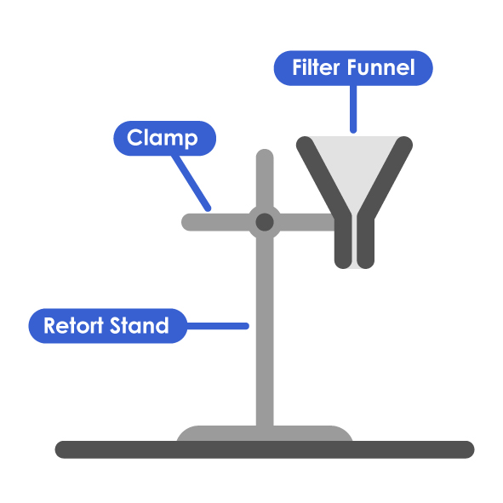

2. Half fill the funnel with small pebbles to make a filter bed. Stir your beaker of contaminated water and then pour about 50 ml through your filter bed and collect the filtered water in a 100 ml beaker. What contaminants were trapped by the pebbles?

3. Empty the pebbles from the funnel, plug the bottom with a small wad of cotton wool and then half fill the funnel with clean sand. Stir your beaker of contaminated water and then pour about 50 ml of contaminated water through your filter bed and collect the filtered water in a 100 ml beaker. What contaminants were trapped by the sand?

4. Compare the two samples of filtered water by placing the beakers on a sheet of newspaper. How cloudy (turbid) is the water? Can you read the newspaper print under both samples? How do they compare?

Discussion
1. What types of material were removed from the contaminated water by the two types of water filters? How is this related to the size of particles used to make the filter?

2. How effective were the two filters in reducing the turbidity of the water? What evidence do you have to claim that one filter was more effective than another?

3. Would your filters remove dissolved material like salt from the contaminated water? Why/why not?

4. Would your filters remove bacteria and protozoa from the contaminated water? Why/why not?

5. What advice would you give to an engineer who was designing a simple water filter made from low-cost materials that could be used to reduce contamination in water?

Appendix 18: Teacher resource sheet 2.7: Recovering pure water from a mixture
Links to the Western Australian Curriculum
Science | Science understandings | Chemical sciences | Mixtures, including solutions, contain a combination of pure substances that can be separated using a range of techniques (ACSSU113)
Introduction
The Year 7 Science curriculum explores methods of separating pure substances from mixtures, including separating solvents, such as water, from solutions. This activity provides an opportunity to introduce the Liebig condenser through a demonstration, develop students’ understanding of the particulate nature of evaporation and condensation, and then consider the design of solar stills used in emergency situations, off-the-grid living and in developing countries.
Safety notes
Copper sulfate is a heavy metal poison and should be treated with care. Always wear safety glasses and avoid contact with the skin. Copper sulfate solution is not to be disposed of down the sink as it will contaminate the environment. If you wish to avoid the issues around copper sulfate, any coloured liquid such as food dye can be used as a substitute.
Procedure for the demonstration
- Set up the Liebig condenser as shown in the diagram, with about 30 mL of copper sulfate solution and some anti-bumping beads in the flask.

- Connect the apparatus to a cold water supply and run a slow flow of water through the apparatus.

- Heat the flask of copper sulfate solution until it boils, then adjust the flame to keep it boiling gently.

- Read the thermometer as water vapour moves past it. It should be 100°C. This is the best test for pure water.

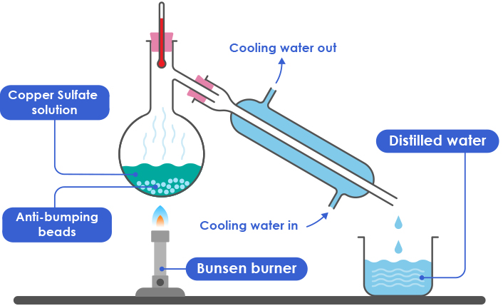
Discussion prompt questions
- Identify each part of the apparatus and ask students to explain the role each part plays (eg What is the purpose of the water flowing through the apparatus?).
- Where does evaporation and condensation occur within the apparatus?
At this point it would be helpful to show a simulation of evaporation and condensation at the particulate level.
- What colour is the solution in the flask? What is the colour of the liquid in the beaker? Why are they different?
- What is the temperature reading on the thermometer? What substance is flowing past the thermometer? How do you know it is water vapour?
- Is this an environmentally sustainable way of making pure water? Why? …because…
Application of distillation principles to the design of solar stills
There are many examples of how the principles of evaporation and condensation have been applied in practical ways to build simple solar stills for extracting drinking water from contaminated water. These designs often use repurposed/recycled materials and the stills have been used in emergency situations and in developing countries.
Challenge students to find an image or diagram of one of these solar stills (using a search engine) and to provide a critique of the design drawing on scientific principles.

Appendix 19: Teacher resource sheet 2.8: Investigation extension
Links to the Western Australian Curriculum
Technologies | Design and Technologies | Knowledge and understanding | Materials and technologies specialisations | Analyse ways to produce designed solutions through selecting and combining characteristics and properties of materials, systems, components, tools and equipment (ACTDEK034)
Science | Science understanding | Earth and space sciences |Some of Earth’s resources are renewable, including water that cycles through the environment, but others are non-renewable (ACSSU116)
Mathematics | Measurement and geometry | Using units of measurement | Calculate volumes of rectangular prisms (ACMMG160)

Water capture and reuse – Rainwater tank design
Show the video Rainwater and Rainwater tanks (Savewater! Alliance, 2012)
youtu.be/aXthXDhJPj8
- The video explains that for every square metre of roof space, 1 mm of rainfall will equal 1 litre of rainwater. Ask students to prove why this is so (rectangular prism). Alternatively, this activity could be done before showing the video.
- The video talks about the rainwater tank needing to hold at least four weeks' worth of water in the summer period. Using the water footprint calculations from Activity 2, ask students to calculate the size of the water tank their family would need. What dimensions could this be as a rectangular prism?
Design a rainwater tank for the school
In groups, students design a rainwater tank for one of the buildings at the school.
- Choose a building at school.
- After determining the necessary measurements, calculate (if plans are available) or estimate the surface area of the roof.
- Determine the monthly rainfall in the school's location.
- Determine the materials required.
- Calculate the dimensions of a rectangular tank required to collect and store the water.
- The video talks about some of the other considerations (gutters, downpipes, plumbing to toilets, space available, run off) that may be included.
- If students wish to draw their design digitally they could use software such as SketchUp or Tinkercad. Support for using these can be found in the Drawing in the design process resource.

Students present their findings to the other groups. They should listen for ideas they have missed or could change and document these ideas for improving their design in their journal. Use this as a way to encourage students to think about the design process as a cyclical process.
Groups re-design their rainwater tanks based on good ideas from the other groups. Base this redesign on questions such as:
- How would you make your design better?
- What else will you need to include?
- What needs to be changed? Why?
Additional activity
Students put together a report to the School Board, P&C or Executive team of the financial viability of installing rainwater tanks at their school. Students can put together a cost-benefit analysis and calculate how many years it will take for the tanks to become a profitable venture.
Note: Given the high costs of rainwater tanks, the relatively low cost of scheme water and the long periods between rainfall in Perth, this option is possibly financially unviable. Students could then consider the ethical question of whether saving water has a higher value than a monetary one.
Additional challenges
Here are some optional additional challenges to get students thinking more broadly. They are worthwhile additions to the task to reinvigorate students creative ideas if they are struggling to progress.
- Ask students if it is really possible to survive in the desert with a tarp stretched over a hole in the ground.
- Ask them to invent a method to transport water efficiently from a waterhole to a camp each day like so many people in developing countries have to do.
- Ask how they could cheaply stop evaporation from a storage pond or dam.

Appendix 20: Teacher resource sheet 2.9: Water footprint – Class spreadsheet template 1

Appendix 21: Teacher resource sheet 2.9: Water footprint – Class spreadsheet template 2

Appendix 22: Teacher resource sheet 2.9: Water footprint – Class spreadsheet template 3

Appendix 23: Student activity sheet 3.1: Prototype troubleshooting
Problem | Reason for the problem | Possible changes to your design to solve the problem

Appendix 21: Alternative Activity 4A: Student showcase
Activity focus | Two activities are provided for Activity 4. Both are based around the Evaluate and communicate stage of the design process. Each emphasises different aspects and teachers should choose to do Activity 4 or 4A. The choice should be based on the desired learning, available time and expertise.  Alternative Activity 4A is designed to develop students’ project management skills and provide them with ownership of the Student Showcase event. This activity will also develop students’ interpersonal and communication skills.  The students' solutions will be showcased to other students, parents, teachers and special guests.  Students will:  - develop their event management skills by planning and running the student showcase event  - design an invitation using a digital design tool  - improve their interpersonal and communication skills by showcasing their work to the broader community  - gather feedback on their solution for further improvement.
Background information | This activity is about more than showcasing students' work. It is about handing over responsibility to the class to make the showcase happen and encourage students to develop the skills required to organise and run an event of this scale. By owning the project, students will learn organisational skills, problem-solving skills, interpersonal skills and more. The more responsibility students have, the more they will gain from this activity. Therefore, the focus of the activity is on these skills rather than the content. The most important take away from this activity is not the end product, but the process students went through to get there.
Instructional procedures | The following activity is about using broader accountability to encourage students to achieve their best. By encouraging the wider community to become involved in the project, the students will realise they can have an impact and make lasting change.  This event should be planned at the start of the project and students should be reminded of its importance throughout the module's duration. The showcase should be promoted by the teacher as an opportunity for students to expand the sphere of influence for their project idea and think beyond their own horizon.  The activity brings together all the groups to work closely together to achieve a class goal. The teacher may want to discuss with the class about how on a project, big groups work together on different tasks to deliver an overall goal (ie establish small task groups who are responsible for specific tasks).
Expected learning | Students will be able to:  - Work together in small groups to deliver a goal for the larger group.  - Plan, organise and run an event.  - Manage and prioritise tasks.  - Create a digital publication that meets user requirements.  - Review and reflect on a process to determine success.
Equipment required | For the class:  Coloured circle stickers (or equivalent)  Whiteboard and whiteboard markers  Equipment for the event – room, desks, power cables, signage, refreshments etc  Equipment for creating posters – either digital tools or artistic tools
For the students:
Suitable area to showcase student work
Access to digital device, internet and apps
Access to a colour printer to print invitations
Device with required apps installed, logins setup
Preparation | It is recommended that teachers start conducting preparations for the showcase prior to the commencement of the project.  While the students will be preparing for the event, the teacher will be required to coordinate the showcase behind the scenes.  - Determine a suitable date for the event allowing students time to complete the project and book the showcase in the school calendar.  - Arrange for any formalities required to host the showcase at the school, including talking to the executive team, organising teacher reliefs, booking rooms/equipment, permission slips, pre-invitations to groups etc.  - Check and confirm a suitable area to showcase student work.  - Organise gifts for special guests.  - Order refreshments and food.  While the preparation for the showcase may seem overwhelming, remember the more of the showcase the teacher can allocate to students, the more they will learn. The teacher's role should be only for those things for which students cannot be held responsible.
Activity parts | Part 1: Plan the student showcase event  Create task cards using the questions below and allocate to each group. Delegate responsibility to the group for coordinating the area of responsibility and completing all associated tasks for the event. It is up to the teacher whether they want to provide an appropriate date and time for the event or whether they want to delegate this to the class.  The teacher may want to delegate a responsible person or have the class vote for a Project Manager or Events Coordinator who will work between all groups and make sure the event comes together. The teacher may also decide to allocate this to a group of students.  The teacher may want to use a task management tool to monitor the class management of the project. See the Digital resources section for a list of options. The benefits of using a task management tool are that tasks can be organised into groups, due dates allocated on the tasks, tasks assigned to a particular person and comments made on tasks.  Ideally, the Project Manager or Events Coordinator would be charged with creating a single project and inviting other students to collaborate, or else this job could be done by the teacher.  Event management  - How long will the event run for?  - What will be the schedule for the event?  - When will refreshments be served?  - How long will guests require to view the projects and provide feedback?  - Who will MC the event? What will they say? Who needs to be thanked?  - What do the other groups need from each other? Who will coordinate this?  - Which task management tool will be used? Who will arrange this? Who will train the other groups?  - Who will set up and pack up the equipment used for the event?  Location  - In which room or area will the event take place?  - Where will the groups set up? How much space will they need? What specific requirements will they need?  - What equipment will be required?  - When will it be set up?  - How will it be set up?  - Who will set up?  - Who will pack up?  - How and when does equipment need to be returned?  - Will power be required?  Invitation and registration  - How will you contact people to invite them to the event (email, telephone or letter)? Who will do this?  - Which other organising groups may need to know who is coming? When will they need to know?  - Will the guests require name badges? Who will organise this?  - When will guests need to RSVP to the event? How much time will be required by the other groups to complete their tasks?  - How will guests RSVP to the event? Where will this information be stored?  Arrival on the day  - What signage will be required? From where can this be sourced?  - Will the guests need to sign in on the day? How will they sign in?  - Will there be student representatives who will meet, greet and direct guests? Who will do this?  Refreshments  - Will refreshments be provided?  - How much money can be spent on refreshments?  - Will you provide drinks only or will food be provided?  - From where will you order the refreshments?  - Who will pick up the refreshments on the day?  - Who will set up the refreshments on the day?  - Will cutlery, crockery, cups and saucers, plastic cups be required?  Feedback forms and surveys (this could be done as a class activity)  - How will you collect data for each project? How will guests identify each project in the feedback?  - How will information be collected? Will data be collected electronically or with pen and paper?  - If data is used electronically, what tool will be used? A list of tools is provided in the Digital resources section. Which one is best for the data collection requirements?  - How will guests enter feedback? What equipment will be required?  - Who will provide feedback? Will students rate other groups?  - When will feedback be gathered?  - What feedback will be gathered? How will this feedback be gathered?  - What type of data are you hoping to generate? Will it be numerical data? Short answer questions?
Part 2: Each student creates an invitation to the Student Showcase using a design tool.
As a class, do a Think–Pair–Share activity as detailed in Teacher resource sheet 1.4: Cooperative learning – Think, Pair, Share to elicit the features and content of an invitation.
Write the answers on a whiteboard or in an electronic document for the class to see (this might make it easier to share later).

As a class, discuss which of these elements will be required and which can be left out.
Content
- Event name
- Event description
- To ________, from ________
- Date and time
- Location
- RSVP (Students could investigate the meaning of this acronym)
Features
- Colour, Background, Fonts
Students use this information to create an invitation for the Student Showcase using a design tool (see Digital resources). Depending on the time available, the teacher could explore the Elements and Principles of Design (see Digital resources). Students will need to include all of the required elements discussed as a class.
Upon completion, each student will print out the invitation they have designed. These could also be displayed digitally. The invitation designs should be presented so that each student has access to them for voting. This could be done across tables or pinned to a wall.
Students vote for the best invitation. Each student is given five coloured stickers to vote for their favourite design. They are only allowed to stick at most, three on one invitation design. Encourage students to vote for the best design and not just vote for their friends. The winning design will be the one that will be sent to official invitees, including parents and guardians. The design with the most coloured circles after the voting process becomes the winning design.
Part 3: Create an invitation list
As a class, conduct a brainstorm of people the students could invite. Remind students that in order to make change happen, their idea needs traction with other people.
Below is a list of possible invitees, but don’t let that limit the students' imagination.
- Parents or guardians
- Teachers or administration
- P&C Committee, School board or School council representative
- Local council member
- Chamber of Commerce or Small Business Development Corporation representative
- Local members of Parliament
- Water Corporation representative
- Environment centre representative
- Indigenous leaders
The student group that has been delegated the task of coordinating the invitations should manage the sending of the invitations. The student group may want to accompany the invitation with a letter or email with additional information.
Part 4: Prepare project stall for event
Each group will be allocated a space for a stall to present their solution at the Student Showcase event. This activity provides them with the time that they need to prepare their project stall.
Students may like to create:
- posters or digital display including an explanation of how their solution works and estimates of how much water can be saved
- a customer-facing version of their solution
- a name for their solution
- a team logo for their business
- customised name badges (with logo).
Part 5: Manage the event
Students manage the event according to the agreed schedule. On the day, students will man their project stall and tell guests about their solution and how it works (the teacher may want to arrange for different students to man the stall two at a time so they can see the other group's stalls and provide them with feedback). Feedback on their project will be collected as per the event plan.
Resource sheets | Teacher resource sheet 1.4: Cooperative learning – Think, Pair, Share
Digital resources | Elements and principles of design  Visual design elements and principles (Wikipedia, 2017)  en.wikipedia.org/wiki/Visual_design_elements_and_principles  Elements and Principles (Atar Art 12, 2017)  atarart12.weebly.com/elements-and-principles.html  Design elements and principles (Canva, 2017)  designschool.canva.com/design-elements-principles
Digital design tools
Adobe Spark
spark.adobe.com/
Canva
www.canva.com/create/cards/party-invitations/
Task management tools
Asana
asana.com
Wunderlist
www.wunderlist.com/
Todoist
en.todoist.com/gmail
Survey and feedback tools
Google Forms
www.google.com.au/forms/about/
Survey Monkey
www.surveymonkey.com
SurveyGizmo
www.surveygizmo.com/
Microsoft Forms
forms.office.com/Pages/DesignPage.aspx

Appendix 22: Student activity sheet 4.1: Peer evaluation
 | Always | Usually | Sometimes | Rarely
Remains focused on tasks presented
Completes set tasks to best of their ability
Works independently without disrupting others
Uses time well
Cooperates effectively within the group
Contributes to group discussions
Shows respect and consideration for others
Uses appropriate conflict resolution skills
Comes to class prepared for activities
Actively seeks and uses feedback

Comments: __________________________________________________________________________________________________________________________________________________________________________________________________________________________________________________________________________________________________________________________________________________________

Appendix 23: Student activity sheet 4.2: Self-evaluation
 | Always | Usually | Sometimes | Rarely
Remains focused on tasks presented
Completes set tasks to best of their ability
Works independently without disrupting others
Uses time well
Cooperates effectively within the group
Contributes to group discussions
Shows respect and consideration for others
Uses appropriate conflict resolution skills
Comes to class prepared for activities
Actively seeks and uses feedback

Comments: __________________________________________________________________________________________________________________________________________________________________________________________________________________________________________________________________________________________________________________________________________________________

Notes
________________________________________________________________________________________________________________________________________________________________________________________________________________________________________________________________________________________________________________________________________________________________________________________________________________________________________________________________________________________________________________________________________________________________________________________________________________________________________________________________________________________________________________________________________________________________________________________________________________________________________________________________________________________________________________________________________________________________________________________________________________________________________________________________________________________________________________________________________________________________________________________________________________________________________________________________________________________________________________________________________________________________________________________________________________________________________________________________________________________________________________________________________________________________________

