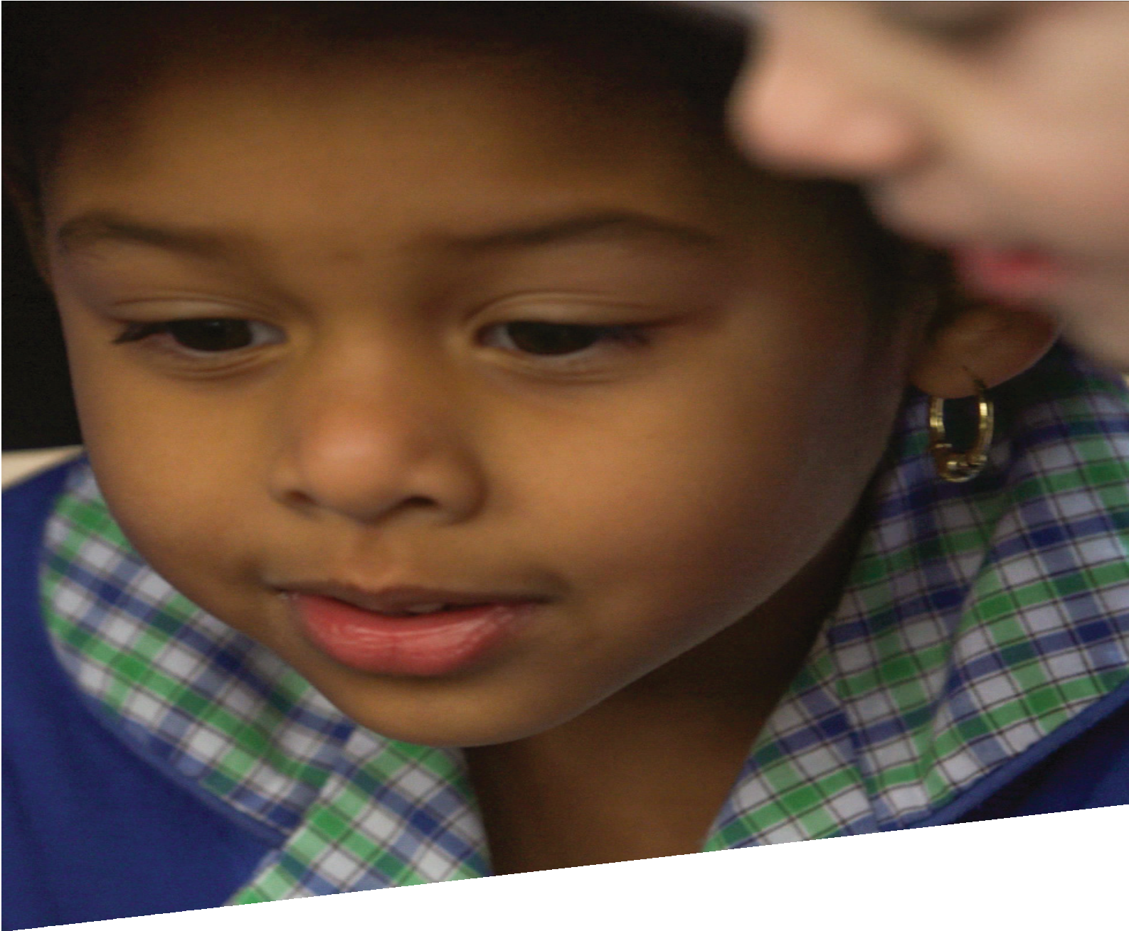

CURRICULUM RESOURCE MODULE
I like quiet, I like noise
KINDERGARTEN
Acknowledgements
The STEM Learning Project is funded by the Western Australian Department of Education (the Department) and implemented by a consortium in STEM education comprising the Educational Computing Association of Western Australia, the Mathematical Association of Western Australia, the Science Teachers Association of Western Australia and Scitech.

We acknowledge and thank the teachers and schools who are the co-creators of these resources.

Copyright and intellectual property
The copyright and intellectual property of this module remain the property of the Department.

Any Western Australian Curriculum content in this resource is used with the permission of the School Curriculum and Standards Authority (the Authority); this permission does not constitute Authority endorsement of the resource. The Authority accepts no liability for any errors or damages arising from reliance on its content.

The Western Australian Curriculum content may be freely copied, or communicated on an intranet, for non-commercial purposes in educational institutions, provided that the Authority is acknowledged as the copyright owner. Copying or communication for any other purpose can be done only within the terms of the Copyright Act 1968 or with prior written permission of the Authority. Any Australian Curriculum content in the Western Australian Curriculum is used by the Authority under the terms of the Creative Commons Attribution NonCommercial 3.0 Australia licence.

Any content on the www.scsa.wa.edu.au domain that has been derived from the Australian Curriculum may be used under the terms of Creative Commons Attribution-NonCommercial 3.0 Australia licence.

Appendix 2: General capabilities continuums are adapted from ACARA, © Australian Curriculum, Assessment and Reporting Authority (ACARA) 2009 to present, unless otherwise indicated. This material was downloaded from the ACARA website (www.acara.edu.au) (accessed December 2015) and was not modified. The material is licensed under CC BY 4.0 (https://creativecommons.org/licenses/by/4.0/). ACARA does not endorse any product that uses ACARA material or make any representations as to the quality of such products. Any product that uses material published on this website should not be taken to be affiliated with ACARA or have the sponsorship or approval of ACARA. It is up to each person to make their own assessment of the product.

This resource includes references and examples of iOS, Android and other apps. The Department does not endorse or recommend any commercial products and simply provides these as examples for teachers.

The Department is committed to providing quality information to its customers. Whilst every effort has been made to ensure accuracy, currency and reliability of the information within these documents, the Department accepts no responsibility for errors, omissions or amendments made since the time of publishing. Confirmation of information may be sought from the Department or the originating bodies providing the information. The Department has no control over the content of material published on websites to which users are referred in this resource. It is the responsibility of the internet user to make their own decision as to the relevancy, accuracy, currency and reliability of information found on those sites.
Attributions: Google, Google Maps, Google Earth, Spotify, Shazam, Seesaw, Explain Everything, iBooks, iMovie, Pages, Class Dojo

Table of contents

The STEM Learning Project 2
Overview 3
Activity sequence and purpose 6
Background 7
Activity 1: Inside voice 10
Activity 2: Sound meter 14
Activity 3: Noise around our school 18
Activity 4: Sharing results 23
Appendix 1: Links to the Kindergarten curriculum guidelines 26
Appendix 2: General capabilities continuums 30
Appendix 3: Materials list 32
Appendix 4: Design process guide 33
Appendix 5: Reflective journal 34
Appendix 6: Teacher resource sheet 1.1: Cooperative learning – Roles 35
Appendix 7: Teacher resource sheet 1.2: Cooperative learning – Think, Pair, Share 36
Appendix 8: Teacher resource sheet 4.1: 3 – 2 – 1 Reflection 37

The STEM Learning Project
The aim of the STEM Learning Project is to generate students’ interest, enjoyment and engagement with STEM (Science, Technology, Engineering and Mathematics) and to encourage their ongoing participation in STEM both at school and in subsequent careers. The curriculum resources will support teachers to implement and extend the Western Australian Curriculum and develop the general capabilities across Kindergarten to Year 12.
Why STEM?
A quality STEM education will develop the knowledge and intellectual skills to drive the innovation required to address global economic, social and environmental challenges.
STEM capability is the key to navigating the employment landscape changed by globalisation and digital disruption. Routine manual and cognitive jobs are in decline whilst non-routine cognitive jobs are growing strongly in Australia. Seventy-five per cent of the jobs in the emerging economy will require critical and creative thinking and problem solving, supported by skills of collaboration, teamwork and literacy in mathematics, science and technology. This is what we call STEM capability. The vision is to respond to the challenges of today and tomorrow by preparing students for a world that requires multidisciplinary STEM thinking and capability.
The approach
STEM capabilities are developed when students are challenged to solve open-ended, real-world problems that engage students in the processes of the STEM disciplines.
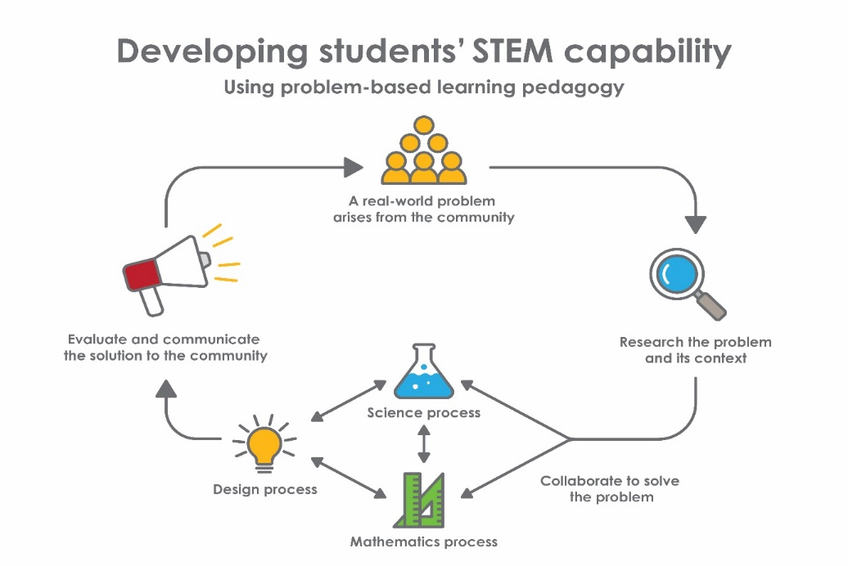
Kindergarten – I like quiet, I like noise

Overview
Noise pollution is a real issue in our communities. Noise is classified as unwanted sound, which among other things can be disruptive, causing loss of sleep, interference to activities and emotional stress (City of Perth, 2017). Construction sites, traffic and outside events such as concerts are common sources of noise pollution. People can create unwanted noise by talking loudly on mobile phones, playing music without wearing headphones or having loud conversations in quiet places such as libraries.
When students begin school, one challenge for them is to learn to regulate their noise levels, in particular their voices. Students begin to learn that different situations and environments require different sound levels.
What is the context?
Noise is a problem that impacts all community members, including students. For students to understand the impact of noise in their community they investigate noises in their school and look at the importance of noise regulation in different places.
What is the problem?
Where and when should we use loud voices or quiet voices in our school?
How does this module support integration of the STEM disciplines?
This module provides a context for students to develop outcomes from the Early Years Learning Framework and opportunities to develop skills in:
Science
Science skills are developed in Activities 1, 2 and 3 when students follow the steps of an investigation to observe sound levels at different locations around the school, record their observations and share them with others.
Technology
Students develop confidence with using technologies in Activities 2 and 3 when they use devices and sound meter apps to measure sound levels. They use Google Maps and Google Earth to view their school.

Mathematics
Mathematical measuring skills are developed when students interpret and compare digital representations of sound levels. When using a noise scale, colour and number recognition is developed. Students analyse a simple bird’s eye view map of their school and use a colour code to identify noise levels in familiar areas. They understand that symbols on the map are pictorial representations of a place. Students develop positional language such as in front, behind, next to, on top of and under when interpreting the school map.
General capabilities
Tasks throughout the module encourage Critical and creative thinking and develop Personal and social capability and Literacy.
Language and negotiating skills are developed as students work collaboratively to reach a general consensus. Students further develop language throughout the module with the introduction of vocabulary such as loud, quiet, soft, big, little, inside, outside. They classify these words and identify opposites. There is an opportunity for literacy extension through verbal cooperative activities such as think – pair – share (see Teacher resource sheets 1.1 and 1.2: Cooperative learning for more information).
What are the pedagogical principles of the STEM learning modules?
The STEM Learning Project modules develop STEM capabilities by challenging students to solve real-world problems set in authentic contexts. The problems engage students in the STEM disciplines and provide opportunities for developing higher order thinking and reasoning, and the general capabilities of creativity, critical thinking, communication and collaboration.
The design of the modules is based on four pedagogical principles:
- Problem-based learning
This is an underlying part of all modules with every module based around solving an initial problem. It is supported through a four-phase instructional model: research the problem and its context; investigate the parameters impacting on the problem; design and develop solutions to the problem; and evaluate and communicate solutions to an authentic audience.
- Developing higher order thinking
Opportunities are created for higher order thinking and reasoning through questioning and discourse that elicits students' thinking, prompts and scaffolds explanations, and requires students to justify their claims. Opportunities for making reasoning visible through discourse are highlighted in the modules with the icon shown here.

- Collaborative learning
This provides opportunities for students to develop teamwork and leadership skills, challenge each other’s ideas, and co-construct explanations and solutions. Information that can support teachers with aspects of collaborative learning is included in the resource sheets.
- Reflective practice
Recording observations, ideas and one’s reflections on the learning experiences in some form of journal fosters deeper engagement and metacognitive awareness of what is being learnt. Information that can support teachers with Journaling is included in the resource sheets.
These pedagogical principles can be explored further in the STEM Learning Project online professional learning modules located in Connect Resources.

Activity sequence and purpose
Inside voice | Students are engaged with the problem of where and when to use loud or quiet sounds at school. They make loud and quiet sounds using instruments and their voices as they sing and dance.
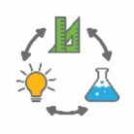  Sound meter | Students investigate when to use loud and quiet voices. Students use a sound meter app to see visual representations of different sound levels and work collaboratively to make predictions about the meaning of the different colours on the app.
Noise around our school | Students identify familiar places on a simple map of their school and predict sound levels at those locations. Through fieldwork, students measure sound levels to see if they match predictions.
Sharing results | Students collaborate to create a presentation showing where it is appropriate to use different sound levels in the school. They share this information with the wider school community at an event such as an assembly.

Background
Learning focus | Students:  - Build a sense of belonging as they join in group activities, such as singing and dancing to songs  - Make choices and decisions as they show initiative by asking questions, negotiating and sharing (connects to the English Curriculum and the Science Curriculum)  - Participate positively as part of a group as they take turns in small group situations  - Respond to others appropriately as they listen to others’ opinions and points of view  - Develop skills for working with others as they share observations while exploring their immediate world using their five senses (connects to the Science Curriculum)  - Develop skills for working with others as they participate with others to solve problems (connects to the Mathematics Curriculum and the Science Curriculum)  - Develop inquiry and communication skills as they plan and carry out a few simple sequenced steps when exploring and investigating (connects to the Science Curriculum and Technologies Curriculum)  - Develop inquiry and communication skills as they use simple language of measurement to describe, compare, order or sort the observations made when exploring (connects to the Mathematics Curriculum and the Science Curriculum)  - Develop inquiry and communication skills as they describe both verbally and non-verbally what they see, hear, touch, feel and taste (connects to the English Curriculum and the Science Curriculum)  - Develop inquiry and communication skills as they use ICT with assistance to collect information and communicate it simply (connects to the English Curriculum)  - Develop inquiry and communication skills as they represent findings and communicate ideas in a variety of ways (connects to the Arts Curriculum, the English Curriculum  - Develop problem solving, investigation and inquiry strategies as they create and use simple representation to organise, record and communicate mathematical and scientific ideas and concepts (connects to the Mathematics Curriculum and the Science Curriculum)  - Develop knowledge of measurement and geometry as they use positional language, such as on, under, behind, between
Vocabulary | This module uses subject-specific terminology. The vocabulary list contains terms that need to be understood, either before the module commences, or developed as they are used including:  behind, high, in front, inside voice, loud, low, next to, noise, outside voice, quiet, shout, soft, sound, sound meter, table-talk, voice, volume, whisper
Timing | There is no prescribed duration for this module. The module is designed to be flexible enough for teachers to adapt. Activities do not equate to lessons; one activity may require more than one lesson to implement.
Consumable materials | A Materials list is provided for this module. This list outlines materials outside of normal classroom equipment that will be needed to complete the activities.
Safety notes | There are potential hazards inherent in these activities and with the equipment being used, and a plan to mitigate any risks will be required.  Potential hazards specific to this module include but are not limited to:  - Exploring outside the classroom  - Sun exposure.  When planning for the delivery of this topic it is important to consider the backgrounds and experiences of students in your class as the Activities may be of concern for some students who have a hearing impairment or are sensitive to noises.
Assessment | While working through the module, the following assessment opportunities will arise:  - photographic and anecdotal evidence collected to assess collaboration skills  - use of pictorial representations when mapping  - observations regarding students colour and number recognition when recording data and mapping  Mapping to the Kindergarten curriculum guidelines is provided in Appendix 1.  Students can further develop the general capabilities of Information and communication technology capability, Critical and creative thinking and Personal and social capability. A continuum for Personal and social capability is included in the General capabilities continuums but is not intended to be for assessment purposes.

Activity 1: Inside voice
Activity focus | This activity is designed to engage students with the problem of where and when to use loud or quiet sounds at school. They listen to a picture book and experiment with loud and quiet voices as they sing and dance to the song I Like Peace, I Like Quiet.
Background information | This activity is designed to introduce students to the idea that sounds can create noise. They explore the notion of appropriate sound levels for different contexts and that they can control their own sound levels.  Sound is an auditory sensation created by variations in the pressure of air reaching the ears. Sounds are made by vibrating objects like the strings on a guitar. When the vibrations are fast the sound has a high pitch and when the vibrations are slow the pitch of the sound is low. When the strings move a long distance the sounds are loud, and when they vibrate a short distance the sound is soft. Vibrations of our vocal cords create the sounds when we talk and sing.  Noise and sound are not the same. Noise is an unwanted sound in a particular environment. Extended exposure to noise at or above 85dB or short exposure to peak noise levels above 140dB can cause noise induced hearing loss. This is why people often wear hearing protection when working with loud machinery, music or other noises.  As students increase their awareness of noise they improve listening skills, which is critical for language development and reading. Listening involves paying attention to environmental sounds, music, conversations and stories.
Instructional procedures | This activity can be completed as a class mat session.  Decibella and Her 6 Inch Voice is a longer story than Too Loud Lily which may influence the choice of story.  To encourage inclusivity, students could learn Australian sign language for key vocabulary. The Auslan Signbank online dictionary at www.auslan.org.au has videos for students to watch and copy.
Learning focus | This is evident when students:  - Build a sense of belonging as they join in group activities, such as singing and dancing to songs.
Equipment required | For the class:  Picture books Too Loud Lily or Decibella and Her 6 Inch Voice (see Literary and Digital resources)  Interactive whiteboard
Preparation | Read and review Too Loud Lily or Decibella and Her 6 Inch Voice.  Download the song I Like Peace, I Like Quiet (see Digital resources).
Activity parts | Part 1: Loud and quiet voices  Read Too Loud Lily or Decibella and her 6 Inch Voice to introduce students to the topic of noise.  As a class, discuss the events in the story and the use of loud and quiet voices.  Use the following questions to guide the class discussion, adapting to the chosen text. Prompt reasoning by using the bridging word ‘because’.  Closed questions  - Was Decibella loud?  - Was Decibella quiet?  - What are the five volumes of voice that Decibella’s teacher taught her?  Open questions  - What did Decibella like to do?  - What does Decibella learn about her voice?  - Why did Decibella need to use different voice levels in different places? Because…  - Do we need to use different voice levels at school too? Why?
Part 2: Singing and dancing
Students sit in a circle and listen to the Play School song
I Like Peace, I Like Quiet. Students make sounds by clapping, stomping, banging and using their loud and quiet voices while they sing and dance.
After dancing and being noisy and quiet, students sit down and as a class discuss the different sounds. Prompt questions can include:
- Which sounds were noisy?
- How did you make sounds noisy?
- Which sounds were quiet?
- How did you make sounds quite?
- How could you make the quiet sounds louder?
Part 3: Prior connections
Ask students if they can remember places they have visited where they have been allowed to be noisy or have had to be quiet. Discuss places such as airports, inside an indoor sports facility, in a place of worship etc. Students share ideas using a Think-pair-share cooperative strategy. See Teacher resource sheet 1.1: Cooperative learning – Roles and Teacher resource sheet 1.2: Cooperative learning – Think, Pair, Share for further information.
Play a listening, guessing game such as Cars, Trucks and Transportation sounds for Kids (see Digital resources) and focus on listening skills and sound identification.
Resource sheets | Teacher resource sheet 1.1: Cooperative learning – Roles  Teacher resource sheet 1.2: Cooperative learning – Think, Pair, Share
Literary resources | Too Loud Lily by Sophia Laguna  Decibella and Her 6 Inch Voice by Julia Cook
Digital resources | Decibella (Willow Brook, 2016)  www.youtube.com/watch?v=pWSq1YZfLjU
Too Loud Lily by Sofie Laguna and Kerry Argent -Read Aloud (The Teaching Toolbox, 2016)
www.youtube.com/watch?v=5hmhjwKEuP0
Online versions of the books are available on Playster
www.playster.com
I Like Peace, I Like Quiet! song (Play School, 2016) available at:
I Like Peace I Like Quiet! (Kate Ceberano - Topic, 2017)
www.youtu.be/Crc3B4RgLDE
Spotify open.spotify.com or Shazam www.shazam.com
Play School in the Car or Famous Friends: Celebrating 50 Years of Play School CD (Australian Broadcasting Corporation, 2016)
Cars, Trucks and Transportation sounds for Kids (Annie Sullivan, 2013)
www.youtube.com/watch?v=4X0pp9MF68s
Extension activity: Different voices lesson and video
Peep and the Big Wide World (WGBH Educational Foundation, 2017)
www.peepandthebigwideworld.com/en/educators/curriculum/center-based-educators/sound/activity/stand-alone/541/different-voices/

Activity 2: Sound meter
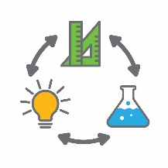  Activity focus | In this activity, students investigate when to use loud and quiet voices.  Students use a sound meter app to see a visual representation of different noise levels and work collaboratively to make predictions about the meaning of the different colours on the app.
Background information | The intensity or loudness of sound is measured in decibels. A normal speaking voice is under 60dB.  For this task students will use the needle and colour code on the sound meter app to measure sound.  When using the Too loud kids noise meter adjust the sensitivity and dampening of the sound meter to ensure measurable increases in sound (eg 30% sensitivity and 34% dampening gives good readings for a silent room, a working room and playground noises). It is best to test and adjust these variables through the app settings prior to the lesson.
Instructional procedures | This activity can be run as a whole class or in small groups, depending on the collaborative learning skills of the students.  Knowledge of colour recognition is necessary for this activity and reviewing colours with the students prior to the lesson is recommended.
Learning focus | This is evident when students:  - Develop skills for working with others as they share observations with others as they explore their immediate world using their five senses (connects to the Science Curriculum)  - Make choices and decisions as they show initiative by asking questions, negotiating and sharing (connects to the English Curriculum and the Science Curriculum)  - Develop inquiry and communication skills as they describe both verbally and non-verbally what they see, hear, touch, feel and taste (connects to the English Curriculum and the Science Curriculum)
Equipment required | For the class:  Interactive whiteboard  Device  Musical instruments such as cymbals, maracas, tambourines and triangles
Preparation | Download a child friendly sound meter application such as Too Loud Kids Noise Meter to the students’s devices and the interactive whiteboard.  Download the video Quiet Loud Quiet Song (see Digital resources). It is best to show this to the whole class on the interactive whiteboard, ensuring students have enough room to move freely.
Activity parts | Part 1: Making sounds with our bodies  Students sing and dance to the Quiet Loud Quiet Song video clip, moving their bodies and making sounds while watching. Encourage them to stamp their feet, clap their hands and sing loudly and softly.
Part 2: Making sounds with musical instruments
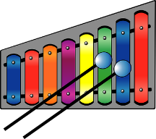
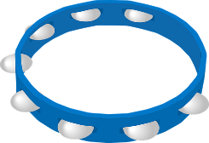
Students sit on the mat for circle time and are introduced to different types of musical instruments. Choose three or four percussion instruments such as cymbals, maracas, tambourines and triangles. Present them to the class one by one and ask the students if they know the instrument names. Play the instruments and ask the students if they can identify the loud sound and the quiet sound for each. Students predict and explore how the instruments can be played differently to produce different sounds. Pass instruments around the circle, ensuring there is one for every child. As a class play loud noises and then soft sounds together.

Additional learning opportunity:
Make musical instruments from recyclable materials. Conduct an image search for ‘making percussion instruments recycled materials’ for inspiration.
Part 3: Sound meter
Introduce students to the sound meter app Too Loud Kids Noise Meter or similar. If the interactive whiteboard does not have a microphone, use a device for demonstration.
Allow the students to take turns using their voices or musical instruments to move the needle on the meter.
Prompt exploration of sound by asking the students:
- Can you make the screen smash? How?
- Can you get the needle into the green zone? How?
Ask the students what they think the colours on the sound meter mean.
- What colour shows the loudest sounds?
- What colour shows the softest sounds?
- What colours would show the sound level when we are working?
The app can be left on while the students are playing throughout the day as they may like to look at the levels of noise they are making.
Additional learning opportunity:
Students make megaphones from card and use them outside to practice their loud voices. Inspiration can be found at Jane Hayes at janehayescreative.com/2016/06/20/cool-kids-party-megaphone/
Part 4: Check for understanding
Students listen to the Play School episode I Like Peace, I Like Quiet or Sesame Street: Quiet or Loud (see Digital resources). The Play School presenters make loud noises and quiet sounds with their voices and a variety of items. This episode will consolidate the students’ learning about loud and quiet sounds.
Discussion questions may include:
- What loud noises did you hear?
- What quiet sounds did you hear?
- What sounds did you like? Because…
Digital resources | Too Loud Kids Noise Meter (Idea4e)  iOS  itunes.apple.com/us/app/too-loud-kids-noise-meter-timer/id1073746536?mt=8  Android play.google.com/store/apps/details?id=com.idea4e.tlknm&hl=en
Quiet Loud Quiet song (Dream English Kids, 2015)
www.youtu.be/-xR5CXzxyMA or dreamenglish.com
 | Play School episodes are available at www.youtube.com/watch?v=Crc3B4RgLDE&list=PLcbzGXsoHYdWMBsyOpienzH64PISUOD8s
Sesame Street: Quiet or Loud (Sesame Street, 2013)
www.youtube.com/watch?v=ylJ2IBauypE

Activity 3: Noise around our school
Activity focus | In this activity, students identify familiar places on a map of the school and predict the appropriate noise levels people would use in these areas. They measure actual noise levels to see if they match predictions.
Background information | This activity allows students to experience a variety of sound levels and encourages them to become conscious of different levels of sound around the school.  Students may need assistance using technology as they develop basic ICT capabilities.  This is a good opportunity for students to practise working collaboratively and will add to the success of the activity.
Instructional procedures | Part 4 is best completed in groups. Smaller groups are beneficial in facilitating student learning, participation and accountability.  Parents or student buddies may assist during this lesson.  If possible, take photographs throughout the process for use in the presentations in Activity 4.
Learning focus | This is evident when students:  - Develop problem solving, investigation and inquiry strategies as they create and use simple representation to organise, record and communicate mathematical and scientific ideas and concepts (connects to the Mathematics Curriculum and the Science Curriculum)  - Develop knowledge of measurement and geometry as they use positional language, such as on, under, behind, between  - Develop inquiry and communication skills as they use simple language of measurement to describe, compare, order or sort the observations made when exploring (connects to the Mathematics Curriculum and the Science Curriculum)  - Develop inquiry and communication skills as they use ICT with assistance to collect information and communicate it simply (connects to the English Curriculum)  - Develop inquiry and communication skills as they plan and carry out a few simple sequenced steps when exploring and investigating (connects to the Science Curriculum and Technologies Curriculum)  - Participate positively as part of a group as they take turns in small group situations  - Develop skills for working with others as they participate with others to solve problems (connects to the Mathematics Curriculum and the Science Curriculum)
Equipment required | For the class:  A bird’s eye view map of the school on interactive whiteboard  A sound app on interactive whiteboard and devices  Google Maps and Google Earth on interactive whiteboard and devices  Craft items such as markers, crayons, card and paper.
For the students:
Each group will need -
A4 school map on a clipboard
Device with sound app loaded
Coloured pencils (green, orange and red) corresponding to sound levels
Preparation | Dedicate some time to teaching mapping skills as students will have little prior knowledge.  Use the vocabulary list on page 7 to create vocabulary cards. Take some photographs of locations around the school and print and laminate them prior to the mapping activity.
Activity parts | Part 1: Making connections  Use Google Earth to show students their school and zoom in on places with which they are familiar. This could be the car park, classroom, roads or administration building. Show students that the photos are taken from above.  Show the class a simple map of their school. Through class discussion identify additional familiar places around the school such as the office, library, play areas, the oval or a buddy class.  Clearly label these places on the map with words and pictures (or pre-printed photos).
Part 2: Abstract to concrete
Revisit the sound meter app introduced in Activity 2. Discuss the meaning of the colours used in the loudness scale to ensure all students understand that green is soft, orange is medium and red is loud.
Colour and noise vocabulary cards can be used as a concrete tool to facilitate the discussion. Alternatively, the interactive whiteboard can be used, allowing students to manipulate words and colours on the map of the school.
Part 3: Predicting noise levels
Students predict what might be an acceptable sound level in each of the familiar areas in the school identified in Part 1. Students place the vocabulary cards onto the map, showing where they think different sound levels should be used.
Facilitate the discussion, allowing students to justify their opinions. Students explore these further in Part 4.
Students decide how they will record the sound levels they will measure on the school walk. Prompt questions include:
- How will we remember what the sound levels were?
- Is there a way we can record the sound levels for different places as we measure them?
A solution could be to colour a printed map the same colours as the app: green for soft, orange for medium and red for loud.
Part 4: School walk
Working in small groups, students participate in a school walk, using the sound app on their devices to measure and record the actual levels of sound in various places. Students may need help from an adult to measure and record the sound levels.
One or two small groups at a time could go on the school walk at a planned time of day to measure the sound levels (eg the playground will be noisy at recess and quiet during class time) and the adult helper could record the findings on a printed map of the school using the method decided by the class.
This is a good opportunity for students to develop Personal and social capabilities through problem solving and negotiation.
The adult helper should act as a facilitator to direct conversations but allow students to reach their own conclusions about the sound levels in different areas.
Part 5: Recording findings
Students discuss the findings of the school walk in a sharing circle.
On a class copy of the school map, record the actual sound levels that the students found using the sound meters. Fill in as many areas on the map as the students recognise using the colour code scale. The map should reflect the appropriate noise level for that area.
Use questioning to direct the students conversation:
- Was the library a loud or quiet place?
- Should the library be a loud place? Because…
- In what areas around the school were people using an inside voice? An outside voice?
Students discuss why there could be differences in noise levels at different times of the day.
- Why might our classroom be quiet at rest time?
- Why might our classroom be very noisy at playtime?
Prompt students to compare:
- Why is the noise level lower during rest time than play time?
- Why is the noise level lower in the library than the classroom?
Compare the expected sound levels around the school as recorded on a school map in Part 3 of this activity with what was observed by the students.
Prompt students to reflect on the school walk:
- Did we discover something that was different to what we predicted?

Digital resources | Too Loud Kids Noise Meter app  iOS  itunes.apple.com/us/app/too-loud-kids-noise-meter-timer/id1073746536?mt=8  Android  play.google.com/store/apps/details?id=com.idea4e.tlknm&hl=en
 | Google Maps and Google Earth

Activity 4: Sharing results
Activity focus | In this activity, students collaborate to create presentations showing where to use different noise levels in their school. They share this information with the wider school community at an event such as an assembly.
Background information | Students will need support and scaffolding to help them prepare for their presentation and to present it.  Photographs taken throughout the investigation process should be used in digital presentations.  Digital options for presentations include creating a comic strip, eBook, poster in Pages, Keynote or PowerPoint or simple iMovie (or similar). The presentation will then be shared through a digital portfolio platform such as Connect, Seesaw or Class Dojo, added to a class blog or shared on an interactive whiteboard. Students may require explicit instruction in using these apps.  If digital technology is not accessible, students could share their project using a traditional poster.
Learning focus | This is evident when students:  - Develop inquiry and communication skills as they represent findings and communicate ideas in a variety of ways (connects to the Arts Curriculum, the English Curriculum)  - Respond to others appropriately as they listen to others’ opinions and points of view
Equipment required | For the class:  Interactive whiteboard, device
Preparation | Prepare necessary resources for presentations.
Activity parts | Part 1: Creating presentations  Ask the students:  - How can we let other students know about noise levels around our school?  - Why would that be a good way to share our story?  - What other ways could we use?  Students may suggest creating pictures and posters or multimodal presentations to inform others about appropriate noise levels for different areas.  Students could record themselves explaining their learning journey. They could listen to themselves and their friends using an app such as Seesaw or Explain Everything.  Students create presentations with the assistance of the teacher, other adult or buddy class.
Part 2: Sharing presentations
Students share their digital presentations with the class and, through class discussion, give and receive feedback. This can be recorded using Teacher resource sheet 4.1: 3 – 2 – 1 Reflection.
Students could present findings to their buddy class, a parent group or at a school assembly. As a class, they could:
- explain their learning journey
- explain the ICT tools used
- explain that the pictures and colour signs informing students of appropriate noise levels will be placed around the school or accessed via a link on the school portal.
Resource sheets | Teacher resource sheet 4.1: 3 – 2 – 1 Reflection
Digital resources | Google Maps and Google Earth
Too Loud Kids Noise Meter Too Loud Kids Noise Meter (Idea4e)
iOS
itunes.apple.com/us/app/too-loud-kids-noise-meter-timer/id1073746536?mt=8
Android play.google.com/store/apps/details?id=com.idea4e.tlknm&hl=en
iBooks Author
www.apple.com/au/ibooks-author/
Book Creator
itunes.apple.com/au/app/book-creator-for-ipad-create/id442378070?mt=8 ($7.99)
iMovie
itunes.apple.com/au/app/imovie/id377298193?mt=8
Pages
itunes.apple.com/au/app/pages/id361309726?mt=8
Keynote
itunes.apple.com/au/app/keynote/id361285480?mt=8
Connect – the DoE portal for teachers
connect.det.wa.edu.au
Seesaw Digital Portfolio
web.seesaw.me
Class Dojo
www.classdojo.com

Appendix 1: Kindergarten curriculum guidelines
The five learning outcomes of the Early years learning framework aim to capture the integrated and complex learning and development of all children from birth to age five. Children’s learning is not predictable and linear, they will progress towards these outcomes in different ways and at different rates. The content included in the following tables is offered as a guide for teachers to modify, as appropriate, to meet the needs of their learning community.
IDENTIFY
Children in the Kindergarten year have a strong sense of identity when they feel safe, secure, accepted and supported
Focus | This is evident for example, when children:
Build a sense of belonging | - join in group activities, such as singing and dancing to songs
Children in the Kindergarten year have a strong sense of identity when they act with increasing autonomy, interdependence, resilience and sense of agency
Focus | This is evident for example, when children:
Make choices and decisions (by themselves and with others) | - show initiative by asking questions, negotiating and sharing (connects to the English Curriculum and the Science Curriculum)
Children in the Kindergarten year have a strong sense of identity when they Interact with others with care, empathy and respect
Focus | This is evident for example, when children:
Participate positively as part of a group | - take turns in small group situations
Respond to others appropriately | - listen to others’ opinions and points of view
CONNECTING AND CONTRIBUTING
Children in the Kindergarten year are connected with and contribute to their world when they work with others to develop skills for communication and inquiry about themselves and their world.
Focus | This is evident for example, when children:
Develop skills for working with others | - share observations with others as they explore their immediate world using their five senses (connects to the Science Curriculum)  - participate with others to solve problems (connects to the Mathematics Curriculum and the Science Curriculum)
Develop inquiry and communication  skills | - plan and carry out a few simple sequenced steps when exploring and investigating (connects to the Science Curriculum and Technologies Curriculum)  - use simple language of measurement to describe, compare, order or sort the observations made when exploring (connects to the Mathematics Curriculum and the Science Curriculum)  - describe both verbally and non-verbally what they see, hear, touch, feel and taste (connects to the English Curriculum and the Science Curriculum)  - use ICT with assistance to collect information and communicate it simply (connects to the English Curriculum)  - represent findings and communicate ideas in a variety of ways (connects to the Arts Curriculum, the English Curriculum

LEARNING AND THINKING
Children in the Kindergarten year are connected with and contribute to their world when they develop a range of skills and processes for learning and thinking.
Focus | This is evident for example, when children:
Develop problem solving, investigation and inquiry strategies | - create and use simple representation to organise, record and communicate mathematical and scientific ideas and concepts (connects to the Mathematics Curriculum and the Science Curriculum)
Children in the Kindergarten year are connected with and contribute to their world when engage in and extend numeracy in personally meaningful ways.
Focus | This is evident for example, when children:
Develop knowledge of measurement and geometry | - use positional language, such as on, under, behind, between

COMMUNICATING
Children in the Kindergarten year are connected with and contribute to their world when they express ideas and make meaning using a range of media.
Focus | This is evident for example, when children:
Investigate the properties of a range of media | - explore music with a variety of instruments or improvised musical instruments
Children in the Kindergarten year are connected with and contribute to their world when they explore resources, tools and information communication technologies to represent ideas and their thinking
Focus | This is evident for example, when children:
Use tools, resources and technologies in play, thinking and learning | - create simple information for a purpose using tools, resources and technologies
Develop simple ICT skills | - develop simple skills to use information and communication technologies
Further information about the Kindergarten curriculum guidelines can be found at:
k10outline.scsa.wa.edu.au/media/documents/outline_downloads/Western-Australian-Kindergarten-Curriculum-Guidelines-pdf.pdf

Appendix 2: General capabilities continuums
The general capabilities continuum shown here is designed to enable teachers to understand the progression students should make with reference to each of the elements. There is no intention for them to be used for assessment.
Personal and social capability learning continuum
Sub element | Level 1A Student | By the end of Foundation year students
Self-awareness element
Recognise emotions | Recognise and identify their own emotions | Identify a range of emotions and describe situations that may evoke these emotions
Recognise personal qualities and achievements | Express a personal preference | Identify their likes and dislikes, needs and wants, and explore what influences these
Understand themselves as learners | Select tasks they can do in different learning contexts | Identify their abilities, talents and interests as learners
Develop reflective practice | Recognise and identify participation in or completion of a task | Reflect on their feelings as learners and how their efforts affect skills and achievements
Self-management element
Express emotions appropriately | Recognise and identify how their emotions influence the way they feel and act | Express their emotions constructively in interactions with others
Develop self-discipline and set goals | Make a choice to participate in a class activity | Follow class routines to assist learning
Work independently and show initiative | Attempt tasks with support or prompting | Attempt tasks independently and identify when and from whom help can be sought
Become confident, resilient and adaptable | Identify people and situations with which they feel a sense of familiarity or belonging | Identify situations that feel safe or unsafe, approaching new situations with confidence
Social awareness element
Appreciate diverse perspectives | Show an awareness for the feelings, needs and interests of others | Acknowledge that people hold many points of view
Contribute to civil society |  | Describe ways they can help at home and school
Understand relationships |  | Explore relationships through play and group experiences
Communicate effectively | Respond to the feelings, needs and interests of others | Identify positive ways to initiate, join and interrupt conversations with adults and peers
Work collaboratively |  | Share experiences of cooperation in play and group activities
Make decisions |  | Identify options when making decisions to meet their needs and the needs of others
Negotiate and resolve conflict |  | Listen to others’ ideas, and recognise that others may see things differently from them
Further information about general capabilities is available at:
k10outline.scsa.wa.edu.au/home/p-10-curriculum/general-capabilities-over/general-capabilities-overview/general-capabilities-in-the-australian-curriculum

Appendix 3: Materials list
You will need the following materials to complete this module:
- One A3 Class STEM Learning Journal
- Interactive whiteboard and devices with access to Google Earth or Google Images and sound meter applications such as Too Loud Kids Noise Meter
- Copies of a school map on clipboards
- Too Loud Lilly or Decibella and her 6 Inch Voice books
- Coloured pencils
- Poster card or paper, marker pens and other creative items for the students to use when making posters.

Appendix 4: Design process guide
Safe production of the final design or multiple copies of the final design.
Fine tuning the production process, such as division of labour for batch or mass production.
Use of intended materials and appropriate tools to safely make the solution to the design problem.
Reflection on the process taken and the success of the design.
Evaluation can lead to further development or improvement of the design and can be a final stage of the design process before a conclusion is reached.
Could be formal or informal and verbal or written.
Ideation
Development
Development of the design ideas. Improvements, refinements, adding detail, making it better.
Activities such as detailed drawings, modelling, prototyping, market research, gaining feedback from intended user, further research – if needed – to solve an issue with the design, testing different tools or equipment, trialling production processes, measuring or working out dimensions, testing of prototypes and further refinement.
Idea generation – turning ideas into tangible forms so they can be organised, ordered and communicated to others.
Activities such as brainstorming, mind mapping, sketching, drawing diagrams and plans, collecting colour samples and/or material samples and talking through these ideas can help to generate more creative ideas.
Using the SCAMPER model can assist with this: www.mindtools.com/pages/article/newCT_02.htm
www.designorate.com/a-guide-to-the-scamper-technique-for- creative-thinking
Analysis
Finding useful and helpful information about the design problem.
Gathering information, conducting surveys, finding examples of existing solutions, testing properties of materials, practical testing.
Understanding the meaning of the research findings.
Analysing what the information means, summarising the surveys, judging the value of existing solutions, understanding test results.
Research
Production
Evaluation

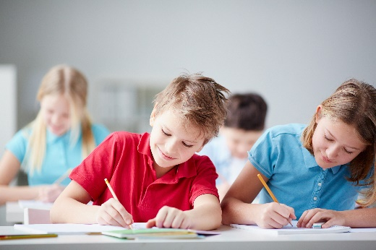
Appendix 5: Reflective journal
When students reflect on learning and analyse their own ideas and feelings, they self-evaluate, thereby improving their metacognitive skills. When students self-monitor or reflect, the most powerful learning happens.
Journaling may take the form of a written or digital journal, a portfolio or a digital portfolio. Early childhood classrooms may use a class reflective floor book with pictures of the learning experience and scribed conversations.
Teachers can model the Journaling process by thinking aloud and showing students how they can express learning and thoughts in a variety of ways including diagrams, pictures and writing.
Journals are a useful tool that gives teachers additional insight into how students value their own learning and progress, as well as demonstrating their individual achievements.
The following links provide background information and useful apps for Journaling.
Kidblog – digital portfolios and blogging
kidblog.org/home
Edmodo – for consolidating and storing class notes and learning materials
www.edmodo.com/
Explain Everything™ – a screen casting, video and presentation tool all in one
explaineverything.com
Popplet – allows you to jot down your ideas and then sort them visually
Popplet.com
Seesaw – for capturing work completed by students in class, using a device’s camera function
web.seesaw.me
Connect – the DoE teachers portal
connect.det.wa.edu.au
Evernote (a digital portfolio app)
evernote.com
Digital portfolios for students (Cool tools for school)
cooltoolsforschool.wordpress.com/digital-student-portfolios

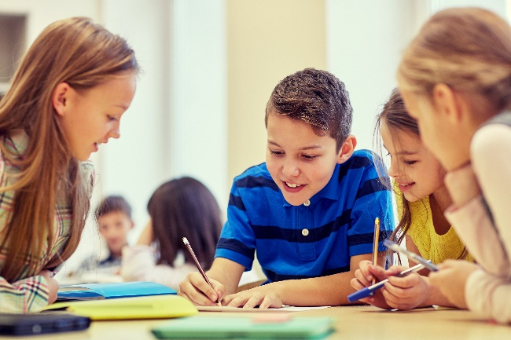
Appendix 6: Teacher resource sheet 1.1: Cooperative learning – Roles
Cooperative learning frameworks create opportunities for groups of students to work together, generally to a single purpose.
As well as having the potential to increase learning for all students involved, using these frameworks can help students develop personal and social capability.
When students are working in groups, positive interdependence can be fostered by assigning roles to group members.
These roles could include:
- working roles such as Reader, Writer, Summariser, Time-keeper.
- social roles such as Encourager, Observer, Noise monitor, Energiser.
Teachers using the Primary Connections roles of Director, Manager and Speaker for their science teaching may find it effective to also use these roles for STEM learning.
Further to this, specific roles can be delineated for specific activities that the group is completing.
It can help students if some background to the purpose of group roles is made clear to them before they start, but at no time should the roles get in the way of the learning. Teachers should decide when or where roles are appropriate to given tasks.
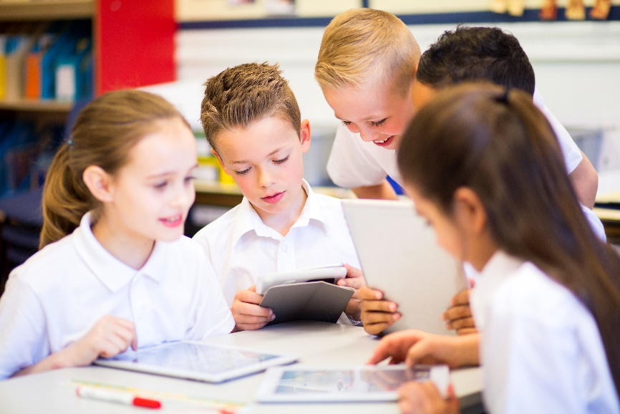

Appendix 7: Teacher resource sheet 1.2: Cooperative learning – Think, Pair, Share
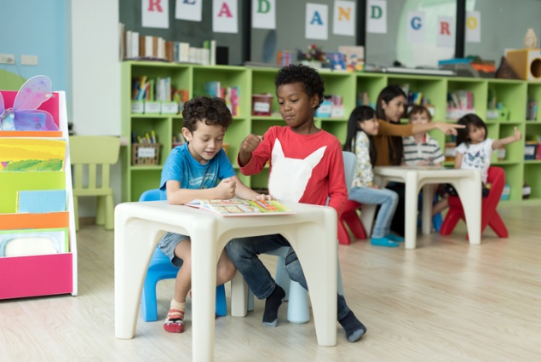
This resource sheet provides a brief outline of a cooperative learning strategy known as 'think – pair – share'.
Cooperative learning frameworks create opportunities for groups of students to work together, generally to a single purpose.
As well as having the potential to increase learning for all students involved, using these frameworks can help students develop personal and social capability.
In the 'think' stage, each student thinks silently about a question asked by the teacher.
In the 'pair' stage, students discuss their thoughts and answers to the question in pairs.
In the 'share' stage, the students share their answer, their partners answer or what they decided together. This sharing may be with other pairs or with the whole class. It is important also to let students 'pass'. This is a key element of making the strategy safe for students.
Think – pair – share increases student participation and provides an environment for higher levels of thinking and questioning.

Appendix 8: Teacher resource sheet 4.1: 3 – 2 – 1 Reflection
3 – 2 – 1 Reflection
Name | 3 things I learnt | 2 things I found interesting | 1 thing I found difficult

Notes
_______________________________________________________________________________________________________________________________________________________________________________________________________________________________________________________________________________________________________________________________________________________________________________________________________________________________________________________________________________________________________________________________________________________________________________________________________________________________________________________________________________________________________________________________________________________________________________________________________________________________________________________________________________________________________________________________________________________________________________________________________________________________________________________________________________________________________________________________________________________________________________________________________________________________________________________________________________________________________________________________________________________________________________________________________________________________________________________________________________________________________________________________________________________________________________________________________________________________

