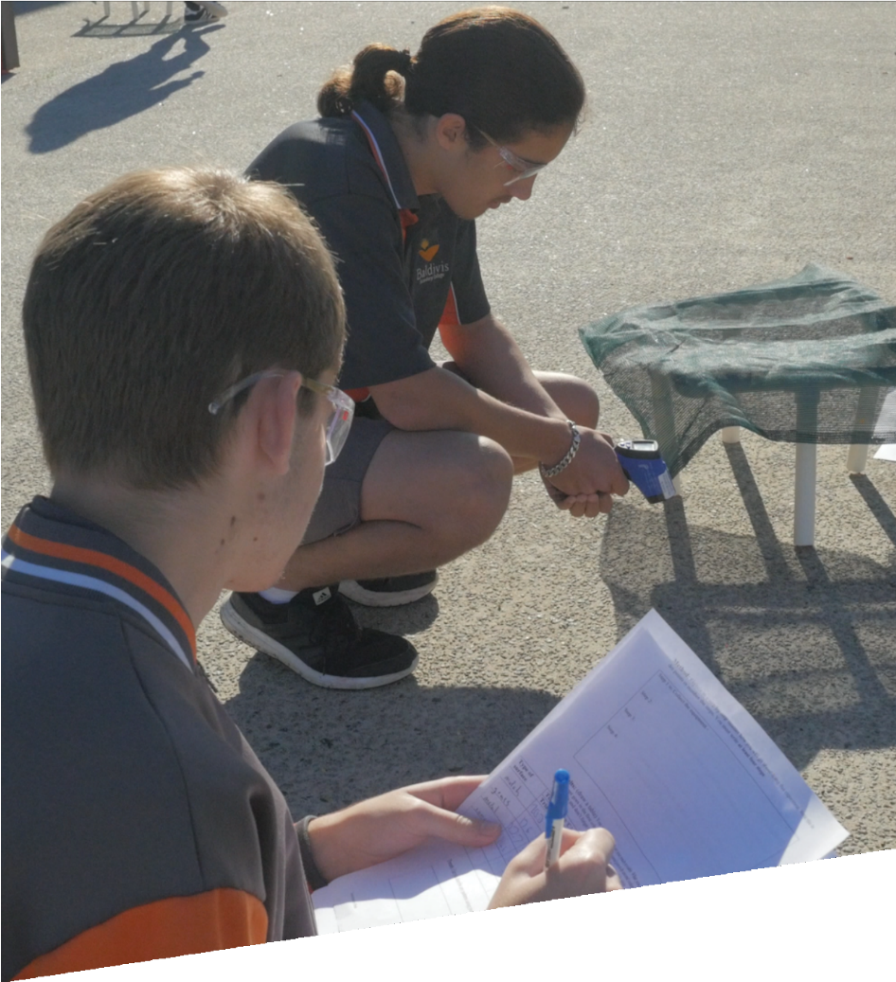

CURRICULUM RESOURCE MODULE
Keeping cool
YEAR 8

Acknowledgements
The STEM Learning Project respectfully acknowledges the Traditional Custodians of the lands upon which our students and teachers live, learn and educate.
The STEM Learning Project is funded by the Western Australian Department of Education (the Department) and implemented by a consortium in STEM education comprising the Educational Computing Association of WA, the Mathematical Association of WA, the Science Teachers Association of WA and Scitech. We acknowledge and thank the teachers and schools who are the co-creators of these resources.

Copyright and intellectual property
The copyright and intellectual property of this module remain the property of the Department.
Any Western Australian Curriculum content in this resource is used with the permission of the School Curriculum and Standards Authority; this permission does not constitute Authority endorsement of the resource. The Authority accepts no liability for any errors or damages arising from reliance on its content.
The Western Australian Curriculum content may be freely copied, or communicated on an intranet, for non-commercial purposes in educational institutions, provided that the Authority is acknowledged as the copyright owner. Copying or communication for any other purpose can be done only within the terms of the Copyright Act 1968 or with prior written permission of the Authority. Any Australian Curriculum content in the Western Australian Curriculum is used by the Authority under the terms of the Creative Commons Attribution NonCommercial 3.0 Australia licence.
Any content on the www.scsa.wa.edu.au domain that has been derived from the Australian Curriculum may be used under the terms of Creative Commons Attribution-NonCommercial 3.0 Australia licence.
Appendix 2: general capabilities continuums is adapted from ACARA, © Australian Curriculum, Assessment and Reporting Authority (ACARA) 2009 to present, unless otherwise indicated. This material was downloaded from the ACARA website (www.acara.edu.au) (accessed December 2015) and was not modified. The material is licensed under CC BY 4.0 (https://creativecommons.org/licenses/by/4.0/). ACARA does not endorse any product that uses ACARA material or make any representations as to the quality of such products. Any product that uses material published on this website should not be taken to be affiliated with ACARA or have the sponsorship or approval of ACARA. It is up to each person to make their own assessment of the product.
This resource includes references and examples of iOS, Android and other apps. The Department does not endorse or recommend any commercial products and simply provides these as examples for teachers.
The Department is committed to providing quality information to its customers. Whilst every effort has been made to ensure accuracy, currency and reliability of the information within these documents, the Department accepts no responsibility for errors, omissions or amendments made since the time of publishing. Confirmation of information may be sought from the Department or the originating bodies providing the information. The Department has no control over the content of material published on websites to which users are referred in this resource. It is the responsibility of the internet user to make their own decision as to the relevancy, accuracy, currency and reliability of information found on those sites.
Attributions: Google Maps, Google Earth and Google Docs; Office365, ArborCarbon, FLIR, WALGA, Kiblog, Weebly, Evernote, Tinkercad, Sketch Up.
Table of contents

The STEM Learning Project 2
Overview 3
Activity sequence and purpose 6
Background 7
Activity 1: Keeping cool 9
Activity 2: How cool is your surface? 17
Activity 3: Design a solution to keeping cool 22
Activity 4: Communicate, evaluate, justify 27
Appendix 1A: Links to the Western Australian Curriculum 29
Appendix 1B: Mathematics proficiency strands 31
Appendix 2: General capabilities continuums 32
Appendix 3: Materials list 35
Appendix 4: Design process guide 36
Appendix 4B: Drawing in the design process 37
Appendix 5: Student journal 38
Appendix 6: Student activity sheet 1.0: Journal checklist 39
Appendix 7: Teacher resource sheet 1.1: Cooperative learning – Roles 40
Appendix 8: Teacher resource sheet 1.2: Cooperative learning – Jigsaw 41
Appendix 9: Teacher resource sheet 1.3: Cooperative learning – Placemat 42
Appendix 10: Teacher resource sheet 1.4: Cooperative learning – Think, Pair, Share 43
Appendix 11: Teacher resource sheet 1.5: Thermal image interpretation 44
Appendix 12: Teacher resource sheet 1.6: Thermal images and maps 47
Appendix 13: Student activity sheet 1.7: Shade calculations 48
Appendix 14: Teacher resource sheet 2.1: WALGA article 51
Appendix 15: Student activity sheet 2.2: Planning and reporting investigations 53
Appendix 16: Student activity sheet 3.1: Your design 57
Appendix 17: Student activity sheet 3.2: Peer evaluation of solutions 60
Appendix 18: Student activity sheet 4.1: Peer evaluation 61
Appendix 19: Student activity sheet 4.2: Self-evaluation 62

The STEM Learning Project
The aim of the STEM Learning Project is to generate students’ interest, enjoyment and engagement with STEM (Science, Technology, Engineering and Mathematics) and to encourage their ongoing participation in STEM both at school and in subsequent careers. The curriculum resources will support teachers to implement and extend the Western Australian Curriculum and develop the general capabilities across Kindergarten to Year 12.
Why STEM?
A quality STEM education will develop the knowledge and intellectual skills to drive the innovation required to address global economic, social and environmental challenges.
STEM capability is the key to navigating the employment landscape changed by globalisation and digital disruption. Routine manual and cognitive jobs are in decline whilst non-routine cognitive jobs are growing strongly in Australia. Seventy-five per cent of the jobs in the emerging economy will require critical and creative thinking and problem solving, supported by skills of collaboration, teamwork and literacy in mathematics, science and technology. This is what we call STEM capability. The vision is to respond to the challenges of today and tomorrow by preparing students for a world that requires multidisciplinary STEM thinking and capability.
The approach
STEM capabilities are developed when students are challenged to solve open-ended, real-world problems that engage students in the processes of the STEM disciplines.
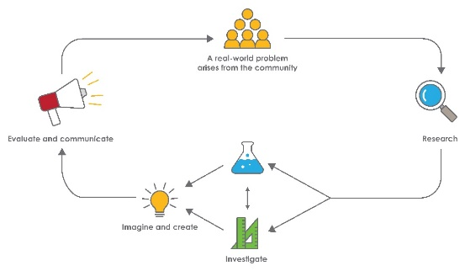
Year 8 – Keeping cool

Overview
What is the context?
As a result of climate change, communities are becoming aware of the need for more shade to help in keeping cool. In new housing areas there is often less shade from established trees and the ambient temperature can be as much as 6°C higher than in shady suburbs. This can impact on energy consumption and the health and wellbeing of a community.
The Australian Government's State of Australian Cities (2013) report stated that 'Major heat waves are Australia’s deadliest natural hazards, particularly for cities. Major heat waves have caused more deaths since 1890 than bushfires, cyclones, earthquakes, floods and severe storms combined' (Department of Infrastructure and Transport 2013).
What is the problem?
How can a community reduce the heating effect of the Sun?
How does this module support integration of the STEM disciplines?
Students are introduced to the technology of thermal (infrared) imagery. This technology, along with government reports, provides evidence of the ‘heat island’ effect.
Science
After writing a research question and making predictions (ACSIS139: Identify questions and problems that can be investigated scientifically and make predictions based on scientific knowledge), students design (ACSIS140: Collaboratively and individually plan and conduct a range of investigation types, including fieldwork and experiments, ensuring safety and ethical guidelines are followed) and conduct a science investigation and represent and analyse data (ACSIS144: Construct and use a range of representations, including graphs, keys and models to represent and analyse patterns or relationships in data using digital technologies as appropriate) about the effect of a variable on the transfer of heat energy to surfaces (ACSSU155: Energy appears in different forms, including movement (kinetic energy), heat and potential energy, and energy transformations and transfers cause change within systems). Students summarise and interpret data from a number of investigations (ACSIS145: Summarise data, from students’ own investigations and secondary sources, and use scientific understanding to identify relationships and draw conclusions based on evidence) about shade and surface types on ambient temperature.
Technology
Students imagine and design a biological or engineered solution that reduces the heat island effect in their community. They take into account social, economic and sustainability considerations in their design (ACTDEK029: Social, ethical and sustainability considerations, in the development of technologies and designed solutions, to meet community needs for economic, environmental and social sustainability). The design is communicated to an authentic audience using appropriate representations and technologies.
The Design process guide is included as a resource to provide assistance to teachers in understanding the complete design process as developed in the technologies curriculum.
Mathematics
Using Google Maps and grids, students analyse percentage tree canopy cover (ACMSP284: Investigate techniques for collecting data, including census, sampling and observation and ACMNA187: Solve problems involving the use of percentages, including percentage increases and decreases, with and without digital technologies) in local suburbs as well as the variation in cover (ACMSP293: Explore the variation of means and proportions of random samples drawn from the same population) and identify that tree canopy cover is related to the heat island effect.
General capabilities
There are opportunities for the development of general capabilities and cross-curriculum priorities as students engage with Keeping cool. In this module, students:
- Develop problem solving skills as they research the problem and its context (Activity1); investigate parameters impacting on the problem (Activity 2); imagine and develop solutions (Activity 3); and evaluate and communicate their solutions to an audience (Activity 4).
- Utilise creative thinking as they generate possible design solutions; and critical thinking, numeracy skills and ethical understanding as they choose between alternative approaches to solving the problem of reducing ambient temperatures resulting from heat island effects in ways that are sustainable.
- Utilise personal and social capability throughout the module as they develop socially cohesive and effective working teams; collaborate in generating solutions; adopt group roles; and reflect on their group work capabilities through self and peer evaluation.

- Utilise a range of literacies and information and communication technologies (ICT) capabilities as they collate records of work completed throughout the module in a journal; represent and communicate their solutions to an audience using digital technologies in Activity 4.
- Communicate and, using evidence, justify their group’s design to a local government councillor or community member either face-to-face, by letter or email.
What are the pedagogical principles of the STEM learning modules?
The STEM Learning Project modules develop STEM capabilities by challenging students to solve real-world problems set in authentic contexts. The problems engage students in the STEM disciplines and provide opportunities for developing higher order thinking and reasoning, and the general capabilities of creativity, critical thinking, communication and collaboration.
The design of the modules is based on four pedagogical principles:
- Problem-based learning
This is an underlying part of all modules with every module based around solving an initial problem. It is supported through a four-phase instructional model: research the problem and its context; investigate the parameters impacting on the problem; design and develop solutions to the problem; and evaluate and communicate solutions to an authentic audience.
- Developing higher order thinking
Opportunities are created for higher order thinking and reasoning through questioning and discourse that elicits students' thinking, prompts and scaffolds explanations and requires students to justify their claims. Opportunities for making reasoning visible through discourse are highlighted in the modules with the icon shown here.
- Collaborative learning
This provides opportunities for students to develop teamwork and leadership skills, challenge each other’s ideas, and co-construct explanations and solutions. Information that can support teachers with aspects of collaborative learning is included in the resource sheets.
- Reflective practice
Recording observations, ideas and one’s reflections on the learning experiences in some form of journal fosters deeper engagement and metacognitive awareness of what is being learned. Information that can support teachers with journaling is included in the resource sheets.
These pedagogical principles can be explored further in the STEM Learning Project online professional learning modules located in Connect Resources.

Activity sequence and purpose
Keeping cool
Analysis of thermal and Google Earth images captures students’ interest and engages them with environmental conditions that can create heat islands.
How cool is your surface?
Stu dents plan and conduct an investigation to gather evidence about factors that impact on the heating of surfaces and ambient air temperature.
Design a solution to keeping cool
Using evidence from their investigations, students design a solution that will reduce ambient temperatures.
Communicate, evaluate, justify
Groups pitch their solutions to a suitable audience such as a representative of local government. They provide a justification for their design based on evidence of a cooling effect and their reflections on the challenges faced when balancing financial, ethical and community concerns.

Background
Expected learning | Students will be able to:  - Analyse and interpret digital thermal and satellite images and use these to calculate the percentage of tree canopy and hard surface areas in a location and compare percentages between locations.  - Explain the relationship between types of ground cover, energy transfer and transformations and the heat island effect.  - Formulate a question, make predictions, plan and conduct an investigation of the impact of a variable on the heating of surfaces and the air above the surface.  - Create tabular and graphical representations of investigation data, and analyse and interpret the data using scientific principles.  - Research, imagine possibilities, design, develop, evaluate and improve a solution to the heating of our suburbs taking into account social, sustainability and economic considerations.  - Work effectively in groups to document their design using an appropriate graphical representation, technical terms and technology.  - Effectively communicate their ideas, arguments and evidence supporting their solution using appropriate technical language, representations and digital technologies.
Vocabulary | The following vocabulary list contains terms that need to be understood, either before the module commences or developed as they are used.  abiotic, absorption, ambient, biotic, conduction, convection, emission, heat island, heat sink, infrared, radiation, thermal image, tree canopy, transpiration.
Timing | There is no prescribed duration for this module. The module is designed to be flexible enough for teachers to adapt. Activities do not equate to lessons; one activity may require more than one lesson to implement.
Consumable materials | A Materials list is provided for this module. The list outlines materials outside of normal classroom equipment that will be needed to complete the activities.
Safety notes | There are potential hazards inherent in these activities and with the equipment being used, and a plan to mitigate any risks will be required.  Potential hazards specific to this module include but are not limited to:  - Possible exposure to cyber bullying, privacy violations and uninvited solicitations when using the internet.  - Sun exposure.  - Breakage of glass thermometers. Only digital or alcohol thermometers should be used.  - Hot water and hot calorimeters.  - Scissors, hot glue guns and sharp objects.
Assessment | The STEM modules have been developed to provide students with learning experiences to solve authentic real-world problems using science, technology, engineering and mathematics capabilities.  Appendix 1 indicates how the activities are linked to the Western Australian Curriculum.  While working through the module, the following assessment opportunities will arise:  - Analyses of the images in Activity 1.  - Investigation reports from Activity 2 Part 3.  - Design template summaries in Activity 3.  - Representations created to communicate their solution to an audience in Activity 4.  Evidence of learning from journaling, presentations and anecdotal notes from this module can contribute towards the larger body of evidence gathered throughout a teaching period and can be used to make on-balance judgements about the quality of learning demonstrated by the students in the science, technologies and mathematics learning areas.  Students can further develop the general capabilities within Information and communication technology (ICT) capability, Critical and creative thinking and Personal and social capability. Continuums for these are included in the General capabilities continuums but are not intended to be for assessment purposes.

Activity 1: Keeping cool
Activity focus | This activity is designed to capture students’ interest, provide an authentic data interpretation experience and engage students with the concepts of energy transfer and transformation. Students identify the problem of the heat island effect, its significance to communities and how this problem may be solved.  Students will:  - compare Google Earth images and thermal images to identify the relationship between types of ground cover and ambient temperatures  - calculate and compare the proportion of tree canopy cover to grass cover to hard surface cover in each area  - explain how different ground covers affect ambient temperatures in terms of heat transfers and transformations.
Background information | Heat island issues:  The Australian Government's State of Australian Cities (2013) report found that 'Major heat waves are Australia’s deadliest natural hazards, particularly for cities. Major heat waves have caused more deaths since 1890 than bushfires, cyclones, earthquakes, floods and severe storms combined' and that the heat island effect was ''caused by the prevalence in cities of heat-absorbing materials, such as dark-coloured pavements and roofs, concrete, urban canyons trapping hot air, and a lack of shade and green space' (Department of Infrastructure and Transport).  The Cool communities: Urban trees, climate and health report argues that trees make an important contribution to cooling our cities, stating that 'Heat from the atmosphere is used in vegetation transpiration processes which convert water from leaves to water vapour.  This has a cooling effect similar to that when humans perspire. It has been estimated that a mature tree can transpire up to 150 litres per day.  In a hot, dry location this produces a cooling effect similar to that of two air conditioners running for 20 hours' (Brown et al., 2013). See Digital resources for website link.  Depending on the species and its maturity, trees are very effective at blocking up to 95% of the Sun’s incoming radiation. They can reduce a building’s temperature by directly blocking radiation through windows and cooling the surrounding air. Trees can also keep the soil cool, providing a sink for heat from a building. 'Evapotranspiration and shading effects can reduce air temperatures by 1°C to 5°C' (Brown et al., 2013).  Infrared imagery is now being widely used to identify hot spots or heat islands. These can be correlated with satellite images such as Google Earth to map hot spots onto areas of ground cover type. This can then be used to determine the impacts of ground covers on heating effects. An example of such a thermal image can be found for Mosman Park at www.waclimate.net/imgs/perth-thermal.jpg  The Western Australian Local Government Association (WALGA) is highly proactive in encouraging local councils to increase tree canopy cover to reduce the heat island effect. A statement by WALGA President Lynne Craigie (2016) which gives a concise summary of the issue is provided as Teacher resource sheet 2.1: WALGA article.  Science background:  Heat can be transferred by radiation, convection and conduction. Radiation from the Sun in the form of light energy (short wavelengths) is absorbed by surfaces and then re-radiated as infrared rays (longer wavelengths). We experience this as heat. Not all of the energy received by a surface is absorbed, some is reflected.  Some surfaces absorb more energy than others. Absorption and emission of heat energy from surfaces, and the balance between these, will determine the temperature of the surface.  Factors which influence the absorption and emission of heat energy include the colour, texture and nature of the materials; the extent of shading; and the flow of air over the surface.  Hard surfaces such as roads, driveways and buildings are often fully exposed to radiation from the Sun and heat up quickly.  Lighter coloured and smooth surfaces tend to reflect more radiation than darker coloured and rough surfaces. Therefore, surfaces such as bitumen roads become very hot and radiate heat, thus increasing the temperature of the air above the road.  Architectural structures such as eaves, shade cloth, blinds and louvres block and reflect radiation, keeping areas behind them cooler than unshaded areas.  Trees confer many benefits. They reflect and block incident solar radiation, they absorb blue and red wavelengths of visible light for photosynthesis, and they release water vapour from their leaves by transpiration which also has a cooling effect. The air and ground beneath a tree canopy is far cooler than unshaded areas. Trees also create microclimates and habitats that support other plants and animals.
Instructional procedures | In Student activity sheet 1.7: Shade calculations the grid sheets enable students to work directly with the Google Earth images from a laptop, tablet screen or from a printed image. Thought needs to be given how scales can be kept constant when making comparisons.  If the Google Earth image is enlarged to street level, students can actually see and map the areas covered by tree canopy, grass, driveways, roofs and roads. Enlargement will also improve the accuracy of their estimations.  Students can also compare locations in older shady suburbs such as Inglewood and Mount Lawley with new suburbs such as Tapping or Butler. This may also be done for the community in which the students live or the school's location.
Expected learning | Students will be able to:  - Analyse and interpret thermal images and Google Earth satellite images (Science).  - Classify cover as tree canopy, grass or hard surface (Science).  - Calculate the percentage of tree canopy cover, grass cover and hard surface cover in an area (Mathematics).  - Use ratios and percentages to compare the proportion of tree canopy cover to grass cover and hard surface cover in different locations (Mathematics).  - Analyse and interpret data to determine the relationships between the types and proportions of cover and the heat island effect (Mathematics, Science).
Equipment required | For the class:  Device for projection, internet connection.  Five thermal images (supplied) to project onto the classroom screen.
For the students:
Teacher resource sheet 1.5: Thermal image interpretation
Teacher resource sheet 1.6: Thermal images and maps
Student activity sheet 1.7: Shade calculations
Devices to access Google Earth images.
Printed copies of images where these are preferred.
A 1 cm² grid on clear plastic A4 sheet. This is for estimating the percentage of different types of cover. These grids can be made by photocopying 1 cm² graph paper (preferably black) onto clear plastic overhead transparency sheets. The 1 cm² graph paper can be printed from the internet.
Preparation | Review the Teacher resource sheets and Student activity sheet, modifying to suit the class if necessary.  Load the necessary images and questions onto the classroom device for projection.  Photocopy the resource sheet and images that are to be analysed.  Prepare 1 cm² clear plastic grids.
Activity parts | Part 1: What do thermal images show  Students are shown the five infrared images from Teacher resource sheet 1.5: Thermal image interpretation.  Using the questions on the resource sheet students share their ideas about infrared images and how they can be interpreted. Students should record their responses in their journals.
Part 2: Thermal imaging of locations
Students are shown the ArborCarbon infrared image and the Google Earth image of Jandakot. (See Teacher resource sheet 1.6: Thermal images and maps). They identify warm and cool areas in the infrared image. They identify the airport runway and areas with tree and grass cover in the Google Earth image.
As before, question the students to help them identify the relationships between types of ground cover and surface temperatures. Establish that areas of tree or grass cover are cooler than areas of hard surface cover.
Introduce the problem of the heat island effect and its impact on quality of life and explain that in this module they will research and design solutions to the problem.
When making the comparisons it is important to have maps of the same location and of an equivalent scale.
These two maps are on Teacher resource sheet 1.6: Thermal images and maps with links to locate them on the internet.
The thermal map is the second image at
www.arborcarbon.com.au/project-urban-island.html
The Google map is drawn using
www.google.com.au/maps/@-32.1099804,115.8899089,6185m/data=!3m1!1e3
It is important to be aware that the on-screen Google map will vary depending on the window size and will change scale if the zoom is used. Hence setting up a map equivalent to the size and scale of the thermal image can be difficult.
If preferred, A4 size equivalent images can printed for students from:
Comparative Jandakot Google Map (pdf)
Comparative Arbor Carbon Jandakot thermal map (jpg)
Part 3: Ground cover types and ratios (students in groups)
In this part students compare proportions of ground cover types in three locations of the Jandakot area on the Jandakot map used in Part 1.

Once the map is available to the students, either on their screens or on a printed A4 sheet, they should use their 1 cm² grid sheet to complete the tasks on Student activity sheet 1.7: Shade calculations.
For example, holding the grid over the Glen Iris area might show 6 cm² of tree canopy cover, 10 cm² of grass cover and 9 cm² of hard surface cover. The values will need to be approximate as each square centimeter may not be all of one type of cover.
In Task 5 students will need to look at the ratios they have generated for Task 2, along with their findings from Task 3, to propose some ratios that identify hot and cool areas. In Task 6 they should verify their proposed ratios against the three given locations to ensure the results match their views from Task 3.
They may subsequently use these ratios when completing Task 7 and looking at other suburbs.
Part 4: Discussion of findings
Once the students have completed Student activity sheet 1.7: Shade calculations, discuss the findings of the activity with the class. This should be followed by an outline of the scientific principles that explain these findings.
Dark surfaces such as the bitumen of roads reflect very little solar energy (about 5%), most of it is absorbed (95%) and transformed into heat energy. Some of this heat is then radiated back to the air above the road so that both the road and the air above it become warmer.
Trees and grass reflect about 30% of solar radiation and absorb 70%.
Of the absorbed energy some is used in photosynthesis and a high proportion is used to evaporate water from the pores in the leaves (latent heat of evaporation), and just like an evaporative air conditioner, this cools the surrounding air.
The video Energy from the Sun and Heat Transfer (see Digital resources) explains that the amount of solar energy reflected back to the atmosphere (albedo) depends on the type of surface, with white snow having a high albedo, reflecting back as much as 95% of the incoming solar energy. The clip goes on to explain the three main types of energy transfer (radiation, convection and conduction).
Part 5: Recording
Students should collate completed materials in a journal. This journal should also be updated with the students' reflections at the ends of each activity.
A guide to Student journals and a Journal checklist are included as resources supporting this module.
Additional learning experiences
Mathematics:
Develop a task that relates zoned house block sizes to the proportion of each ground cover (and hence heat issues). This will be most informative if the suburbs considered are of varying types (eg leafy green older suburbs and newer suburbs).
Science/Technologies:
Develop a task where students are required to colour images according to what they believe the thermal absorption properties are. These images can be of animals, where the students can use their understandings to predict thermal zones. They may also be of buildings or land areas based on the knowledge and understandings they develop in this module.
Resource sheets | Teacher resource sheet 1.5: Thermal image interpretation  Teacher resource sheet 1.6: Thermal images and maps  Student activity sheet 1.7: Shade calculations
Digital resources | State of Australian Cities 2013 (Department of Infrastructure and Transport, 2013)  infrastructure.gov.au/infrastructure/pab/soac/files/2013_08_INFRA1782_MCU_SOAC_CHAPTER_4_WEB_FA.pdf
Cool communities: Urban trees, climate and health (Brown H, Katscherian D, Carter M & Spickett J, 2013)
ehia.curtin.edu.au/local/docs/CoolCommunities.pdf
Energy scan shows gap between rich and poor (The West Australian newspaper)
www.waclimate.net/imgs/perth-thermal.jpg

Materials that make heat worse for our kids demand a rethink by designers (The Conversation – April 2018)
theconversation.com/materials-that-make-heat-worse-for-our-kids-demand-a-rethink-by-designers-93274?utm_medium=email&utm_campaign=Latest%20from%20The%20Conversation%20for%20April%2011%202018%20-%2098968596&utm_content=Latest%20from%20The%20Conversation%20for%20April%2011%202018%20-%2098968596+CID_ccc8d2881f48d9c59f03b7aa8c24bcd8&utm_source=campaign_monitor&utm_term=Materials%20that%20make%20heat%20worse%20for%20our%20kids%20demand%20a%20rethink%20by%20designers
Urban heat island mapping project maps (ArborCarbon)
www.arborcarbon.com.au/project-urban-island.html
Map of Perth southern suburbs (Google Maps, 2017)
google.com.au/maps/@-32.1099804,115.8899089,6185m/data=!3m1!1e3
Energy from Sun and Heat Transfer (Scott Goetsch, 2014)
www.youtube.com/watch?v=MYPbqsv5UUc
Discovery of infra-red (Dave Evans, 2012)
www.youtube.com/watch?v=_L7UlqldGuQ
This site is interesting as it re-enacts Herschel’s experiments with colours and temperatures and the discovery of ‘infrared’ radiation.
How infrared imaging cameras work (Air Concern, 2012)
www.youtube.com/watch?v=jX0gIWU49iI
By FLIR Technologies for the Herschel Experiment
Infra-red radiation (Dave Evans, 2012)
www.youtube.com/watch?v=xZVPhWxC9V8
This video is about night vision cameras and how they work.
Near-infrared imagery (Landgate, 2017)
www0.landgate.wa.gov.au/maps-and-imagery/imagery/aerial-photography/near-infrared-imagery
Comparing canopy and infrared imagery of areas around Perth.

Activity 2: How cool is your surface?
Activity focus | In this activity, students will be challenged to design, conduct and evaluate a science investigation that will provide evidence about factors impacting on heat transfer.  Students will:  - work in collaborative learning groups to plan and conduct an investigation  - submit an individual written report.
Background information | Any solution that reduces the heating effect around our homes would need to take into account variables such as materials, shading and wind. Groups of three or four students investigate one of these variables, confer with others who have studied the same variable, and then report their findings to the class.  Variables and research questions that could be investigated might include:  How does the colour of a material affect how much heat it absorbs?  - Colour of surfaces can be investigated using tin cans painted different colours placed at equal distances from a heat lamp or incandescent globe and the temperature inside the cans recorded at standard time intervals.  How does the rating of shade cloth affect the temperature of a shaded surface and the air above?  - The effect of shade density can be investigated using shade cloth of different percentage ratings. This could be done using a heat source suspended over the different shade cloths for standard times over standard surfaces. This would allow comparisons to be made between the temperature of the shaded surface and the temperature above the shade cloth using a temperature probe or thermometer.  How does the density of natural shade affect the temperature of soil and the air above the soil surface?  - The effect of natural shade from trees on air and ground temperatures can be investigated by recording air and surface soil temperatures in more and less densely shaded locations under trees on a warm and sunny day.  How does the speed of wind affect the temperature of a surface and the air above?  - The effect of wind speed can be investigated by suspending a heat lamp or incandescent globe over a surface which is exposed to wind of different speeds generated by an electric fan. Temperatures of the surface and air above the surface could be measured with a temperature probe or thermometer.  Students should collect and represent data from these investigations for analysis.  Depending on the investigation, the data collected may be continuous (time, temperature, shade cloth density) or discrete (colour, high/medium/low wind speeds).  Graphical representation of the data will be either a line graph (continuous data) or a bar or column graph (discrete). Correct selection and use of these graphs is an important skill for students to learn.  Note: Temperature change will only occur over extended periods of time, especially with wind effect which causes only a marginal shift in temperature. Plan to provide other learning for students to engage in while they are monitoring their experiments.
Instructional procedures | There are various opportunities for students to work collaboratively throughout this activity and module.  The following resources provide direction and information on how to use four cooperative learning techniques:  Teacher resource sheet 1.1: Cooperative learning – Roles  Teacher resource sheet 1.2: Cooperative learning – Jigsaw  Teacher resource sheet 1.3: Cooperative learning – Placemat  Teacher resource sheet 1.4: Cooperative learning – Think, Pair, Share
Expected learning | Students will be able to:  - Identify independent and dependent variables, and formulate a research question to investigate and make a prediction (Science).  - Plan a controlled experiment to investigate their research question, and collect and record data (Science).  - Represent data as tables and graphs as appropriate (Mathematics).  - Interpret the impact of the variables investigated on the heating of surfaces and air using concepts of energy transfer and transformation by analysing data, and identifying patterns and relationships (Mathematics and Science).
Equipment required | For the class:  Device for projection, internet connection.
For the students:
A variety of materials to choose from, depending on the variables tested (eg heat sources, thermometers, data loggers or temperature probes, shade cloth of varying densities, tin cans painted black, green, white and silver, and electric fans to simulate air flow).
Preparation | Gather the materials for the range of investigations to be conducted. Shade cloth can be purchased at hardware stores for about $25/metre.  Review the content description: Energy appears in different forms, including movement (kinetic energy), heat and potential energy, and energy transformations and transfers cause change within systems (ACSSU155).  Review the Science inquiry skills content descriptions related to this investigation to determine the level of support students require. Many Year 8 students will need scaffolding to formulate a research question and plan a controlled experiment.  The template Student activity sheet 2.2: Planning and reporting investigations is provided as a Word document that can be edited to suit the needs of your class.  It is also likely the procedures for taking the temperature of surfaces, soils and liquids will need to be reviewed so reliable data are collected.  Ensure that with collection of data, all groups provide it in a consistent form so that it can be collated in Part 4.
Activity parts | Part 1: Tree canopy cover  Students read the article published in The West Australian that outlines the views of the WA Local Government Association (WALGA) on the need for more shade and cooler suburbs (see Teacher resource sheet 2.1: WALGA article).  Discuss the graph of percentage tree canopy cover in different Perth local government areas using the following photo.  Canopy cover (%) for selected West Australian Local Government Areas  www.watoday.com.au/content/dam/images/g/j/n/8/7/j/image.related.articleLeadwide.620x349.gjn834.png/1449019684928.png
Part 2: Plan the investigation
Brainstorm independent and dependent variables and research questions for investigation (examples are listed in Background information).
Each group of students decides on a research question and plans an investigation. Students can use Student activity sheet 2.2: Planning and reporting investigations to design their investigation.
Part 3: Conduct the investigation
Groups conduct their investigations, document their findings in their journals and interpret their results with support as appropriate.
The use of various types of temperature measuring devices such as alcohol thermometers, maximum minimum thermometers and digital data loggers in these investigations will provide the opportunity for comparisons between data as well as extending skills in digital technology.
The data interpretation and reporting of findings can be completed as an individual activity and submitted to facilitate individual assessment.
Part 4: Reporting back
Facilitate the groups reporting back to the class so that findings from each of the investigations are shared. This may be done using a shared document technology such as Office365 or Google Docs to develop the students' skills in this area. Discussions in Connect classrooms could also be used for this purpose.
Discuss the limitations of the investigations, the scientific principles involved and how the findings inform the nature of the problem of heat islands making our suburbs hotter.
Resource sheets | Teacher resource sheet 2.1: WALGA article  Student activity sheet 2.2: Planning and reporting investigations
Digital resources | Canopy cover (%) for selected West Australian Local Government Areas (University of Technology Sydney, 2014)  www.watoday.com.au/content/dam/images/g/j/n/8/7/j/image.related.articleLeadwide.620x349.gjn834.png/1449019684928.png
Trees cut heat on city’s streets – City of Perth (ArborCarbon, 2016)
arborcarbon.com.au/blog/trees-cut-heat-on-citys-streets-city-of-perth/
UTS researchers tackle Australia’s first urban tree analysis (University of Technology Sydney, 2014)
newsroom.uts.edu.au/news/2014/07/uts-researchers-tackle-australias-first-urban-tree-analysis
Where are all the trees? An analysis of tree canopy cover in urban Australia (202020 Vision, 2014)
202020vision.com.au/media/7145/where_are_all_the_trees.pdf

Activity 3: Design a solution to keeping cool
Activity focus | In this activity students will design a solution to reduce the heating effect of the Sun taking account of the evidence from the investigations in Activity 2.
Background information | The main variables that can reduce the heating effect are shade, air flow and the size and nature of exposed surfaces which vary in the extent to which they reflect or absorb radiant energy. Any design solution will need to take account of these variables.  While the students are completing their designing of the solution, use the following questions to ensure they have considered necessary factors.  - How can shading and air flow be increased?  - How can surfaces that are good absorbers of radiant energy be reduced in area?  - How can surfaces that are good absorbers be replaced or covered by surfaces that absorb less energy?  Design solutions might involve engineered mechanical structures that maximise shade or biological solutions such as street trees, more grassed areas or alternatives such as wall gardens. Solutions may also be a combination of changes.  A set of design principles or objectives helps a design team ensure they develop a design that meets the requirements of the community and goals related to sustainability. Hence student groups should be encouraged to formulate a set of design principles.  To offer a sustainable solution, the design would need to:  - be acceptable to the community  - be aesthetically pleasing  - be inexpensive  - minimise the use of non-renewable resources  - be energy efficient  - be durable  - need little maintenance  - satisfy Local Government regulations.
Instructional procedures | It is expected that students will work in groups to develop a design solution. To allow for individual assessment, students will individually document their design, the design principles they followed and the scientific justification.  Additional learning experiences:  - Students could construct a 3D model of their design.  - Students could work with a Design and Technology teacher to build the design.
Expected learning | Students will be able to:  - Research, imagine possibilities, design, develop, and evaluate and improve a solution to the heating of our suburbs (Technologies).  - Document their design using an appropriate graphical representation, technical terms and technology (Technologies).  - Outline the design principles and the scientific justification for their solution (Science, Technologies).
Equipment required | For the class:  Data projector, laptop and screen, internet connection.
For the students:
Materials depending on requirements (eg computers and software for design, paper, pencils, rulers).
Preparation | Review examples of solutions including those listed in Part 1.  Decide the extent to which digital technologies will be utilised in designing, documenting and sharing processes, and which hardware and software options will be utilised.  If students choose to draw their plan digitally then software such as Sketch Up or Tinkercad will need to be organised. Support for these can be found in the Drawing in the design process resource sheet.  Consider which materials might be required if students are constructing models.  Source local council requirements for students to use in Part 2.
Activity parts | Part 1: Community solutions  Engage students in the concept of a solution to keeping cool by researching different types of solutions from Australasia.  - Vertical gardens such as the Blanc Building, One Central Park Sydney, NSW  www.centralparksydney.com/explore/the-visionaries/patrick-blanc  - An example of engineered ‘abiotic’ structures such as Supertree Grove, Singapore  www.gardensbythebay.com.sg/en/the-gardens/supertree-grove/visitor-information.html  www.nparks.gov.sg/news/2011/6/gardens-by-the-bay--supertrees  grant-associates.uk.com/projects/super-trees  - Cool communities: Urban trees, climate and health  ehia.curtin.edu.au/local/docs/CoolCommunities.pdf  - The Calyx, Royal Botanic Garden Sydney  www.rbgsyd.nsw.gov.au/About-Us/Major-Projects/The-Calyx  Most local government councils provide street tree planting programs and guidelines which can be accessed from their websites.  Local parks within suburbs are also a means of reducing the heat absorbed from the sun.  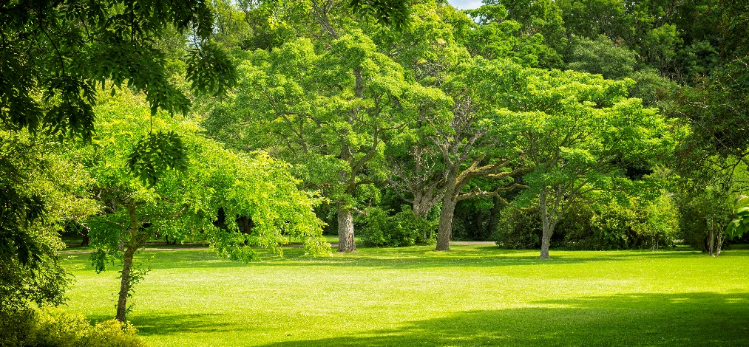
Part 2: The model
Students work in groups and decide whether the product will be a drawn plan (digital or by hand) and/or a 3D model. Both will require written documentation and a scientific and design justification.
Introduce the task and offer the following guiding questions:
- What type of location will you choose: the students’ school, suburb, a local park, street or playground?
- What parameters impact on ambient temperatures?
- What scientific principles should inform the design?
- How can you ensure the solution is one that is acceptable to the community and the local council, and is sustainable?
- Is a biological (biotic) or engineered (abiotic) solution the best option for your location?
- How will you know your solution is effective?
Note: It is important to ensure that students understand the local council requirements as mentioned in Question 4 and these should be sourced by the teacher and provided to the students. These requirements will be 'checked' later in Student activity sheet 3.1 Your design.
Part 3: Timeline
As a class, produce a checklist and timeline for progress and completion of the design project. This might involve a mix of Science class time, Design and Technology class time and homework. Student groups discuss plans and progress them with support.
Gantt charts could be used here to illustrate the project schedule. See this link for reference:
www.smartsheet.com/blog/gantt-chart-excel
Part 4: Recording
On completion of the design phase, students document their design. This can be done using Student activity sheet 3.1: Your design or a suitable alternative.
This documentation could be shared using technology such as Office365, Google Docs or Discussions in Connect classrooms.

Groups of students present their solution to the class for evaluative feedback.
Students watching the presentation can evaluate the designs by making notes on the Student activity sheet 3.2: Peer evaluation of design.
Feedback could also be shared using Connect, Office365, Google Docs or similar. Sharing of the evaluations needs to be facilitated so that each group of students is provided with feedback on their design so that it can be reviewed and improved if necessary.
Student journals should be updated with learnings from this activity.
Resource sheets | Student activity sheet 3.1: Your design  Student activity sheet 3.2: Peer evaluation of design
Digital resources | Stirling Urban Tree Network  stirlingtrees.com/videos/
Patrick Blanc on One Central Park’s vertical gardens (Central Park Sydney, 2017)
www.centralparksydney.com/explore/the-visionaries/patrick-blanc
The Calyx (Royal Botanic Garden Sydney, 2017)
www.rbgsyd.nsw.gov.au/About-Us/Major-Projects/The-Calyx
Gardens by the Bay Supertrees, Singapore - An example of engineered ‘abiotic’ structures.
Supertree Grove (Gardens by the Bay, 2017)
www.gardensbythebay.com.sg/en/the-gardens/supertree-grove/visitor-information.html
Gardens by the Bay – Supertrees (National Parks Singapore, 2011)
www.nparks.gov.sg/news/2011/6/gardens-by-the-bay--supertrees
Gardens by the Bay – Supertrees (Grant Associates, 2017)
grant-associates.uk.com/projects/super-trees/
Cool communities: Urban trees, climate and health (Brown H, Katscherian D, Carter M & Spickett J, 2013)
ehia.curtin.edu.au/local/docs/CoolCommunities.pdf

Activity 4: Communicate, evaluate, justify
Activity focus | In this activity groups ‘pitch’ their designs, or the best designs selected by the class, to representatives of the community for which they have developed the solutions. The pitch will describe their proposed solution and their reflections on the challenges faced. These may include balancing financial, ethical, sustainability and community concerns. The students will justify their design using scientific, mathematical and design principles explaining how their solution would ameliorate the heating of the location in summer. The pitch may involve face-to-face presentations or the writing of emails or letters.
Background information | Students have the opportunity to revise their design, presentation and justifications so they can effectively communicate them to an authentic audience. This provides opportunities for clarification and elaboration of students’ thinking about scientific, mathematical and design principles addressed through their problem-solving work.
Expected learning | Students will be able to:  - Work effectively in groups to develop appropriate representations of their solution that can be communicated to an audience (Technologies).  - Provide a clearly argued justification that demonstrates their understanding of the design and the scientific and mathematical principles on which it is based (Science, Mathematics and Technologies).  - Effectively communicate their ideas, arguments and evidence supporting their solution using appropriate technical language, representations and digital technologies (Technologies).
Equipment required | For the class:  Data projector, laptop and screen, internet connection.
For the students:
Materials depending on requirements (eg laptops, paper and writing instruments).
Preparation | Nil
Activity parts | Part 1: Reviewing designs  Groups review the peer evaluations of their designs and modify Student activity sheet 3.1: Your design as necessary.
Part 2: Selecting the best designs
Class meeting-style discussion where decisions are made about which designs should be communicated and the appropriate audience and mode of communication. Tasks are allocated to students to identify key people from the relevant community groups (eg local councillor, chairperson of school P&C, a parent who is a member of a street community or a resident close to a park), find their contact details, and to arrange appropriate times and means of communicating the design solutions. A school P&C meeting with invited guests might be a suitable forum for the presentations.
Part 3: Preparing for the presentation
Provide a combination of class and homework time for the development and review of the letters, emails or presentations.
Part 4: Building an audience
Invite community members to the presentation of the students’ solutions or develop a covering letter to go with the design solutions to be posted to community members.
Another method of sharing the student's solutions would be using Connect classrooms.
Part 5: Presentations
Delivery of the presentations. This should be using a digital presentation format such as PowerPoint or similar.
Resource sheets | Student activity sheet 4.1: Peer evaluation  Student activity sheet 4.2: Self-evaluation

Appendix 1A: Links to the Western Australian Curriculum
The Keeping cool module provides opportunities for developing students’ knowledge and understandings in science, technologies and mathematics. The table below shows how this module aligns to the content of the Western Australian Curriculum and can be used by teachers for planning and monitoring.
KEEPING COOL  Links to the Western Australian Curriculum | ACTIVITY
 | 1 | 2 | 3 | 4
SCIENCE
SCIENCE UNDERSTANDING
Physical sciences: Energy appears in different forms, including movement (kinetic energy), heat and potential energy, and energy transformations and transfers cause change within systems (ACSSU155) |  |  | ●
SCIENCE INQUIRY SKILLS
Questioning and predicting: Identify questions and problems that can be investigated scientifically and make predictions based on scientific knowledge (ACSIS139) |  |  | ●
Planning and conducting: Collaboratively and individually plan and conduct a range of investigation types, including fieldwork and experiments, ensuring safety and ethical guidelines are followed (ACSIS140) |  |  | ●
Processing and analysing: Construct and use a range of representations, including graphs, keys and models to represent and analyse patterns or relationships in data using digital technologies as appropriate (ACSIS144) |  |  | ●
Processing and analysing: Summarise data, from students’ own investigations and secondary sources, and use scientific understanding to identify relationships and draw conclusions based on evidence (ACSIS145) |  |  | ●
DESIGN AND TECHNOLOGIES
KNOWLEDGE AND UNDERSTANDING
Technologies and society: Social, ethical and sustainability considerations, in the development of technologies and designed solutions, to meet community needs for economic, environmental and social sustainability (ACTDEK029) | ● | ●
PROCESS AND PRODUCTION SKILLS
Designing: Design, develop, evaluate and communicate alternative solutions, using appropriate technical terms and technology | ● | ●

MATHEMATICS
NUMBER AND ALGEBRA
Real numbers: Solve problems involving the use of percentages, including percentage increases and decreases, with and without digital technologies (ACMNA187) | ● |  |  | ●
STATISTICS AND PROBABILITY
Data representation and interpretation: Investigate techniques for collecting data, including census, sampling and observation (ACMSP284) |  | ●
Data representation and interpretation: Explore the variation of means and proportions of random samples drawn from the same population (ACMSP293) |  | ●
Further information about assessment and reporting in the Western Australian Curriculum can be found at: https://k10outline.scsa.wa.edu.au/home

Appendix 1B: Mathematics proficiency strands
Key ideas
In Mathematics, the key ideas are the proficiency strands of understanding, fluency, problem-solving and reasoning. The proficiency strands describe the actions in which students can engage when learning and using the content. While not all proficiency strands apply to every content description, they indicate the breadth of mathematical actions that teachers can emphasise.
Understanding
Students build a robust knowledge of adaptable and transferable mathematical concepts. They make connections between related concepts and progressively apply the familiar to develop new ideas. They develop an understanding of the relationship between the ‘why’ and the ‘how’ of mathematics. Students build understanding when they connect related ideas, when they represent concepts in different ways, when they identify commonalities and differences between aspects of content, when they describe their thinking mathematically and when they interpret mathematical information.
Fluency
Students develop skills in choosing appropriate procedures; carrying out procedures flexibly, accurately, efficiently and appropriately; and recalling factual knowledge and concepts readily. Students are fluent when they calculate answers efficiently, when they recognise robust ways of answering questions, when they choose appropriate methods and approximations, when they recall definitions and regularly use facts, and when they can manipulate expressions and equations to find solutions.
Problem-solving
Students develop the ability to make choices, interpret, formulate, model and investigate problem situations, and communicate solutions effectively. Students formulate and solve problems when they use mathematics to represent unfamiliar or meaningful situations, when they design investigations and plan their approaches, when they apply their existing strategies to seek solutions, and when they verify that their answers are reasonable.
Reasoning
Students develop an increasingly sophisticated capacity for logical thought and actions, such as analysing, proving, evaluating, explaining, inferring, justifying and generalising. Students are reasoning mathematically when they explain their thinking, when they deduce and justify strategies used and conclusions reached, when they adapt the known to the unknown, when they transfer learning from one context to another, when they prove that something is true or false, and when they compare and contrast related ideas and explain their choices.
Source: www.australiancurriculum.edu.au/f-10-curriculum/mathematics/key-ideas/?searchTerm=key+ideas#dimension-content

Appendix 2: General capabilities continuums
The general capabilities continuums shown here are designed to enable teachers to understand the progression students should make with reference to each of the elements. There is no intention for them to be used for assessment.
Information and communication technology (ICT) capability learning continuum
Sub-element | Typically by the end of Year 6 | Typically by the end of Year 8 | Typically by the end of Year 10
Create with ICT  Generate ideas, plans and processes | use ICT effectively to record ideas, represent thinking and plan solutions | use appropriate ICT to collaboratively generate ideas and develop plans | select and use ICT to articulate ideas and concepts, and plan the development of complex solutions
Create with ICT  Generate solutions to challenges and learning area tasks | independently or collaboratively create and modify digital solutions, creative outputs or data representation/transformation for particular audiences and purposes | design and modify simple digital solutions, or multimodal creative outputs or data transformations for particular audiences and purposes following recognised conventions | design, modify and manage complex digital solutions, or multimodal creative outputs or data transformations for a range of audiences and purposes
Communicating with ICT  Collaborate, share and exchange | select and use appropriate ICT tools safely to share and exchange information and to safely collaborate with others | select and use appropriate ICT tools safely to lead groups in sharing and exchanging information, and taking part in online projects or active collaborations with appropriate global audiences | select and use a range of ICT tools efficiently and safely to share and exchange information, and to collaboratively and purposefully construct knowledge

Critical and creative thinking learning continuum
Sub-element | Typically by the end of Year 6 | Typically by the end of Year 8 | Typically by the end of Year 10
Inquiring – identifying, exploring and organising information and ideas  Organise and process information | analyse, condense and combine relevant information from multiple sources | critically analyse information and evidence according to criteria such as validity and relevance | critically analyse independently sourced information to determine bias and reliability
Generating ideas, possibilities and actions  Imagine possibilities and connect ideas | combine ideas in a variety of ways and from a range of sources to create new possibilities | draw parallels between known and new ideas to create new ways of achieving goals | create and connect complex ideas using imagery, analogies and symbolism
Generating ideas, possibilities and actions  Seek solutions and put ideas into action | assess and test options to identify the most effective solution and to put ideas into action | predict possibilities, and identify and test consequences when seeking solutions and putting ideas into action | assess risks and explain contingencies, taking account of a range of perspectives, when seeking solutions and putting complex ideas into action
Reflecting on thinking and processes  Transfer knowledge into new contexts | apply knowledge gained from one context to another unrelated context and identify new meaning | justify reasons for decisions when transferring information to similar and different contexts | identify, plan and justify the transfer of knowledge to new contexts

Personal and social capability learning continuum
Sub-element | Typically by the end of Year 6 | Typically by the end of Year 8 | Typically by the end of Year 10
Social management  Work collaboratively | contribute to groups and teams, suggesting improvements in methods used for group investigations and projects | assess the extent to which individual roles and responsibilities enhance group cohesion and the achievement of personal and group objectives | critique their ability to devise and enact strategies for working in diverse teams, drawing on the skills and contributions of team members to complete complex tasks
Social management  Negotiate and resolve conflict | identify causes and effects of conflict, and practise different strategies to diffuse or resolve conflict situations | assess the appropriateness of various conflict resolution strategies in a range of social and work-related situations | generate, apply and evaluate strategies such as active listening, mediation and negotiation to prevent and resolve interpersonal problems and conflicts
Social management  Develop leadership skills | initiate or help to organise group activities that address a common need | plan school and community projects, applying effective problem-solving and team-building strategies, and making the most of available resources to achieve goals | propose, implement and monitor strategies to address needs prioritised at local, national, regional and global levels, and communicate these widely  discuss the concept of leadership and identify situations where it is appropriate to adopt this role
Further information about general capabilities is available at:
k10outline.scsa.wa.edu.au/home/p-10-curriculum/general-capabilities-over/general-capabilities-overview/general-capabilities-in-the-australian-curriculum

Appendix 3: Materials list
The following materials are required to complete this module.
Cover type calculations:
A 1 cm² grid on clear plastic A4 sheet. This is for estimating the percentage of different types of cover. These grids can be made by photocopying 1 cm² graph paper (preferably black) onto clear plastic overhead transparency sheets. The 1 cm² graph paper can be printed from the internet (ensure the correct type of transparency sheets are being used when photocopying).
Heat transfer investigations:
- Shade cloth of varying densities
- Tin cans of equal sizes painted black, green, white and silver
- Electric fans
- Heat sources
- Thermometers, data loggers or temperature probes
Images:
- A4 size thermal image of Jandakot area
- A4 size Google Earth satellite image of Jandakot area

These two images are shown on Teacher resource sheet 1.6: Thermal images and maps with links to locate them on the internet.
The thermal map is the second image at
www.arborcarbon.com.au/project-urban-island.html
The Google map is drawn using
www.google.com.au/maps/@-32.1099804,115.8899089,6185m/data=!3m1!1e3
It is important to be aware that the on-screen Google map will vary depending on the window size, and will change scale if the zoom is used. Hence setting up a map equivalent to the size and scale of the thermal image can be difficult.
If preferred, A4 size equivalent images can be linked to and printed for students from:
Comparative Jandakot Google Map (pdf)
Comparative Arbor Carbon Jandakot thermal map (jpg)
For additional learning opportunity:
To construct a model of their design students will require suitable materials, dependent on the design.

Appendix 4: Design process guide
Safe production of the final design or multiple copies of the final design.
Fine tuning the production process, such as division of labour for batch or mass production.
Use of intended materials and appropriate tools to safely make the solution to the design problem.
Reflection on the process taken and the success of the design.
Evaluation can lead to further development or improvement of the design and can be a final stage of the design process before a conclusion is reached.
Could be formal or informal and verbal or written.
Ideation
Development
Development of the design ideas. Improvements, refinements, adding detail, making it better.
Activities such as detailed drawings, modelling, prototyping, market research, gaining feedback from intended user, further research – if needed – to solve an issue with the design, testing different tools or equipment, trialling production processes, measuring or working out dimensions, testing of prototypes and further refinement.
Idea generation – turning ideas into tangible forms so they can be organised, ordered and communicated to others.
Activities such as brainstorming, mind mapping, sketching, drawing diagrams and plans, collecting colour samples and/or material samples and talking through these ideas can help to generate more creative ideas.
Using the SCAMPER model can assist with this: www.mindtools.com/pages/article/newCT_02.htm
www.designorate.com/a-guide-to-the-scamper-technique-for- creative-thinking
Analysis
Finding useful and helpful information about the design problem.
Gathering information, conducting surveys, finding examples of existing solutions, testing properties of materials, practical testing.
Understanding the meaning of the research findings.
Analysing what the information means, summarising the surveys, judging the value of existing solutions, understanding test results.
Research
Production
Evaluation

Appendix 4B: Drawing in the design process
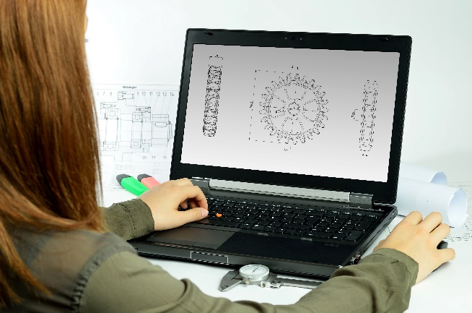
Incorporating the design process into the STEM modules will often result in the need for students to draw plans of their designs. This can be done at a simple level using hand drawn sketches or at a more technical level using computer-aided design (CAD).
By developing skills using industry standard software, students may be well-placed to explore future career pathways.
There are a number of CAD software options, two free examples are detailed below. Autodesk is a third package that is also free for educational use.
Tinkercad
- Format: Web-based app requiring internet access via a browser
- Purpose: A simple, online 3D design and 3D printing app
- Home: www.tinkercad.com
- Blog: blog.tinkercad.com
- Tutorials: www.tinkercad.com/learn
- Feature: Connects to 3D printing and laser cutting.
SketchUp
- Format: Can be downloaded and installed on devices, or used in a browser
- Purpose: Enables students to draw in 3D
- Home: www.sketchup.com 'Products' 'SketchUp Make'
- Help centre: help.sketchup.com/en
- Blog: blog.sketchup.com
- Tutorials: www.youtube.com/user/SketchUpVideo. From beginner tool tips to intermediate and advanced modelling techniques, the video tutorials help to build SketchUp skills.

Appendix 5: Student journal
When students reflect on learning and analyse their ideas and feelings, they self-evaluate, thereby improving their metacognitive skills.
These modules encourage students to self-reflect and record the stages of their learning in a journal. This journal may take the form of a written journal, a portfolio or a digital portfolio.
Using digital portfolios can help develop students’ Information and Communication Technology (ICT) capability.
Reflective practice and recording can be supported in classrooms by creating opportunities for students to think about and record their learning through notes, drawings or pictures. Teachers should encourage students to revisit earlier journal entries to help them observe the progress of their thoughts and understanding.
Journals are a useful tool that gives teachers additional insight into how students value their own learning and progress, as well as demonstrating their individual achievements.
The following links provide background information and useful apps for journaling.
Reflective journal (University of Technology Sydney)
www.uts.edu.au/sites/default/files/reflective_journal.pdf
Reflective thinking (Association of Independent Schools of South Australia, 2013)
www.ais.sa.edu.au/__files/f/173001/AISSA%20Reflective%20Thinking.pdf
Balancing the two faces of ePortfolios (Helen Barrett, 2009)
electronicportfolios.org/balance/Balancing.jpg
Digital portfolios for students (Cool tools for school)
cooltoolsforschool.wordpress.com/digital-student-portfolios
Kidblog – digital portfolios and blogging
kidblog.org/home
Evernote (a digital portfolio app)
evernote.com
Weebly for education (a drag and drop website builder)
education.weebly.com
Connect – the Department of Education’s integrated, online environment
connect.det.wa.edu.au

Appendix 6: Student activity sheet 1.0: Journal checklist
As an ongoing part of this module, you have been keeping a journal of your work.
Before submitting your journal to your teacher please ensure you have included the following information.
- Tick each box once complete and included.
- Write N/A for items that were not required in this module.

Your name and group member's names or photographs.
An explanation of the problem you are solving.
Your notes from Activity 1
Your notes from Activity 2
Your notes from Activity 3
Your notes from Activity 4
Responses to Teacher resource sheet 1.5: Thermal image interpretation
Responses to Teacher resource sheet 1.6: Thermal images and maps
Student activity sheet 1.7: Shade calculations
Student activity sheet 2.2: Planning and reporting investigations
Student activity sheet 3.1: Your design
Student activity sheet 3.2: Peer evaluation of design
Student activity sheet 4.1: Peer evaluation
Student activity sheet 4.2: Self-evaluation
Student activity sheet 1.0: Journal checklist

Appendix 7: Teacher resource sheet 1.1: Cooperative learning – Roles
Cooperative learning frameworks create opportunities for groups of students to work together, generally to a single purpose.
As well as having the potential to increase learning for all students involved, using these frameworks can help students develop personal and social capability.
When students are working in groups, positive interdependence can be fostered by assigning roles to group members.
These roles could include:
- working roles such as Reader, Writer, Summariser, Time-keeper.
- social roles such as Encourager, Observer, Noise monitor, Energiser.
Further to this, specific roles can be delineated for specific activities that the group is completing. It can help students if some background to the purpose of group roles is made clear to them before they start, but at no time should the roles get in the way of the learning. Teachers should decide when or where roles are appropriate to given tasks.

Appendix 8: Teacher resource sheet 1.2: Cooperative learning – Jigsaw
This resource sheet provides a brief outline of a collaborative learning strategy known as 'jigsaw'.
Cooperative learning frameworks create opportunities for groups of students to work together, generally for a single purpose.
As well as having the potential to increase learning for all students involved, using these frameworks can help students develop personal and social capability.
The jigsaw strategy typically has each member of the group becoming an 'expert' on one or two aspects of a topic or question being investigated. Students start in their cooperative groups, then break away to form 'expert’ groups to investigate and learn about a specific aspect of a topic. After developing a sound level of understanding, the students return to their cooperative groups and teach each other what they have learnt.
Within each expert group, issues such as how to teach the information to their group members are considered.

Step 1 | Cooperative groups  (of four students) | 1 2 3 4 |  | 1 2 3 4
Step 2 | Expert groups  (size equal to the number of groups) | 1 1 | 2 2 | 3 3 | 4 4
Step 3 | Cooperative groups  (of four students) | 1 2 3 4 |  | 1 2 3 4

Appendix 9: Teacher resource sheet 1.3: Cooperative learning – Placemat
This resource sheet provides a brief outline of a cooperative learning strategy known as 'placemat'.
Cooperative learning frameworks create opportunities for groups of students to work together, generally for a single purpose.
As well as having the potential to increase learning for all students involved, using these frameworks can help students develop personal and social capability.
The placemat strategy involves students working collaboratively to record prior knowledge about a common topic and brainstorm ideas. Students use the centre of the placemat to record the ideas on which the group agree.
Placemat enables teachers to readily see the contribution of each student. The diagram below shows a typical placemat template.
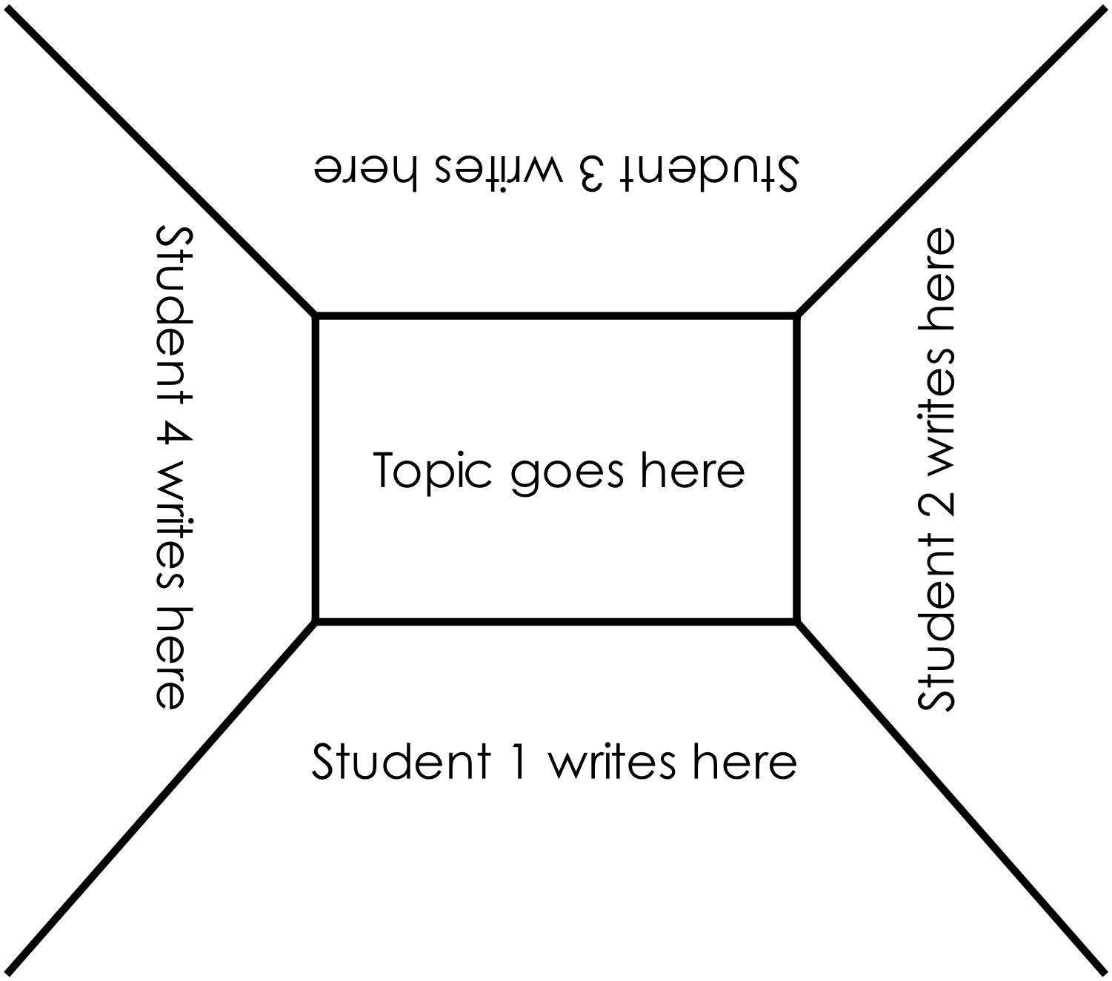

Appendix 10: Teacher resource sheet 1.4: Cooperative learning – Think, Pair, Share
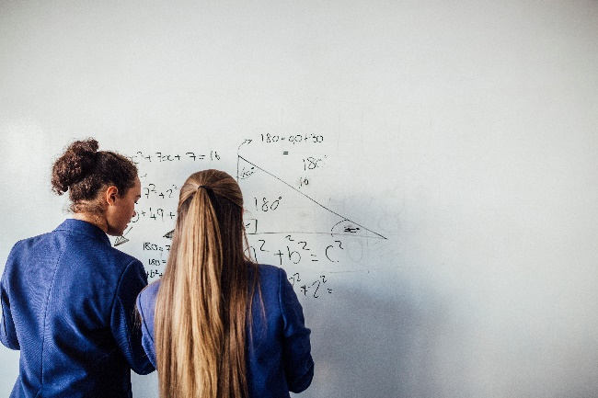
This resource sheet provides a brief outline of a cooperative learning strategy known as 'think – pair – share'.
Cooperative learning frameworks create opportunities for groups of students to work together, generally to a single purpose.
As well as having the potential to increase learning for all students involved, using these frameworks can help students develop personal and social capability.
In the 'think' stage, each student thinks silently about a question asked by the teacher.
In the 'pair' stage, students discuss their thoughts and answers to the question in pairs.
In the 'share' stage, the students share their answer, their partners answer or what they decided together. This sharing may be with other pairs or with the whole class. It is important also to let students 'pass'. This is a key element of making the strategy safe for students.
Think – pair – share increases student participation and provides an environment for higher levels of thinking and questioning.

Appendix 11: Teacher resource sheet 1.5: Thermal image interpretation
Thermal image | Observations | Explanations and elaborations | Further exploration
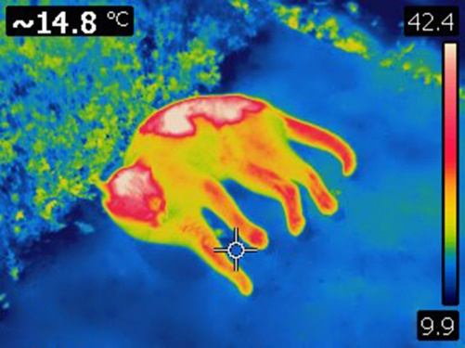  Resting cat | What do you observe in this thermal image?  Which parts of the cat are the hottest?  Where is the cat coolest? | What is the meaning of the scale?  What is being detected by the camera?  What is the significance of the colours in terms of heat transfer? (radiation, conduction, convection)  Comment on how hot the cat's head is in degrees Celsius?  What might the 14.8°C refer to? | How and when was infrared radiation first detected?  Which animals are able to detect infrared radiation?  Research and explain how an infrared camera works.
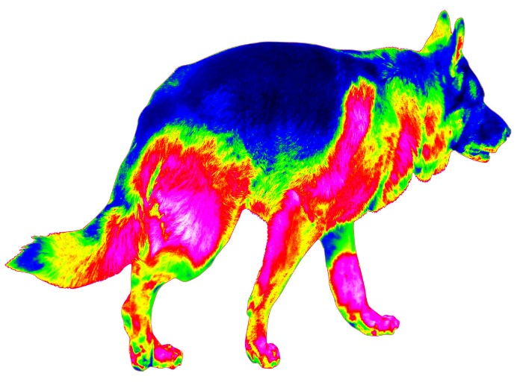  Walking dog | What do you observe in this image?  Comment on the dog's heat loss relative to its body parts. | Do the colours represent the same temperatures as in the previous image?  How hot is the dog's back? | What does FLIR stand for?
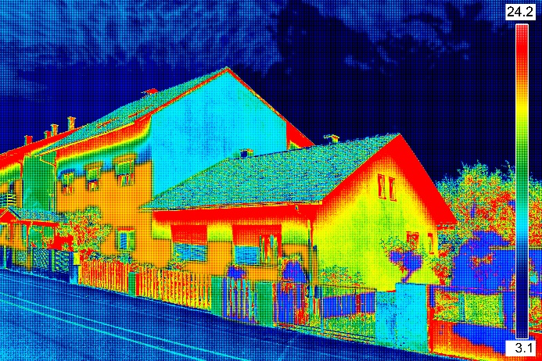  House | What do you observe in this image?  Where is the house losing the most heat?  Where is the house losing the least heat? | Explain in terms of heat transfer why the window appears hot.  Explain in terms of heat transfer why the roof appears cool.  Why is it hot just under the roof line? | Why can’t we detect images like this with our eyes?  Research how short wave radiation (visible light) may transform into long wave radiation (infrared).
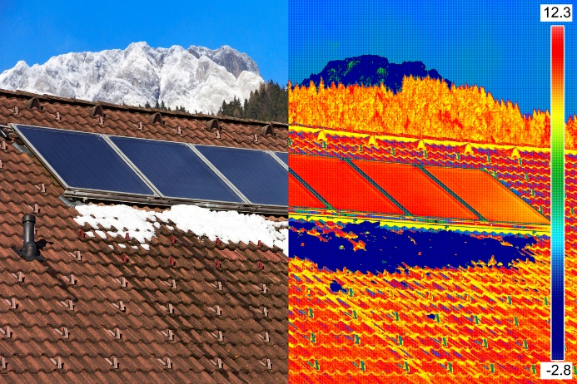  Rooftop in Europe | What do you observe in this image? | What is the purpose of the split image?  Discuss the European location of this rooftop in relation to the temperatures shown. | Why is thermal imaging of houses important?
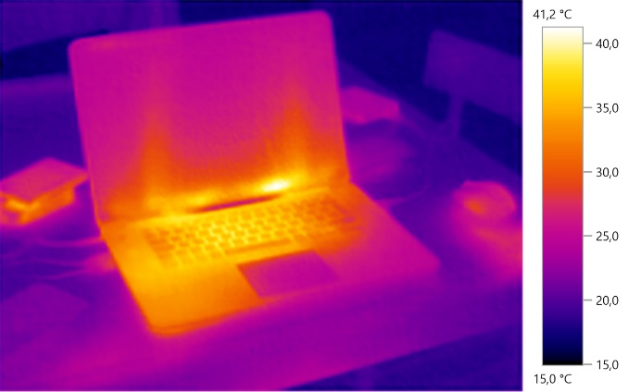  Laptop | What do you observe in this image? | In what sort of temperature range does a laptop operate? | Given this knowledge about laptops and heat, suggest ways of ensuring your laptop won't overheat.

Appendix 12: Teacher resource sheet 1.6: Thermal images and maps
Image | Observations | Explanations and elaborations | Further exploration
Jandakot Western Australia  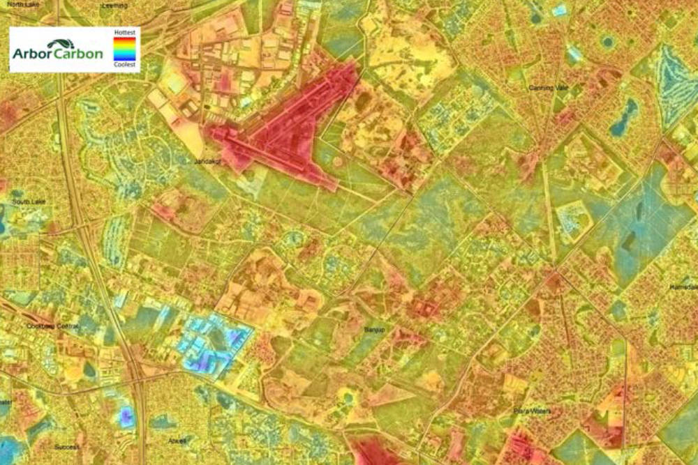  www.arborcarbon.com.au/project-urban-island.html | The colours represent the same temperatures as in previous thermal images.  What do you observe in this image?  Where is the hottest area?  Where are the coolest areas? | From what materials are airport runways made?  What colour is an airport runway? | Research how different types of materials reflect and absorb radiation.  Research how different colours of materials reflect and absorb radiation.
Jandakot Western Australia  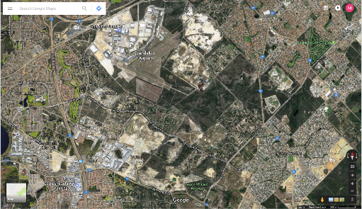  www.google.com.au/maps/@-32.1099804,115.8899089,6185m/data=!3m1!1e3 | List the colours you observe in this image and what they represent.  - Dark green – tree canopy  - Light green – grass, ground cover  - Cream/white – sands  - Light grey – roads  - Dark grey – tarmac  - Terracotta – tile roofs  - Silver/white – buildings such as hangars, warehouses | Compare the two images.  Match the materials in this image to the temperatures of the materials in the thermal image.  Which materials or ground cover are hottest?  Which materials or ground cover are coolest?  Why is the runway so hot? | How would tree cover affect the temperature of the ground and the air beneath the trees?

Appendix 13: Student activity sheet 1.7: Shade calculations
The image here shows the location in which the shade calculations are going to be made.
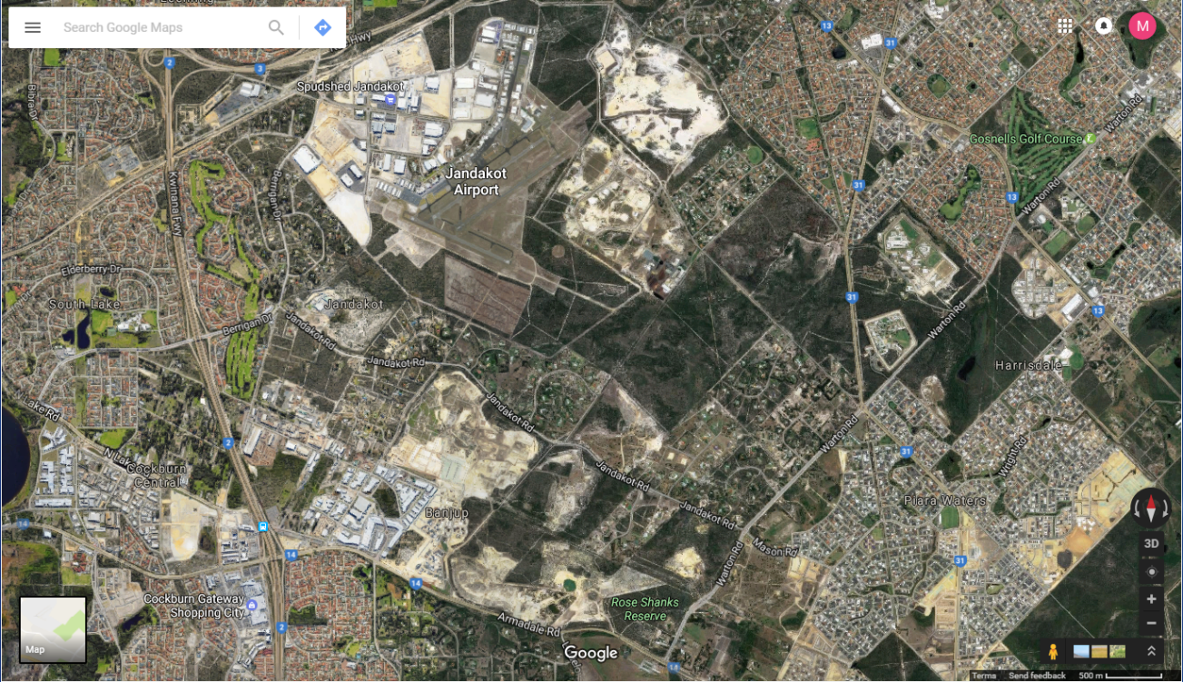
Location 1: Glen Iris Location 2: Canning Vale Location 3: Piara Waters
Task 1: Place the 1 cm² grid sheet on the centre of each of the three locations and look at an area 5 cm by 5 cm (25 cm².) Record the following results in the given table (use the A4 sized image for this).
(a) Count, to the nearest square centimetre, the area of tree canopy cover.
(b) Calculate the percentage of tree canopy cover.
(c) Count, to the nearest square centimetre, the area of grass cover.
(d) Calculate the percentage of grass cover.
(e) Count, to the nearest square centimetre, the area of hard surface cover.
(f) Calculate the percentage of hard surface cover.

Location | 1. Glen Iris | 2. Canning Vale | 3. Piara Waters
(a) area of tree canopy cover (cm²)
(b) per cent tree canopy cover
(c) area of grass cover (cm²)
(d) per cent grass cover
(e) area of hard surface cover (cm²)
(f) per cent hard surface cover

Task 2: Write down a ratio for – tree canopy cover : grass cover : hard surface cover – for each of the locations.

Task 3: Use the thermal image of Jandakot from your previous work to compare the levels of heat in Glen Iris, Canning Vale and Piara Waters. Comment on what you find for each location.

Task 4: Use the scale on the map to calculate the actual area studied for each location (You will need to work out what 25 cm² on the map equates to in the real world).

Task 5: Propose a mathematical rule for the ground cover proportions that identify 'hot areas' and the proportions that identify 'cool areas'. For example, a ratio that has 'twice as many trees plus grass than hard cover' may be classified as cool.

Task 6: Verify that your mathematical rule for the proportions that identify 'hot areas' and the proportions that identify 'cool areas' is valid by using it to classify the three given locations as 'cool' or 'hot' and then comparing the results to your Task 3 comments.

Task 7: The first image on www.arborcarbon.com.au/project-urban-island.html shows infrared images for Perth's southern suburbs. This image can be compared to Google Earth images of the same regions.
Using these images, comment on any regional differences in terms of heat balance, energy transfer and transformation. Consider variables that may affect surface temperatures.

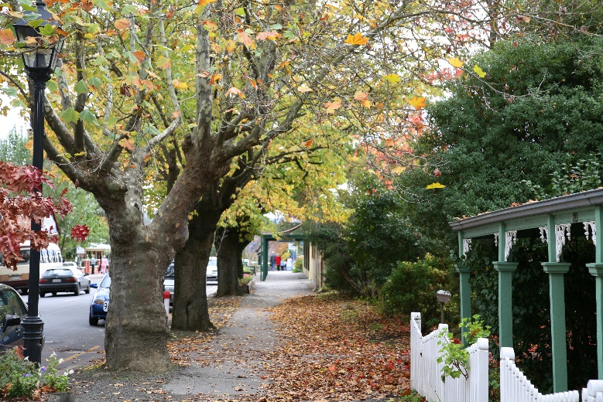

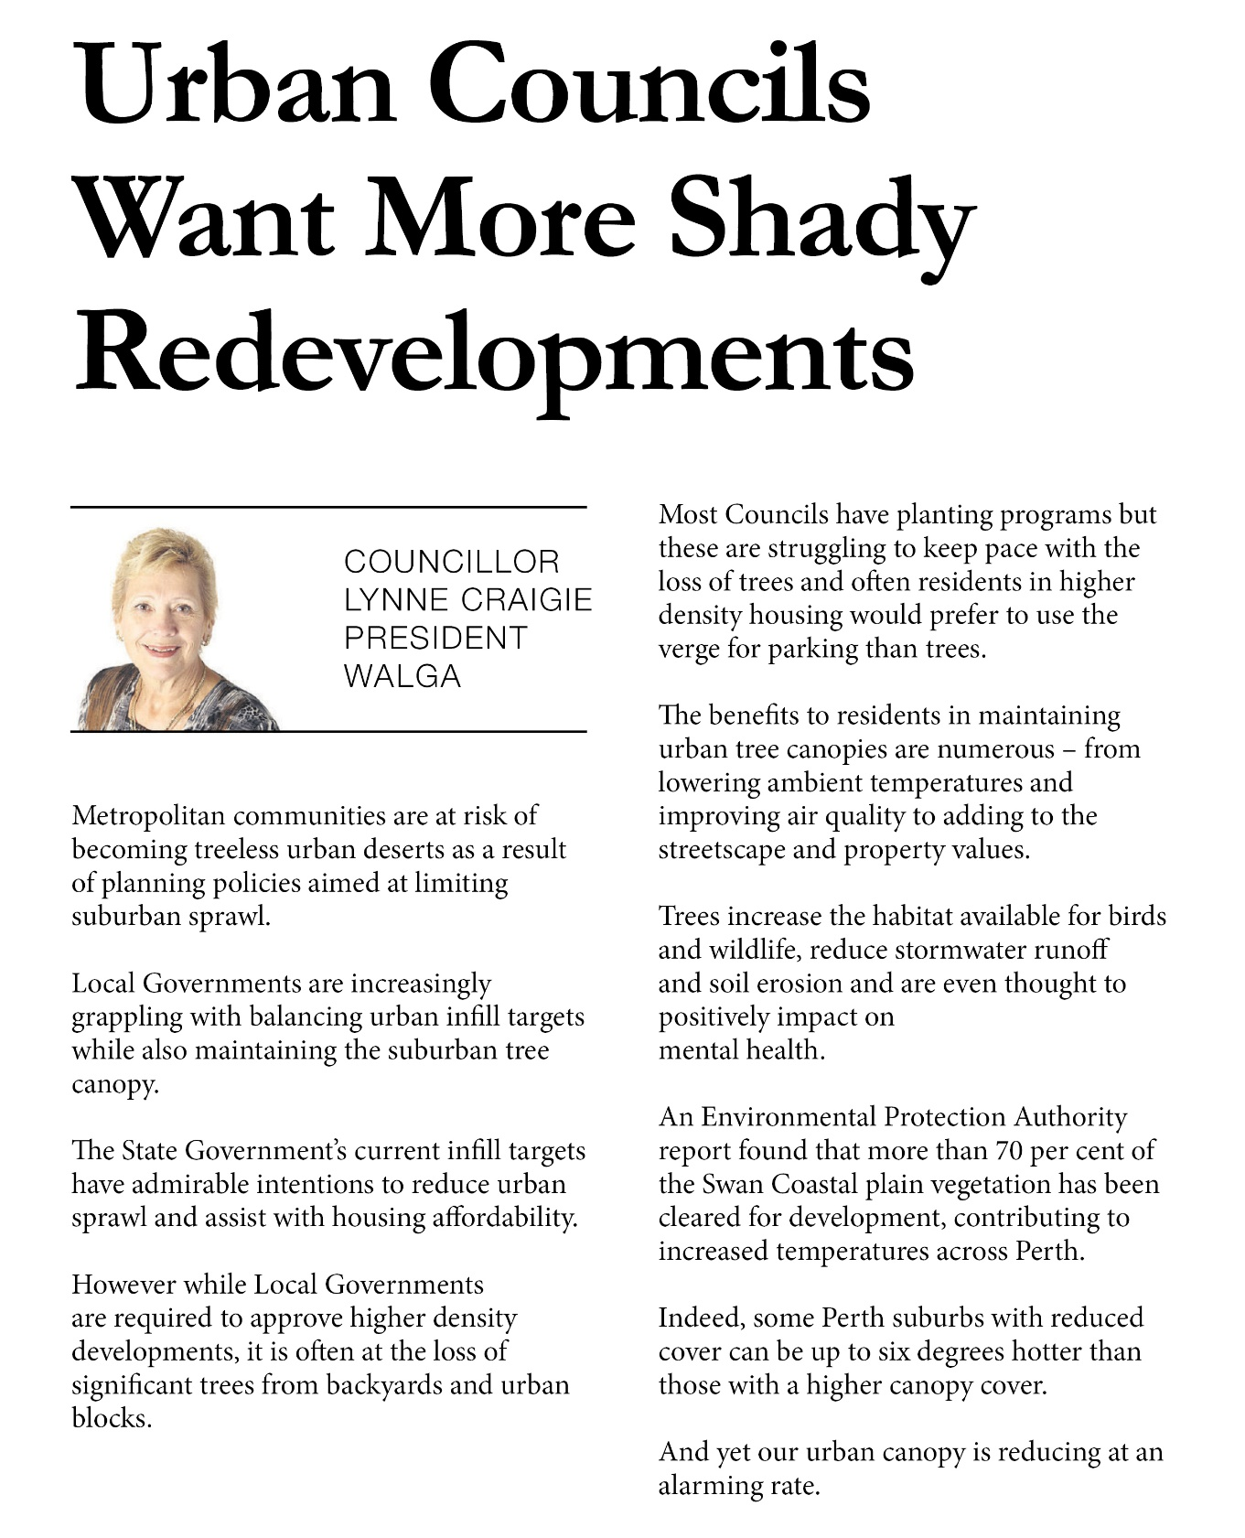
Appendix 14: Teacher resource sheet 2.1: WALGA article

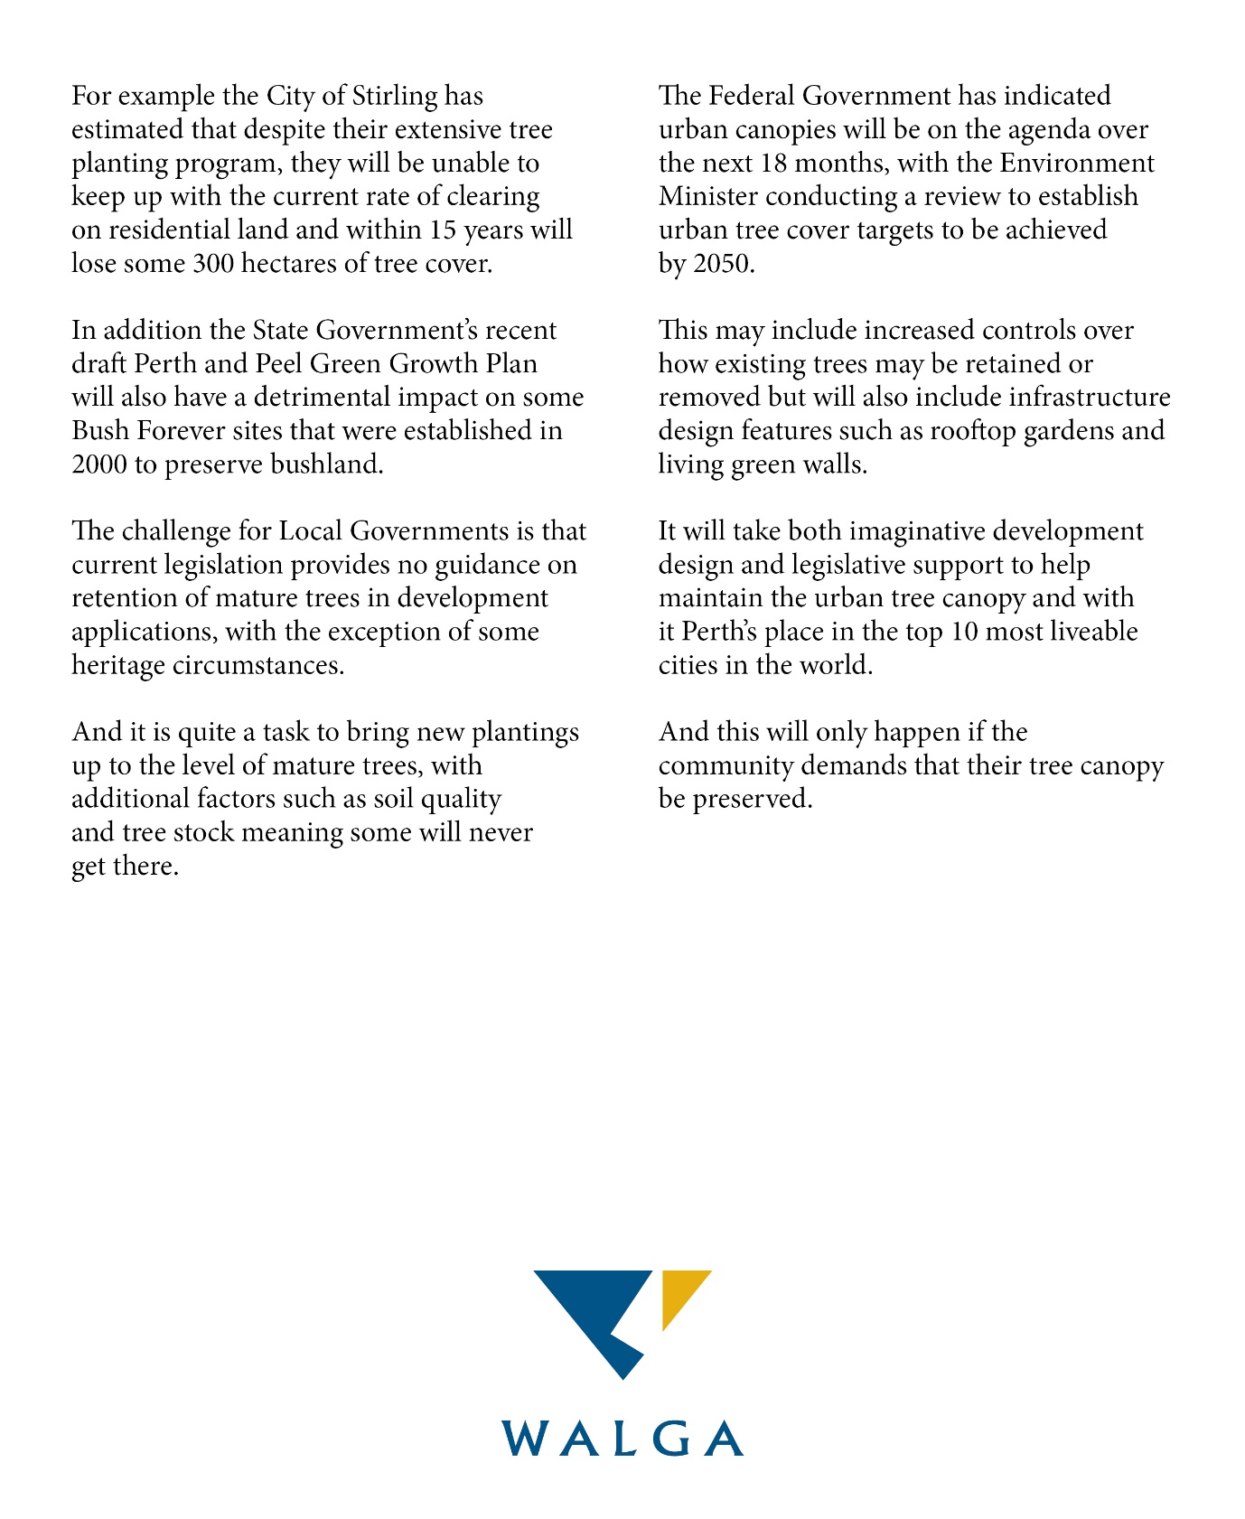

Appendix 15: Student activity sheet 2.2: Planning and reporting investigations
Student name: _________________________________ Class: ____________
Other members of your group:
__________________________________________________________________________

- What is your research question and how will you investigate it?

- Which variables are you going to
- change?

- measure?

- keep the same?

- What do you think the result will be? Explain why.

- What equipment will you need?

- Describe your experimental set-up using a labelled diagram and explain how you will collect your data.

- What happened? Describe your observations.

- Present your results here in table form.

- Graph your results.
- What do your results tell you? Are there any relationships, patterns or trends in your results?

- Can you explain the relationships, patterns or trends in your results? Try to use some science ideas to help explain what happened.

- Was the outcome different from your prediction? Explain.

- What did you find out from your investigation that helps you better understand what you were investigating?

- What difficulties did you experience during this investigation?

- How could you improve your investigation (eg control of variables, measurement accuracy)?

Appendix 16: Student activity sheet 3.1: Your design
Student name: ______________________________ Class: ________________
Other members of your group:
___________________________________________________________________________

- Briefly outline your design for reducing the heating effect of the Sun (no more than 100 words).

- Provide a diagram of your design with labels and annotations to name the parts and the materials used.

- Using the words you have come to understand in this module, such as heat, energy, transfer, absorption, reflection and others, explain why your design will be effective.

- Explain how your design satisfies the following requirements:
- Meets local council regulations

- Is acceptable to the community and sustainable in terms of aesthetics, cost, use of non-renewable materials, low energy consumption and low maintenance

- The design would not have any negative consequences if implemented in various locations around Western Australia.

- How would you know if your design was effective?

- What did you learn from peer feedback? How would you modify your design to improve it? (Complete this part after receiving your feedback in Student activity sheet 3.2: Peer evaluation of solutions)

Appendix 17: Student activity sheet 3.2: Peer evaluation of solutions
Group | Title of design | Biotic, abiotic or hybrid solution to keeping cool | Positive elements of the design | Improvements to the design | Ideas generated from this design
1.
2.
3.
4.
5.
6.
7.
8.

Appendix 18: Student activity sheet 4.1: Peer evaluation
 | Always | Usually | Sometimes | Rarely
Remains focused on tasks presented
Completes set tasks to best of their ability
Works independently without disrupting others
Uses time well
Cooperates effectively within the group
Contributes to group discussions
Shows respect and consideration for others
Uses appropriate conflict resolution skills
Comes to class prepared for activities
Actively seeks and uses feedback

Comments: __________________________________________________________________________________________________________________________________________________________________________________________________________________________________________________________________________________________________________________________________________________________

Appendix 19: Student activity sheet 4.2: Self-evaluation
 | Always | Usually | Sometimes | Rarely
Remains focused on tasks presented
Completes set tasks to best of their ability
Works independently without disrupting others
Uses time well
Cooperates effectively within the group
Contributes to group discussions
Shows respect and consideration for others
Uses appropriate conflict resolution skills
Comes to class prepared for activities
Actively seeks and uses feedback

Comments: __________________________________________________________________________________________________________________________________________________________________________________________________________________________________________________________________________________________________________________________________________________________

Notes
_______________________________________________________________________________________________________________________________________________________________________________________________________________________________________________________________________________________________________________________________________________________________________________________________________________________________________________________________________________________________________________________________________________________________________________________________________________________________________________________________________________________________________________________________________________________________________________________________________________________________________________________________________________________________________________________________________________________________________________________________________________________________________________________________________________________________________________________________________________________________________________________________________________________________________________________________________________________________________________________________________________________________________________________________________________________________________________________________________________________________________________________________________________________________________________________________________________________________

Notes
_______________________________________________________________________________________________________________________________________________________________________________________________________________________________________________________________________________________________________________________________________________________________________________________________________________________________________________________________________________________________________________________________________________________________________________________________________________________________________________________________________________________________________________________________________________________________________________________________________________________________________________________________________________________________________________________________________________________________________________________________________________________________________________________________________________________________________________________________________________________________________________________________________________________________________________________________________________________________________________________________________________________________________________________________________________________________________________________________________________________________________________________________________________________________________________________________________________________________

Notes
________________________________________________________________________________________________________________________________________________________________________________________________________________________________________________________________________________________________________________________________________________________________________________________________________________________________________________________________________________________________________________________________________________________________________________________________________________________________________________________________________________________________________________________________________________________________________________________________________________________________________________________________________________________________________________________________________________________________________________________________________________________________________________________________________________________________________________________________________________________________________________________________________________________________________________________________________________________________________________________________________________________________________________________________________________________________________________________________________________________________________________________________________________________________________

