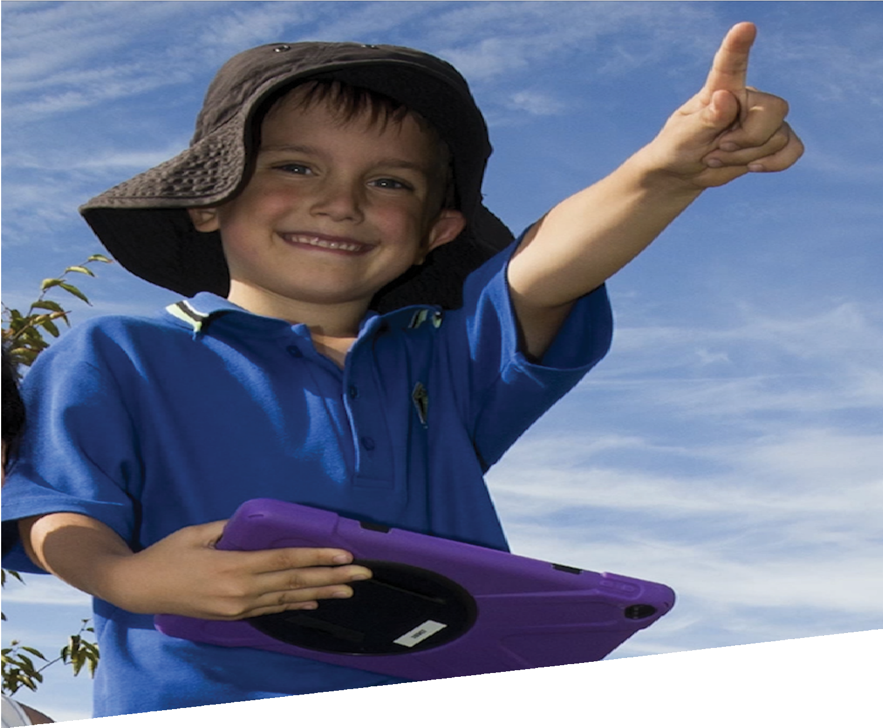

CURRICULUM RESOURCE MODULE
Swooping birds
KINDERGARTEN

Acknowledgements
The STEM Learning Project respectfully acknowledges the Traditional Custodians of the lands upon which our students and teachers live, learn and educate.
The STEM Learning Project is funded by the Western Australian Department of Education (the Department) and implemented by a consortium in STEM education comprising the Educational Computing Association of Western Australia, the Mathematical Association of Western Australia, the Science Teachers Association of Western Australia and Scitech. We acknowledge and thank the teachers and schools who are the co-creators of these resources.
Copyright and intellectual property
The copyright and intellectual property of this module remain the property of the Department.
Any Western Australian Curriculum content in this resource is used with the permission of the School Curriculum and Standards Authority (the Authority); this permission does not constitute Authority endorsement of the resource. The Authority accepts no liability for any errors or damages arising from reliance on its content.
The Western Australian Curriculum content may be freely copied, or communicated on an intranet, for non-commercial purposes in educational institutions, provided that the Authority is acknowledged as the copyright owner. Copying or communication for any other purpose can be done only within the terms of the Copyright Act 1968 or with prior written permission of the Authority. Any Australian Curriculum content in the Western Australian Curriculum is used by the Authority under the terms of the Creative Commons Attribution NonCommercial 3.0 Australia licence.
Any content on the www.scsa.wa.edu.au domain that has been derived from the Australian Curriculum may be used under the terms of Creative Commons Attribution-NonCommercial 3.0 Australia licence.
This resource includes references and examples of iOS, Android and other apps. The Department does not endorse or recommend any commercial products and simply provides these as examples for teachers.
The Department is committed to providing quality information to its customers. Whilst every effort has been made to ensure accuracy, currency and reliability of the information within these documents, the Department accepts no responsibility for errors, omissions or amendments made since the time of publishing. Confirmation of information may be sought from the Department or the originating bodies providing the information. The Department has no control over the content of material published on websites to which users are referred in this resource. It is the responsibility of the internet user to make their own decision as to the relevancy, accuracy, currency and reliability of information found on those sites.
Attributions: Evernote, Seesaw, Popplet, iBook creator, Kidblog, Edmodo, Kids Doodle, Explain everything, Keynote, Chatterpix, Voice Record Pro, Connect, eBook, Pages, PuppetPal, Class Dojo, iMovie, Scratch Jr.

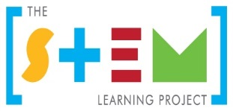
Table of contents

The STEM Learning Project 2
Overview 4
Activity sequence and purpose 7
Background 8
Activity 1: Swooping birds 10
Activity 2: We are investigators 17
Activity 3: Build and test 24
Activity 4: Evaluate and share 28
Appendix 1: Links to the Kindergarten Curriculum Guidelines 31
Appendix 2: Materials list 37
Appendix 3: Design process guide 38
Appendix 4: Reflective journal 39
Appendix 5: Teacher resource sheet: Cooperative learning – Think-Pair-Share 40
Appendix 6: Teacher resource sheet: Sample parent letter 41
Appendix 7: Teacher Resource sheet: Prototype troubleshooting 42
Appendix 8: Teacher resource sheet: Construction skills 43

The STEM Learning Project
The aim of the STEM Learning Project is to generate students’ interest, enjoyment and engagement with STEM (Science, Technology, Engineering and Mathematics) and to encourage their ongoing participation in STEM both at school and in subsequent careers. The curriculum resources will support teachers to implement and extend the Western Australian Curriculum and develop the general capabilities across Kindergarten to Year 12.
Why STEM?
A quality STEM education will develop the knowledge and intellectual skills to drive the innovation required to address global economic, social and environmental challenges.
STEM capability is the key to navigating the employment landscape changed by globalisation and digital disruption. Routine manual and cognitive jobs are in decline whilst non-routine cognitive jobs are growing strongly in Australia. Seventy-five per cent of the jobs in the emerging economy will require critical and creative thinking and problem solving, supported by skills of collaboration, teamwork and literacy in mathematics, science and technology. This is what we call STEM capability. The vision is to respond to the challenges of today and tomorrow by preparing students for a world that requires multidisciplinary STEM thinking and capability.
The approach
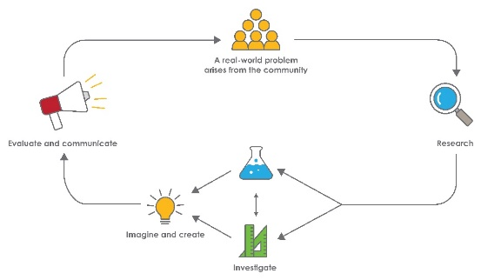
STEM capabilities are developed when students are challenged to solve open-ended, real-world problems that engage students in the processes of the STEM disciplines.

STEM in the early years
STEM is about children exploring the world around them and asking questions about how or why something works. Whether it is playing with water, building towers with blocks, talking about changes in the weather, or planting seeds, children demonstrate from an early age their readiness to engage in STEM.
When children come to school, they bring with them all the things they have learned. As their partners in learning, you can build on these skills, interests and knowledge using play-based learning alongside intentional teaching experiences. This balanced approach can help to keep every child productive and engaged in STEM.
Play is an essential and fun part of every child’s learning and development and helps them to build their knowledge, skills and attitudes. When children are playing they are learning to talk and interact with other children and adults. They observe and copy others and discover new ways of doing things, have the freedom to explore their own interests, test solutions, problem solve and answer questions for themselves. By encouraging children to play, explore and investigate, teachers are helping children become active participants in their own learning.
The inquiry question posed in this module allows children to pursue knowledge and increase understanding of related content across the five learning and development areas of the Kindergarten Curriculum Guidelines which are based on the five outcomes of the Early Years Learning Framework (EYLF) (DEEWR, 2009). The EYLF recognises inquiry as a central component in effective learning, not only in childhood but also throughout life,
This module focuses on this kind of learning which addresses the National Quality Standard (NQS), Quality Area 1 – Educational Program and Practice. The module also focuses on Quality Area 5 – Relationships with Children.
STEM exploration and discovery can be embedded in the daily practices of your early learning setting and can also build students’ competence within the seven general capabilities.

Kindergarten – Swooping birds

Overview
The communities we live in are not only places for humans, but also for many native animals including birds. Some birds build nests high in trees, while others build nests on the ground in large open areas like parks, or in ponds and dams.
Competing for nesting sites, food and water can place some birds in conflict with other animals including humans. Some birds may swoop people who get too close to their nest while others may swoop for food. Not all birds intend or will make contact with people when they swoop, it is often a way of scaring off intruders who enter their territory.
In this module students will learn about the behaviours of nesting birds; in particular, swooping behaviours to protect their young. Students will extend their knowledge of bird behaviour and begin to understand the reasons birds swoop. To help prevent injury from bird attacks during swooping season, students will investigate solutions and design and build a swooping bird protector. The book Waddle Giggle Gargle! by Pamela Allen is used as a stimulus for this module.
What is the context?
Birds protecting their young may swoop and attack people and other animals. They can pose a real threat as attacks are unpredictable and can result in injuries.
What is the problem?
How can we protect ourselves from swooping birds?
How does this module support integration of the STEM disciplines?
Science
Students develop science ideas as they broaden their understanding of the world in which they live and establish an awareness of the impact of human activity on environments. They investigate bird behaviours and how birds co-exist with others in their environment.
Students are given the opportunity to make predictions and generalisations about aspects of the natural world to manipulate objects and to experiment cause and effect when making their swooping bird protector.
Technology
Students learn about technology ideas and processes when they investigate solutions to the problem. They manipulate available resources to investigate, assemble and construct a solution that will help deter and protect them from swooping birds. Students develop construction skills such as cutting, drawing, joining and gluing.
Students reflect on designs and models, following the design process to make improvements. They also use information and communication technology, with teacher assistance, as a way of designing, editing, reflecting and creating through programs such as SeeSaw, Padlet and Scratch Jr. Digital cameras and mobile devices are also used.
The Design process guide is included as a resource to provide assistance to teachers in understanding the complete design process as developed in the Technologies curriculum.
Mathematics
Students develop a range of mathematical ideas such as identifying and communicating patterns using appropriate language as they build concepts of time by examining seasonal changes and analysing daily routines where they may encounter a nesting bird. Students begin to develop an understanding of measurement and number and use appropriate vocabulary to describe size and length.

What are the pedagogical principles of the STEM learning modules?
The STEM Learning Project modules develop STEM capabilities by challenging students to solve real-world problems set in authentic contexts. The problems engage students in the STEM disciplines and provide opportunities for developing higher order thinking and reasoning, and the general capabilities of creativity, critical thinking, communication and collaboration.
The design of the module is based on four pedagogical principles:
- Problem-based learning
This module is based around students’ solving an initial problem. Students’ learning is supported through a four-phase instructional model: research the problem and its context; investigate the parameters impacting on the problem; design and develop solutions to the problem; and evaluate and communicate solutions to an authentic audience.
- Developing higher order thinking
Opportunities are created for higher order thinking and reasoning through questioning and shared conversations that elicit students' thinking, prompts and scaffolds explanations, and requires students to justify their claims. Opportunities for making reasoning visible through shared conversations are highlighted in the module with the icon shown here.
- Collaborative learning
This provides opportunities for students to develop teamwork and leadership skills, work with others to solve a problem, consider and challenge each other’s ideas, and co-construct explanations and solutions. Information that can support teachers with aspects of collaborative learning is included in the resource sheets.
- Reflective practice
Through shared conversations, teachers can enrich and guide students’ thinking and learning. Recording observations, ideas and reflections on the learning experiences in some form of journal fosters deeper engagement and metacognitive awareness of what is being learnt. Information that can support teachers with journaling is included in the resource sheets.
These pedagogical principles can be explored further in the STEM Learning Project online professional learning modules located in Connect Resources.

Activity sequence and purpose
Swooping birds
To capture students’ interest, they listen to the story Waddle Giggle Gargle! by Pamela Allen.
The problem ‘How can we protect ourselves from swooping birds?’ is posed and students mind map ideas.
We are investigators
Students analyse information about seasons and nesting patterns and investigate reasons for swooping behaviours of birds.
Build and test
Students build their design and are guided through the design process to improve their ideas. Students discuss the solution used in the story and compare it to their own. Using their swooping bird protector, they re-enact the story and consider whether adjustments are necessary.
Evaluate and share
Students record oral reflections using digital devices, share their thinking and creations with the class and where possible, an audience beyond the classroom.

Background
Learning focus | Students will make progress towards being able to:  - Explain how and why the behaviour of birds may change at nesting time (Science).  - Observe and sort materials according to their shape (Maths).  - Observe and describe the physical properties of materials using their five senses (Science).  - Use given materials to safely make simple solutions to protect themselves from swooping birds (Technology).  - Evaluate their solution and explain reasons for changes in their designs (Technology).  - Orally recount a story using everyday language and correctly sequence the order of events.  - Compare and order the duration of events using everyday language of time (Maths).  - Describe changes in sunlight, temperature, clouds and rain for the seasons (Science).
Vocabulary | This module uses subject-specific terminology.  The following vocabulary list contains terms that need to be understood, either before the module commences, or developed as they are used including:  Ordinals: first, second, third, fourth etc.  Local bird names and key features of birds: eyes, feet, wings, tail, feathers, beak.  Appropriate year level language for colours, shapes and sizes, and for the physical properties of materials.
Timing | There is no prescribed duration for this module. The module is designed to be flexible enough for teachers to adapt. Activities do not equate to lessons; one activity may require more than one lesson to implement.  This module will run best during nesting time for birds such as magpies (ie September and October).
Consumable materials | A Materials list is provided for this module. The list outlines materials outside of normal classroom equipment that are needed to complete the activities.  Reusable materials should be collected for use in Activities 2 and 3. A sample letter to parents explaining this is included as Teacher resource sheet: Sample parent letter.
Safety notes | There are potential hazards inherent in these activities and with the equipment being used. A plan to mitigate any risks will be required.  Potential hazards specific to this module include but are not limited to:  - use of construction tools  - trip hazards  - sun exposure.  It is advisable not to test the students’ swooping bird protectors with birds during nesting season, as this may lead to injury.
Assessment | The STEM modules have been developed to provide students with learning experiences to solve authentic real-world problems using science, technology, engineering and mathematics capabilities. While working through the module, formative and summative assessment opportunities will arise, including:  - Collaboration skills can be assessed throughout the module as students draw on their verbal skills, ability to share resources, and value their own work and the work of others.  - Does the student communicate his or her ideas independently and appropriately?  - Does the student participate with others and in planned experiences with a positive attitude?  - Does the child show curiosity and demonstrate resourcefulness and perseverance in problem solving?  - Data can be collected using ICT, showing how students use devices to capture their work.  - Photographic and anecdotal evidence can be collected to assess collaboration skills, language development, colour, shape and number recognition and the development of ICT skills.  Mapping of this module to the five learning and development areas of the Kindergarten Curriculum Guidelines is provided (see Appendix 1).

Activity 1: Swooping birds
Activity focus | To capture students’ interest, they listen to the story Waddle Giggle Gargle! by Pamela Allen. Students share prior knowledge about swooping birds, sequence and map the story, and recreate scenes in small groups. Students are posed the question ‘How can we protect ourselves from swooping birds?’ and mind map ideas.
Background information | The Australian magpie is a medium-sized black and white bird native to Australia and southern New Guinea. Magpies are protected throughout Australia.  Magpies are found in various types of habitat from semi-desert to coastal fringe, including cities.  Magpies occupy the same territory for their entire life. This area might be a couple of hectares or a lot less in suburban areas. They prefer open land so they can see across their territory. They usually build their nests in the outer branches of trees, up to 15 metres above the ground.  The ABC science web page (www.abc.net.au/news/science/2017-12-11) explains that the morning call of the magpie is known as 'caroling' and it is used for a number of reasons including to mark their territory.  Magpies adapt very well to the presence of humans and can easily be found in gardens, public parks and other urban environments. If people live within a magpie’s territory, the magpie will recognise each of them by their faces. This is why some magpies will ‘make friends’ with people in their territory.  Although magpies are not usually aggressive, during September and October which is their breeding season, some may attack unfamiliar people and other animals who enter their territory and venture too close to their nests.  According to Magpie Alert, the website that tracks magpie attacks in Australia (www.magpiealert.com), the frequency of attacks peaks during the breeding season.  To prevent and avoid swooping magpies, wear protective clothing such as sunglasses and a wide-brimmed hat, stay calm and try not to wave your arms around as this can be  seen as an aggressive behaviour and provoke further attack. Magpies usually attack from behind so try to face the magpie as you walk out of their territory.  The Noongar word for magpie is Koolbardi. See www.mdahlem.net/birds/22/aumagpie.php for names in other Aboriginal language groups.
Instructional procedures | Reusable materials should be collected for Activities 2 and 3. See Teacher resource sheet 1.3: Sample parent letter for a sample letter requesting parents to donate materials from home.  This activity may work best with groups of three to four students during group rotation activities. Social group skills such as listening and taking turns when talking may be a focus prior to this activity.  The cooperative strategy think–pair–share can be incorporated in any of the activities to develop social skills, increase student participation and provide an environment for higher levels of thinking and questioning. Further explanations on this strategy can be found in Teacher resource sheet 1.2: Cooperative learning – Think-Pair-Share.  Students’ ideas and conversations should be recorded throughout the activity. Choose the best digital device and software (eg Voice Record Pro) to record ideas and thinking. Decide what platforms (eg Connect, Seesaw) will be used to collate this data to share with the parent community.  The apps suggested in this activity will need to be explored and the best digital options for recording learning will need to be selected.
Learning focus | This will be evident when students:  - View and listen to simple printed text.  - Make connections between their own experiences and ideas in the text.  - Contribute their ideas in discussion about experiences in the natural environment.  - Orally recount the story using everyday language and correctly order the sequence of events (Mathematics).  - Participate in dramatic play, role-play and learning experiences that explore aspects of swooping birds.
Equipment required | For the class:  Text – Waddle Giggle Gargle! by Pamela Allen  Photocopy the main illustrations from the book for the sequencing activity  Device with app/s
Preparation | Organise a safe, open area for students to move around when recreating scenes from the story.  It is suggested a letter be sent to parents informing them about the STEM module students will be undertaking. The letter should explain the duration of the activities, the resources and reusable materials that will be required as donations, and the times when parent help will be required. See Teacher resource sheet: Sample parent letter.
Activity parts | Part 1: Waddle Giggle Gargle!  Read the story Waddle Giggle Gargle! by Pamela Allen (or The Kinder Hat by Morag Loh is an alternative story). Stop reading at the page where it asks, What were they to do? The end of the story will be read in Activity 3.  Before opening the book, look at the front page with the class to talk about the illustrations and identify familiar images. Use these to predict the plot of the story. Use questioning prompts such as I wonder why…? and practise wait time to encourage higher order thinking and reasoning.  The story works around the idea of family; the human family and the bird family. This point in the story is a good opportunity to talk about similarities and differences in family. Discuss positive wellbeing and the feelings and emotions students have about their family members. The conversation could also lead to developing students’ understanding of protective behaviours. Students may be able to give other examples of how animals protect themselves or their babies.  Reflect upon the section of Waddle Giggle Gargle! read so far and direct the discussion towards swooping birds. Draw on the students’ prior experiences of swooping birds through questioning. Practise wait time to allow students to think deeply about their answers and continue to use why and because as prompts to encourage elaborations:  - Why did the magpie build a nest?  - Why did the magpie swoop grandpa, grandma and Jonathon?  Possible answers: Feeling scared or threatened, to protect the eggs, signaling the story characters should move away.  Talk about the bird’s territory and protecting its young.  - Have you ever been swooped by a bird? What happened? How did you feel?  Possible answers: Was injured, felt scared, the bird was injured.  - What would you do if a bird swooped you?  Possible answers: Run away, shoo it away, ask an adult for help, cover head and face.
Part 2: Swooping birds drama activity
Engage students in a drama activity, acting out how a swooping bird might fly and the noises it might make. Conduct the activity in a safe, open area to avoid students injuring themselves.
Gather students together and talk about the actions of the magpie and Jonathan in the story. Ask the students to predict:
- What did the magpie look like when it swooped?
- I wonder if there are other things that swoop like magpies.
Possible answers: airplanes, kites, drones.
- What did Jonathon do when the magpie swooped him?
- How do you think Jonathon felt when the magpie swooped him?
Possible answers: Scared, worried, frightened, surprised.
- What else could Jonathon do to stop the magpie from swooping him?
Possible answers: Shout for help, duck down, wave
his arms about, move to somewhere out of the way of the magpie, wear a hat, go a different way to school.
Talk about walking away from the bird, not running, staying calm, facing the bird, as these may contribute to the bird ceasing to swoop.
Put these ideas into action, with students pretending to be Jonathan being attacked by the magpie and acting to avoid being hurt.
Play a stuck-in-the-mud style game (See Digital resources for links to the game and more drama activities) where students endeavour to get to a safe zone while a ‘swooping bird’ tries to catch them. Have students designate an area for the bird’s territory using cones, ropes or natural borders such as pathways. Use the appropriate language of measurement in the conversation.
Part 3: Sequencing
To focus on sequencing, create a story map with the class using photocopies of the main events from the story Waddle Giggle Gargle!
Sequencing steps is an introduction to algorithms. Model the use of ordinals (eg first, second, third) and the everyday language of time when helping students to sequence the illustrations. See Digital resources for supporting resources.
After this, students work in small groups of three to four to re-enact different scenes from the story. Give each group a different illustration from the story and encourage them to work together to act out the scene. Prompt with questions about order eg What happened first? What happened second?
Have groups share their performances in the same order as the story. Ask students to decide which group should go first, second, third etc. using the book as a guide.
After the performances, promote higher order thinking by practising wait time and using why and because as prompts. Questions could include:
- Did the magpie swoop during the day or night?
- I wonder if the magpie would swoop Johnathon if it was nighttime instead of daytime? Why?
- Do you think the magpie would swoop a dog or another animal if it was in the story? Why?
- Who else might walk down the street where Jonathon lives?
- What might happen if they walk near the magpie’s nest?
- What do you think Grandma, Grandpa and Jonathan will do next?
Mind map student ideas and learning using an app such as Popplet. Use images or videos of the students participating in the activities to enhance the mind map.
Part 4: Journaling
Record students’ learning in a class journal. Include photos of students working together on the activities along with annotations capturing their thinking and conversations.
A digital option is to use an app to create a journal (eg Kidblog, Explain everything, Keynote) or create a class iBook.
The digital version could be uploaded to an app of choice, such as Connect or Seesaw, to share students’ learning with the parent community.
Resource sheets | Teacher resource sheet: Cooperative learning – Think- Pair- Share  Teacher resource sheet: Sample parent letter
Digital resources | Waddle Giggle Gargle! (Pamela Allen, 1996)  https://www.youtube.com/watch?v=db9RcUTd2Iw  __________________________________________________________  Voice Record Pro  itunes.apple.com/au/app/voice-record-pro/id546983235?mt=8
Keynote
www.apple.com/au/keynote
Drama games for kids (Beat by Beat Press)
www.bbbpress.com/dramagames
Stuck in the mud game (Kidspot, 2018)
www.kidspot.com.au/things-to-do/activity-articles/stuck-in-the-mud-game/news-story/b3cd3e263e9efa3b54998eeac98dd3d6
Magpie sound (digifishmusic, 2007)
freesound.org/people/digifishmusic/sounds/42189/
Australian magpie singing (crocdoc2, 2010)
www.youtube.com/watch?v=oYEYc8Ge3nw
Compare and order duration of events using everyday language of time (ACMMG007) Primary Resources (Twinkl, 2018)
www.twinkl.com.au
Literary resources | Waddle Giggle Gargle! (Pamela Allen, 1996)
 | The Kinder Hat (Morag Loh, 1985)

Activity 2: We are investigators
Activity focus | Looking at seasons and bird nesting patterns, students investigate reasons for the swooping behaviours of birds. Students are presented with a range of materials and explore their properties and shapes.
Background information | Aboriginal people have developed an intricate understanding of the environment over 60,000 years. Their traditional knowledge about the weather and climate have been passed from generation to generation through storytelling, songs, dances, art and ceremonies which has ensured continuity of their spiritual connection to their traditional lands.  Aboriginal people across Australia have diverse histories languages, cultures and knowledge. The exercise of caring for their traditional lands, flora and fauna in accordance with their traditional laws and customs, has ensured a flourishing environment and the continuation of the world’s oldest living culture.  Inviting local Aboriginal elders, parents and community members to share what they know about the environment provides an opportunity for traditional Aboriginal knowledge and perspectives to be used as the context for learning and the reciprocal exchange of information.  The Bureau of Meteorology Indigenous Weather Knowledge website (www.bom.gov.au/iwk/) provides information about the varied seasonal descriptions of some geographic regions of Australia.  Traditionally Aboriginal people hunted and gathered food according to the six seasons, being guided by the signs in nature as to which animal and plant resources were plentiful at those times. See Digital resources for more links on Indigenous seasons.  Most magpie swooping behaviour occurs when they are nesting during spring which is September to November in Australia.

Instructional procedures | To enhance the learning experience, the class could undertake a field trip to local wetlands or ecosystems or take a nature walk to observe birds in the local environment.  A visiting speaker could also add to the students’ experience. A local ornithologist could discuss bird behaviour with the students.  It is important to ensure that resources about Aboriginal histories, cultures and languages are relevant to the local context.  Record students’ ideas and conversations throughout the activities in the class journal as these will also be used for the presentations in Activity 4.
Learning focus | This will be evident when students:  - Explain why the behaviour of birds may change during the nesting season (Science).  - Investigate places where people and plants and animals live (Science).  - Create drawings of birds to illustrate common characteristics.  - Observe and describe the properties of materials (Science).  - Observe and describe the shapes of objects (Mathematics).
Equipment required | For the class:  Internet access  Digital camera  Images of birds  Images of eggs in bird nests or a chicken egg in a pretend nest  Clothing and other items suitable for each season  Class journal
For the students:
Drawing materials
Natural materials such as feathers, sand, sticks, leaves
Variety of materials for construction as outlined in the Materials list
Preparation | A community expert such as a wildlife centre representative, ranger, vet, ornithologist or Aboriginal Elder could be invited into the classroom to share their work and knowledge of bird behaviour with the class.  If the activity is being conducted during spring, be aware of areas where there are swooping birds and ensure the students do not go into these areas. It may be possible to observe from a safe distance.  Source clothing and other items from each of the four seasons for the activity in Part 3.
Activity parts | Part 1: Bird behaviours  Provide students with additional information on birds and their behaviours. This may be in the form of inviting a visitor into the classroom, going on a field trip to wetlands, nature reserve or local park, or taking a nature walk in the school grounds  On a walk in the school grounds, have shared conversations with the students about the natural and built elements in their environment, and the birds seen on the walk. Take digital devices to record photos of students, the environment they are exploring and birds they may see. Students could make pipe-cleaner or cardboard roll binoculars prior to taking the walk to enhance the bird watching experience.
Part 2: Drawing birds
Show the class images of different types of birds. Engage the class in a discussion to identify the main characteristics shared by many birds ie feathers, wings, beak or bill, skeleton, egg laying. Prompt their thinking with questions such as:
- Did we see any of these birds on our walk? Which ones?
- What makes these birds the same? Different?
- What is this part of a bird called? (Prompt by pointing to the beak/bill, wings, feathers, feet/claws.) What other parts do you know?
- Is this bird’s beak big or small?
- I wonder why some birds have big beaks and some have small beaks?
- Why do you think some birds have long legs?
- Are all birds the same colour? Tell me what colours you have seen on birds.
- Where have you seen birds near your house?
As students are sharing their answers, write the words they use on a word wall to build and extend their vocabulary. Illustrate each word with a simple picture.
Students could learn the names of some birds in local Aboriginal language.
Give students a variety of drawing materials and natural materials (eg feathers, sand, sticks) and encourage them to create a picture of a bird. Through questioning, ask students to identify the main features of their bird. Record student ideas as annotations, photos or videos in the class journal.
This activity can assist the teacher to determine how students' observation skills and fine motor skills are developing. Key points to look for include the student’s ability to:
- identify and represent key features of birds (ie wings, eyes, tail, feet, beak)
- represent the various colours of birds
- use small muscles to manipulate implements such as pencils, crayons and textas
- use their senses and translate this into a pictorial representation.
To incorporate ICT, students could animate their drawings using an app such as Chatterpix or Kids Doodle. These apps allow students to take photos of their work, draw a line over the mouth of the bird and record voices so it appears as if the bird is talking. This activity can help students verbalise their ideas and demonstrate understandings from the point of view of the bird.
Additional learning experiences
Students take photographs of their bird drawings outside in a bird habitat.
Students make shadows of birds by shining a data projector or torch onto a whiteboard or wall. Encourage students to explore light using their hands and cut=- out shapes.
Part 3: Seasons
Investigate the seasons of summer, autumn, winter and spring. A four corners strategy could be used to determine students’ prior knowledge. In each of the four corners of the classroom place clothing or items suitable for each season eg umbrella, sun hat and sunglasses, jumper, bathers. Give students some statements about the weather, specific to their geographical location. Ask them to move to the corner where the clothes/items would be the best choice for that statement. Examples include:
- It’s raining and it’s very cold. There are lots of grey clouds in the stormy sky.
- The brown leaves are crunching under my feet. There are some clouds in the sky.
- The sun is very bright in the sky. I feel hot and sticky.
- The sun is just a little bit warm. I can see flowers starting to come out.
Engage students in a conversation about the weather and how it changes during the year. Relate the seasons to things students may have experienced e.g. going swimming when it’s hot in summer, playing in the puddles when it rains and putting the heater on to stay warm in winter.
Explain that during the year there are usually four seasons that happen at different times depending on where you live in the world. Explain that in some areas of Australia, Aboriginal people identify with six seasons, other parts of Western Australia use the terms ‘wet’ and ‘dry’. Add the name of each season to the word wall.
Part 4: Connecting seasons and bird behaviours
Show the class images of birds’ eggs in nests or create a place a chicken egg in a pretend nest. As a class discuss:
- I wonder why birds lay their eggs in nests.
- Have you ever dropped an egg? What happened?
- I wonder if birds lay their eggs when it’s cold and windy in winter? Why?
- When do you think it would be good for birds to lay their eggs? Why? (Use the season name.)
- I wonder what birds do to protect and keep their eggs safe?
- Why do some birds swoop people and other animals in spring?
Record students’ thinking as annotations or photos in a digital class journal.
Part 5: Protecting ourselves from swooping birds
Introduce the problem to the students by asking:
- How can we protect ourselves from swooping birds?
Engage students in a class discussion to generate ideas. Record student thinking and add their ideas on the mind map from Activity 1.
Present students with a range of materials that they will be using to construct a swooping bird protector. Before they begin construction in Activity 3, encourage students to sort the objects by shape and size. Explore and talk about the properties of familiar shapes with the class and use comparative language.
- Can you see other things in the classroom that are the same shape as this? Where?
- Where have you seen this shape in your home? In the playground? On the roads?
- Is this shape smaller or bigger than this shape?
There are many videos on YouTube that could be shown to enhance this mathematics concept. See Digital resources for some examples.
Extend students’ play and exploration of the materials by encouraging them to describe some properties using their senses (eg it feels rough, it’s slippery, it won’t bend, it’s soft, it’s brown, it has wrinkles, it smells funny). This may work best in a small group rotation activity. Prompt questions could include:
- What does it look like?
- What does it feel like?
- What sound can you hear when you rub them together?
- Does it smell?
- I wonder what you could use to make something that will protect you from a swooping bird? Why?
Explain some animals use colour to protect themselves from predators (eg ladybirds are red to stop them being eaten – see Digital resources). Ask students to suggest colours that might protect people from swooping birds.

Part 6: Journaling
Students reflect on their learning. Update the class journal using quotes from students, work samples or photos taken during the lesson.
Digital resources | Indigenous seasonal descriptions (Bureau of Meteorology, 2018)  www.bom.gov.au/iwk/climate_culture/Indig_seasons.shtml
Indigenous season calendars (CSIRO, 2018)
www.csiro.au/en/Research/Environment/Land-management/Indigenous/Indigenous-calendars
The Seasons of Arnold's Apple Tree by Gail Gibbons (Stories and Tales, 2017)
youtu.be/hZSHsGdge7U
Dress for the Season (PBS Learning Media, 2018)
www.pbslearningmedia.org/resource/evscps.sci.ess.watcyc.dress/dress-for-the-weather/#.WeVb_E2wdD8
Seasons and Weather (Interactive Sites for Education, 2017)
interactivesites.weebly.com/seasons--weather.html
The Cat in the Hat – Weather Transformer (PBS Kids, 2018)
pbskids.org/catinthehat/games/weather-transformer
Ladybird facts! (National Geographic Kids, 2018)
www.natgeokids.com/au/discover/animals/insects/ladybird-facts/#!/register
Shapes in everyday life (OnInLe2010, 2010)
www.youtube.com/watch?v=dNIuP-nHIgk
Shapes and patterns in everyday life (EDUC W200)
www.youtube.com/watch?v=AMnFFlnv4nc
ChatterPix
itunes.apple.com/au/app/chatterpix-by-duck-duck-moose/id734038526?mt=8
Kids Doodle
itunes.apple.com/us/app/kids-doodle-movie-kids-color-draw/id460712294?mt=8

Activity 3: Build and test
Activity focus | Students design and construct a swooping bird protector using a range of materials, and considering shape, colour, size and physical properties. Guide students through the design process to develop and improve ideas.  Students use their swooping bird protector while re-enacting the story from Activity 1 and consider whether adjustments to their design are necessary.
Background information | The design process is a series of steps that guide the development of a solution to a problem. The core steps in the process are the same whether applied in engineering or areas such as software design. These steps are:  - Define the problem: What is the need?  - Research and gather information.  - Analysis: Imagine: Brainstorm ideas.  - Ideation: Plan: Pick the best idea, how will it work? Draw a diagram, what materials or tools will be needed?  - Development/production: Create: Build the solution and test it out.  - Evaluation: Improve: What works, what doesn’t, what could work better? Repeat the steps.  Further detail is provided in the Design process guide.
Learning focus | This will be evident when students:  - Generate ideas for a swooping bird protector (Technologies).  - Develop a design for a swooping bird protector and record their design as a drawing (Technologies).  - Use materials and implements such as pencils and scissors to safely make a swooping bird protector (Technologies).  - Explore the shapes of familiar objects (Mathematics).
Equipment required | For the class:  Teacher resource sheet: Prototype troubleshooting  Teacher resource sheet: Construction skills
For the students:
Variety of reusable materials of different shapes, colours, sizes and textures
Construction materials as outlined in the Materials list
Preparation | Parents or a buddy class could be arranged to help those students who may need assistance with skills such as cutting and joining.  Organise workspaces for students to create their swooping bird protectors, ensuring easy access of materials and construction tools. Small group rotation activities may be the best way to accommodate this, with one adult or buddy at each table of three to four students.
Activity parts | Part 1: Designing  Review the problem that Jonathon, grandma and grandpa faced in the story Waddle Giggle Gargle! Ask the class to guess what the characters might do to protect themselves from the swooping magpie during nesting season.  Brainstorm ideas for the design of a swooping bird protector with the class. Ask questions to prompt their thinking:  - How can we protect ourselves from swooping birds?  - What would a swooping bird protector look like?  - What would a swooping bird protect sound like?  - What materials could we make it from?  Students draw their ideas for a swooping bird protector and, with assistance, label their designs. As an alternative to drawing, a digital option such as Kids Doodle could also be used.
Part 2: Building
Students begin to construct their swooping bird protector using the selection of materials and implements provided. Develop each student’s thinking through questioning:
- Tell me about the materials you have chosen?
- Why did you choose those materials?
- Where in your design will you use it?
- What shapes have you used? Can you find a square in your design? A triangle? A circle?
- What colours are you going to use? Have you used them to make it look pretty? Look scary? Why?
- What tools are you going to use? Glue? Scissors? Why?
- Is your protector going to big enough? Is it too big?
- Is there anything more you could add to make it bigger, stronger or louder?
- Tell me more about your protector.
Encourage students to express their ideas and seek and apply feedback from one another at any stage to enhance their protector (see Design process guide). These changes along with student reasoning could be captured on a device. Anecdotal notes can be recorded using Teacher resource sheet: Prototype troubleshooting.
Part 3: Making connections
Ask students to predict the ending of the story Waddle Giggle Gargle? Re-read the story then discuss how the characters in the story solved their problem of the swooping magpie.
- What did grandma, grandpa and Jonathon use to protect themselves from the magpie?
- Did the protector hurt the magpie? Why is that a good thing?
- Tell me how your swooping bird protector is the same. Different?
- Can you use some of their ideas to make your swooping bird protector work better? Which ones? Why?
Part 4: Reasoning
Encourage the development of cooperative skills such as listening and taking turns to talk. Discuss whole body listening and how it is important to show respect when others are talking. See Digital resources for more on whole body listening.
Students take turns in listening to others and sharing their swooping bird protector. Encourage students to identify the thinking behind their design and what they did well.
Ask the class to share what they think is good about each student’s design and one thing that might improve the design.
Note: Students do not have to apply the change but should be given the opportunity to give and receive feedback and make informed decisions. This will also encourage teamwork and skills for working with others.
Part 5: Testing
Students go outside to a safe open area to re-enact the story using their swooping bird protector.
Revisit the topic of weather. Once outside, ask students:
- Is it windy today? Will that be a problem for your swooping bird protector?
- Is it raining today? Will that be a problem for your swooping bird protector?
The teacher may take on the role of the bird or use a puppet to imitate the swooping behaviour of the magpie in the story.
After each attempt, question students to help them evaluate the success of their design. Practise wait time and encourage deeper thinking, using why and because as prompts:
- Did your swooping bird protector stop the bird from pecking you? Why?
- What worked well on your design?
- Is there anything you would change? Why?
Asking these questions will give students an opportunity to critically analyse their swooping bird protector and engage further with the design process.
Capture on video students’ justifications about their design and any changes they intend to make. Record their thinking as photographs or videos using an app of choice (eg Popplet) and upload to a platform such as Connect or SeeSaw to share with the parent community.
Resource sheets | Teacher resource sheet 3.1: Prototype troubleshooting  Teacher resource sheet 3.2: Construction skills
Digital resources | Teaching children the skills for whole body listening (Communication Works, 2012)  www.cwtherapy.com/teachingchildrentheskillsforwholebodylistening/

Activity 4: Evaluate and share
Activity focus | Students record oral reflections using digital devices, share their thinking and designs with the class and where possible, an audience beyond the classroom.
Instructional procedures | Students will need support and scaffolding to prepare for their presentation.  The presentations will provide a rich opportunity for assessing student ICT capability, as well as the literacies associated with speaking and listening.  Individual, small group or whole class presentations could be made.  Photographs and videos taken throughout the design process should be used in digital presentations.  Digital options could include creating an eBook, Keynote, poster in Pages, PuppetPal presentation or simple iMovie which can then be shared through a digital portfolio platform such as Connect, Seesaw or Class Dojo. Students will require prior instruction and teacher support to use these apps.  If digital technology is not accessible, students could share their solution through an oral presentation.
Learning focus | This will be evident when students:  - Describe their swooping bird protector and justify the choice of materials and tools that were used (Technologies and Science).  - Evaluate their design, explaining what they would keep the same or change (Technologies).
Equipment required | For the class:  Devices loaded with appropriate apps, photos and videos from the learning journey
For the students:
Design solutions from Activity 3
Preparation | Ensure devices are charged and loaded with appropriate apps, photos and videos
Activity parts | Part 1: Justifying thinking  Students demonstrate their swooping bird protector, reflect orally and record their thinking using a digital device. Encourage students to celebrate their own efforts and achievements and those of others. Questioning prompts could include:  - I made my swooping bird protector … because…  - I made it this way… (What did you do first? Second? Third?)  - I used … to make it because…  - I changed my design because…  - I used… (tools) because...  - The best thing about my swooping bird protector is…  - One thing I did well was…
Part 2: Presentation of findings
Students present the digital recording to either their buddy class or an authentic audience beyond the classroom such as a bird specialist visitor, a parent group or the whole school during an assembly. The presentations can also be uploaded to a digital platform such as Seesaw or Connect to allow parents who were unable to attend the opportunity to view the learning experience. Students could invite the community to give feedback.
Additional learning opportunity
Using Scratch Jr (coding), students create a scene with their swooping bird protector added to a person (using their own face) and a magpie swooping. Students may need assistance from a buddy class to achieve this.
Digital resources | Scratch Jr  www.scratchjr.org
Keynote
www.apple.com/au/keynote
Pages
www.apple.com/au/pages

PuppetPal
itunes.apple.com/au/app/puppet-pals-hd/id342076546?mt=8
iMovie
www.apple.com/au/imovie
Connect
https://connect.det.wa.edu.au/
Class Dojo
www.classdojo.com
Seesaw
web.seesaw.me
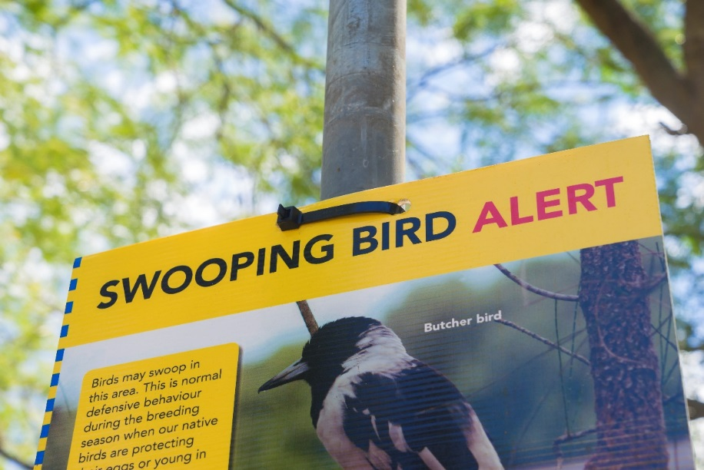

Appendix 1: Links to the Kindergarten Curriculum Guidelines
The five areas of learning and development in the Kindergarten Curriculum Guidelines are based on the five outcomes of the Early Years Learning Framework. They are:
- Identity
- Connecting and Contributing
- Wellbeing
- Learning and Thinking
- Communicating
The table below maps the Swooping birds module to the content of the Kindergarten Curriculum Guidelines, and can be used by teachers for planning and monitoring.
KINDERGARTEN CURRICULUM GUIDELINES  AREAS OF LEARNING AND DEVELOPMENT | ACTIVITY
 | 1 | 2 | 3 | 4
IDENTITY
Children in the Kindergarten year have a strong sense of identity when they:
Feel safe, secure, accepted and supported
Build a sense of stability and trust – initiate interactions and conversations with peers, teachers and other adults in a range of contexts; initiate and join in play with enjoyment and satisfaction | ● | ● | ● | ●
Build a sense of belonging – describe places they live in and belong to, such as their family, community and kindergarten community; join in group activities; approach new situations with a positive attitude | ● | ● | ● | ●
Act with increasing autonomy, interdependence, resilience and sense of agency
Show resilience – persevere with tasked when faced with challenges; make new discoveries and celebrate their own efforts and achievements and those of others |  |  | ● | ●
Make choices and decisions (by themselves and with others) – show initiative by asking questions, negotiating and sharing (S); make decisions and choices and describe options |  |  | ● | ●
Manage routines, organise self and belongings – respond to ideas and suggestions from others |  |  | ● | ●

Build knowledgeable and confident self-identities
Show confidence in own learning and capabilities – show increasing confidence in their abilities, achievements and ideas as learners; show curiosity, engagement and purpose for learning; participate in dramatic play, role play and learning experiences that explore aspects of identity and points of view; celebrate achievement and share contributions with others |  |  |  | ●
Display a positive image of self, their family and culture – build an understanding that there are other social and cultural heritages different from their own; engage with elders and cultural community members to explore their social and cultural heritage |  | ●
Interact with others with care, empathy and respect
Participate positively as part of a group – participate appropriately in a social context; take turns in small group situations; cooperate and contribute to play and small group experiences | ● | ● | ● | ●
Respond to others appropriately – listen to others’ opinions and points of view; show respect for others, their views and property |  |  | ●
CONNECTING AND CONTRIBUTING
Children in the Kindergarten year are connected with and contribute to their world when they:
Work with others to develop skills for communication and inquiry about themselves and their world
Develop skills for working with others - listen to others and share own ideas; share observations with others as they explore their immediate world using their five senses(S); participate with others to solve problems (M) | ● | ● | ● | ●
Develop inquiry and communication skills – participate and carry out a few simple sequenced steps when exploring and investigating (S, T); use simple language of measurement to describe, compare, order or sort the observations made when exploring (M,S); describe both verbally and non-verbally what they see, hear, touch, feel and taste (S); use ICT with assistance to collect information and communicate it simply; represent findings and communicate ideas in a variety of ways. |  | ● | ● | ●

Explore diversity and respond with respect
Explore the diversity of culture, heritage, background and tradition – name who is in their family and recognise not all family structures are the same | ●
Respond respectfully to diversity
Show respect for the environment
Explore natural and constructed environments – use simple and safe tools to explore and investigate the environment (T); contribute their ideas in discussion about experiences in the natural and constructed environment; use play to investigate, project and explore new ideas |  | ●
Respect, care for and sustain the environment – observe, reflect and ask questions about their environment |  | ●
Investigate the interactions between the environment and its people – describe the basic needs of people, plants and animals, and places where they live; investigate places where people, plants and animals live; describe the relationships that are living and non-living things; develop an awareness of the impact of human activity on environments and the interdependence of living things |  | ●
WELLBEING
Children in the Kindergarten year have a strong sense of wellbeing when they:
Become strong in their social and emotional wellbeing
Interact positively to form relationships and friendships – demonstrate increasing awareness of the needs and rights of others; acknowledge and accept affirmation | ● | ● | ● | ●
Recognise simple emotions and build self-regulation - make choices, accept challenges and take considered risks |  | ● | ● | ●
Take increasing responsibility for their own health and physical wellbeing
Build knowledge, skills and positive attitudes to physical movement – use small muscles to use implements such as pencils, scissors and paintbrushes with some control and coordination; demonstrate a willingness to participate in energetic physical activity including dance, drama, movement and games; |  | ●
Explore ways to promote own and others health and safety – suggest ways to keep themselves, others and their surroundings safe; engage in experiences, conversations and routines that promote healthy lifestyles, good nutrition, safety and personal hygiene practices | ● | ● | ● | ●
LEARNING AND THINKING
Children in the Kindergarten year are confident and involved learners when they:
Develop positive dispositions for learning
Build enthusiasm, confidence, cooperation, commitment, persistence – express curiosity and wonder about events, experiences and interest in their environments (S); persist even when a task is difficult and experience satisfaction of achievement | ● | ● | ● | ●
Develop curiosity, resourcefulness and reflexivity – explore the properties of familiar objects (S); build concentration and ability to focus on important aspects of learning experiences; actively engage in learning experiences, conversations and play experiences; ask questions about people, events, objects and the environment | ● | ● | ● | ●
Develop a range of skills and processes for learning and thinking
Develop problem solving, investigation and inquiry strategies – ask questions, develop own simple theories and test own theories (S); inquire, investigate, attempt to solve problems (S);create and use simple representation to organise, record and communicate mathematical and scientific ideas and concepts (M, S) |  | ● | ● | ●
Reflect on thinking and learning and transfer and adapt what they have learned – use skills of prediction, hypothesising, testing, experimenting and evaluating in play experiences (S); respond to ideas and suggestions from others; use reflective thinking to consider why things happen and what can be learnt from these experiences; apply a range of thinking strategies to engage with situations and solve problems and adapt these strategies to new situations | ● | ● | ● | ●
Make choices and organise self for learning – make simple plans and carry them out to complete a task; organise self and simple resources to carry out a task or participate in an activity | ● | ● | ● | ●
Engage in creative and inventive ways of thinking and doing
Use imagination and innovation – explore and experiment with form, shape, colour, line, texture, contrast, patters in art works; explore different ways of creating models and doing things | ● | ● | ●
Represent ideas, feelings and experiences in creative ways – engage in dramatic, fantasy and role play; use simple tools and materials to investigate, take apart, invent, construct, change and represent ideas (S, T) |  | ●
Engage in and extend numeracy in personally meaningful ways
Develop knowledge of number and algebra – count objects by using one to one correspondence (M) | ●
Develop knowledge of measurement and geometry – use positional language such as on, under, behind, between (M) |  | ● | ●
Develop knowledge of statistics and probability – sort, classify and match objects according to attributes, for example colours, sizes and shapes (M)
COMMUNICATING
Children in the Kindergarten year are effective communiators when they:
Interact verbally and non-verbally with others for a range of purposes
Build aural and oral language | ● | ● | ● | ●
Develop phonological awareness skills
Convey and construct messages for a range of purposes in a variety of contexts
Engage in and extend literacy practices in personally meaningful ways
Develop understanding of purpose and meanings of a range of texts
Engage in reading, writing and viewing behaviours | ● | ● | ● | ●
Understand how symbols and pattern systems work
Develop concepts of print
Investigate symbols and pattern systems
Express ideas and make meaning using a range of media
View and create with media – express ideas and feelings and make meaning using creative arts, such as drawing, painting, sculpture, drama, dance movement, music and storytelling |  | ●
Investigate the properties of a range of media
Explore resources, tools and information communication technologies to represent ideas and their thinking
Use tools, resources and technologies in play, thinking and learning – create simple information for a purpose using tools, resources and technologies (T) |  | ● | ● | ●
Develop simple ICT skills – develop simple skills to use information and communication technologies (T); engage with information communication technologies for fun and to promote thinking and learning (T) | ● | ● | ● | ●

Further information about the Kindergarten Curriculum Guidelines can be found at:
k10outline.scsa.wa.edu.au/media/documents/outline_downloads/Western-Australian-Kindergarten-Curriculum-Guidelines-pdf.pdf

Appendix 2: Materials list
The following materials are required to complete this module.
A range of waste/reusable items, including:
- newspaper
- cans
- plastic bottles
- ice-cream containers
- yoghurt containers
- small cardboard boxes e.g. shoes, cereal
- plastic wrapping
- bubble wrapping
- boxes
- foil
- pop sticks
- cardboard tubes
- fabric scraps
- egg cartons
- bottle caps.

A selection of cutting and construction tools such as:
- tape
- scissors
- cutting mats
- glue sticks
- PVA glue
- paint brushes
- tacks
- cable ties
- string.

Appendix 3: Design process guide
Safe production of the final design or multiple copies of the final design.
Fine tuning the production process, such as division of labour for batch or mass production.
Use of intended materials and appropriate tools to safely make the solution to the design problem.
Reflection on the process taken and the success of the design.
Evaluation can lead to further development or improvement of the design and can be a final stage of the design process before a conclusion is reached.
Could be formal or informal and verbal or written.
Ideation
Development
Development of the design ideas. Improvements, refinements, adding detail, making it better.
Activities such as detailed drawings, modelling, prototyping, market research, gaining feedback from intended user, further research – if needed – to solve an issue with the design, testing different tools or equipment, trialling production processes, measuring or working out dimensions, testing of prototypes and further refinement.
Idea generation – turning ideas into tangible forms so they can be organised, ordered and communicated to others.
Activities such as brainstorming, mind mapping, sketching, drawing diagrams and plans, collecting colour samples and/or material samples and talking through these ideas can help to generate more creative ideas.
Using the SCAMPER model can assist with this: www.mindtools.com/pages/article/newCT_02.htm
www.designorate.com/a-guide-to-the-scamper-technique-for- creative-thinking
Analysis
Finding useful and helpful information about the design problem.
Gathering information, conducting surveys, finding examples of existing solutions, testing properties of materials, practical testing.
Understanding the meaning of the research findings.
Analysing what the information means, summarising the surveys, judging the value of existing solutions, understanding test results.
Research
Production
Evaluation

Appendix 4: Reflective journal
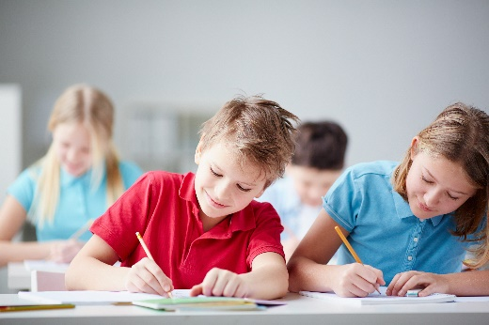
When students reflect on learning and analyse their own ideas and feelings, they self-evaluate, thereby improving their metacognitive skills. When students self-monitor or reflect, the most powerful learning happens.
Journaling may take the form of a written or digital journal, a portfolio or a digital portfolio. Early childhood classrooms may use a class journal or student journals that includes photos of the learning experiences and scribed conversations demonstrating students’ reflections.
Teachers can model the journaling process by thinking aloud and showing students how they can express learning and thoughts in a variety of ways including diagrams, drawings, photos and writing.
Journals are a useful tool that give teachers additional insight into how students value their own learning and progress, as well as demonstrating their individual achievements.
The following links provide background information and useful apps for journaling.
Kidblog – digital portfolios and blogging
kidblog.org/home
Edmodo – for consolidating and storing class notes and learning materials
www.edmodo.com
Explain Everything™ – a screen casting, video and presentation tool all in one
explaineverything.com/
Popplet – allows you to jot down your ideas and then sort them visually
Popplet.com
Seesaw – for capturing work completed by students in class, using a device’s camera function
web.seesaw.me
Connect – the DoE portal for teachers
connect.det.wa.edu.au
Evernote (a digital portfolio app)
evernote.com
Digital portfolios for students (Cool tools for school)
cooltoolsforschool.wordpress.com/digital-student-portfolios

Appendix 5: Teacher resource sheet: Cooperative learning – Think-Pair-Share
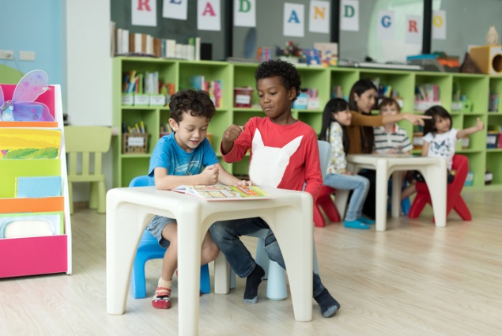
This resource sheet provides a brief outline of a cooperative learning strategy known as 'think-pair-share’.
Cooperative learning strategies create opportunities for students to work together, generally to a single purpose.
Think-pair-share increases student participation and provides an environment for higher levels of thinking and questioning.
As well as having the potential to increase learning for all students involved, using these strategies can help students develop personal and social capabilities.
In the 'think' stage, each student thinks silently about a question asked by the teacher.
In the 'pair' stage, students discuss their thoughts and answers to the question with a partner.
In the 'share' stage, the students talk about their answer and their partner’s answer or what they decided with other pairs or with the whole class. It is important to give students the option to 'pass' in the sharing step.
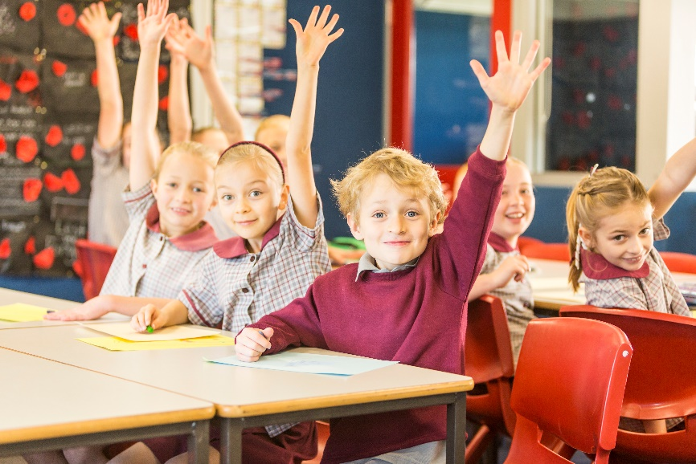

Appendix 6: Teacher resource sheet: Sample parent letter
(School details and letterhead)
(Date)

Dear parents/caregivers,

RE: REUSABLE ITEMS COLLECTION FOR OUR SWOOPING BIRDS STEM PROJECT

Our class is undertaking a STEM (Science, Technology, Engineering and Mathematics) project called Swooping birds this term. Based on the picture book Waddle Giggle Gargle! by Pamela Allen, this project will involve students in our class creating a solution to protect themselves from swooping birds.
This project also focuses on repurposing items to give students opportunities to consider sustainability and the impact of our lifestyles on our environment, while developing their ability to design, create and problem-solve. We will be discussing the shape and properties of the materials before students use them to design and make a swooping bird protector.
To enable us to create swooping bird protectors, we would appreciate if you would collect clean items from your house and send them to school with your child such as small to medium sized cardboard boxes and tubes, ice-cream and milk containers, foil plates, egg cartons etc. Please do not include any alcohol containers or toilet rolls.
We will be starting the project on (date) and would like the items to be delivered to the classroom before then.
We may need some parents during the construction phase of the project, so please let me know if you are available to help.

Thank you in advance.

(Classroom teacher)

Appendix 7: Teacher Resource sheet: Prototype troubleshooting
What is the problem? | Reason for the problem | Possible changes to your design to solve the problem

Appendix 8: Teacher resource sheet: Construction skills
Construction skills help students to generate and produce solutions for real-world problems. This resource develops students' skills in design and technologies.
This resource can be used as a visual stimulus to prompt students to develop solutions to design problems. The cards can be printed out to create stations.
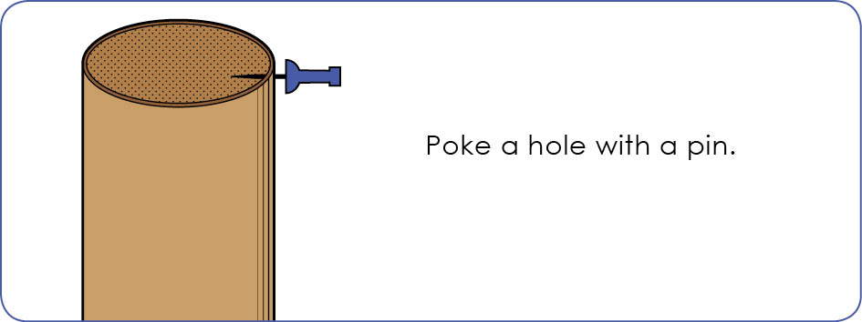
In the early years, students may need assistance with these skills.

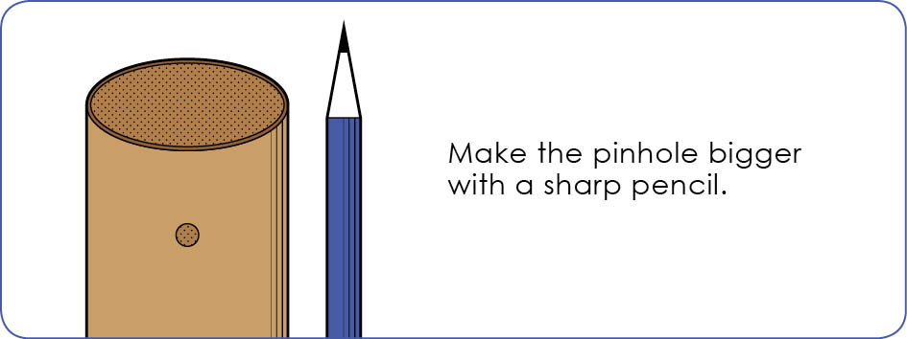
Poke a hole with a pin.

