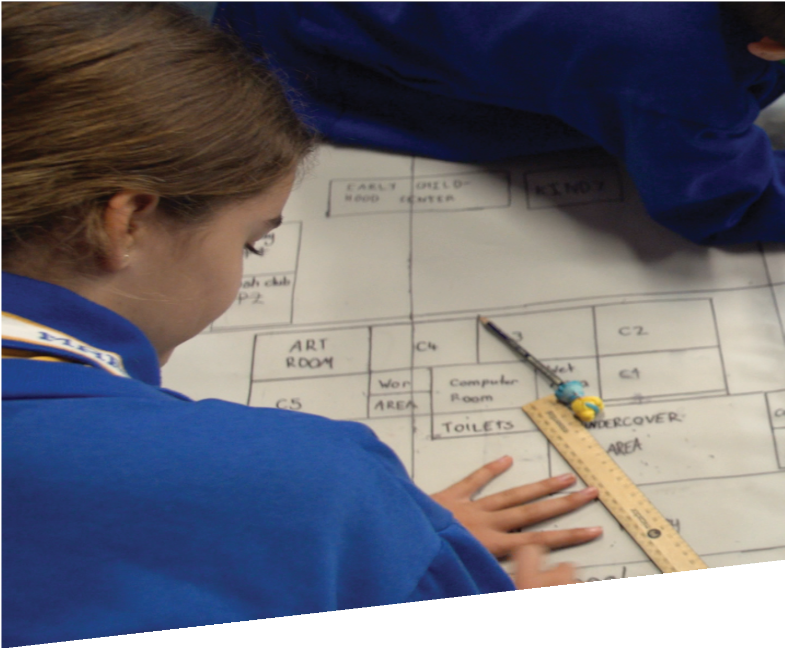

CURRICULUM RESOURCE MODULE

**Evacuation robot**

YEAR 5

**Acknowledgements**

The STEM Learning Project is funded by the Western Australian Department of Education (the Department) and implemented by a consortium in STEM education comprising the Educational Computing Association of WA, the Mathematical Association of WA, the Science Teachers Association of WA and Scitech.

We acknowledge and thank the teachers and schools who are the co-creators of these resources.

**Copyright and intellectual property**

The copyright and intellectual property of this module remain the property of the Department.

Any Western Australian Curriculum content in this resource is used with the permission of the School Curriculum and Standards Authority; this permission does not constitute Authority endorsement of the resource. The Authority accepts no liability for any errors or damages arising from reliance on its content.

The Western Australian Curriculum content may be freely copied, or communicated on an intranet, for non-commercial purposes in educational institutions, provided that the Authority is acknowledged as the copyright owner. Copying or communication for any other purpose can be done only within the terms of the Copyright Act 1968 or with prior written permission of the Authority. Any Australian Curriculum content in the Western Australian Curriculum is used by the Authority under the terms of the Creative Commons Attribution­ NonCommercial 3.0 Australia licence.

Any content on the www.scsa.wa.edu.au domain that has been derived from the Australian Curriculum may be used under the terms of Creative Commons Attribution-NonCommercial 3.0 Australia licence.

Appendix 2: general capabilities continua are adapted from ACARA, © Australian Curriculum, Assessment and Reporting Authority (ACARA) 2009 to present, unless otherwise indicated. This material was downloaded from the ACARA website (www.acara.edu.au) (accessed December 2015) and was not modified. The material is licensed under CC BY 4.0 (https://creativecommons.org/licenses/by/4.0/). ACARA does not endorse any product that uses ACARA material or make any representations as to the quality of such products. Any product that uses material published on this website should not be taken to be affiliated with ACARA or have the sponsorship or approval of ACARA. It is up to each person to make their own assessment of the product.

This resource includes references and examples of iOS, Android and other apps. The Department does not endorse or recommend any commercial products and simply provides these as examples for teachers.

The Department is committed to providing quality information to its customers. Whilst every effort has been made to ensure accuracy, currency and reliability of the information within these documents, the Department accepts no responsibility for errors, omissions or amendments made since the time of publishing. Confirmation of information may be sought from the Department or the originating bodies providing the information. The Department has no control over the content of material published on websites to which users are referred in this resource. It is the responsibility of the internet user to make their own decision as to the relevancy, accuracy, currency and reliability of information found on those sites.

Attributions: *Scratch, Scratch Jnr, eBook, Pages, Keynote, MS Word and PowerPoint, iMovie, Seesaw, Class Dojo, Padlet, Google Earth, Explain everything, Puppet Pals.*



Table of contents

The STEM Learning Project 2

Overview 3

Activity sequence and purpose 8

Background 9

Activity 1: Robot! Get me out of here! 11

Activity 2: Planning an evacuation 16

Activity 3: What is the digital solution? 26

Activity 4: Let’s pitch our solution 35

Appendix 1A: Links to the Western Australian Curriculum 40

Appendix 1B: Mathematics proficiency strands 42

Appendix 2: General capabilities continuums 43

Appendix 3: Materials list 46

Appendix 4: Design process guide 47

Appendix 5: Student journal 48

Appendix 6: Teacher resource sheet 1.1: Cooperative learning – Roles 49

Appendix 7: Teacher resource sheet 3.1: Flowcharting symbols 50

Appendix 8: Teacher resource sheet 3.2: Flowchart examples 51

Appendix 9: Student activity sheet 3.3: Animation – Storyboarding 52

Appendix 10: Student activity sheet 4.1: Peer evaluation 53

Appendix 11: Teacher resource sheet 2.1: 8 x 12 grid 54

Appendix 12: Teacher resource sheet 2.2: Sample school plan with grid reference overlay 55

# The STEM Learning Project

The aim of the STEM Learning Project is to generate students’ interest, enjoyment and engagement with STEM (Science, Technology, Engineering and Mathematics) and to encourage their ongoing participation in STEM both at school and in subsequent careers. The curriculum resources will support teachers to implement and extend the Western Australian Curriculum and develop the general capabilities across Kindergarten to Year 12.

**Why STEM?**

A quality STEM education will develop the knowledge and intellectual skills to drive the innovation required to address global economic, social and environmental challenges.

STEM capability is the key to navigating the employment landscape changed by globalisation and digital disruption. Routine manual and cognitive jobs are in decline whilst non-routine cognitive jobs are growing strongly in Australia. Seventy-five per cent of the jobs in the emerging economy will require critical and creative thinking and problem solving, supported by skills of collaboration, teamwork and literacy in mathematics, science and technology. This is what we call STEM capability. The vision is to respond to the challenges of today and tomorrow by preparing students for a world that requires multidisciplinary STEM thinking and capability.

**The approach**

STEM capabilities are developed when students are challenged to solve open-ended, real-world problems that engage students in the processes of the STEM disciplines.

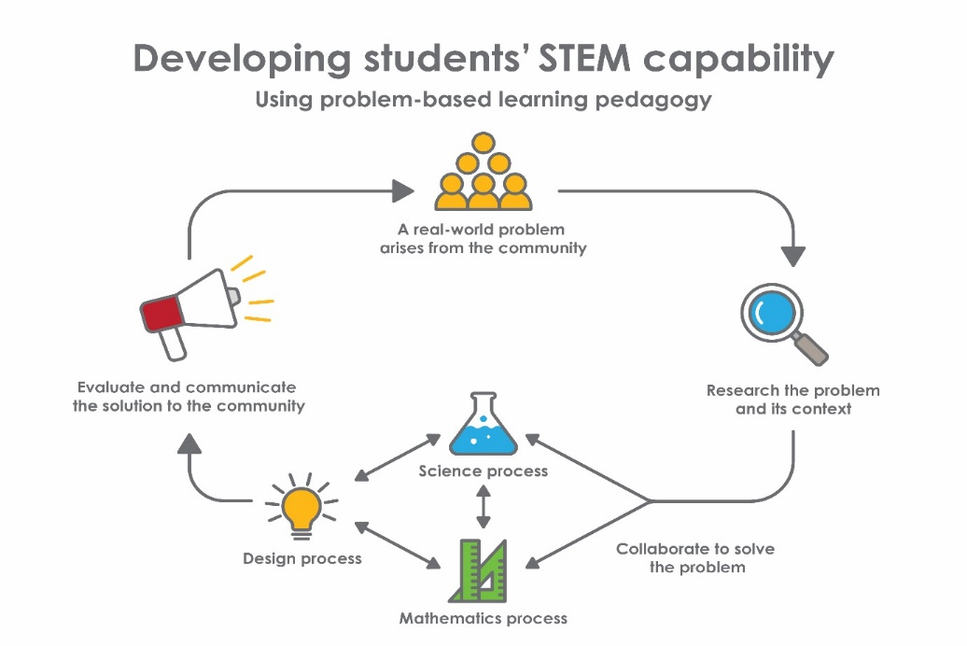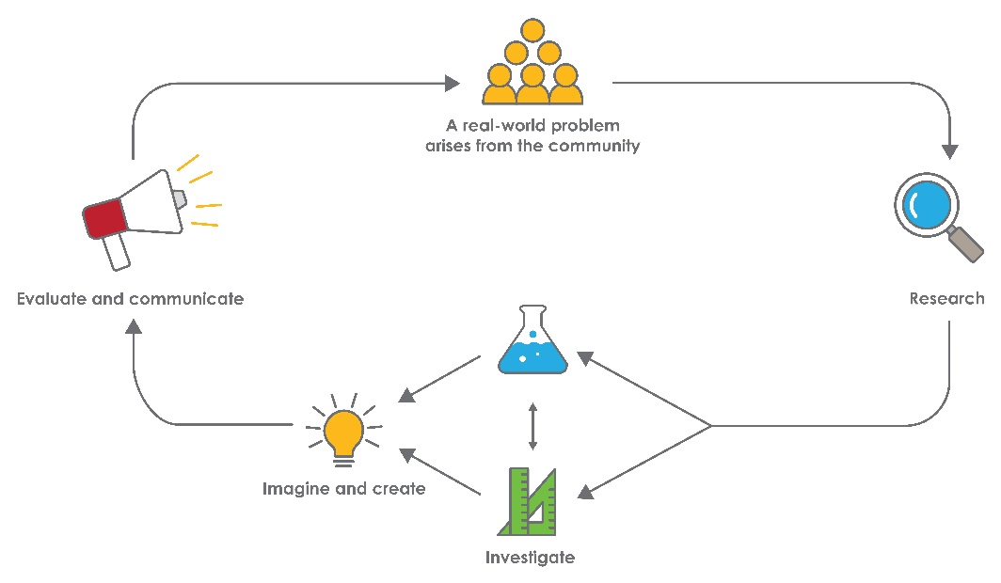

**Year 5 – Evacuation robot**

# Overview

|  |
| --- |
| Robots, drones and other automated systems are becoming increasingly prevalent in our daily lives.  This module leverages the rise of automated and autonomous systems used to perform routine or dangerous tasks. It seeks to empower students to be not only smart consumers of technology, but creators and innovators in the digital technology space. They work collaboratively to develop an algorithm and program a robot to simulate leading students to an evacuation point in the event of an emergency.  **What is the context?**  Swiftly and safely evacuating people from a building can be a difficult and hazardous process. Escape routes may be filled with smoke or debris, and people may be unfamiliar with the building, unaware of the dangers present, or may even have some incapacity that makes evacuation more difficult.  Automated systems, such as drones or robots, present an opportunity to provide a solution which minimises risk to human safety.  **What is the problem?**  How can we design an evacuation route and program a robot to safely guide students from their classroom to a muster point in the event of an emergency? |
| **How does this module support integration of the STEM disciplines?**  Students engage with the problem of evacuating students from their classroom in the event of a threat. They analyse evacuation plans, describe and document possible evacuation routes, develop an algorithm and program a robot to lead students to safety on a scaled plan of their school.  **Science**  Students entering Year5 should be able to identify when science can be used to explain the effect of their actions.  During Year 5 students will develop an understanding that science knowledge develops from many people’s contributions and that scientific developments have affected people’s lives and help us solve problems. They are beginning to explain how scientific knowledge helps us to solve problems and inform decisions. (**ACSHE083: Scientific knowledge is used to solve problems and inform personal and community decisions**).  During the blogging process, students are encouraged to consider how scientific developments can inform choices about where people live and how they respond to emergencies.  **Mathematics**  Students use a grid reference system on an A4 plan of their school to identify locations such as their classroom and potential muster points in order to plan possible evacuation routes. They describe the evacuation routes using landmarks and directional language (**ACMMG113: Use a grid reference system to describe locations. Describe routes using landmarks and directional language**). To create a ‘floor plan’ large enough to test their robot’s programmed actions, they enlarge the A4 plan of the school using a grid reference system to match and copy the contents of squares on to an enlarged grid system [(**ACMMG115: Apply the enlargement transformation to familiar two dimensional shapes and explore the properties of the resulting image compared with the original**)](https://k10outline.scsa.wa.edu.au/home/teaching/codes/mathematics/year-5/acmmg115). They compare distances and angles in the enlarged plan with the A4 plan and consider what changes and what must remain the same (**ACMMG112: Estimate, measure and compare angles using degrees. Construct angles using a protractor**).  By Year 5, students typically understand that maps and plans provide a ‘birds eye’ or ‘top down’ view of the world. While they identify and match landmarks shown in a map or plan to the real world, they may not be able to orient themselves to a location on a plan and provide accurate directions as they visualise their movement along a route. They should have encountered simple grid reference systems and are likely to know how to identify a given cell from a grid reference. They have an intuitive sense of scale but are unlikely to have the multiplicative thinking needed to construct accurately scaled plans or create precise enlargements. They are likely to recognise ‘right angles’ and understand that angle size relates to an amount of ‘turn’. However, they may not yet realise that the sizes of angles do not change when a figure is enlarged or reduced.  In this module, the *Understanding Proficiency* and the *Location and Transformation* content descriptions, ACMMG113 and ACMMG115, form the core mathematical focus of the activities.  Before students can learn the robot programming requirements, they should be repeatedly identifying locations and landmarks using a grid reference system and describing routes on a school plan using everyday directional language and landmarks. This should precede the expectation that they describe possible evacuation routes around the school using formal directional turns and distances. Initially students will mainly use landmarks to describe direction and distance, but will need to translate this into the directional and distance information needed to plan the algorithms and programming instructions for their robot. This step is best introduced after the enlarged floor plan has been created and they can measure the actual distances and angles required.  Once students have created the enlarged floor plan they can focus on programming their robot. They use the floor plan to test and refine their programs and alternative evacuation routes. This experience will form the basis for coding more complex algorithms that involve branching and iteration.  When students have successfully programmed their robots to physically follow evacuation routes on the floor plan, they can be challenged to consider how their programming instructions would translate to the real world. They consider what, mathematically, would need to change and what would need to stay the same for their robot to follow their chosen routes around the actual school. Students then test their ‘real world’ evacuation design by giving their program ‘instructions’ to a fellow student who acts out the role of the evacuation robot.  The calculation of proportional increases in the distances to be travelled in this final activity involves multiplicative problem solving processes to determine and use scale factors and so is an ideal context for developing the Number and Algebra Content Description, ([**ACMNA121**](https://k10outline.scsa.wa.edu.au/home/teaching/codes/mathematics/year-5/acmna121) **Find unknown quantities in number sentences involving multiplication and division and identify equivalent number sentences involving multiplication and division**)**.** The application of the inverse relationship between multiplication and division in this activity will contribute to the development of multiplicative thinking and their understanding of Algebra in later years. The Problem-Solving and Reasoning Proficiencies are the foci of the mathematics in this final section of the module.  **Technologies**  Students develop digital technology skills as they describe evacuation procedures using a flowchart with branching and iteration (**ACTDIP019: Design, follow and represent diagrammatically, a simple sequence of steps (algorithm), involving** [**branching**](https://k10outline.scsa.wa.edu.au/home/p-10-curriculum/curriculum-browser/syllabus/technologies-overview/glossary/branching) **(decisions) and** [**iteration**](https://k10outline.scsa.wa.edu.au/home/p-10-curriculum/curriculum-browser/syllabus/technologies-overview/glossary/iteration) **(repetition)**), transfer the algorithm to a simple programming platform such as Scratch (**ACTDIP020: Implement and use simple programming environments that include** [**branching**](https://k10outline.scsa.wa.edu.au/home/p-10-curriculum/curriculum-browser/syllabus/technologies-overview/glossary/branching) **(decisions) and** [**iteration**](https://k10outline.scsa.wa.edu.au/home/p-10-curriculum/curriculum-browser/syllabus/technologies-overview/glossary/iteration) **(repetition)**) and apply this through a digital interface to a robot (**ACTDIP018: Design solutions to a** [**user interface**](https://k10outline.scsa.wa.edu.au/home/p-10-curriculum/curriculum-browser/syllabus/technologies-overview/glossary/user-interface) **for a digital system**).  Students use Information and communication technology capabilities to present their solution to an audience beyond the classroom (**ACTDIP022: Create and communicate** [**information**](https://k10outline.scsa.wa.edu.au/home/p-10-curriculum/curriculum-browser/syllabus/technologies-overview/glossary/information)**, including online collaborative projects, using agreed social, ethical and** [**technical protocols**](https://k10outline.scsa.wa.edu.au/home/p-10-curriculum/curriculum-browser/syllabus/technologies-overview/glossary/technical-protocols) **(codes of conduct)**).  The Design process guide is included as a resource to provide assistance to teachers in understanding the complete design process as developed in the Technologies syllabus. |

|  |
| --- |
| **General capabilities**  There are opportunities for the development of general capabilities and cross-curriculum priorities as students engage with *Evacuation robot*. In this module, students:   * Develop problem solving skills as they research the problem and its context (*Activity 1*); investigate parameters impacting on the problem (*Activity 2*); imagine and develop solutions (*Activity 3*); and evaluate and communicate their solutions to an audience (*Activity 4*). * Utilise creative thinking as they generate possible design solutions; and critical thinking, numeracy skills and ethical understanding as they choose between alternative approaches to solving the problem. * Utilise personal and social capability throughout the module as they develop socially cohesive and effective working teams; collaborate in generating solutions; adopt group roles; and reflect on their group work capabilities through peer evaluation. * Utilise a range of literacies and information and communication technologies (ICT) capabilities as they collate records of work completed throughout the module in a journal; represent and communicate their solutions to an audience using digital technologies in *Activity 4.* * Communicate and, using evidence, justify their group’s design to an authentic audience. |
| **What are the pedagogical principles of the STEM learning modules?**  The STEM Learning Project modules develop STEM capabilities by challenging students to solve real-world problems set in authentic contexts. The problems engage students in the STEM disciplines and provide opportunities for developing higher order thinking and reasoning, and the general capabilities of creativity, critical thinking, communication and collaboration.  The design of the modules is based on four pedagogical principles:   * **Problem-based learning**   This is an underlying part of all modules with every module based around solving an initial problem. It is supported through a four-phase instructional model: research the problem and its context; investigate the parameters impacting on the problem; design and develop solutions to the problem; and evaluate and communicate solutions to an authentic audience.   * **Developing higher order thinking**   Opportunities are created for higher order thinking and reasoning through questioning and discourse that elicits students' thinking, prompts and scaffolds explanations, and requires students to justify their claims. Opportunities for making reasoning visible through discourse are highlighted in the modules with the icon shown here.   * **Collaborative learning**   This provides opportunities for students to develop teamwork and leadership skills, challenge each other’s ideas, and co-construct explanations and solutions. Information that can support teachers with aspects of collaborative learning is included in the resource sheets.   * **Reflective practice**   Recording observations, ideas and one’s reflections on the learning experiences in some form of journal fosters deeper engagement and metacognitive awareness of what is being learnt. Information that can support teachers with journaling is included in the resource sheets.  These pedagogical principles can be explored further in the STEM Learning Project online professional learning modules located in Connect Resources. |



Department of Education WA

# 

# Activity sequence and purpose

|  |  |
| --- | --- |
|  | Robot! Get me out of here!  Students’ interest is captured when they view videos on the use of robots in dangerous situations and begin investigating school evacuation procedures and possible emergencies that could arise in a school context. |
|  | **Planning an evacuation**  Students are provided with a plan of the school buildings, rooms and paths on a grid system. They identify potential threats in their school and plan optimum evacuation routes for various threats. |
|  | **What is the digital solution?**  Students extend their coding skills by designing a ‘smart’ evacuation plan that will use a robot to guide students in an emergency. They translate their solution to the real world, considering what needs to change to code a full size robot to lead an evacuation in their school. |
|  | **Let’s pitch our solution**  Students evaluate the success of their evacuation design by simulating a real world evacuation of their classroom, conveying their programming instructions to a human robot substitute. Students present their evacuation design to an authentic audience. |

# Background



|  |  |
| --- | --- |
| **Expected learning** | The students will be able to:  Explain what a robot is and describe the way in which robots can improve our lives.  Identify possible threats that could occur at their school and decide on safe escape route/s for likely kinds of threats.  Use a grid reference system to identify locations and use directional language and landmarks to describe evacuation routes for their school and as a method for creating an enlarged plan of the school.  Document programming instructions in a systematic way and successfully program a robot so that it leads a class to safety on an enlarged floor plan of the school  Refine directional and distance information using a flowchart to develop and code an evacuation algorithm involving branching and iteration and then translate that information to successfully simulate a full size robotic led evacuation of the school.  Use technologies to organise and present information about the design and the design process.  Work collaboratively to plan, develop and communicate ideas and solutions.   1. Solve problems and make decisions based on scientific knowledge. |
| **Vocabulary** | This module uses subject-specific terminology.  The following vocabulary list contains terms that need to be understood, either before the module commences, or developed as they are used.  algorithm, blog, branching, chance, drone, enlargement, evacuation, grid reference system, iteration, map, plan, robot, route, scale, system. |
| **Timing** | There is no prescribed duration for this module. The module is designed to be flexible enough for teachers to adapt. Activities do not equate to lessons; one activity may require more than one lesson to implement. |
| **Consumable materials** | A Materials list is provided for this module. The list outlines materials outside of normal classroom equipment that will be needed to complete the activities. |
| **Safety notes** | There are potential hazards inherent in these activities and with the equipment being used, and a plan to mitigate any risks will be required.  Potential hazards specific to this module include but are not limited to:   * + - * Possible exposure to cyber bullying, privacy violations and uninvited solicitations when using the internet.       * Exposure to mains power when re-charging robots and devices. |
| **Assessment** | The STEM modules have been developed to provide students with learning experiences to solve authentic real-world problems using science, technology, engineering and mathematics capabilities. While working through the module, the following assessment opportunities will arise:   * Student design portfolios (blog), annotated diagrams, flowchart design solutions and their presentation. * Student peer and group reflections where they evaluate their collaborative working skills. This will be ongoing and formative in nature. * Mathematics can be assessed by noting or recording the location language used, both orally and in their written responses, their skills in enlarging the plan and their ability to use a protractor when measuring angles. There is opportunity to assess their multiplicative understanding when converting scaled measurements to robot steps and to real world dimensions.   Appendix 1 indicates how the activities are linked to the Western Australian Curriculum.  Evidence of learning from students’ journaling and presentations and teachers’ anecdotal notes from this module can contribute towards the larger body of evidence gathered throughout a teaching period and can be used to make on-balance judgements about the quality of learning demonstrated by the students in the science, technologies and mathematics learning areas.  Students can further develop the general capabilities within ICT capability, Critical and creative thinking and Personal and social capability. Continuums for these are included in the General capabilities continuums but are not intended to be for assessment purposes. |

# Activity 1: Robot! Get me out of here!

|  |  |
| --- | --- |
| **The Activity 1 icon consists of a magnifying class.Activity focus** | This activity is designed to spark students’ imagination and interest in the problem. Students watch a number of stimulus videos on the use of robots in dangerous situations. Working in groups, students begin investigating evacuation procedures for the school.  Students begin blogging about what they have learnt. |
| **Background information** | A robot is a machine that can be programmed to complete a series of tasks. Some robots are programmed to work independently; other robots are directly controlled by people using a remote device. Some robots have sensors which let them detect and respond to changes (eg change in temperature or light levels).  Robots are often used to perform tasks that people cannot do (eg tasks that require super strength or are dangerous), or tasks that people don’t want to do (eg repetitive tasks). One example is a Western Australian company Fast Brick Robotics ([www.fbr.com.au](http://www.fbr.com.au/)) who are developing a robot that can lay bricks for a wall.  Examples of robot and drone uses include: aerial photography, threat management, search and rescue, wildlife monitoring, storm tracking and weather forecasting.  Warehouse robots are programmed to follow tracks to locate and retrieve packages. They follow predetermined routes in the same way as an evacuation robot might. |
| **Expected learning** | Students will be able to:   1. Describe what a robot is and they ways in which they can improve our lives (Science). 2. Identify the features shown on a school evacuation plan (Mathematics). |
| **Equipment required** | **For the students:**  Digital devices for research |
| **For the class:**  Interactive whiteboard |
| **Preparation** | Test links to videos and download to reduce streaming issues during lesson time.  Locate and copy the school evacuation plan or create a digital copy for sharing. |
| **Activity parts** | **Part 1: About drones and robots**  Use class discussion to determine students' prior knowledge of robots. This can be recorded as a brainstorm on a digital platform such as *Padlet* or on the whiteboard.   * What are some uses of robots? * Why do they have different uses? * How can robots change people’s lives? * What are drones and how are they useful? * How are they controlled?   Further engage students in the topic by playing a range of videos. Links to suggested videos can be found in the *Digital resources* section. | |
| **Part 2: Researching robots**  Working in small groups, students use digital devices to research more uses of robots.  Through discussion, students share what they have learnt with the class before adding to the brainstorm from *Part 1*. Students can use different colours to distinguish between prior and new knowledge. |
| **Part 3: Evacuation plans**  Students analyse the school’s evacuation plan and identify the current evacuation routes from a variety of rooms. Assist students to understand the plan’s ‘top down’ view and symbols by asking:   * How are buildings, rooms, doorways and paved areas identified on the plan? * What does the plan show and what doesn’t it show compared to an aerial or ‘Google Maps’ photograph of the school? * How are the evacuation routes shown? * What do the extra symbols mean on the plan? * How could you describe the route from your classroom in words?   Students discuss and deduce the possible reasons and criteria that led to the specific routes being chosen.  Distance may have been only one criterion; others may have included the location of flammable materials, disability access, congestion and ventilation. |
| **Part 4: Class review**  Conduct a class discussion to review the findings of the student research about robots and evacuation routes and how science can inform decisions about the way we respond to and manage emergencies. |
| **Part 5: Blogging the findings**  Students begin blogging what they have learnt about robots and evacuation routes. See *Resources for class blogging* for a list of blogging options. Alternatively, they could reflect on their learning in a digital journal. See Student journalfor elaboration. |
| **Digital resources** | *Creativity, technology & learning through play – Don’t learn to code – code to learn* (John Lilley, Junior Game Creators, 2016)  [www.juniorgamecreators.co.uk/creativity-technology-learning-play-dont-learn-code-code-learn](http://www.juniorgamecreators.co.uk/creativity-technology-learning-play-dont-learn-code-code-learn/) |
| *Programming Parrot Drones with Tynker* (Tynker, 2017)  [www.tynker.com/blog/articles/ideas-and-tips/coding-at-school/programming-parrot-drones-with-tynker](http://www.tynker.com/blog/articles/ideas-and-tips/coding-at-school/programming-parrot-drones-with-tynker/) |
| *Robots, drones and heart-detectors: How disaster technology is saving lives* (Chris Boyette, CNN, 2015)  [edition.cnn.com/2015/08/24/us/robot-disaster-technology](http://edition.cnn.com/2015/08/24/us/robot-disaster-technology/) |
| *Disaster drones: How robot teams can help in a crisis* (Dougal Shaw, BBC, 2012)  [www.bbc.com/news/technology-18581883](http://www.bbc.com/news/technology-18581883) |
| *How robots are changing search and rescue* (BBC, 2014)  [www.bbc.com/future/story/20140612-robots-to-the-rescue](http://www.bbc.com/future/story/20140612-robots-to-the-rescue) |
| *5 amazing drone use ideas* (Drone Compilations, 2016)  [www.youtube.com/watch?v=1bg0vRQOc9Q](https://www.youtube.com/watch?v=1bg0vRQOc9Q) |
| *Drone project aims to deliver rapid disaster response after cyclones* (Patrick Wood, ABC News, 2017)  [www.abc.net.au/news/2017-03-31/drone-trial-to-deliver-rapid-disaster-relief-after-cyclones/8403334](http://www.abc.net.au/news/2017-03-31/drone-trial-to-deliver-rapid-disaster-relief-after-cyclones/8403334) |
| *French farmers use drones to examine crops* (VOA Learning English, 2015)  [learningenglish.voanews.com/a/french-farmers-use-drones-to-examine-crops/2611191.html](http://learningenglish.voanews.com/a/french-farmers-use-drones-to-examine-crops/2611191.html) |
| *Here are the coolest ways drones have been used in advertising* (Richard Feloni & Aaron Taube, 2014)  [www.businessinsider.com.au/drones-in-advertising-2014-9?r=US&IR=T](https://www.businessinsider.com.au/drones-in-advertising-2014-9?r=US&IR=T) |
| *RIO Tinto Driverless trucks program*  [thewest.com.au/business/mining/rio-tintos-driverless-trucks-program-shifts-gear-to-make-pilbara-mine-full-auto-ng-b88693612z](https://thewest.com.au/business/mining/rio-tintos-driverless-trucks-program-shifts-gear-to-make-pilbara-mine-full-auto-ng-b88693612z) |
| *Telerobots, we need you* (Splash ABC, 2013)  [www.splash.abc.net.au/home#!/media/2090458/telerobots-we-need-you](http://www.splash.abc.net.au/home#!/media/2090458/telerobots-we-need-you) |
| **Resources for class blogging** | Connect  A Department of Education resource which provides a platform for teachers and students to upload and share work.  [www.connect.det.wa.edu.au](http://www.connect.det.wa.edu.au) |
| Edublogs  A WordPress blogging platform. The free version of Edublogs is rather limited in that the teacher cannot include videos, use custom HTML to embed items into posts, or manage students’ accounts.  [edublogs.org](http://www.Edublogs.org) |
| Kidblog  KidBlog is a free hosted blogging service designed for teachers to use with students. Teachers can create accounts for their students to use to write blog posts and to write comments on blog posts. Students do not have to have email addresses in order to use KidBlog.  [kidblog.org](http://www.kidblog.org) |
| Edmodo  For providing clear feedback, many teachers like this learning management system.  [www.edmodo.com](http://www.edmodo.com) |
| Blogger  This is Google’s free blogging service. Blogger offers a good selection of colourful themes and templates. Customising the layout of a blog can be done by dragging and dropping elements into place.  [www.blogger.com](http://www.blogger.com) |

# Activity 2: Planning an evacuation

|  |  |
| --- | --- |
| The Activity 2 icon consists of images of maths equipment, a beaker, and a light bulb to represent design. **Activity focus** | In this activity, students identify possible consequences arising from potential threats occurring at various locations in their school. They identify a safe route from their classroom to a muster point and then program a robot to follow the route on a plan of the school. |
| **Instructional procedures** | It is recommended that students work in small groups of three to four from this activity onwards. Mixed ability groups encourage peer tutoring and collaboration in problem solving. Collaboration is an important STEM capability.  Many robots can be used for this *Evacuation robot* module including, but not limited to *Sphero, Dash* and *Dot, Edison* and *Bee-Bot.* Some are more suitable than others so teachers are encouraged to explore the capabilities of the particular robot you plan to use with the students. For example,   * Sphero is difficult to program to go slow enough to stop where you want it. * Dash, the moving robot in Dash and Dot, is quite large so it will require a larger floor plan than Edison. * Edison, is smaller than some others and can move around on a smaller plan, and can also use EdScratch, a programming platform from Scratch. * Blue-Bot, rather than Bee-Bot, is more limited than some others, but can be programmed to perform 45 degree turns using a tablet or laptop – unlike Bee-Bot which is only programmed by pushing buttons on the robot. |
| **Expected learning** | Students will be able to**:**   1. Identify locations and landmarks using a grid reference system on a plan of the school and decide on an optimum evacuation route from their classroom to a given muster point (Mathematics). 2. Use a grid reference system to enlarge a plan of the school and formulate instructions to follow an evacuation route using the distance and directional information that is recognized by the particular robot they are using. (Mathematics). 3. Use a computer to program their robot to physically move along their chosen route on the enlarged floor plan of the school. (Technologies). |
| **Equipment required** | **For the class:**  Interactive whiteboard or data projector to show videos  Robots and devices for programming robots |
| **For the students**:  A4 scale plan of the school, or part of the school, showing buildings, rooms and paved areas on which an 8 x 12 grid reference system is photocopied. See Teacher resource sheet 2.1: 8 x 12 grid and Teacher resource sheet 2.2: Sample school plan with grid reference overlay. |
| **Preparation** | Ensure robots are fully charged.  Prior to the lesson, students need to be familiar with the particular robot or robots you have available. This is best achieved when students are given time to freely explore the robot’s capabilities and its coding system, before expecting that they can program the robot to follow a given procedure.  Prepare the sheet of card with a grid reference system ready for creating the enlarged floor plan. Choose the grid dimensions according to the size of your school and the robot the students will use. For example, if using Dash, pathways need to be at least 15 cm wide on the floor plan. If using Edison, 10 cm wide paths will be sufficient. Check the width of your robot to decide how much you need to enlarge your A4 grid to achieve a suitable map.  Join sufficient A2 cards edge to edge with tape to make a rectangle proportionally larger than an A4 page and then draw on it a corresponding enlarged 8 x 12 grid reference system. The size of the enlarged grid squares can be 10 cm x 10 cm (requiring four A2 cards) or 20 cm x 20 cm (requiring sixteen A2 cards).  **Content warning:**  When planning for the delivery of this topic, it is important to consider the backgrounds and experiences of the students as content may cause distress for some students. It may be necessary to notify parents, alert students and provide alternative lesson content. |
| **Activity parts** | **Part 1: Threat and location**  Discuss with students the kinds of emergencies that may require an evacuation of a school and the likelihood of such events happening at their school. For example; fire (is the school close to bushland?), flood (is the school on low land close to a river?), earthquake (have there been tremors or quakes in the past?), chemical spills (is the school near factories or a main highway?). Take care during the discussion not to alarm students.  Explain to students they will be planning to use an evacuation robot to safely guide students from their classroom to a muster point in the event of an emergency.  Tell them they will be creating a scaled ‘floor plan’ of the school on which they will be able to test their robot’s ability to follow their emergency route. |
| **Part 2: School plans**  Students examine an A4 size scale plan of the school with an 8 x 12 grid reference overlay and main landmarks labelled. An example is provided here, with an enlarged version provided in *Teacher resource sheet 2.2: Sample school plan with grid reference overlay*.  Ask students to identify the grid references for labelled landmarks and then to find their classroom on the plan, labelling it and any other significant buildings, rooms or areas.  Students discuss and decide on a good ‘muster point’ in the event of an evacuation. They should be encouraged to use the grid reference system to say where this and other landmarks are on the plan.  Have students describe to a partner a route from their classroom to the muster point, for example:  *“I stood at the door facing the Library, then I turned right and walked until I got to the end of Room 1. I cut across in front of Admin and walked towards the Car Park, then out onto the street.”*  To assist students to orient themselves to the plan, suggest they imagine standing at their classroom door on the plan and identify the landmark they would be facing and which way they would need to turn to begin their route to the muster point. They could use left and right or compass directions if they are shown on the plan.  This is an opportunity to observe the informal location language students are using. While students can work in groups to share and discuss their ideas, it is suggested that each student has their own plan. They can also be provided with a range of starting and muster points and be challenged to describe these different routes in order to practice the language.  When sufficient landmarks have been identified and labelled on the plan and students have described their routes, have each student slip their plan into a plastic sleeve and use a felt pen to draw their preferred evacuation route from their classroom to the chosen muster point. Students can compare with each other and discuss how different emergencies might affect their route. When they have drawn their chosen route on the plastic sleeve, have students write their names on the sleeves and remove the plan. Save the plastic sleeves for Part 4 of this activity. |
| **Part 3: Enlarging the plan**  Students begin with the A4 plan of the school without any routes marked on it. Explain that the plan is too small to use with a robot and that, together, they will create an enlarged plan of the school on which their robot will try out their evacuation route.  Provide each student with blank paper on which there are photocopied squares exactly the same size as the squares on the pre-prepared enlarged grid reference system. Students are allocated grid reference ‘squares’ to enlarge by copying the corresponding squares from their A4 plan. Remind them to use pencil so they can erase and redraw if needed. Ensure they label the square with its correct grid reference the right way up. When satisfied, they cut out their enlarged square and place it on to the corresponding grid reference square on the floor plan.  This part of the activity lends itself to differentiation by choosing easier or more difficult sections of the plan for different students. Some may be able to enlarge several squares, while others might only manage one.  There is opportunity for collaboration by having students work together to consider the continuity of figures across the grid lines of adjoining squares and inviting them to problem solve how to adjust the shapes to proportionally match the original.  If students have not had experience with this kind of enlargement process, you may need to spend some time modelling the kind of proportional approximation needed to accurately carry out the enlargement process. For example, if a line crosses the grid about a third of the way along the side of a square, then the enlarged line also needs to cross about a third the way along the side of the larger square. The intuitive spatial skills needed for noticing this will vary among students so sharing of expertise should be encouraged.  C:\Users\E0406321\Desktop\photos evacuation\measuring no face.jpg  When students are satisfied they can carefully glue their squares on to the correct grid reference square to form the complete enlarged floor plan.  If possible, pin the enlarged plan to a wall alongside a copy of the original A4 plan, so that it can continue to be observed and discussed as to what ‘looks right’ and what looks wrong. It can continue to be corrected by any of the students over a period of days.  This is also an opportunity to draw attention to angles. For example, students can check that the corners of buildings are at right angles. The accuracy of the angles formed when a line crosses a grid boundary can also be considered.  When all are satisfied as to its accuracy, the main building outlines and doorways can be traced over with black felt pen. Buildings, paths and grassed areas can be shaded or painted in different colours to achieve an attractive, accurate and clearly defined, scale plan of the school, ready for its further use in this module.  Make sure squares are fully adhered to ensure a smooth surface. It can be covered with plastic film or laminated in sections and taped back together if a smoother surface is needed.  **C:\Users\E0100578\AppData\Local\Microsoft\Windows\INetCache\Content.Outlook\HC4WG5KD\Plan grid.jpg** |
| **Part 4: Programming robots**  Return the plastic sleeves to the students so they can review their planned route. Students then copy their route onto their A4 plan and take turns using a pointer to show the route on the larger plan while describing it using informal distance and direction language.  It is assumed students are familiar with the type of coding needed to program the selected robots. If not, provide opportunities for them to practise using their robot until they understand how distance and direction of turn are defined in that code.  They consider how their informal directional and distance language using landmarks will need to change in order to program their robot. Ask:   * What kind of instructions does your robot ‘understand’? * What ‘turning’ language could you use? * How can you tell your robot how far to move before it has to stop and turn? * What would you need to measure on the floor plan before you can tell your robot what to do?   When they are ready, students should plan and list the programming steps required for their robot to follow their evacuation route on the floor plan. They should take measurements on the floor plan and consider how those distances can be translated into the particular ‘step sizes’ their robot may take in response to the coding input. The students will need to consider direction and amount of turn.  Students may not understand the idea of angle in this context as the amount of turn needed to change direction (see diagram below). This might need explicit teaching. Many students have the misconception that angle measures the shape of a corner, in which case they may focus on the angle formed by the route, rather than the angle of turn required to change direction. To measure this angle, they can draw a line extending the original direction of travel to create the ray on which to line up their protractor.  This is the angle of directional turn between a continuation of the original direction of travel and the new direction.  Later, students can learn to measure the angle shown on the route and subtract that from 180 degrees to find the angle of direction.  Students translate their planned instructions into the appropriate code and test it on the enlarged floor plan, making adjustments as needed. Depending on the interest level of the students and the group sizes, the class can observe each student or group testing their instructions and contribute advice about changes that might improve the performance of the robot. Otherwise, students can conduct their testing in their groups while the class is engaged in other activities.  C:\Users\E0406321\Desktop\photos evacuation\Mackenzie, zane and robots.jpg |

|  |  |
| --- | --- |
|  | **Part 5: Video robots**  Students use a digital device to video each other’s robot following the evacuation routes on the floor plan.  Students can use a program such as *Explain everything,* *Puppet pals* or *iMovie* to record a voice over for the video, explaining the process and the route the robot travelled.  Alternatively, they can write a description of the process they have followed in creating the enlarged plan, determining an evacuation route and programing their robot, including photos.  This can provide an opportunity for evaluating some of the Mathematics and Technology Standards for Year 5. |
|  | **Part 6: Class review and Updating blogs**  Conduct a whole class discussion to review the lesson and consider how science can inform choices about the way communities respond to and manage emergencies.  Students continue blogging about their learning and upload their video with voice over or written description from *Part 5*. |
| **Resource sheets** | Teacher resource sheet 2.1: 8 x 12 grid  Teacher resource sheet 2.2: Sample school plan with grid reference overlay |
| **Digital resources** | Information regarding the flying of drones in Australia  [www.casa.gov.au/aircraft/landing-page/flying-drones-australia](http://www.casa.gov.au/aircraft/landing-page/flying-drones-australia) <https://scratch.mit.edu/> |
| To see a wide range of robots associated with *Tickle* go to  [www.tickleapp.com/devices](http://www.tickleapp.com/devices) |
| **For coding information go to:**  GROK Learning  <https://groklearning.com/> |
| *CSER Digital Technologies Education*  <https://csermoocs.adelaide.edu.au/> |
| *The Digital Technologies Hub*  <https://www.digitaltechnologieshub.edu.au/> |
| *Edison* (coding information)  [meetedison.com/robot-programming-software/edscratch/](https://meetedison.com/robot-programming-software/edscratch/)  *Dash and Dot*  [teachers.makewonder.com](https://teachers.makewonder.com/)  *Sphero*  [www.sphero.com/education](http://www.sphero.com/education/)  Blue-bot  [www.bee-bot.us](http://www.bee-bot.us) |

# Activity 3: What is the digital solution?

|  |  |
| --- | --- |
| **The Activity 3 icon consists of a light buld representing imagine, design and create.Activity focus** | In this activity, students extend their coding skills by designing a ‘smart’ evacuation plan in which a robot will make decisions according to specific circumstances experienced in an emergency.  They then translate their programming solution to the real world, considering what will stay the same and what will need change to code a full size robot to carry out their evacuation solution in their actual school. |
| **Background information** | An algorithm is a sequence of steps that is followed to solve a problem. People use algorithms every day to solve problems and complete tasks, for example baking a cake or getting dressed. In computer language, an algorithm involves considering all possible actions that may be needed to complete a task.  A flowchart is a diagrammatic representation of an algorithm and includes shapes and arrows to indicate decision‑making points and repeated actions (branching and iteration). The shapes used in a coding flowchart are shown in Teacher resource sheet 3.1: Flowcharting symbols and an example of a flowchart is shown in Teacher resource sheet 3.2: Flowchart examples*.*  Algorithms can be modelled mathematically or converted to computer code, and can range from very simple to extremely complex. |
| **Instructional procedures** | Students are introduced to a more complex level of coding than that used to program their robots in Activity 2. Through a programing platform such as *Scratch*, they will be using visual block-based programming to engage in the process of computational thinking. They will use a formalised flowchart to plan a program for an evacuation robot that includes branching and iteration in response to the different conditions that might be created by different emergencies.  They will then consider and test how their programming solution can be translated to a real world context, using a student to play the role of a robot. |
| **Expected learning** | Students will be able to:  Design a flowchart, including branching and iteration, that can be used as the basis for programming a robot (Technologies).  Image of a block of Scratch coding.Use block-based coding software (see Scratch example below) to write a program for an evacuation robot from their flowchart. (Technologies).  Understand how scale factors are determined and use multiplicative processes to convert their programmed solution to a full sized robot. (Mathematics) |
| **Equipment required** | **For the class:**  Interactive whiteboard or data projector to show videos  *Scratch* or *Scratch Jnr* (or other block based coding platform) |
| **For the students**:  Laptops or digital devices for programming  Plan of the school  Butchers paper or A3 paper  Flowchart symbols  Student activity sheet 3.3: Animation – Storyboarding |
| **Preparation** | Research flowcharting and *Scratch* (see *Digital resources* section). It is necessary for students to preview *Scratch* (or other coding software) and familiarise themselves with the programming language prior to the lesson.  Download the videos to minimise streaming issues.  Provide access to laptops or devices.  Prepare the necessary resource sheets. |
| **Activity parts** | **Part 1: Alternative routes**  Students continue to work in their same small groups and on the same location allocated in *Activity 2*. They refer to their A4 sheets with their robot instructions for a single route evacuation.  In a class discussion, review the possible emergencies previously considered and decide on two or three consequences that may affect the evacuation route. Have students add information to their maps and include two or three routes from their classroom to the muster point, that might result from local conditions, and that would involve the robot making decisions about conditions and changing course where needed. For example, detecting smoke or heat if there is a fire, or avoiding debris in an earthquake.  Have each student or group talk through their imaginary scenario and the choices they would want their robot to make when leading a class to safety.  Factors that may influence the choice of paths on the evacuation route could include:   * Distance * Congestion – could the robot detect too many people? * Blocked passages – How could the robots detect and adjust for a blocked pathway? * Accessibility (eg uneven surfaces) – Are there pathways through the school that are not suitable for people with crutches or in wheelchairs? * Fire – How could robots detect fire? Can they be made to use their sensors to detect and respond to heat or smoke? |
| **Part 2: Algorithms and Flowcharting**  Introduce the idea of an algorithm in coding as involving all the steps necessary to lead to the completion of a task. This could be related to the buying of a new pair of red shoes, or having breakfast. Clarify the need to think about the decisions that need to be made and the alternative steps that might need to be included in the algorithm.  For example, in preparing breakfast, you might plan to have cereal, so you pick up the packet and find there are none left in the packet, what do you do? You might then consider having porridge instead, in which case, both alternatives would need to be included in your algorithm.  Ask students consider the example flowchart used to represent the algorithm for buying a pair of red shoes in Teacher resource sheet 3.2: Flowchart examples.  Watch the video *The Big Bang Theory* - *The Friendship Algorithm*. See the *Digital resources* section and Teacher resource sheet 3.1: Flowcharting symbols for the basic shapes. Use the video to draw attention to the iteration and branching used in Sheldon’s ‘Friendship Algorithm’  Discuss the use of a flowchart to help visualise and plan algorithms. Have students identify the meaning of the shapes and flowlines in a flowchart.  Have students add to the ‘red shoes’ flowchart to reflect a range of scenarios, for example, an $80 limit, or a specific shoe size.  A full set of flowcharting symbols is available in *MS Word* using the ‘Insert – Shapes’ menu. |
| **Part 3: Evacuation routes**  Students return to their A4 plans and notes. Challenge them to apply algorithmic thinking, and use the symbols provided to create a flow chart that represents an evacuation route algorithm for their chosen routes. Their algorithm should include all the decisions required for the robot to avoid dangerous conditions caused by their chosen emergencies.  Students can be encouraged to expand their thinking beyond the simple robot ‘following of a route’ that was their focus in Activity 3. For example:   * Could their robot first determine the capabilities of the students, such as to ask if any are in a wheelchair, and choose a different path if the answer is ‘yes’? * Can the robot speak? Can it issue commands to the people it is leading, telling them to wait while it goes ahead and scouts for the best path before returning to collect them? * Think of a robot able to peer around a corner and make decisions based on what is observed. * Can their robot smell smoke for example, or detect dangerous chemicals?   In this activity, students should not be restricted by the physical constraints of the small robots they have used. They can plan their algorithm for an imagined very sophisticated robot.  Note: There is an example on Teacher resource sheet 3.2: Flowchart examples but as there are many solutions, it is recommended not to show this very simple flowchart to the students until after they have found their own solution.  Students share their algorithms, talking others through their flowchart and their branching and iteration opportunities, enhancing collaboration and problem solving, and stimulating reasoning and justification of their decisions.   * Why is this the best escape route for …? … *Because*. . . * What would happen if…? * How would the robot respond to …? * What happens if this part keeps repeating …? * What other choice could there be for …?   Groups share their thinking with the class. Encourage other groups to provide verbal feedback to develop peer mentoring. |
| **Part 4: Programming using Scratch**  Using their flowcharts from *Part 3* students consider how this algorithm can be transferred to the *Scratch platform*. There are different ways this can be accomplished. Students may import a plan of the school and use animation to simulate different emergencies and create a sprite of a robot to move around the plan and make decisions based on random emergencies.  Alternatively, students may ignore the plan and work from a storyboard to create animations that act out the emergency and the evacuation routes, without following a plan. An animation can include appropriate sprites, backgrounds, music and dialogue.  While the nature of the output of their programming may vary according to their imagination and skill level, their coding should involve the branching and iteration procedures as reflected in their flowchart, this being the main Technology learning purpose for Activity 3.  Groups share their *Scratch* programs with the class on the interactive whiteboard.  **An image showing a student work sample of coding.** An example of a Scratch animated program |
| **Part 5: Real-world application**  In this part, students return to their floor plan and together with their flowchart, plan a series of ‘programming’ instructions to give to a ‘pretend robot’ (a classmate) so they can simulate the evacuation procedure in the real world (the school).  Discuss with students what would remain the same and what would need to change between a program that worked for a robot moving around the floor sized plan and a full sized robot moving around the actual school.  With some support students should decide that right/left directions and angles of turn would remain the same, but the distances would be greater than on the school plan.   * How could we decide how far the full size robot should travel before it turns? * Could the measurements on the floor plan help us with this? * How could we compare a length measurement on the floor plan with the full size measurement? * How many of these lengths would fit along that wall? * What measurements could we take and how could we use our calculator to work it out?   Year five students are unlikely to know how to calculate and then apply a scale factor to determine real world measurements from a scaled plan. To develop this understanding, have different students take and record different length measurements on the plan, and then take and record the corresponding full size measurements. Enter these pairs of measurements into a table and ask students to try and find a relationship between the scaled and full sized measures. To focus students on multiplicative relationships, ask, for example,   * How many times longer is the real wall compared to the wall on the plan? * What would you need to multiply the measurement on the plan by to get to the measurement in the real world? * What operation would you need to use to calculate that from the two measurements you have taken (on the plan and in the real world)?   Have students use a calculator to divide the real world lengths by the corresponding lengths on the plan. Record their results and, while it is expected that there will be  variation due to measuring and scaling errors, the results should approximate a scale factor that represents how many times larger the real world is than the floor plan.  Students can then test this by taking other length measurements on the plan, multiplying this by the scale factor, and then checking those lengths in the real world.  Discuss why there is still likely to be some variation, and how that could be minimized through a more carefully constructed A4 scale plan and enlarged floor plan.  When ready, ask them to return to their algorithm and flow chart and adjust it to reflect real world measurements for distance while maintaining the same angles of turn and directional information.  With a partner they decide on an ‘emergency’ and then test their Evacuation Plan around the school, with one acting as a ‘robot’, blindly following the directions they are given by the ‘programmer’, making choices (branching) and repeating actions (iteration) as per the program.  The ‘robot’ can travel the given distance in metres using a trundle wheel, or, alternatively, they can convert metres to ‘paces’ and calculate how many ‘robot paces’ will match the given distance.  Have students reflect on the accuracy of their programs and the implications for developing and programing effective life size evacuation robots. |
| **Part 6: Updating blogs**  Students update their blog explaining the design process and the benefits of using robots to guide an evacuation.  See Design process guidefor elaboration. |
| **Resource sheets** | Teacher resource sheet 3.1: Flowcharting symbols  Teacher resource sheet 3.2: Flowchart examples  Student activity sheet 3.3: Animation – Storyboarding |
| **Digital resources** | Scratch Software  [scratch.mit.edu](https://scratch.mit.edu/) |
| Scratch Jnr  [www.scratchjr.org](http://www.scratchjr.org/) |
| Scratch: Instructional Videos  [scratch.mit.edu/help/videos](https://scratch.mit.edu/help/videos/) |
| *What is an algorithm and why should you care?* (Khan Academy, 2017). Mostly a teacher reference.  [www.khanacademy.org/computing/computer-science/algorithms/intro-to-algorithms/v/what-are-algorithms](https://www.khanacademy.org/computing/computer-science/algorithms/intro-to-algorithms/v/what-are-algorithms) |
| *The Big Bang Theory –* *The Friendship Algorithm* (Zarhejo, 2009).  [www.youtube.com/watch?v=k0xgjUhEG3U](https://www.youtube.com/watch?v=k0xgjUhEG3U) |
| *Algorithms:* *Plugged & Unplugged* (CSER Professional Learning, 2016)  [docs.google.com/presentation/d/1K-6F3yYRf2lkwkU1C2-yLxveV9Zt8RtyrVBfEzB0qS8/edit#slide=id.g13ec2dcc77_1_67](https://docs.google.com/presentation/d/1K-6F3yYRf2lkwkU1C2-yLxveV9Zt8RtyrVBfEzB0qS8/edit#slide=id.g13ec2dcc77_1_67) |
| *How to explain algorithms to kids* (Tynker, 2017)  [www.tynker.com/blog/articles/ideas-and-tips/how-to-explain-algorithms-to-kids](http://www.tynker.com/blog/articles/ideas-and-tips/how-to-explain-algorithms-to-kids/) |
| *Legend of symbols used in algorithm* (Unknown)  [1.bp.blogspot.com/_-n5ew-cmW7o/TU6u0Mt768I/AAAAAAAAAIE/9PB0Vy0BeJU/s1600/flowchart-symbols.gif](http://1.bp.blogspot.com/_-n5ew-cmW7o/TU6u0Mt768I/AAAAAAAAAIE/9PB0Vy0BeJU/s1600/flowchart-symbols.gif) |

# Activity 4: Let’s pitch our solution

|  |  |
| --- | --- |
| **The Activity 4 icon consists of a megaphone to represent the communication part of this stage.Activity focus** | In this activity, students use digital technologies to present their design to the class and a wider audience such as parents, carers, teachers and emergency response teams.  Students justify design choices for their robot evacuation solution, including their final findings using a full size simulation of their robot. |
| **Instructional procedures** | The presentations provide a rich opportunity for assessing students’ understanding of the science, technology and mathematics principles and processes as well as cross-curriculum assessment of literacy, speaking and listening.  Students continue to work in their groups. They will need support and scaffolding to help them prepare for their presentation. Students may need information about effective presentation skills such as voice clarity, projection, volume, pitch and tone. Time constraints should be set for presentations and all students should have an opportunity to speak.  To scaffold cooperative group work, each member of the group could have a role and responsibility. For example, one could be the content director, one the media director and a third the presentation director. See Teacher resource sheet 1.1: Cooperative learning – Roles.  Presentation options include creating a comic strip, *eBook*, poster in *Pages, Keynote* *or PowerPoint* or simple *iMovie* (or similar), which can then be shared through a digital platform such as *Connect or Seesaw*, added to a class blog, or shared on the interactive whiteboard. Students may require explicit instruction when using these apps.  If digital technology is not accessible, students could share their project using a traditional poster or recount.  To enable the completion of the design process students should be given time to make improvements to their work based on feedback received from the presentations. This could be provided in groups or as a private reflection in learning journals. Time should be taken to discuss how to give constructive feedback and how to take feedback positively.  There is an opportunity to evaluate students’ development of the general capability of Personal and social capability using Student activity sheet 4.1: Peer evaluation. |
| **Expected learning** | Students will be able to:  Use technologies to organise and present information about the design and the design process (Technologies).   1. Work collaboratively to plan, develop and communicate ideas and information for solutions (Technologies). |
| **Equipment required** | **For the class:**  Interactive whiteboard or data projector  Multimedia specific to students’ presentation requirements |
| **For the students**:  Digital devices loaded with appropriate apps for multimedia presentations  Student activity sheet 4.1: Peer evaluation |
| **Preparation** | Ensure technology and media are available.  Invite a local community expert, for example a firefighter or SES volunteer, to view the final presentations.  Prepare the necessary resource sheets.  It is assumed that presentations will be made by groups, which means the presentations may have to be scheduled across two separate sessions.  How long will the presentations be? Suggest five minutes plus two minutes for questions and two minutes swap over between groups (ie nine to ten minutes per group).  Who will speak? One person might introduce the presentation, another give the presentation, and a third answer any questions.  Information on developing presentation skills and teacher resources for scaffolding student learning can be sourced from the Phys.org article in the *Digital resources* section. |
| **Activity parts** | **Part 1: Deciding on content**  Students prepare their multimedia presentation to describe their work and flowchart from *Activities 2* and *3*, share their evacuation robot video, justify its design and effectiveness, and highlight options for further enhancements.  All students in each group contribute to all three phases of developing the presentation – deciding on content, preparing the media presentation and delivering the presentation. One student may have overall responsibility for managing each phase of the task.  Students decide on the content of their presentation by asking:   * Why is there a need for an evacuation procedure? * What were we trying to achieve in our solution? * What decisions did we make as we developed our solution? * How did our mathematics and science knowledge help us develop our ideas? * How did technology help us develop our solution? * How could science and technology influence the school’s response to an emergency. |
| **Part 2: Preparing media**  Students decide on the media to be used for their presentation. Options include:   * Talk using the model or a poster. * Speak to slides which include photos of the model.   Digital options include comic strips, *eBook*, poster in *Pages*, *Keynote* or *PowerPoint* or simple *iMovie* (or similar), which can then be shared through a digital platform such as *Connect,* *Seesaw* or *Class Dojo*, or added to a class blog. |
| **Part 3:** **Creating and delivering presentations**  Students work in their groups to prepare the presentations. Timing and speaking skills will need to be discussed as well as content for the slides (ie slides should not be text heavy).  Teacher resources for developing presentation skills in students can be found in the Phys.org article in the *Digital resources* section. Students will need help developing the skills needed for pitching their ideas.  Once students have finished, they present their work to an authentic audience. This also presents an opportunity to develop community partnerships. |
| **Part 4: Peer feedback**  Students should provide peer feedback on group work skills using Student activity sheet 4.1: Peer evaluation.  If possible, students should test and review each algorithm design, leaving notes for the group. A 3–2–1 strategy would work well where students identify 3 things they discovered, 2 things they found interesting and 1 question they still have for the group.  Feedback could be recorded on a printed copy of the algorithm or added to blogs. |
| **Part 5: Completing the design**  Using peer feedback students apply changes to their design solution. |
| **Part 6: Reflection**  Students reflect on their learning journey, recording thoughts on their blogs. |
| **Resource sheets** | Teacher resource sheet 1.1: Cooperative learning – Roles  Student activity sheet 4.1: Peer evaluation |
| **Digital resources** | Comic Life [itunes.apple.com/us/app/comic-life/id432537882?mt=8&ign-mpt=uo%3D4](https://itunes.apple.com/us/app/comic-life/id432537882?mt=8&ign-mpt=uo%3D4) ($4.99) |
| Comic Maker HD  [bugunsoft.com/comicmakerhd](http://www.bugunsoft.com/comicmakerhd) |
| iBooks Author  [www.apple.com/au/ibooks-author](http://www.apple.com/au/ibooks-author/) |
| Book Creator  [bookcreator.com](http://www.bookcreator.com) |
| iMovie  [itunes.apple.com/au/app/imovie/id377298193?mt=8](https://itunes.apple.com/au/app/imovie/id377298193?mt=8) |
| Pages  [itunes.apple.com/au/app/pages/id361309726?mt=8](https://itunes.apple.com/au/app/pages/id361309726?mt=8) |
| Keynote  [itunes.apple.com/au/app/keynote/id361285480?mt=8](https://itunes.apple.com/au/app/keynote/id361285480?mt=8) |
| Seesaw Digital Portfolio  [web.seesaw.me](http://web.seesaw.me/) |
| Class Dojo  [www.classdojo.com](https://www.classdojo.com/) |
| eBook  [www.ebooks.com](http://www.ebooks.com/) |
| Scratch  [www.scratch.mit.edu](http://www.scratch.mit.edu)  [splash.abc.net.au/home#!/digibook/2427023/introduction-to-scratch](http://splash.abc.net.au/home#!/digibook/2427023/introduction-to-scratch) |
| Kids coached to pitch world-changing ideas (Phys.org, 2014)  [phys.org/news/2014-01-kids-pitch-world-changing-ideas.html](https://phys.org/news/2014-01-kids-pitch-world-changing-ideas.html) |

# Appendix 1A: Links to the Western Australian Curriculum

The *Evacuation robot* module provides opportunities for developing students’ knowledge and understandings in science, technologies and mathematics. The table below shows how this module aligns to the content of the Western Australian Curriculum and can be used by teachers for planning and monitoring.

|  |  |  |  |  |
| --- | --- | --- | --- | --- |
| **EVACUATION ROBOT**  Links to the Western Australian Curriculum | ACTIVITY | | | |
| **1** | **2** | **3** | **4** |
| **SCIENCE** |  |  |  |  |
| SCIENCE AS A HUMAN ENDEAVOUR |  |  |  |  |
| Use and influence of science: Scientific knowledge is used to solve problems and inform personal and community decisions [(ACSHE083)](http://k10outline.scsa.wa.edu.au/home/p-10-curriculum/codes/science/year-5/acshe083). | ● | ● | ● |  |
| **DIGITAL TECHNOLOGIES** |  |  |  |  |
| PROCESS AND PRODUCTION SKILLS |  |  |  |  |
| Digital implementation: Design solutions to a [user interface](https://k10outline.scsa.wa.edu.au/home/p-10-curriculum/curriculum-browser/syllabus/technologies-overview/glossary/user-interface) for a digital system (ACTDIP018). |  | ● | ● |  |
| Digital implementation: Design, follow and represent diagrammatically, a simple sequence of steps (algorithm), involving [branching](http://k10outline.scsa.wa.edu.au/home/p-10-curriculum/curriculum-browser/technologies/digital-technologies2/technologies-overview/glossary/branching) (decisions) and [iteration](http://k10outline.scsa.wa.edu.au/home/p-10-curriculum/curriculum-browser/technologies/digital-technologies2/technologies-overview/glossary/iteration) (repetition) ([ACTDIP019](http://www.scootle.edu.au/ec/search?accContentId=ACTDIP019)). |  | ● | ● |  |
| Digital implementation: Implement and use simple programming environments that include [branching](http://k10outline.scsa.wa.edu.au/home/p-10-curriculum/curriculum-browser/technologies/digital-technologies2/technologies-overview/glossary/branching) (decisions) and [iteration](http://k10outline.scsa.wa.edu.au/home/p-10-curriculum/curriculum-browser/technologies/digital-technologies2/technologies-overview/glossary/iteration) (repetition) ([ACTDIP020](http://www.scootle.edu.au/ec/search?accContentId=ACTDIP020)). |  | ● | ● |  |
| Digital implementation: Create and communicate [information](http://k10outline.scsa.wa.edu.au/home/p-10-curriculum/curriculum-browser/technologies/digital-technologies2/technologies-overview/glossary/information), including online collaborative projects, using agreed social, ethical and [technical protocols](http://k10outline.scsa.wa.edu.au/home/p-10-curriculum/curriculum-browser/technologies/digital-technologies2/technologies-overview/glossary/technical-protocols) (codes of conduct) ([ACTDIP022](http://www.scootle.edu.au/ec/search?accContentId=ACTDIP022)). |  |  |  | ● |

|  |  |  |  |  |
| --- | --- | --- | --- | --- |
| **EVACUATION ROBOT** | ACTIVITY | | | |
| Links to the Western Australian Curriculum | 1 | 2 | 3 | 4 |
| **MATHEMATICS** |  |  |  |  |
| MEASUREMENT AND GEOMETRY |  |  |  |  |
| Location and transformation: Use a grid reference system to describe locations. Describe routes using landmarks and directional language [(ACMMG113)](http://k10outline.scsa.wa.edu.au/home/p-10-curriculum/codes/mathematics/year-5/acmmg113). |  | ● | ● |  |
| Location and transformation: Apply the enlargement transformation to familiar two-dimensional shapes and explore the properties of the resulting image compared with the original (ACMMG115). |  |  | ● |  |
| Geometric reasoning: Estimate, measure and compare angles using degrees. Construct angles using a protractor (ACMMG112). |  | ● | ● |  |
| NUMBER AND ALGEBRA |  |  |  |  |
| Patterns and algebra: Find unknown quantities in number sentences involving multiplication and division and identify equivalent number sentences involving multiplication and division ([ACMNA121](https://k10outline.scsa.wa.edu.au/home/teaching/codes/mathematics/year-5/acmna121)). |  |  | ● |  |

Further information about assessment and reporting in the Western Australian Curriculum can be found at [k10outline.scsa.wa.edu.au/home](https://k10outline.scsa.wa.edu.au/home)

# Appendix 1B: Mathematics proficiency strands

**Key ideas**

In Mathematics, the key ideas are the proficiency strands of understanding, fluency, problem-solving and reasoning. The proficiency strands describe the actions in which students can engage when learning and using the content. While not all proficiency strands apply to every content description, they indicate the breadth of mathematical actions that teachers can emphasise.

**Understanding**

Students build a robust knowledge of adaptable and transferable mathematical concepts. They make connections between related concepts and progressively apply the familiar to develop new ideas. They develop an understanding of the relationship between the ‘why’ and the ‘how’ of mathematics. Students build understanding when they connect related ideas, when they represent concepts in different ways, when they identify commonalities and differences between aspects of content, when they describe their thinking mathematically and when they interpret mathematical information.

**Fluency**

Students develop skills in choosing appropriate procedures; carrying out procedures flexibly, accurately, efficiently and appropriately; and recalling factual knowledge and concepts readily. Students are fluent when they calculate answers efficiently, when they recognise robust ways of answering questions, when they choose appropriate methods and approximations, when they recall definitions and regularly use facts, and when they can manipulate expressions and equations to find solutions.

**Problem-solving**

Students develop the ability to make choices, interpret, formulate, model and investigate problem situations, and communicate solutions effectively. Students formulate and solve problems when they use mathematics to represent unfamiliar or meaningful situations, when they design investigations and plan their approaches, when they apply their existing strategies to seek solutions, and when they verify that their answers are reasonable.

**Reasoning**

Students develop an increasingly sophisticated capacity for logical thought and actions, such as analysing, proving, evaluating, explaining, inferring, justifying and generalising. Students are reasoning mathematically when they explain their thinking, when they deduce and justify strategies used and conclusions reached, when they adapt the known to the unknown, when they transfer learning from one context to another, when they prove that something is true or false, and when they compare and contrast related ideas and explain their choices.

Source: [www.australiancurriculum.edu.au/f-10-curriculum/mathematics/key-ideas/?searchTerm=key+ideas#dimension-content](https://www.australiancurriculum.edu.au/f-10-curriculum/mathematics/key-ideas/?searchTerm=key+ideas%23dimension-content%20)

# Appendix 2: General capabilities continuums

The general capabilities continuums shown here are designed to enable teachers to understand the progression students should make with reference to each of the elements. There is no intention for them to be used for assessment.

**Information and communication technology (ICT) capability learning continuum**

|  |  |  |  |
| --- | --- | --- | --- |
| **Sub-element** | **Typically by the end of Year 4** | **Typically by the end of Year 6** | **Typically by the end of Year 8** |
| **Create with ICT**  **Generate ideas, plans and processes** | use ICT to generate ideas and plan solutions | use ICT effectively to record ideas, represent thinking and plan solutions | use appropriate ICT to collaboratively generate ideas and develop plans |
| **Create with ICT**  **Generate solutions to challenges and learning area tasks** | create and modify simple digital solutions, creative outputs or data representation/ transformation for particular purposes | independently or collaboratively create and modify digital solutions, creative outputs or data representation/ transformation for particular audiences and purposes | design and modify simple digital solutions, or multimodal creative outputs or data transformations for particular audiences and purposes following recognised conventions |
| **Communicating with ICT**  **Collaborate, share and exchange** | use appropriate ICT tools safely to share and exchange information with appropriate known audiences | select and use appropriate ICT tools safely to share and exchange information and to safely collaborate with others | select and use appropriate ICT tools safely to lead groups in sharing and exchanging information, and taking part in online projects or active collaborations with appropriate global audiences |

**Critical and creative thinking learning continuum**

|  |  |  |  |
| --- | --- | --- | --- |
| **Sub-element** | **Typically by the end of Year 4** | **Typically by the end of Year 6** | **Typically by the end of Year 8** |
| **Inquiring – identifying, exploring and organising information and ideas**  **Organise and process information** | collect, compare and categorise facts and opinions found in a widening range of sources | analyse, condense and combine relevant information from multiple sources | critically analyse information and evidence according to criteria such as validity and relevance |
| **Generating ideas, possibilities and actions**  **Imagine possibilities and connect ideas** | expand on known ideas to create new and imaginative combinations | combine ideas in a variety of ways and from a range of sources to create new possibilities | draw parallels between known and new ideas to create new ways of achieving goals |
| **Generating ideas, possibilities and actions**  **Seek solutions and put ideas into action** | experiment with a range of options when seeking solutions and putting ideas into action | assess and test options to identify the most effective solution and to put ideas into action | predict possibilities, and identify and test consequences when seeking solutions and putting ideas into action |
| **Reflecting on thinking and processes**  **Transfer knowledge into new contexts** | transfer and apply information in one setting to enrich another | apply knowledge gained from one context to another unrelated context and identify new meaning | justify reasons for decisions when transferring information to similar and different contexts |

**Personal and social capability learning continuum**

|  |  |  |  |
| --- | --- | --- | --- |
| **Sub-element** | **Typically by the end of Year 4** | **Typically by the end of Year 6** | **Typically by the end of Year 8** |
| **Social management**  **Work collaboratively** | describe characteristics of cooperative behaviour and identify evidence of these in group activities | contribute to groups and teams, suggesting improvements in methods used for group investigations and projects | assess the extent to which individual roles and responsibilities enhance group cohesion and the achievement of personal and group objectives |
| **Social management**  **Negotiate and resolve conflict** | identify a range of conflict resolution strategies to negotiate positive outcomes to problems | identify causes and effects of conflict, and practise different strategies to diffuse or resolve conflict situations | assess the appropriateness of various conflict resolution strategies in a range of social and work-related situations |
| **Social management**  **Develop leadership skills** | discuss the concept of leadership and identify situations where it is appropriate to adopt this role | initiate or help to organise group activities that address a common need | plan school and community projects, applying effective problem-solving and team-building strategies, and making the most of available resources to achieve goals |

Further information about general capabilities is available at:

k10outline.scsa.wa.edu.au/home/p-10-curriculum/general-capabilities-over/general-capabilities-overview/general-capabilities-in-the-australian-curriculum

# Appendix 3: Materials list

The following materials are required to complete this module:

* Robots – where possible each group should have access to a robot. Groups could use different robots or the class could share one robot. Note: if sharing robots, then programming activities are best completed in small group rotations.
* Software or hardware for programming robots.
* A4 Plastic Sleeves
* A2 white card

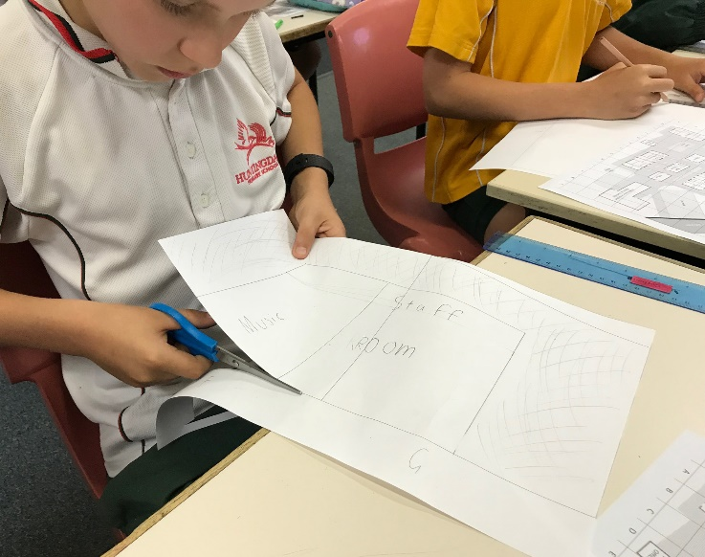

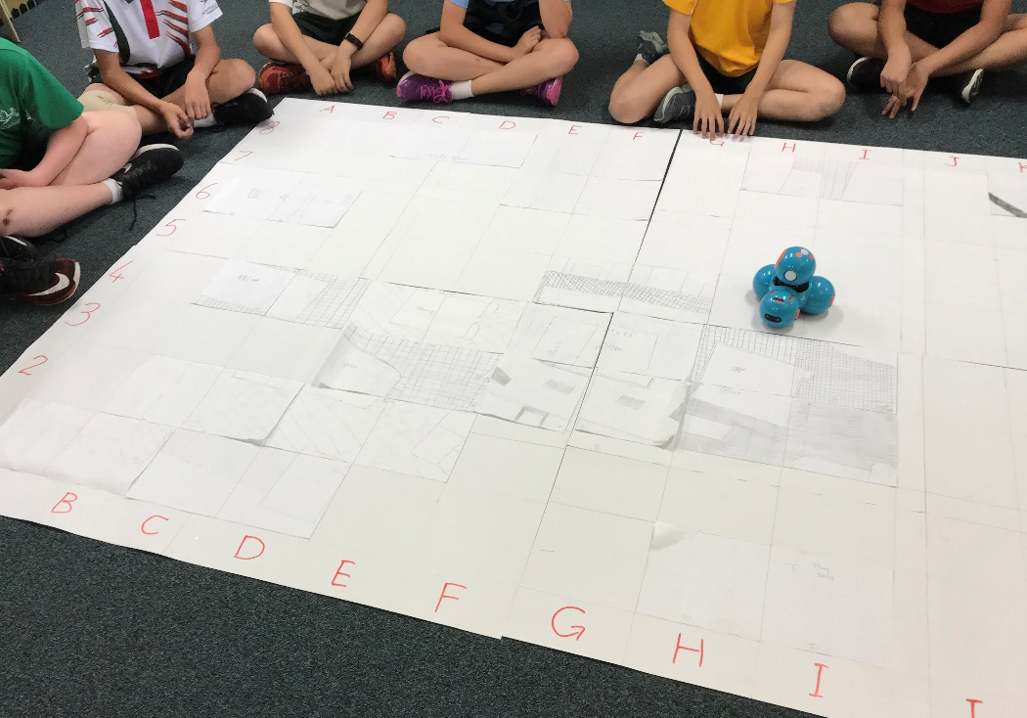

# Appendix 4: Design process guide

**Safe production of the final design or multiple copies of the final design**.

Fine tuning the production process, such as division of labour for batch or mass production.

Use of intended materials and appropriate tools to safely make the solution to the design problem.

**Reflection on the process taken and the success of the design.**

Evaluation can lead to further development or improvement of the design and can be a final stage of the design process before a conclusion is reached.

Could be formal or informal and verbal or written.

**Ideation**

**Development**

**Development of the design ideas. Improvements, refinements, adding detail, making it better.**

Activities such as detailed drawings, modelling, prototyping, market research, gaining feedback from intended user, further research – if needed – to solve an issue with the design, testing different tools or equipment, trialling production processes, measuring or working out dimensions, testing of prototypes and further refinement.

**Idea generation – turning ideas into tangible forms so they can be organised, ordered and communicated to others.**

Activities such as brainstorming, mind mapping, sketching, drawing diagrams and plans, collecting colour samples and/or material samples and talking through these ideas can help to generate more creative ideas.

Using the **SCAMPER** model can assist with this: [www.mindtools.com/pages/article/newCT_02.htm](http://www.mindtools.com/pages/article/newCT_02.htm)

[www.designorate.com/a-guide-to-the-scamper-technique-for-](http://www.designorate.com/a-guide-to-the-scamper-technique-for-%20) creative-thinking

**Analysis**

**Finding useful and helpful information about the design problem.**

Gathering information, conducting surveys, finding examples of existing solutions, testing properties of materials, practical testing.

**Understanding the meaning of the research findings.**

Analysing what the information means, summarising the surveys, judging the value of existing solutions, understanding test results.

**Research**

**Production**

**Evaluation**

# Appendix 5: Student journal

When students reflect on learning and analyse their ideas and feelings, they self-evaluate, thereby improving their metacognitive skills.

These modules encourage students to self-reflect and record the stages of their learning in a journal. This journal may take the form of a written journal, a portfolio or a digital portfolio.

Source: iStock

Using digital portfolios can help develop students’ Information and Communication Technology (ICT) capability.

Reflective practice and recording can be supported in classrooms by creating opportunities for students to think about and record their learning through notes, drawings or pictures. Teachers should encourage students to revisit earlier journal entries to help them observe the progress of their thoughts and understanding.

Journals are a useful tool that gives teachers additional insight into how students value their own learning and progress, as well as demonstrating their individual achievements.

The following links provide background information and useful apps for journaling.

|  |
| --- |
| *Reflective journal* (University of Technology Sydney)  [*www.uts.edu.au/sites/default/files/reflective_journal.pdf*](https://www.uts.edu.au/sites/default/files/reflective_journal.pdf) |
| *Reflective writing* (University of New South Wales Sydney))  [*student.unsw.edu.au/reflective-writing*](https://student.unsw.edu.au/reflective-writing) |
| *Balancing the two faces of ePortfolios* (Helen Barrett, 2009)  [*electronicportfolios.org/balance/Balancing.jpg*](http://electronicportfolios.org/balance/Balancing.jpg) |
| *Digital portfolios for students* (Cool tools for school)  [*cooltoolsforschool.wordpress.com/digital-student-portfolios*](https://cooltoolsforschool.wordpress.com/digital-student-portfolios/) |
| Kidblog – digital portfolios and blogging  [kidblog.org/home](https://kidblog.org/home/) |
| Evernote (a digital portfolio app)  [*evernote.com*](https://evernote.com/) |
| Weebly for education (a drag and drop website builder)  [*education.weebly.co*m](https://education.weebly.com/) |
| Connect – the Department of Education’s integrated, online environment  [*connect.det.wa.edu.au*](http://connect.det.wa.edu.au) |

# Appendix 6: Teacher resource sheet 1.1: Cooperative learning – Roles

Cooperative learning frameworks create opportunities for groups of students to work together, generally to a single purpose.

As well as having the potential to increase learning for all students involved, using these frameworks can help students develop personal and social capability.

When students are working in groups, positive interdependence can be fostered by assigning roles to group members.

These roles could include:

* working roles such as Reader, Writer, Summariser, Time-keeper.
* social roles such as Encourager, Observer, Noise monitor, Energiser.

Teachers using the *Primary Connections* roles of Director, Manager and Speaker for their science teaching may find it effective to also use these roles for STEM learning.

Further to this, specific roles can be delineated for specific activities that the group is completing.

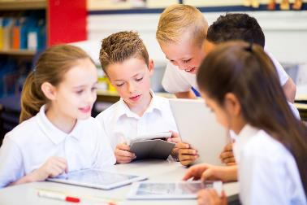It can help students if some background to the purpose of group roles is made clear to them before they start, but at no time should the roles get in the way of the learning. Teachers should decide when or where roles are appropriate to given tasks.

Source: iStock

# Appendix 7: Teacher resource sheet 3.1: Flowcharting symbols

A flowchart is a diagrammatic representation of an algorithm. It can take the form of a branching set of shapes with decision‑making steps. The shapes used in a flowchart are shown here with explanations of their purpose.

|  |  |
| --- | --- |
|  | **Terminator**  This symbol is used to represent the start and end of a flowchart. |
|  | **Process**  This symbol is used to represent one or more instructions or things to do. |
|  | **Data**  This symbol is used to represent the input or output of any information. |
|  | **Decision**  This symbol is used to represent a point in the flowchart where a decision is made and from which two or more paths could be followed. |
|  | **Flowline**  This symbol is used to show the direction of the process or data flow. |

# Appendix 8: Teacher resource sheet 3.2: Flowchart examples

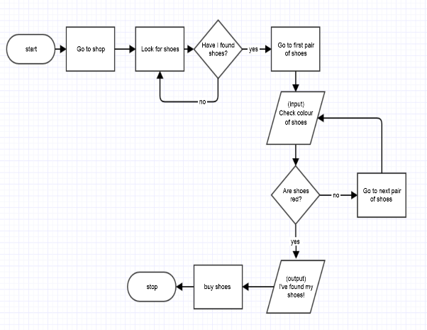

Source: Department of Education

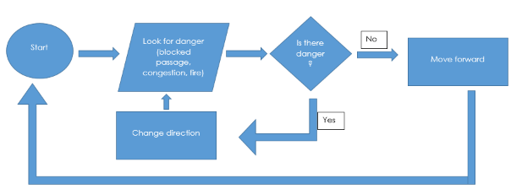

Source: Department of Education

# Appendix 9: Student activity sheet 3.3: Animation – Storyboarding

Scene 3

Scene 1

Scene 2

Sprites and Backgrounds

Music and FX

# Appendix 10: Student activity sheet 4.1: Peer evaluation

|  |  |  |  |  |
| --- | --- | --- | --- | --- |
|  | **Always** | **Usually** | **Sometimes** | **Rarely** |
| Remains focused on tasks presented |  |  |  |  |
| Completes set tasks to best of their ability |  |  |  |  |
| Works independently without disrupting others |  |  |  |  |
| Uses time well |  |  |  |  |
| Cooperates effectively within the group |  |  |  |  |
| Contributes to group discussions |  |  |  |  |
| Shows respect and consideration for others |  |  |  |  |
| Uses appropriate conflict resolution skills |  |  |  |  |
| Actively seeks and uses feedback |  |  |  |  |

**Comments:** __________________________________________________________________________________________________________________________________________________________________________________________________________________________________________________________________________________________________________________________________________________________

# Appendix 11: Teacher resource sheet 2.1: 8 x 12 grid

8

7

6

5

4

3

2

1

A

B

C

D

E

G

F

H

I

J

K

L

# Appendix 12: Teacher resource sheet 2.2: Sample school plan with grid reference overlay

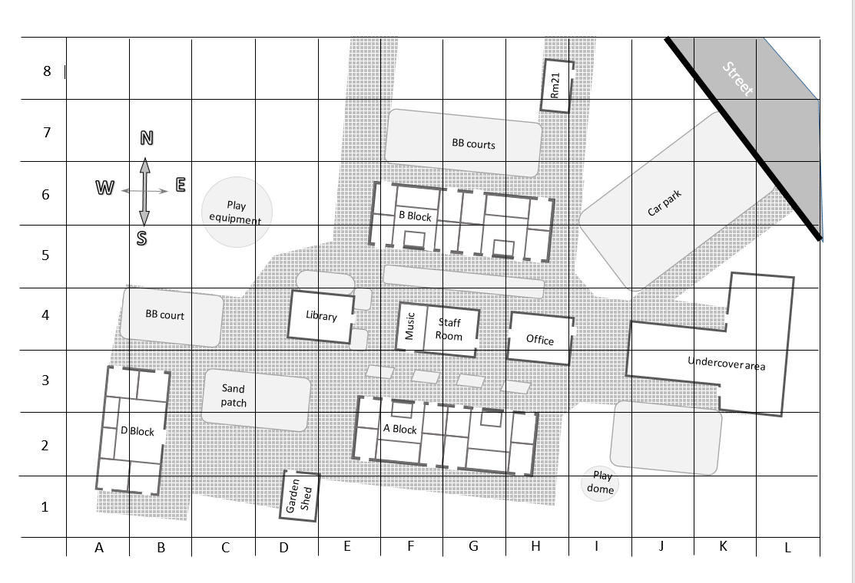

# 

# Notes

_______________________________________________________________________________________________________________________________________________________________________________________________________________________________________________________________________________________________________________________________________________________________________________________________________________________________________________________________________________________________________________________________________________________________________________________________________________________________________________________________________________________________________________________________________________________________________________________________________________________________________________________________________________________________________________________________________________________________________________________________________________________________________________________________________________________________________________________________________________________________________________________________________________________________________________________________________________________________________________________________________________________________________________________________________________________________________________________________________________________________________________________________________________________________________________________________________________________________

# Notes

_______________________________________________________________________________________________________________________________________________________________________________________________________________________________________________________________________________________________________________________________________________________________________________________________________________________________________________________________________________________________________________________________________________________________________________________________________________________________________________________________________________________________________________________________________________________________________________________________________________________________________________________________________________________________________________________________________________________________________________________________________________________________________________________________________________________________________________________________________________________________________________________________________________________________________________________________________________________________________________________________________________________________________________________________________________________________________________________________________________________________________________________________________________________________________________________________________________________________