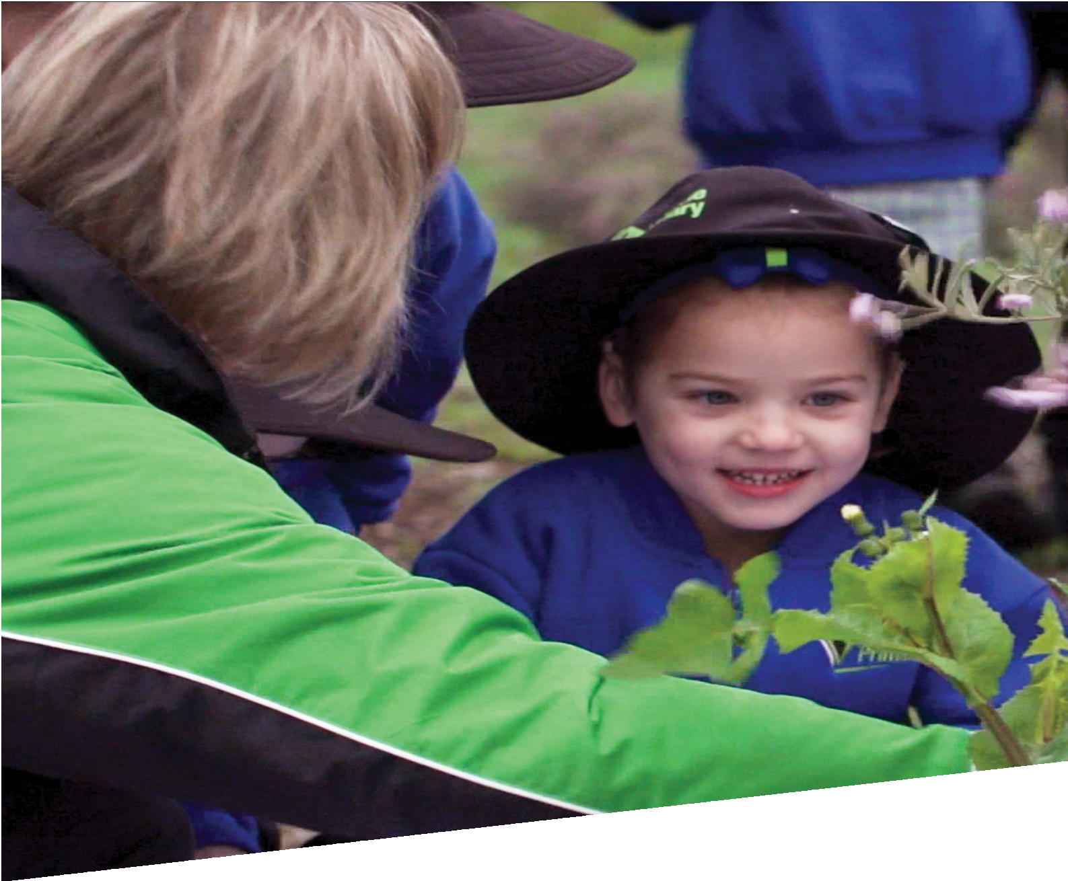

CURRICULUM RESOURCE MODULE
Template
KINDERGARTEN TO YEAR 2
Acknowledgements
The STEM Learning Project is funded by the Western Australian Department of Education and implemented by a consortium in STEM education comprising the Educational Computing Association of WA, the Mathematical Association of WA, the Science Teachers Association of WA and Scitech. We acknowledge and thank the teachers and schools who are creating and sharing good STEM teaching and learning.
This curriculum resource module has been produced using a template developed through the STEM Learning Project. The content of the module not been reviewed or recommended by the Department of Education or any members of the STEM education consortium.
Copyright and intellectual property
The copyright and intellectual property of this module remain the property of the Department.
Any Western Australian Curriculum content in this resource is used with the permission of the School Curriculum and Standards Authority; this permission does not constitute Authority endorsement of the resource. The Authority accepts no liability for any errors or damages arising from reliance on its content.
The Western Australian Curriculum content may be freely copied, or communicated on an intranet, for non-commercial purposes in educational institutions, provided that the Authority is acknowledged as the copyright owner. Copying or communication for any other purpose can be done only within the terms of the Copyright Act 1968 or with prior written permission of the Authority. Any Australian Curriculum content in the Western Australian Curriculum is used by the Authority under the terms of the Creative Commons Attribution-NonCommercial 3.0 Australia licence.
Any content on the www.scsa.wa.edu.au domain that has been derived from the Australian Curriculum may be used under the terms of Creative Commons Attribution-NonCommercial 3.0 Australia licence.
Appendix 2: General capabilities continuums is adapted from ACARA, © Australian Curriculum, Assessment and Reporting Authority (ACARA) 2009 to present, unless otherwise indicated. This material was downloaded from the ACARA website (www.acara.edu.au) (accessed December 2015) and was not modified. The material is licensed under CC BY 4.0 (https://creativecommons.org/licenses/by/4.0/). ACARA does not endorse any product that uses ACARA material or make any representations as to the quality of such products. Any product that uses material published on this website should not be taken to be affiliated with ACARA or have the sponsorship or approval of ACARA. It is up to each person to make their own assessment of the product.
Attributions: List in italics any trademarked products you refer to such as Google, Word etc
Kidblog, Weebly, Evernote (should be in all Yr 7 to 12 modules as part of Appendix 5.)
Autodesk, Tinkercad, SketchUp (if Appendix 4B is present)

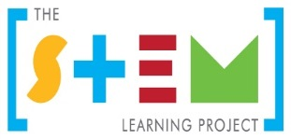
The table of contents will build itself. Simply right click and "update field".
Table of contents
The STEM Learning Project 2
Developing a STEM curriculum resource module 4
Instructions on using the CRM template 5
Overview 6
Activity sequence and purpose 9
Background 10
Activity 1: Title 12
Activity 2: Title 14
Activity 3: Title 16
Activity 4: Title 18
Appendix 1: Links to the Western Australian Curriculum 20
Appendix 1B: Mathematics proficiency strands 24
Appendix 1: Kindergarten curriculum guidelines 25
Appendix 2: General capabilities continuums 38
Appendix 3: Materials list 41
Appendix 4: Design process guide 42
Appendix 5: Reflective journal 43
Appendix 6: Student activity sheet 1.0: Journal checklist 44
Appendix 7: Teacher resource sheet 1.1: Cooperative learning – Roles 45
Appendix 8: Teacher resource sheet 1.2: Cooperative learning – Think-pair-share 46
Appendix 9: Teacher resource sheet 1.3: Cooperative learning – Pass it on 47
Appendix 10: Teacher resource sheet 1.4: Cooperative learning – Inside-outside 48
Appendix 11: Teacher resource sheet 1.5: Cooperative learning – Silent card sort 49
Appendix 12: Student activity sheet 1.6: I see, I think, I wonder 50
Appendix XX: Teacher resource sheet X.X: Construction skills 51
Appendix XX: Student activity sheet X.X: Prototype troubleshooting 56
Appendix XX: Student activity sheet XX: Analysis 57
Appendix XX: Student activity sheet XX: Analysis 58
Appendix XX: Teacher resource sheet XX: Evaluation 59
Appendix XX: Teacher resource sheet XX: 3 – 2 – 1 Reflection 60

The STEM Learning Project
The aim of the STEM Learning Project is to generate students’ interest, enjoyment and engagement with STEM (Science, Technology, Engineering and Mathematics) and to encourage their ongoing participation in STEM both at school and in subsequent careers. The curriculum resources will support teachers to implement and extend the Western Australian Curriculum and develop the general capabilities across Kindergarten to Year 12.
Why STEM?
A quality STEM education will develop the knowledge and intellectual skills to drive the innovation required to address global economic, social and environmental challenges.
STEM capability is the key to navigating the employment landscape changed by globalisation and digital disruption. Routine manual and cognitive jobs are in decline whilst non-routine cognitive jobs are growing strongly in Australia. Seventy-five per cent of the jobs in the emerging economy will require critical and creative thinking and problem solving, supported by skills of collaboration, teamwork and literacy in mathematics, science and technology. This is what we call STEM capability. The vision is to respond to the challenges of today and tomorrow by preparing students for a world that requires multidisciplinary STEM thinking and capability.
The approach
STEM capabilities are developed when students are challenged to solve open-ended, real-world problems that engage students in the processes of the STEM disciplines.
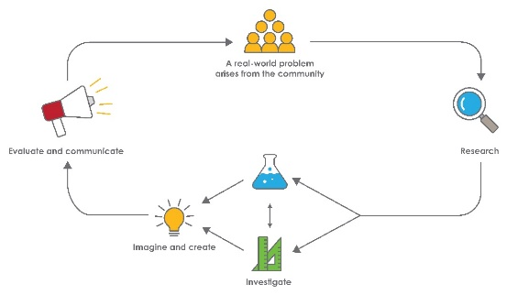
STEM Consortium
STEM in the early years
STEM is about children exploring the world around them and asking questions about how or why something works. Whether it is playing with water, building towers with blocks, talking about changes in the weather, or planting seeds, children demonstrate from an early age their readiness to engage in STEM.
When children come to school, they bring with them all the things they have learned. As their partners in learning, you can build on these skills, interests and knowledge using play-based learning alongside intentional teaching experiences. This balanced approach can help to keep every child productive and engaged in STEM.
Play is an essential and fun part of every child’s learning and development and helps them to build their knowledge, skills and attitudes. When children are playing, they are learning to talk and interact with other children and adults. They observe and copy others and discover new ways of doing things, have the freedom to explore their own interests, test solutions, problem solve and answer questions for themselves. By encouraging children to play, explore and investigate, teachers are helping children become active participants in their own learning.
The inquiry question posed in this module allows children to pursue knowledge and increase understanding of related content across the five learning and development areas of the Kindergarten Curriculum Guidelines which are based on the five outcomes of the Early Years Learning Framework (EYLF) (DEEWR, 2009). The EYLF recognises inquiry as a central component in effective learning, not only in childhood but also throughout life,
This module focuses on this kind of learning which addresses the National Quality Standard (NQS), Quality Area 1 – Educational Program and Practice. The module also focuses on Quality Area 5 – Relationships with Children.
STEM exploration and discovery can be embedded in the daily practices of your early learning setting and can also build students’ competence within the seven general capabilities.

Developing a STEM curriculum resource module
A STEM learning module should encourage learning that is student-led and teacher-facilitated, and have an open-ended problem-solving approach. Problem solving involves an intellectual struggle that provides opportunities for higher-order thinking, reasoning and creativity.
Steps to designing an effective CRM
- Consider the elements and pedagogy the module should include, such as:
- A problem-based learning pedagogy
- A real-world problem in an authentic context
- STEM learning area content
- Suitability for learners
- The Design process
- Opportunities, where possible, to use and develop ICT skills
- Opportunities for developing higher order thinking, collaborative learning skills and reflective practice.
- Consider the Western Australian Curriculum
Review the year level curriculum content descriptions from each of the Science, Technology and Mathematics learning areas or from the Early Years Learning Framework and the Kindergarten Curriculum Guidelines. Consider students previous learning.
Identify opportunities for students to develop the general capabilities and cross-curriculum priorities.
- Develop a clear theme and the driving question you would like students to solve.
Consider current real-world problems both globally and locally. Review the United Nations Sustainable Development Goals for inspiration. Think about the big issues for Western Australia.
Consolidate the real-world problem down to the context of the students: How does this problem relate to important issues for the local community, students in your classroom or families at your school?
- Develop an outline for each of the Activities
- Activity 1 – Research
What and how will the students research to develop their understandings of the problem? How will their prior knowledge be drawn upon?
Students can research aspects of any or all of the learning areas.
- Activity 2 – Investigate
What investigations will students carry out to understand the variables that impact upon the problem?

- Activity 3 – Imagine and create
How will students enagae with the process strands of the learning areas as well as the the design process to ideate their solutions?
- Activity 4 – Evaluate and communicate
How will students pitch their solutions? How could industry or other authentic audienes be involved?

Instructions on using the CRM template
When working with this template it is helpful to do the following things each time the document is opened:
- The green text and the ### symbols are either instructions or examples and should be replaced as you develop your CRM.
- It may be useful to have a copy of an existing module as an example of how a module looks and what it contains.

Year X – Module title

Overview
A general overarching view of the module:

What is the context?
State the context in relation to the year level of the student.

What is the problem?
State the problem the students will be solving?

How does this module support integration of the STEM disciplines?
Science
Describe how the Western Australian Curriculum: Science is integrated into this module. How are the content descriptions related to the activtities in which the students will participate? What will the students learn?

Technology
Describe how the Western Australian Curriculum: Technologies is integrated into this module. How are the content descriptions related to the activtities in which the students will participate? What will the students learn?
The Design process guide is included as a resource to provide assistance to teachers in understanding the complete design process as developed in the Technologies syllabus.

Mathematics
Describe how the Western Australian Curriculum: Mathematics is integrated into this module. How are the content descriptions related to the activtities in which the students will participate? What will the students learn?

General capabilities
There are opportunities for the development of general capabilities and cross-curriculum priorities as students engage with module title. In this module, students:
- Develop critical and creative thinking skills as they research the problem and its context (Activity 1); investigate parameters impacting on the problem (Activity 2); imagine and develop solutions (Activity 3); and evaluate and communicate their solutions to an audience (Activity 4).
- Utilise creative thinking as they generate possible design solutions; and critical thinking, numeracy skills and ethical understanding as they choose between alternative approaches to solving the problem of …………...
- Utilise personal and social capability as they develop socially cohesive and effective working teams; collaborate in generating solutions; adopt group roles; and reflect on their group work capabilities through self and peer evaluation.
- Utilise a range of literacies and information and communication technology (ICT) capabilities as they collate records of work completed throughout the module in a journal; represent and communicate their solutions to an audience using digital technologies in Activity 4.
- Communicate and, using evidence, justify their group’s design to an authentic audience that might include………………………………………...
What are the pedagogical principles of the STEM learning modules?
The STEM Learning Project modules develop STEM capabilities by challenging students to solve real-world problems set in authentic contexts. The problems engage students in the STEM disciplines and provide opportunities for developing higher order thinking and reasoning, and the general capabilities of creativity, critical thinking, communication and collaboration.
The design of the modules is based on four pedagogical principles:
- Problem-based learning
All modules are designed around students solving an open-ended, real-world problem. Learning is supported through a four-phase instructional model: research the problem and its context; investigate the parameters impacting on the problem; design and develop solutions to the problem; and evaluate and communicate solutions to an authentic audience.
- Developing higher order thinking
Opportunities are created for higher order thinking and reasoning through questioning and discourse that elicits students' thinking, prompts and scaffolds explanations, and requires students to justify their claims. Opportunities for making reasoning visible through discourse are highlighted in the modules with the icon shown here.
- Collaborative learning
This provides opportunities for students to develop teamwork and leadership skills, challenge each other’s ideas, and co-construct explanations and solutions. Information that can support teachers with aspects of collaborative learning is included in the resource sheets.
- Reflective practice
Recording observations, ideas and one’s reflections on the learning experiences in some form of journal fosters deeper engagement and metacognitive awareness of what is being learnt. Information that can support teachers with journaling is included in the resource sheets.
These pedagogical principles can be explored further in the STEM Learning Project online professional learning modules located in Connect Resources.

Activity sequence and purpose
Activity title
Activity 1 focus. One or two sentences that summarise the main aspects of the Activity.
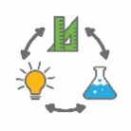  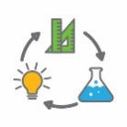 | Activity title  Activity 2 focus. One or two sentences that summarise the main aspects of the Activity.
Activity title
Activity 3 focus. One or two sentences that summarises the main aspects of the Activity.
Activity title
Activity 4 focus. One or two sentences that summarise the main aspects of the Activity.

Background
Expected learning | Summarise the curriculum content and expected learning. Write these as learning outcomes.  These should also be included in Appendix 1.  Students will be able to:
Vocabulary | The specific vocabulary of the module can be captured here or listed in a resource sheet in the appendices.  This module uses subject-specific terminology, some of which is shown in Teacher resource sheet #.#: title title.  The following vocabulary list contains other terms that need to be understood, either before the module commences or developed as they are used.
Timing | There is no prescribed duration for this module. The module is designed to be flexible enough for teachers to adapt. Activities do not equate to lessons; one activity may require more than one lesson to implement.
Consumable materials | The specific materials required for the module that are not ordinarily found in your classroom can be captured here or listed in a resource sheet in the appendices.  A Materials list is provided for this module. The list outlines materials outside of normal classroom equipment that will be needed to complete the activities.
Safety notes | There are potential hazards inherent in these activities and with the equipment being used, and a plan to mitigate any risks will be required.  Potential hazards specific to this module include but are not limited to:  - Possible exposure to cyber bullying, privacy violations and uninvited solicitations when using the internet
Enterprise skills | The ######### module focuses on higher order skills, with significant emphasis on outcomes from the general capabilities and enterprise skills.  Enterprise skills include problem solving, communication skills, digital literacy, teamwork, critical thinking and presentation skills.  Further background is available from the Foundation for Young Australians in the New Work Order six report series. A summary can be found at: www.fya.org.au/report/new-work-order-summary
Assessment | The STEM modules have been developed to provide students with learning experiences to solve authentic real-world problems using science, technology, engineering and mathematics capabilities. While working through the module, the following assessment opportunities will arise:  - List potential assessment opportunities here.  Appendix 1 indicates how the activities are linked to the Western Australian Curriculum.  or  Mapping to the Kindergarten Curriculum Guidelines is provided in Appendix 1.  Evidence of learning from journaling, presentations and anecdotal notes from this module can contribute towards the larger body of evidence gathered throughout a teaching period and can be used to make on-balance judgements about the quality of learning demonstrated by the students in the science, technologies and mathematics learning areas.  Students can further develop the general capabilities of Information and communication technology capability, Critical and creative thinking, and Personal and social capability. Continuums for these are included in the General capabilities continuums but are not intended to be for assessment purposes.

Activity 1: Title
Activity focus | One or two sentences that summarise the main aspects of the Activity.
Background information | Information the teacher may find useful prior to implementing the lesson.  The purpose is to provide teachers with comprehensive information and reduce the need to research areas outside their subject area expertise.
Instructional procedures | Procedures to assist in the successful implementation of the activity. For example, visualisation strategies, cooperative learning strategies, inquiry based instructional strategies, differentiation, use of technology, higher order thinking and reasoning questions, modelling of classroom discourse and behaviour management strategies.
Expected learning | Summarise the curriculum content and expected learning. Write these as learning outcomes.  These should also be included in Appendix 1  Students will be able to:
Equipment required | For the class:
 | For the students:
Preparation | List any tasks or equipment that needs to be organised prior to the start of the Activity.
Activity parts | Decide on the individual tasks students will complete and describe them here.  Include some well considered, open questions.  Part 1: ###
 | Part 2: ###
 | Part 3: ###
 | Part 4: ###
 | Part 5: Reflection / journaling
Resource sheets | List resource sheets you develop here.
Digital resources | Provide links to websites with information to enhance learning.
Literary resources | Provide links to relevant literary resources.

Activity 2: Title
Activity focus | One or two sentences that summarise the main aspects of the Activity.
Background information | Information the teacher may find useful prior to implementing the lesson.  The purpose is to provide teachers with comprehensive information to reduce the need to research areas outside their subject area expertise.
Instructional procedures | Procedures to assist in the successful implementation of the activity. For example, visualisation strategies, cooperative learning strategies, inquiry based instructional strategies, differentiation, use of technology, higher order thinking and reasoning questions, modelling of classroom discourse and behaviour management strategies.
Expected learning | Summarise the curriculum content and expected learning. Write these as learning outcomes.  These should also be included in Appendix 1  Students will be able to:  1.  2.  3.
Equipment required | For the class:
 | For the students:
Preparation | List any tasks or equipment that needs to be organised prior to the start of the Activity.
Activity parts | Decide on the individual tasks students will complete and describe them here.  Include some well considered, open questions.  Part 1: ###
 | Part 2: ###
 | Part 3: ###
 | Part 4: ###
 | Part 5: ### Reflection / journaling
Resource sheets | List resource sheets you develop here.
Digital resources | Provide links to websites with information to enhance learning.
Literary resources | Provide links to relevant literary resources.

Activity 3: Title
Activity focus | One or two sentences that summarise the main aspects of the Activity.
Background information | Information the teacher may find useful prior to implementing the lesson.  The purpose is to provide teachers with comprehensive information to reduce the need to research areas outside their subject area expertise.
Instructional procedures | Procedures to assist in the successful implementation of the activity. For example, visualisation strategies, cooperative learning strategies, inquiry based instructional strategies, differentiation, use of technology, higher order thinking and reasoning questions, modelling of classroom discourse and behaviour management strategies.
Expected learning | Summarise the curriculum content and expected learning. Write these as learning outcomes.  These should also be included in Appendix 1  Students will be able to:  1.  2.  3.
Equipment required | For the class:
 | For the students:
Preparation | List any tasks or equipment that needs to be organised prior to the start of the Activity.
Activity parts | Decide on the individual tasks students will complete and describe them here.  Include some well considered, open questions.  Part 1: ###
 | Part 2: ###
 | Part 3: ###
 | Part 4: ###
 | Part 5: ### Reflection / journaling
Resource sheets | List resource sheets you develop here.
Digital resources | Provide links to websites with information to enhance learning.
Literary resources | Provide links to relevant literary resources.

Activity 4: Title
Activity focus | One or two sentences that summarise the main aspects of the Activity.
Background information | Information the teacher may find useful prior to implementing the lesson.  The purpose is to provide teachers with comprehensive information to reduce the need to research areas outside their subject area expertise.
Instructional procedures | Procedures to assist in the successful implementation of the activity. For example, visualisation strategies, cooperative learning strategies, inquiry based instructional strategies, differentiation, use of technology, higher order thinking and reasoning questions, modelling of classroom discourse and behaviour management strategies.
Expected learning | Summarise the curriculum content and expected learning. Write these as learning outcomes.  These should also be included in Appendix 1  Students will be able to:  1.  2.  3.
Equipment required | For the class:
 | For the students:
Preparation | List any tasks or equipment that needs to be organised prior to the start of the Activity.
Activity parts | Decide on the individual tasks students will complete and describe them here.  Include some well considered, open questions.  Part 1: ###
 | Part 2: ###
 | Part 3: ###
 | Part 4: ###
 | Part 5: ### Reflection / journaling
Resource sheets | List resource sheets you develop here.
Digital resources | Provide links to websites with information to enhance learning.
Literary resources | Provide links to relevant literary resources.

Appendix 1: Links to the Western Australian Curriculum
The XXXX module provides opportunities for developing students’ knowledge and understandings in science, technologies and mathematics. The table below shows how this module aligns to the content of the Western Australian Curriculum and can be used by teachers for planning and monitoring.
Delete sections and add content descriptions as required
Module title  Links to the Western Australian Curriculum | ACTIVITY
 | 1 | 2 | 3 | 4
SCIENCE
SCIENCE UNDERSTANDING
Biological sciences: | ●
Chemical sciences: | ●
Earth and space sciences: | ●
Physical sciences: | ●
SCIENCE AS A HUMAN ENDEAVOUR
Nature and development of science: | ●
Use and influence of science: | ●
SCIENCE INQUIRY SKILLS
Questioning and predicting: | ●
Planning and conducting: | ●
Processing and alalysing data and information: | ●
Evaluating: | ●
Communicating: | ●

Module title  Links to the Western Australian Curriculum | ACTIVITY
 | 1 | 2 | 3 | 4
DESIGN AND TECHNOLOGIES
KNOWLEDGE AND UNDERSTANDING
Technologies and society: | ●
Technologies contexts: Engineering principles and systems | ●
Technologies contexts: Food and Fibre production | ●
Technologies contexts: Materials and technologies specialistaions | ●
PROCESSES AND PRODUCTION SKILLS
Creating solutions by: Investigating and defining: | ●
Creating solutions by: Designing | ●
Creating solutions by: Producing and implementing | ●
Creating solutions by: Evaluating | ●
Creating solutions by: Collaborating and managing | ●

Module title  Links to the Western Australian Curriculum | ACTIVITY
 | 1 | 2 | 3 | 4
DIGITAL TECHNOLOGIES
KNOWLEDGE AND UNDERSTANDING
Digital systems: | ●
Representation of data: | ●
PROCESSES AND PRODUCTION SKILLS
Collecting, managing and analysing data: | ●
Digital implementation: | ●
Creating solutions by: Investigating and defining | ●
Creating solutions by: Designing | ●
Creating solutions by: Producing and implementing | ●
Creating solutions by: Evaluating | ●
Creating solutions by: Collaborating and managing | ●

Module title  Links to the Western Australian Curriculum | ACTIVITY
 | 1 | 2 | 3 | 4
MATHEMATICS
NUMBER AND ALGEBRA
Number and place value: | ●
Fractions and decimals: | ●
Money and financial mathematics: | ●
Patterns and algebra: | ●
MEASUREMENT AND GEOMETRY
Using units of measurement: | ●
Shape: | ●
Location and transformation: | ●
STATISTICS AND PROBABILITY
Chance: | ●
Data representation and interpretation: | ●
Further information about assessment and reporting in the Western Australian Curriculum can be found at: k10outline.scsa.wa.edu.au/home.

Appendix 1B: Mathematics proficiency strands
Key ideas
In Mathematics, the key ideas are the proficiency strands of understanding, fluency, problem-solving and reasoning. The proficiency strands describe the actions in which students can engage when learning and using the content. While not all proficiency strands apply to every content description, they indicate the breadth of mathematical actions that teachers can emphasise.
Understanding
Students build a robust knowledge of adaptable and transferable mathematical concepts. They make connections between related concepts and progressively apply the familiar to develop new ideas. They develop an understanding of the relationship between the ‘why’ and the ‘how’ of mathematics. Students build understanding when they connect related ideas, when they represent concepts in different ways, when they identify commonalities and differences between aspects of content, when they describe their thinking mathematically and when they interpret mathematical information.
Fluency
Students develop skills in choosing appropriate procedures; carrying out procedures flexibly, accurately, efficiently and appropriately; and recalling factual knowledge and concepts readily. Students are fluent when they calculate answers efficiently, when they recognise robust ways of answering questions, when they choose appropriate methods and approximations, when they recall definitions and regularly use facts, and when they can manipulate expressions and equations to find solutions.
Problem-solving
Students develop the ability to make choices, interpret, formulate, model and investigate problem situations, and communicate solutions effectively. Students formulate and solve problems when they use mathematics to represent unfamiliar or meaningful situations, when they design investigations and plan their approaches, when they apply their existing strategies to seek solutions, and when they verify that their answers are reasonable.
Reasoning
Students develop an increasingly sophisticated capacity for logical thought and actions, such as analysing, proving, evaluating, explaining, inferring, justifying and generalising. Students are reasoning mathematically when they explain their thinking, when they deduce and justify strategies used and conclusions reached, when they adapt the known to the unknown, when they transfer learning from one context to another, when they prove that something is true or false, and when they compare and contrast related ideas and explain their choices.

Source:
www.australiancurriculum.edu.au/f-10-curriculum/mathematics/key-ideas/?searchTerm=key+ideas#dimension-content

Appendix 1: Kindergarten curriculum guidelines
The five learning outcomes of the Early years learning framework aim to capture the integrated and complex learning and development of all children from birth to age five. Children’s learning is not predictable and linear, so children will progress towards these outcomes in different ways and at different rates. The content included in the following tables is offered as a guide for teachers to modify, as appropriate, to meet the needs of their learning community.
Delete sections and points as required.
Identity
Children in the Kindergarten year have a strong sense of identity when they feel safe, secure, accepted and supported
Focus | This is evident for example, when children:
Build a sense of belonging | - join in group activities, such as singing and dancing to songs
Build a sense of stability and trust | - initiate interactions and conversations with peers, teachers and other adults in a range of contexts  - form stable relationships within familiar environments  - initiate and join in play with enjoyment and satisfaction
Children in the Kindergarten year have a strong sense of identity when they act with increasing autonomy, interdependence, resilience and sense of agency
Focus | This is evident for example, when children:
Show resilience | - persevere with tasks when faced with challenges  - make new discoveries and celebrate their own efforts and achievements and those of others
Make choices and decisions (by themselves and with others) | - demonstrate an increasing capacity for self-regulation  - show initiative by asking questions, negotiating and sharing  - make decisions and choices and describe options  - demonstrate simple goal-setting strategies with adult support
Manage routines, organise self and belongings | - take increasing responsibility for their own actions and learning  - manage and participate in setting routines and processes  - organise and look after their own belongings  - respond to ideas and suggestions from others
Children in the Kindergarten year have a strong sense of identity when they build knowledgeable and confident self-identities
Focus | This is evident for example, when children:
Show confidence in own learning and capabilities | - show increasing confidence in their abilities, achievements and ideas as learners  - show curiosity, engagement and purpose for learning  - participate in dramatic play, role play and learning experiences that explore aspects of identity and points of view  - build positive relationships in their peer group and social circles  - celebrate achievement and share contributions with others
Display a positive image of self, their family and culture | - build an understanding that there are other social and cultural heritages different from their own  - use their home language at school (  - share aspects of their culture with others where appropriate  - engage with elders and cultural community members to explore their social and cultural heritage
Children in the Kindergarten year have a strong sense of identity when they interact with others with care, empathy and respect
Focus | This is evident for example, when children:
Participate positively as part of a group | - participate appropriately in a social context  - take turns in small group situations  - empathise with and express concern for others  - cooperate and contribute to play and small group experiences
Respond to others appropriately | - listen to others’ opinions and points of view  - show respect for others, their views and property  - apply simple strategies for conflict management and resolution with assistance  - reflect on their actions and consider consequences

Connecting and contributing
Children in the Kindergarten year are connected with and contribute to their world when they work with others to develop skills for communication and inquiry about themselves and their world.
Focus | This is evident for example, when children:
Develop skills for working with others | - listen to others and share own ideas  - share observations with others as they explore their immediate world using their five senses  - participate with others to solve problems  - cooperate with others and negotiate roles and relationships in play and group experiences  - contribute to fair decision making about matters that affect them
Develop inquiry and communication skills | - plan and carry out a few simple sequences steps when exploring and investigating  - use simple language of measurement to describe, compare, order or sort the observations made when exploring  - describe both verbally and non-verbally what they see, hear, touch, feel and taste  - use ICT with assistance to collect information and communicate it simply  - represent findings and communicate ideas in a variety of ways
Children in the Kindergarten year are connected with and contribute to their world when they explore diversity and respond with respect
Focus | This is evident for example, when children:
Explore the diversity of culture, heritage, background and tradition | - build an understanding that people can speak different languages  - describe own family’s commemoration of festivals and past events  - name who is in their family and recognise not all family structures are the same  - identify and compare similarities and differences in their own and others’ histories and culture  - sequence familiar events  - build an understanding that stories of the past can be communicated in different ways such as photos, artefacts and oral stories
Respond respectfully to diversity | - explore Aboriginal and Torres Strait Islander Peoples’ cultures that have a connection with places and people, past and present  - react in respectful ways to diversity  - investigate Aboriginal and Torres Strait Peoples’ artwork and artefacts, past and present
Children in the Kindergarten year are connected with and contribute to their world when they show respect for the environment
Focus | This is evident for example, when children:
Explore natural and constructed environments | - name simple natural and built elements in their environment use simple and safe tools to explore and investigate the environment (connects to the Technologies Curriculum)  - describe some of the simple aspects of materials and places in their environment (connects to the Technologies Curriculum)  - observe and describe changes in sunlight, temperature, clouds and rain  - contribute their ideas in discussion about experiences in the natural and constructed environment  - use play to investigate, project and explore new ideas
Respect, care for and sustain the environment | - suggest ways to care for and sustain the environment  - observe, reflect and ask questions about their environment
Investigate the interactions between the environment and its people | - describe the basic needs of people, plants and animals and places where they live  - investigate places where people, plants and animals live  - describe relationships that are living and non-living things  - discuss how not caring for the environment might harm it (connects to the Humanities and Social Sciences Curriculum)  - infer, predict and hypothesise in order to develop an increased understanding of the interdependence between land, people, plants and animals

Wellbeing
Children in the Kindergarten year have a strong sense of wellbeing when they become strong in their social and emotional wellbeing
Focus | This is evident for example, when children:
Interact positively to form relationships and friendships | - negotiate friendships and build and maintain respectful, trusting relationships with other children and teachers  - demonstrate increasing awareness of the needs and rights of others  - describe their contributions to shared projects and experiences  - acknowledge and accept affirmation
Recognise simple emotions and build self-regulation | - demonstrate an increasing capacity to self-regulate their feelings, emotions and behaviour, appropriate to the situation  - recognise basic emotions  - show an increasing capacity to act and speak appropriately when resolving conflict  - share humour, happiness and satisfaction  - demonstrate moments of solitude and reflection  - make choices, accept challenges and take considered risks
Children in the Kindergarten year have a strong sense of wellbeing when they take increasing responsibility for their own health and physical wellbeing
Focus | This is evident for example, when children:
Build knowledge, skills and positive attitudes to physical movement | - move to tempo of music, and developmotor movements to the rhythm of music, such as trot or gallop  - demonstrate correct fundamental movement skills, such as running, hopping, jumping, catching, kicking, balancing, striking, dodging, galloping and leaping  - move around the environment safely demonstrating spatial awareness  - use small muscles to use implements such as pencils, scissor and paintbrushes with some control and coordination  - develop hand/eye and hand/foot coordination  - develop perceptual motor skills, strength, flexibility and muscle tone  - demonstrate a willingness to participate in energetic physical activity including dance, drama, movement and games  - demonstrate positive attitudes to physical movement and exercise  - combine gross and fine motor movement and balance to achieve increasingly complex patterns of activity including dance, creative movement and drama  - respond through movement to traditional and contemporary music, dance and storytelling
Explore ways to promote own and others health and safety | - suggest ways to keep themselves, others and heir surroundings safe  - suggest ways of getting help when they feel uncomfortable or unsafe  - engage in experiences, conversations and routines that promote healthy lifestyles, good nutrition, safety and personal hygiene practices  - demonstrate self-help skills and participate in health routines

Learning and thinking
Children in the Kindergarten year are connected with and contribute to their world when they develop positive dispositions for learning
Focus | This is evident for example, when children:
Build enthusiasm, confidence, cooperation, commitment, persistence | - express curiosity and wonder about events, experiences and interest in their environments  - follow and extend their own interests with enthusiasm, energy and concentration  - persist even when a task is difficult, and experience satisfaction of achievement
Develop curiosity, resourcefulness and reflexivity | - explore the properties of familiar objects  - build concentration and ability to focus on important aspects of learning experiences  - actively engage in learning experiences, conversations and play experiences  - ask questions about people, events, objects and the environment
Children in the Kindergarten year are connected with and contribute to their world when they develop a range of skills and processes for learning and thinking.
Focus | This is evident for example, when children:
Develop problem solving, investigation and inquiry strategies | - create and use simple representation to organise, record and communicate mathematical and scientific ideas and concepts
Reflect on thinking and learning and transfer and adapt what they have learned | - use skills of prediction, hypothesising, testng, experimenting and evaluating in play experiences  - respond to ideas and suggestions from others  - use reflective thinking to consider why things happen and what can be learnt from these experiences  - apply a range of thinking strategies to engage with situations and solve problems and adapt these strategies to new situations
Make choices and organise self for learning | - make simple plans and carry them out to complete a task  - organise self and simple resources to carry out a task or participate in an activity

Children in the Kindergarten year are connected with and contribute to their world when they engage in creative and inventive ways of thinking and doing
Focus | This is evident for example, when children:
Use imagination and innovation | - explore and experiment with form, shape, colour, line, texture, contrast, patterns in art works  - explore ideas, theories using imagination and dramatic play  - explore different ways of creating models and doing things
Represent ideas, feelings and experiences in creative ways | - engage in music-making and create simple compositions  - combine singing, dancing and drama in play  - respond, express and communicate ideas, feelings in a variety of ways to a range of stimuli, for example, music and artworks  - engage in dramatic, fantasy and role play  - use simple tools and materials to investigate, take apart, assemble, invent, construct, change and represent ideas  - create simple stories, act them out using voice, movement and space
Children in the Kindergarten year are connected with and contribute to their world when they engage in and extend numeracy in personally meaningful ways
Focus | This is evident for example, when children:
Develop knowledge of number and algebra | - name the last number in the count that represents how many in the set (cardinal value)  - count objects by using one to one correspondence  - know that numbers always happen in a conventional order (stable order)  - begin to understand that the starting point and order in which you count them does not affect how many (order irrelevance)  - begin to understand that the arrangement, size or differences of the objects doesn’t affect how many (abstraction)  - recite number names in order, initially to 5, then to 10 consistently  - recall what number is missing in a number line 1 to 10  - recognise numerals initially to 5 and then to 10 and begin to order them  - partition small numbers (part, part, whole)  - subitise small quantities of objects or standard patterns on a die  - compare collections of objects and describe whether there is more, less, the same or not the same  - copy and create simple two part patterns
Develop knowledge of measurement and geometry | - use the appropriate language of measurement to describe, compare and order: length, size, mass, height  - describe the sequence of familiar events and routines and use the everyday language of time such as morning, afternoon, daytime  - use language words to describe duration and relative duration, such as quick, slow, fast, it takes a long time  - use positional language, such as on, under, behind, between  - recognise names, sort and match basic two-dimensional shapes such as square, triangle and circle
Develop knowledge of statistics and probability | - sort, classify and match objects according to attributes, for example colours, sizes and shapes  - order objects according to one attribute  - answer simple questions to collect information, such as using yes/no and group items in response to questions such as favourite pets

Communicating
Children in the Kindergarten year are connected with and contribute to their world when they interact verbally and non-verbally with others for a range of purposes
Focus | This is evident for example, when children:
Build aural and oral language | - sustain conversations with others in different situations  - use speech that can be understood by others  - listen to others  - act upon simple instructions and statements  - develop auditory discrimination, for example able to identify environmental sounds  - modulate voice appropriate to the situation  - use simple sentences when speaking  - use turn-taking in conversations  - increase use of vocabulary by exploring meanings of new words and talk about language (metalanguage)  - know that languages other than English are used in the home, school and community environment  - use simple non-verbal ways of communicating through gesture and signs
Develop phonological awareness skills | - know that spoken and written language can be broken into smaller parts  - hear and clap syllables in simple words  - investigate and explore onset and rime in simple CVC (consonant, vowel, consonant) words  - discriminate rhyme in words  - investigate and explore individual sounds and sounds in spoken words  - hear and begin to identify first and last sounds in simple words  - explore letter-sound relationships
Convey and construct messages for a range of purposes in a variety of contexts | - verbalise ideas and simple concepts and ask questions to clarify concepts  - retell a simple story  - engage in discussion about narratives and informational texts  - use imagination to recreate roles and experiences  - explore common language patterns in narratives
Children in the Kindergarten year are connected with and contribute to their world when they engage in and extend literacy practices in personally meaningful ways.
Focus | This is evident for example, when children:
Develop understanding of purpose and meanings of a range of texts | - share a range of textx for enjoyment  - explore the language presented in fiction and non-fiction texts  - make connections between their own experiences and ideas in text  - identify key ideas from simple texts  - recognise simple literary conventions, such as setting and characters in narratives  - predict what happens next in simple texts, and why it might happen  - start moving from literal interpretation of text to inferential  - join in with chorus from narratives and rhymes in narratives/ nursery rhymes/songs/chants  - investigate with assistance how texts present particular views such as gender, stereotypes and diversity  - recognise and engage with written and oral constructed texts
Engage in reading, writing and viewing behaviours | - show an awareness that print holds meaning  - use books/texts appropriately, turn pages and identify the front cover  - recognise familiar written symbols in context, such as road signs and their name  - display reading/writing/viewing like behaviours in play and experiences  - use, engage with and share the enjoyment of language and texts in a range of ways
Children in the Kindergarten year are connected with and contribute to their world when they understand how symbols and pattern systems work.
Focus | This is evident for example, when children:
Develop concepts of print | - build an understanding that print is constant and a reader moves (in English) left to right and top to bottom with a return sweep  - describe how the illustrations connect to the text  - identify simple punctuation, such as full stops and question marks  - become aware that words are separated by spaces  - build an understanding of book features, such as the title, author, illustrator  - become aware that sentences are made up of words, that words are made of sounds and sounds are represented by letters or groups of letters
Investigate symbols and pattern systems | - recognise simple patterns and relationships  - recognise some letter names, for example the letters in their own name  - become aware that numbers are different from letters  - use symbols in play to represent and make meaning  - identify patterns in the environment  - copy simple patterns
Children in the Kindergarten year are connected with and contribute to their world when they express ideas and make meaning using a range of media
Focus | This is evident for example, when children:
View and create with media | - view and listen to simple printed, visual and multimedia texts and music  - express ideas and feelings and make meaning using creative arts, such as drawing, painting, sculpture, drama, dance movement, music and storytelling
Investigate the properties of a range of media | - expplore music with a variety of instruments or improvised musical instruments  - experiment with elements of texture, colour, shape, space and form in two or three dimensions
Children in the Kindergarten year are connected with and contribute to their world when they explore resources, tools and information communication technologies to represent ideas and their thinking
Focus | This is evident for example, when children:
Use tools, resources and technologies in play, thinking and learning | - use a range of tools, technologies and resources safely and appropriately  - explore simple systems such as mechanical systems (pulleys); organisational systems (recipe); environmental (reticulation)  - create simple information for a purpose using tools, resources and technologies
Develop simple ICT skills | - experiment with a range of tools, media, sounds and graphics in ICT play and discovery  - develop simple skills to use information and communication technologies  - engage with information communication technologies for fun and to promote thinking and learning  - use imaginary technologies as props in their play
Further information about the Kindergarten curriculum guidelines can be found at:

k10outline.scsa.wa.edu.au/media/documents/outline_downloads/Western-Australian-Kindergarten-Curriculum-Guidelines-pdf.pdf
www.acecqa.gov.au/sites/default/files/2018-02/belonging_being_and_becoming_the_early_years_learning_framework_for_australia.pdf

Appendix 2: General capabilities continuums
The general capabilities continuums shown here are designed to enable teachers to understand the progression students should make with reference to each of the elements. There is no intention for them to be used for assessment.
Information and communication technology (ICT) capability learning continuum
Sub-element | Typically by the end of Foundation Year | Typically by the end of Year 2 | Typically by the end of Year 4
Create with ICT  Generate ideas, plans and processes | use ICT to follow or contribute to a simple plan for a solution | use ICT to prepare simple plans to find solutions or answers to questions | use ICT to generate ideas and plan solutions
Create with ICT  Generate solutions to challenges and learning area tasks | use ICT as a creative tool to generate simple solutions, modifications or data representations for personal or school purposes | experiment with ICT as a creative tool to generate simple solutions, modifications or data representations for particular audiences or purposes | create and modify simple digital solutions, creative outputs or data representation/ transformation for particular purposes
Communicating with ICT  Collaborate, share and exchange | use purposefully selected ICT tools safely to view information shared by trusted adults | use purposefully selected ICT tools safely to share and exchange information with appropriate local audiences | use appropriate ICT tools safely to share and exchange information with appropriate known audiences

Critical and creative thinking learning continuum
Sub-element | Typically by the end of Foundation Year | Typically by the end of Year 2 | Typically by the end of Year 4
Inquiring – identifying, exploring and organising information and ideas  Organise and process information | gather similar information or depictions from given sources | organise information based on similar or relevant ideas from several sources | collect, compare and categorise facts and opinions found in a widening range of sources
Generating ideas, possibilities and actions  Imagine possibilities and connect ideas | use imagination to view or create things in new ways and connect two things that seem different | build on what they know to create ideas and possibilities in ways that are new to them | expand on known ideas to create new and imaginative combinations
Generating ideas, possibilities and actions  Seek solutions and put ideas into action | predict what might happen in a given situation and when putting ideas into action | investigate options and predict possible outcomes when putting ideas into action | experiment with a range of options when seeking solutions and putting ideas into action
Reflecting on thinking and processes  Transfer knowledge into new contexts | connect information from one setting to another | use information from a previous experience to inform a new idea | transfer and apply information in one setting to enrich another

Personal and social capability learning continuum
Sub-element | Typically by the end of Foundation Year | Typically by the end of Year 2 | Typically by the end of Year 4
Social management  Work collaboratively | share experiences of cooperation in play and group activities | identify cooperative behaviours in a range of group activities | describe characteristics of cooperative behaviour and identify evidence of these in group activities
Social management  Negotiate and resolve conflict | listen to others’ ideas, and recognise that others may see things differently from them | practise solving simple interpersonal problems, recognising there are many ways to solve conflict | identify a range of conflict resolution strategies to negotiate positive outcomes to problems
Social management  Develop leadership skills | identify ways to take responsibility for familiar tasks at home and school | discuss ways in which they can take responsibility for their own actions | discuss the concept of leadership and identify situations where it is appropriate to adopt this role
Further information about general capabilities is available at:
k10outline.scsa.wa.edu.au/home/p-10-curriculum/general-capabilities-over/general-capabilities-overview/general-capabilities-in-the-australian-curriculum

Appendix 3: Materials list

The following materials are required to complete this module.

Materials for optional or extension parts are identified separately.

Appendix 4: Design process guide
Safe production of the final design or multiple copies of the final design.
Fine tuning the production process, such as division of labour for batch or mass production.
Use of intended materials and appropriate tools to safely make the solution to the design problem.
Reflection on the process taken and the success of the design.
Evaluation can lead to further development or improvement of the design and can be a final stage of the design process before a conclusion is reached.
Could be formal or informal and verbal or written.
Ideation
Development
Development of the design ideas. Improvements, refinements, adding detail, making it better.
Activities such as detailed drawings, modelling, prototyping, market research, gaining feedback from intended user, further research – if needed – to solve an issue with the design, testing different tools or equipment, trialling production processes, measuring or working out dimensions, testing of prototypes and further refinement.
Idea generation – turning ideas into tangible forms so they can be organised, ordered and communicated to others.
Activities such as brainstorming, mind mapping, sketching, drawing diagrams and plans, collecting colour samples and/or material samples and talking through these ideas can help to generate fu creative ideas.
Using the SCAMPER model can assist with this: www.mindtools.com/pages/article/newCT_02.htm
www.designorate.com/a-guide-to-the-scamper-technique-for- creative-thinking
Analysis
Finding useful and helpful information about the design problem.
Gathering information, conducting surveys, finding examples of existing solutions, testing properties of materials, practical testing.
Understanding the meaning of the research findings.
Analysing what the information means, summarising the surveys, judging the value of existing solutions, understanding test results.
Research
Production
Evaluation

Appendix 5: Reflective journal
When students reflect on learning and analyse their own ideas and feelings, they self-evaluate, thereby improving their metacognitive skills. When students self-monitor or reflect, the most powerful learning happens.
istockphoto.com
Journaling may take the form of a written or digital journal, a portfolio or a digital portfolio. Early childhood classrooms may use a class reflective floor book with pictures of the learning experience and scribed conversations.
Teachers can model the journaling process by thinking aloud and showing students how they can express learning and thoughts in a variety of ways including diagrams, pictures and writing.
A journal is a useful tool that gives teachers additional insight into how students value their own learning and progress, as well as demonstrating their individual achievements.
The following links provide background information and useful apps for journaling.
Kidblog – digital portfolios and blogging
kidblog.org/home
Edmodo – for consolidating and storing class notes and learning materials
www.edmodo.com/
Explain Everything™ – a screen casting, video and presentation tool all in one
explaineverything.com
Popplet – allows you to jot down your ideas and then sort them visually
Popplet.com
Seesaw – for capturing work completed by students in class, using a device’s camera function
web.seesaw.me
Connect – the Department of Education’s integrated, online environment
connect.det.wa.edu.au
Evernote (a digital portfolio app)
evernote.com
Digital portfolios for students (Cool tools for school)
cooltoolsforschool.wordpress.com/digital-student-portfolios

Appendix 6: Student activity sheet 1.0: Journal checklist
As an ongoing part of this module, you have been keeping a journal of your work.
Before submitting your journal to your teacher please ensure you have included the following information.
- Tick each box once complete and included.
- Write N/A for items that were not required in this module.
istockphoto.com

Your name and group member's names or photographs
An explanation of the problem you are solving
Your notes from Activity 1
Your notes from Activity 2
Your notes from Activity 3
Your notes from Activity 4
Student activity sheet #.#: #############
Student activity sheet #.#: #############
Student activity sheet #.#: #############
Student activity sheet 1.0: Journal checklist

Appendix 7: Teacher resource sheet 1.1: Cooperative learning – Roles
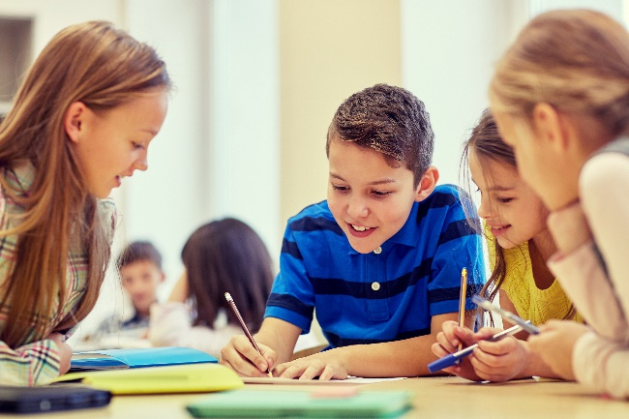
Cooperative learning frameworks create opportunities for groups of students to work together, generally to a single purpose.
istockphoto.com
As well as having the potential to increase learning for all students involved, using these frameworks can help students develop personal and social capability.
When students are working in groups, positive interdependence can be fostered by assigning roles to group members.
These roles could include:
- working roles such as Reader, Writer, Summariser, Timekeeper
- social roles such as Encourager, Observer, Noise monitor, Energiser.
Teachers using the Primary Connections roles of Director, Manager and Speaker for their science teaching may find it effective to also use these roles for STEM learning.
Further to this, specific roles can be delineated for specific activities that the group is completing.
It can help students if some background to the purpose of group roles is made clear to them before they start, but at no time should the roles get in the way of the learning. Teachers should decide when or where roles are appropriate to given tasks.
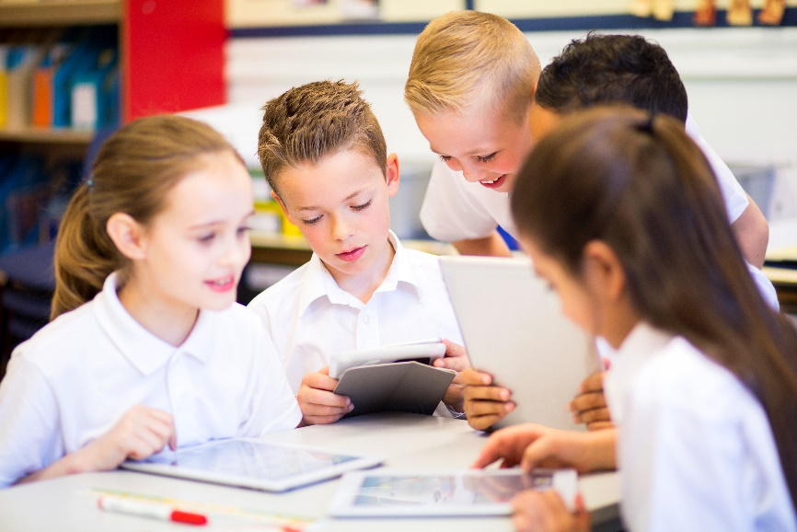
istockphoto.com

Appendix 8: Teacher resource sheet 1.2: Cooperative learning – Think-pair-share
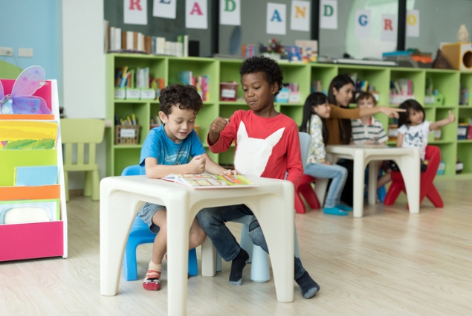
Cooperative learning frameworks create opportunities for groups of students to work together, generally to a single purpose.
istockphoto.com
As well as having the potential to increase learning for all students involved, using these frameworks can help students develop personal and social capability.
The think-pair-share strategy increases student participation and provides an environment for higher levels of thinking and questioning.
In the 'think' stage, each student thinks silently about a question asked by the teacher.
In the 'pair' stage, students discuss their thoughts and answers to the question in pairs.
In the 'share' stage, students share their answer, their partners answer or what they decided together. This sharing may be with other pairs or with the whole class. It is important also to let students 'pass'. This is a key element of making the strategy safe for students.
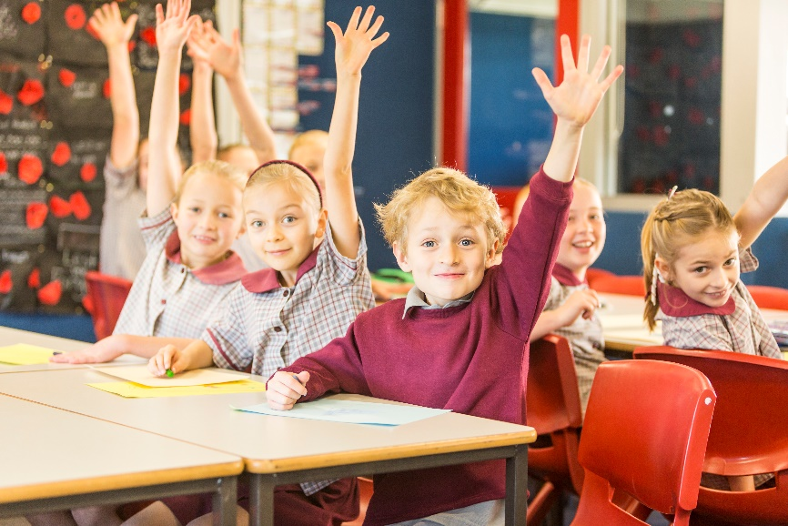
istockphoto.com

Appendix 9: Teacher resource sheet 1.3: Cooperative learning – Pass it on
Cooperative learning allows students to exchange ideas, thoughts or responses with each other, rather than with the teacher. It can generate new avenues of learning and multiple interactions with others can amplify student learning.
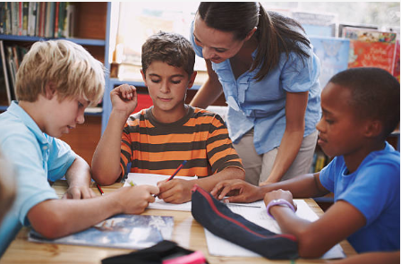
‘Pass it on’ is a brainstorming activity that starts with groups of four students, or however many can fit around a large sheet of paper and record ideas.
Gettyimages.com
The groups are spread around the room in a circular shape. Each group has a large sheet of paper on which a nominated group leader writes the brainstorm topic or phrase in the middle.
The students have one minute to start recording ideas about the topic or phrase. When the minute has passed, each group leader takes their sheet to the neighbouring group, working in a clockwise direction.
Student groups, now with a new brainstorm paper, have 30 seconds to read it followed by 30 seconds to add something new, as exposure to new ideas can inspire more new ideas.
When that minute has passed, group leaders again must take their sheet to the neighbouring group to their left. Once again, students have 30 seconds to read, followed by 30 seconds to write.
Students continue this pattern until the sheets have completed a rotation to every group, or the sheets have no more space.
Following the activity, the teacher facilitates a class discussion by asking:
- What were the favourite ideas you read?
- What were the favourite ideas you recorded?
- What are the ideas you came up with after reading others’ ideas?
- Why do you think new ideas generate more new ideas?
The activity works well when students are motivated by the time limits; however, when conducting it for the first time, students may benefit with longer than one minute to learn the activity.

Appendix 10: Teacher resource sheet 1.4: Cooperative learning – Inside-outside
Cooperative learning allows students to exchange ideas, thoughts or responses with each other, rather than with the teacher. It can generate new avenues of learning and multiple interactions with others can amplify student learning.
The inside-outside strategy involves setting up the class into two halves.
Students in the first half stand and form a tight circle, with each student facing outwards.
Students in the second half form a circle outside the first circle, with each student standing to face a student from the inside circle.
Gettyimages.com.au
The teacher poses a question that asks for a response (eg What types of animals have you seen around our school? What do you think they eat? And, where do you think they find it?).
Students respond to the question by taking turns sharing their ideas and listening to their ‘face partner’. After 30 seconds or an appropriate amount of time, the teacher instructs students to pause.
Students in the outside circle rotate two steps to the left (so their new partner isn’t the neighbour who they may have just overheard). The new face partners exchange responses/ideas to the same teacher question.
After roughly seven rotations, the outside circle moves just one step to the left, and then returns to two step rotations to achieve interaction between every possible face partner combination.
Follow the activity, the teacher facilitates a class discussion by asking:
- What things did others tell you?
- How many new things did you learn?
- What were the most interesting things?
- What things do you want to know more about?
Content generated from this activity can feed into ongoing teaching and learning.

Appendix 11: Teacher resource sheet 1.5: Cooperative learning – Silent card sort
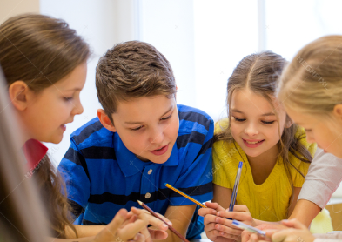
Cooperative learning frameworks create opportunities for groups of students to work together, generally for a single purpose.
As well as having the potential to increase learning for all students involved, using these frameworks can help students develop personal and social capability.
To engage in a silent card sort, students should be in groups of three or four students.
Groups are provided with a set of cards that need to be sorted into two or more given categories. In the initial phase, students must not speak at all. They silently use their fingers to move the cards around, all at the same time, cooperating and coordinating their actions without using any words or sounds.
istockphoto.com
When most have completed the sort, the teacher gives the signal to begin talking and students then explain to each other their actions and negotiate any changes group members think necessary.
This activity provides for equal engagement from all in the group during the silent card sort, without any one person using language to take control of the activity. It requires cooperation and initial consensus through the movement of the cards alone. Students often use body language to convey meaning requiring attention to visual rather than aural cues.
When given the opportunity to talk, the participant then can justify and present arguments for any changes and gain final consensus through discussion.

Appendix 12: Student activity sheet 1.6: I see, I think, I wonder

What do you see when you look at this image?
Pixabay.com
What are you thinking about as you look at this image?
Pixabay.com
What are your wonderings (questions)?
Pixabay.com
Information about the I see, I think, I wonder cooperative strategy can be found at: http://pz.harvard.edu/resources/see-think-wonder-at

Appendix XX: Teacher resource sheet X.X: Construction skills
Construction skills help students to generate and produce solutions for real-world problems.
This resource can be used as a visual stimulus to prompt students to develop solutions to design problems. The cards can be printed to create stations.
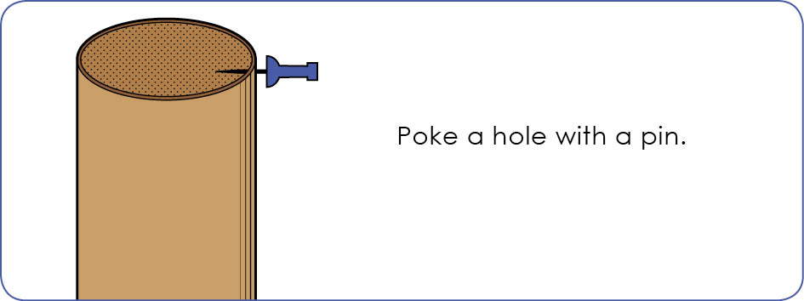
STEM Consortium
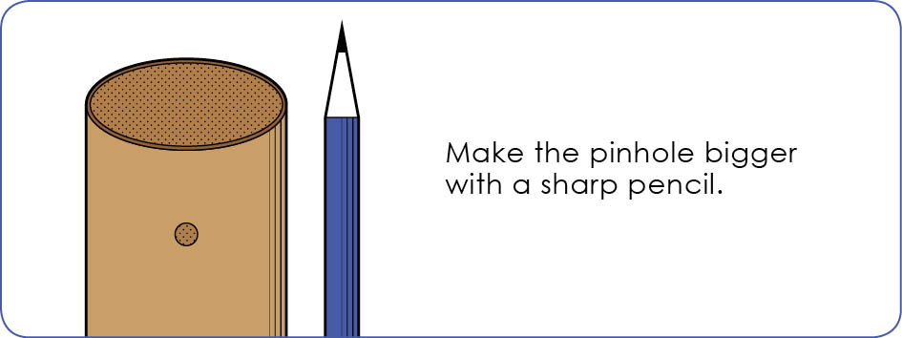
STEM Consortium
Poke a hole with a pin.

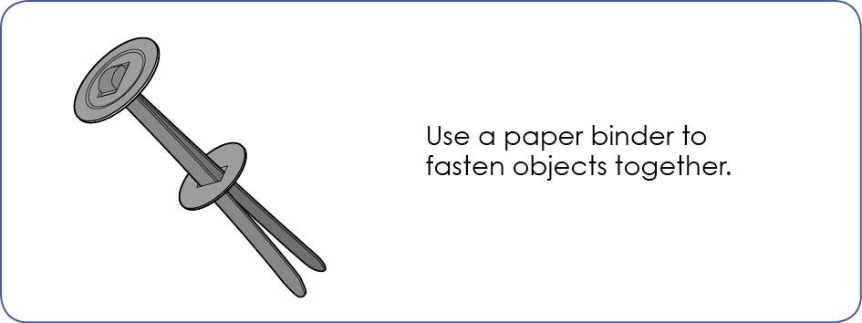
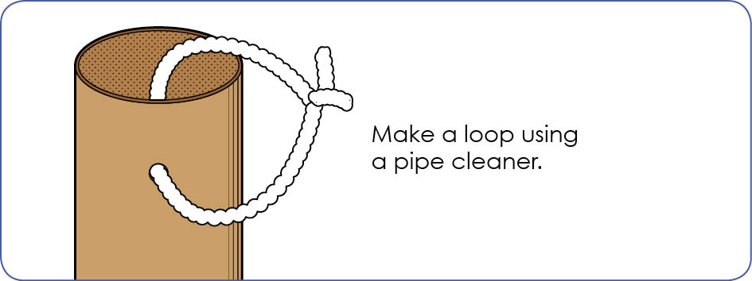
STEM Consortium
STEM Consortium
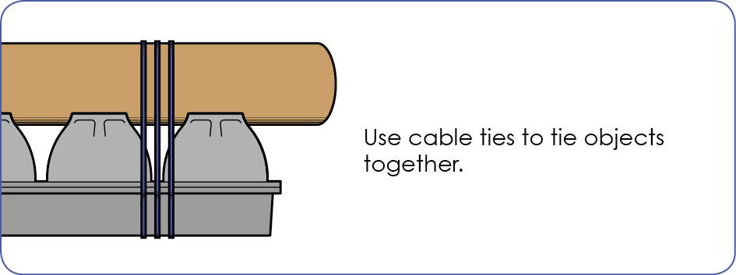
STEM Consortium

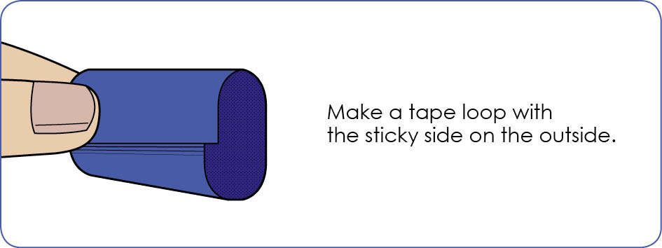
STEM Consortium
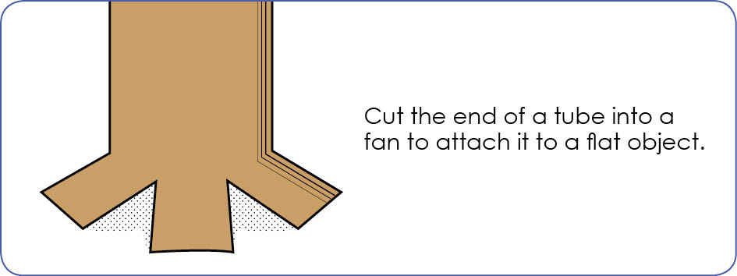
STEM Consortium
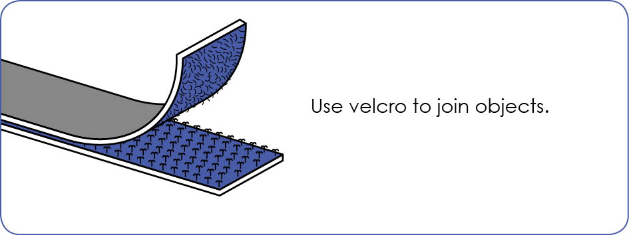
STEM Consortium

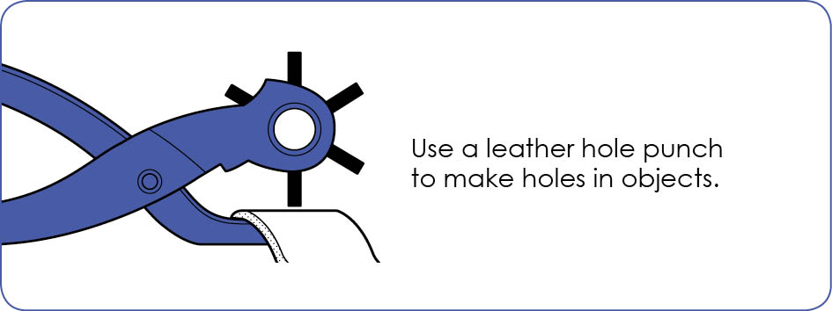
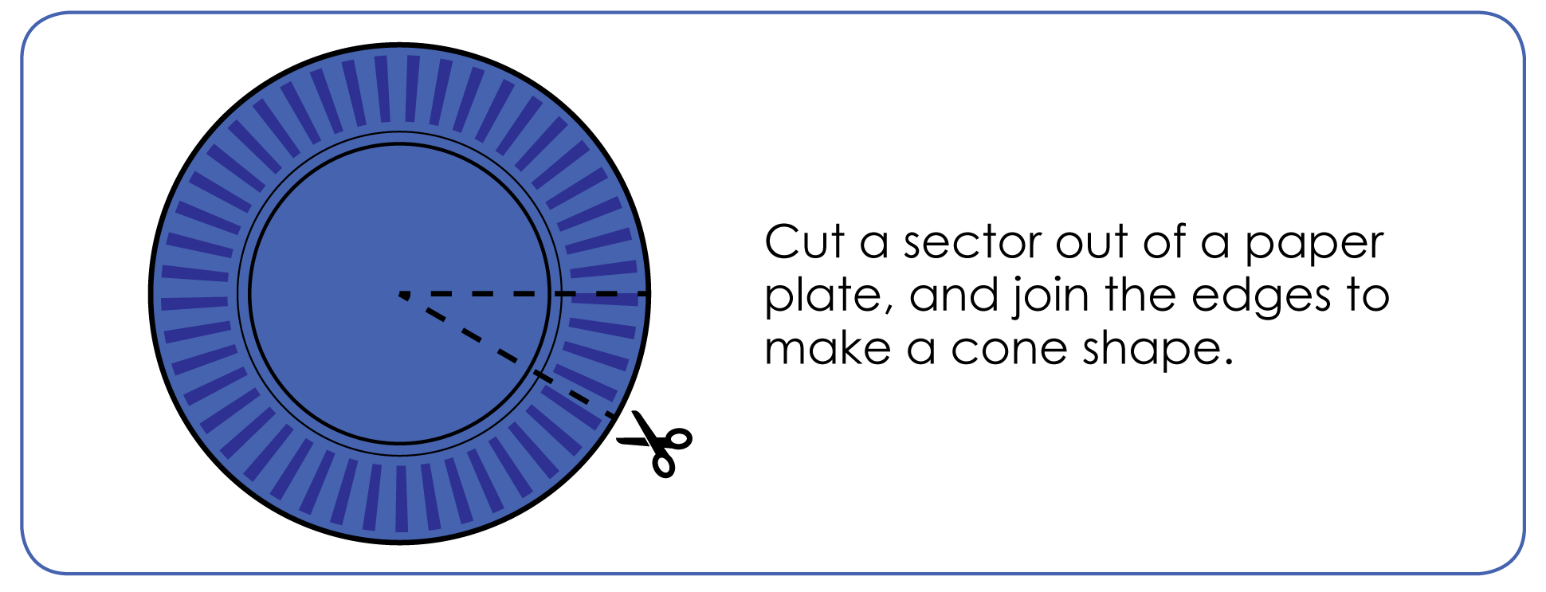
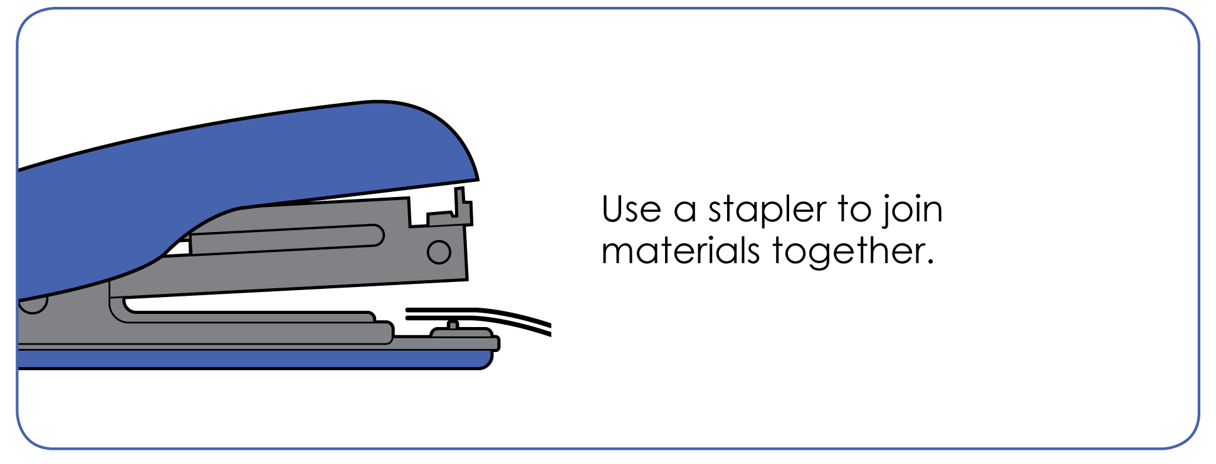
STEM Consortium
STEM Consortium
STEM Consortium

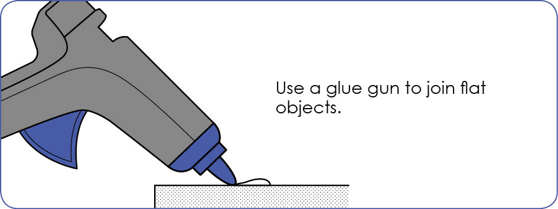
STEM Consortium

Appendix XX: Student activity sheet X.X: Prototype troubleshooting
Problem | Reason for the problem | Possible changes to your design to solve the problem

Appendix XX: Student activity sheet XX: Analysis
Write the steps you took to make your XXX.

What is it?
What does it do?
Is it different to your plan? How?
What is it made from?

Appendix XX: Student activity sheet XX: Analysis
Draw or glue a picture of your XXX

Appendix XX: Teacher resource sheet XX: Evaluation
Key:  - Sometimes  - Consistently  - Independently and consistently | Student name
Remains focused on tasks presented
Completes set tasks to best of their ability
Works independently without disrupting others
Manages time effectively
Cooperates effectively within the group
Contributes to group discussions
Shows respect and consideration for others
Uses appropriate conflict resolution skills
Actively seeks and uses feedback

Appendix XX: Teacher resource sheet XX: 3 – 2 – 1 Reflection
3 – 2 – 1 Reflection
Name | 3 things I learned | 2 things I found interesting | 1 thing I found difficult

Notes
________________________________________________________________________________________________________________________________________________________________________________________________________________________________________________________________________________________________________________________________________________________________________________________________________________________________________________________________________________________________________________________________________________________________________________________________________________________________________________________________________________________________________________________________________________________________________________________________________________________________________________________________________________________________________________________________________________________________________________________________________________________________________________________________________________________________________________________________________________________________________________________________________________________________________________________________________________________________________________________________________________________________________________________________________________________________________________________________________________________________________________________________________________________________________________________________________________________________

