WAPC OP2.4 – Planning for School Sites

FACT SHEET 2 – Developer Contributions for Public Primary Schools

Purpose of a developer contribution
All new residential lots created through the subdivision process (including survey strata) generate demand for a public primary school site based on a ratio of one notional four-hectare primary school site for every 1,500 dwellings.
Under the Western Australian Planning Commission’s (WAPC) Operational Policy 2.4 – Planning for School Sites (OP 2.4), public primary school sites identified on an approved structure plan and created through the subdivision process are to be either ceded free-of-cost or in a form of pro-rata developer contribution particularly where the subdivision land is held in multiple land ownership.
Any pro-rata cash contributions collected by the Department of Education (Department) are to be used to acquire land for any public primary school site, including land adjacent to existing public primary school sites for the purpose of expansion, or reimbursement for Department expenses in preparing school sites to be made developable/augmented where the school site land is affected by unique site constraints/features.

General principles of developer contributions
- Subdivider/landowners who have either all, or a portion of a primary school site, within their subdivision application are required to cede the school site land or relevant portion, to the Crown at the time of subdivision. Notwithstanding this, where a subdivision is proposed to be cleared in stages, the subdivider/landowner may, by agreement with the Department, enter into an arrangement to address ceding of the primary school site.

- Subdivider/landowners who do not have any portion of the primary school site within their subdivision application are required to pay a pro-rata developer contribution in cash to the Department. The contribution payable is based on the eligible lots proposed in the subdivision in accordance with the ‘Developer contribution formula’ (formula) in Appendix 2 of OP 2.4.

- Where all or a portion of a primary school site is identified within a subdivider/landowner’s landholdings, and subdivision of the landholdings is proposed to be staged, the subdivider/landowner may, by legal agreement with the Department:
- undertake preliminary calculations for the total landholdings as part of stage one and determine the developer contribution arrangements; and
- reconcile the final contribution or reimbursement to be made upon completion of the final stage and structure through a legal agreement and caveat registered on the title.

- Where a subdivider/landowner cedes a portion of land where its value is deemed to be in excess or less than the amount apportioned through the formula identified in OP 2.4, the subdivider/landowner will be reimbursed or required to make an additional cash payment to account for the oversupply or deficit respectively.

- A valuation report of the land market value of the proposed deposited plan area is to be undertaken and submitted to the Department prior to the clearance of the relevant subdivision condition to calculate the developer contribution amount. Please also refer to the Department’s Valuation for Pro-rata Developer Contribution Fact Sheet for more details.
Please refer to Appendix 1 for working examples of the methodology.

Application of developer contribution
Developer contributions for Government (public) primary schools apply to any subdivision creating more than an additional five lots where it is located within:
- the Metropolitan Region Scheme area; or
- the Peel Region Scheme area; or
- the Greater Bunbury Region Scheme area; or
- an approved structure plan area.

The following will be exempt from a pro-rata contribution:
- subdivision applications which propose less than an additional five lots; or
- any identified balance lot(s); or
- lots which are identified for aged/dependent persons developments as this typology is not expected to generate average (if any) level of demand on primary schools.
A development contribution calculation will be required to be undertaken where the following model condition is imposed on a WAPC subdivision approval:
S3 “The landowner/applicant making a pro-rata cash contribution to the Department of Education towards the provision of land for a primary school site(s) to serve the area, in accordance with the contribution methodology outlined in the Western Australian Planning Commission’s Operational Policy 2.4 (Department of Education)”
In order to clear the condition (S3), the landowner/applicant is responsible for undertaking a per hectare valuation for the land subject of the subdivision application within the six (6) months prior to seeking clearance of the condition from the Department. The per hectare value will be used by the Department to inform the pro-rata contribution (1/1,500th per applicable lot created) payable to the Department in accordance with the WAPC’s Operational Policy 2.4.
The Department will equalise any deficit or oversupply of land ceded by the landowner/applicant for the provision of the primary school site land in consultation with the landowner/applicant.

Timing of developer contribution payment
If a primary school developer contribution is required as a condition of a WAPC approved subdivision, then the contribution is to be paid to the Department for each deposited plan area before the relevant subdivision condition will be cleared, unless by alternate agreement if staged subdivision is occurring.

Information to be submitted to the Department of Education
The developer contribution rate:
- WAPC subdivision approval letter with applicable developer contribution condition;
- Proposed deposited plan;
- Structure plan covering the deposited plan area if relevant; and
- A current valuation report for the proposed deposited plan area in accordance with the report template provided by the Department– refer to the Department’s Valuation for Pro-rata Developer Contribution Fact Sheet for more details.
Upon determination of the developer contribution rate, and at the request of the proponent, the Department will then issue an invoice to the proponent for review.

Further information
For more information on the pre-lodgement structure plan referral process, please email your enquiries to Landplanning@education.wa.edu.au
Disclaimer
This Fact Sheet is prepared by the Department of Education to provide general guidance for developers, landowners and proponents on the pre-lodgement structure plan referral process based on the provisions of the Western Australian Planning Commission’s Operational Policy 2.4 – Planning for school sites (OP 2.4). Should there be any inconsistency between this Fact Sheet and the OP 2.4, the OP 2.4 shall prevail.
Any representation, statement, opinion or advice expressed or implied in this publication is made in good faith and on the basis that the government, its employees and agents are not liable for any damage or loss whatsoever which may occur as a result of action taken or not taken, as the case may be, in respect of any representation, statement, opinion or advice referred to herein. Professional advice should be obtained before applying the information contained in this fact sheet to particular circumstances.

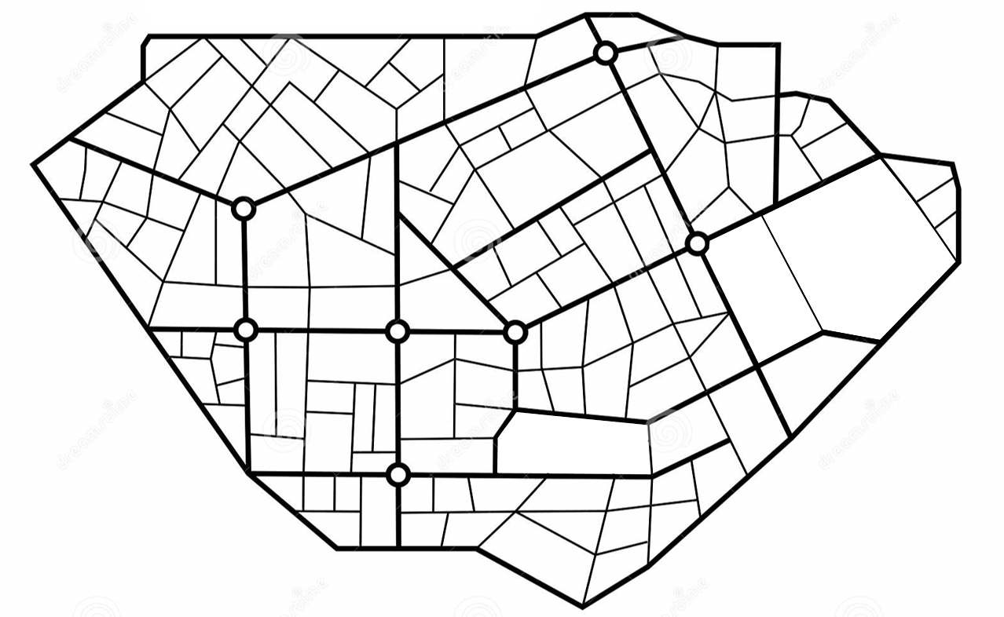
Appendix 1
B
PS
A
Hypothetical examples

Development A: Creates 26 new lots in deposited plan area with a land valuation of $1.20m per Ha (no primary school site ceded)
 | Example A | Calculations
New Lots | 26
$ Per Ha | $1.20m
DC per lot | $3,200 | (1,200,000*4/1,500)
Total DC | $83,200 | 3,200*26
Value PS Ceded | $0 | 83,200 - 0
Under Supply | $83,200 | Landowner pays $83,200 to DoE
Development B: Creates 60 new lots in deposited plan area with a land valuation of $1.25m per Ha
(2 ha or $2.5m of primary school site ceded)
 | Example B | Calculations
New Lots | 60
$ Per Ha | $1.25m
DC per lot | $3,333 | (1,250,000*4/1,500)
Total DC | $200,000 | 3,333*60
Value PS Ceded | $2.5m | 200,000 – 2,500,000
Over Supply | -$2.3m | DoE pays $2.3m to the landowner

