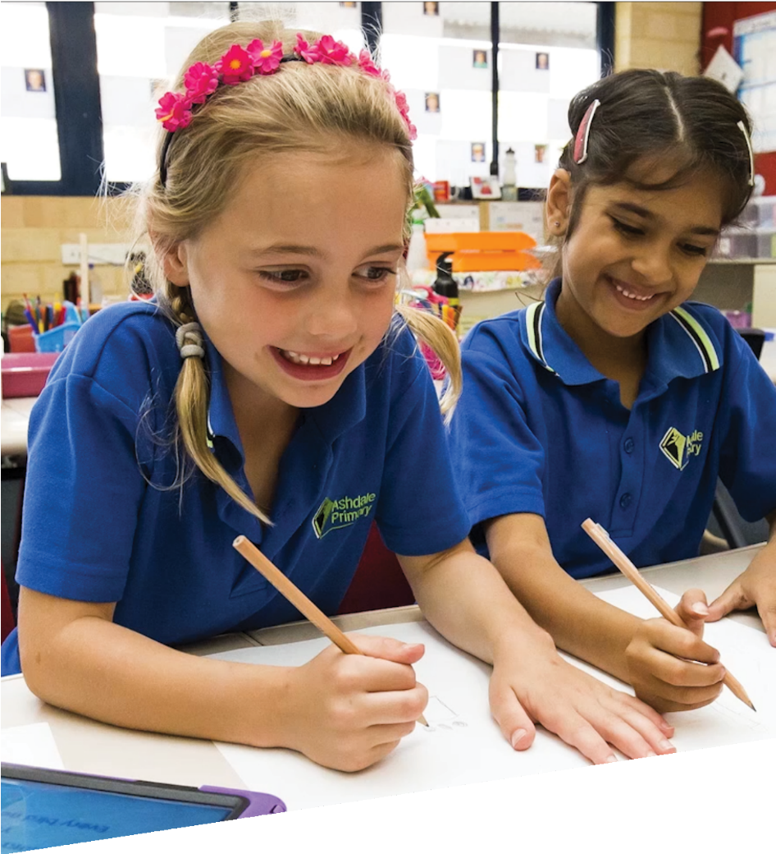
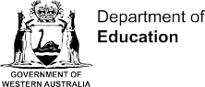

CURRICULUM RESOURCE MODULE
Rice baby
YEAR 1

Acknowledgements
The STEM Learning Project respectfully acknowledges the Traditional Custodians of the lands upon which our students and teachers live, learn and educate.

The STEM Learning Project is funded by the Western Australian Department of Education (the Department) and implemented by a consortium in STEM education comprising the Educational Computing Association of WA, the Mathematical Association of WA, the Science Teachers Association of WA and Scitech. We acknowledge and thank the teachers and schools who are the co-creators of these resources.

Copyright and intellectual property

The copyright and intellectual property of this module remain the property of the Department.

Any Western Australian Curriculum content in this resource is used with the permission of the School Curriculum and Standards Authority (the Authority); this permission does not constitute Authority endorsement of the resource. The Authority accepts no liability for any errors or damages arising from reliance on its content.

The Western Australian Curriculum content may be freely copied, or communicated on an intranet, for non-commercial purposes in educational institutions, provided that the Authority is acknowledged as the copyright owner. Copying or communication for any other purpose can be done only within the terms of the Copyright Act 1968 or with prior written permission of the Authority. Any Australian Curriculum content in the Western Australian Curriculum is used by the Authority under the terms of the Creative Commons Attribution-NonCommercial 3.0 Australia licence. Any content on the www.scsa.wa.edu.au domain that has been derived from the Australian Curriculum may be used under the terms of Creative Commons Attribution-NonCommercial 3.0 Australia licence.

Appendix 2: General capabilities continuums is adapted from ACARA, © Australian Curriculum, Assessment and Reporting Authority (ACARA) 2009 to present, unless otherwise indicated. This material was downloaded from the ACARA website (www.acara.edu.au) (Website) (accessed December 2015) and was not modified. The material is licensed under CC BY 4.0 (https://creativecommons.org/licenses/by/4.0/). ACARA does not endorse any product that uses ACARA material or make any representations as to the quality of such products. Any product that uses material published on this website should not be taken to be affiliated with ACARA or have the sponsorship or approval of ACARA. It is up to each person to make their own assessment of the product.

This resource includes references and examples of iOS, Android and other apps. The Department does not endorse or recommend any commercial products and simply provides these as examples for teachers.

The Department is committed to providing quality information to its customers. Whilst every effort has been made to ensure accuracy, currency and reliability of the information within these documents, the Department accepts no responsibility for errors, omissions or amendments made since the time of publishing. Confirmation of information may be sought from the Department or the originating bodies providing the information. The Department has no control over the content of material published on websites to which users are referred in this resource. It is the responsibility of the internet user to make their own decision as to the relevancy, accuracy, currency and reliability of information found on those sites.
This resource contains various images from iStock used under license.
Attributions: Kidblog, Edmodo, Explain everything, Evernote, Cool tools for schools, Keynote, Voice Record Pro, Pages, PuppetPal, iMovie, Class Dojo, Seesaw, Popplet, Kids Doodle, ebook.

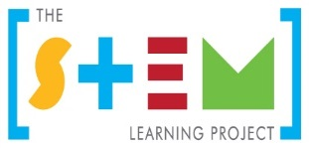
Table of contents

The STEM Learning Project 2
Overview 3
Activity sequence and purpose 7
Background 8
Activity 1: Rice baby 10
Activity 2: Our families and their babies 17
Activity 3: Create, build and test 25
Activity 4: Evaluate and share 31
Appendix 1: Links to the Western Australian Curriculum 34
Appendix 1B: Mathematics proficiency strands 36
Appendix 2: General capabilities continuums 37
Appendix 3: Materials list 40
Appendix 4: Design process guide 41
Appendix 5: Reflective journal 42
Appendix 6: Teacher resource sheet 1.1: Cooperative learning – Roles 43
Appendix 7: Teacher resource sheet 1.2: Cooperative learning – Think, Pair, Share 44
Appendix 8: Teacher resource sheet 1.3: Sample parent letter and instructions for making a rice baby 45
Appendix 9: Teacher resource sheet 3.1: Prototype troubleshooting 48
Appendix 10: Teacher resource sheet 3.2: Construction skills 49
Appendix 11: Student activity sheet 4.1: Reflection 53

The STEM Learning Project
The aim of the STEM Learning Project is to generate students’ interest, enjoyment and engagement with STEM (Science, Technology, Engineering and Mathematics) and to encourage their ongoing participation in STEM both at school and in subsequent careers. The curriculum resources will support teachers to implement and extend the Western Australian Curriculum across Kindergarten to Year 12 and develop the general capabilities.
Why STEM?
A quality STEM education will develop the knowledge and intellectual skills to drive the innovation required to address global economic, social and environmental challenges.
STEM capability is the key to navigating the employment landscape changed by globalisation and digital disruption. Routine manual and cognitive jobs are in decline whilst non-routine cognitive jobs are growing strongly in Australia. Seventy-five per cent of the jobs in the emerging economy will require critical and creative thinking and problem solving, supported by skills of collaboration, teamwork and literacy in mathematics, science and technology. This is what we call STEM capability. The vision is to respond to the challenges of today and tomorrow by preparing students for a world that requires multidisciplinary STEM thinking and capability.
The approach
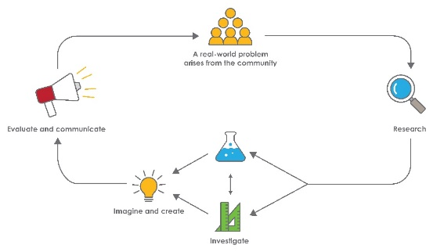
STEM capabilities are developed when students are challenged to solve open-ended, real-world problems that engage students in the processes of the STEM disciplines.

Rice baby
STEM Consortium

Overview
The Rice baby module connects students to the world around them as they discover that each person is unique whilst also sharing common traits and needs. Students cultivate a sense of empathy and experience different perspectives by being encouraged to care for their rice baby.
A rice baby is made by filling a stocking with rice and can be made to look more realistic by including arms and legs.
This module integrates repurposing items, giving students the opportunity to consider sustainability and the impact of our lifestyles on the environment while developing their ability to design, create and problem-solve.
What is the context?
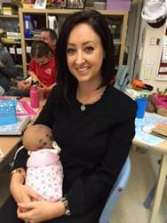
Small babies are vulnerable and need protection. There are many devices to help protect babies and keep them safe. When transporting a baby, many parents choose to wear a front pack, baby wrap or sling, or a soft fabric backpack for slightly older babies. A stroller or pram, car seat, cradle and playpen are other ways we keep babies and small children safe.
What is the problem?
How can we make a device to keep our babies safe?
STEM Consortium
How does this module support integration of the STEM disciplines?
In addition to providing a context in which students can develop outcomes for the Early Years Learning Framework, this module gives students the opportunity to develop skills in the STEM learning areas.
Science
Students begin to understand the nature of science as they identify the external features as well as the needs of babies and baby animals (ACSSU211: Living things live in different places where their needs are met, and ACSSU017:Living things have a variety of external features) and investigate the properties of materials when testing the strength of various materials they will use to construct their baby protection devices (ACSIS025: Participate in guided investigations to explore and answer questions).
Technology
Students develop a design of a baby protection device and document their design as a drawing (WATPPS07: Develop and communicate design ideas through describing, drawing, modelling and/or a sequence of written or spoken steps). Students use given materials to safely make (WATPPS08: Use given components and equipment to safely make solutions) and evaluate a baby protection device, explaining what they liked or disliked, what they would keep the same or change (WATPPS09: Use personal preferences to evaluate the success of design processes). As students design their baby protection device they begin to understand how products are designed to meet needs (ACTDEK001: People produce familiar products and services to meet personal and community needs) and how materials behave when used to make these products (ACTDEK004: Characteristics and behaviours of individual materials used in products).
The Design process guide is included as a resource to help teachers understand the complete design process as developed in the Technologies curriculum.
Mathematics
Students group rice babies based on specified criteria, count the number in each group and, with assistance, represent the numbers visually, where one baby represents one data value (ACMSP263: Represent data with objects and drawings where one object or drawing represents one data value. Describe the displays). Students develop simple questions about their rice babies, gather responses and make simple inferences (ACMSP262: Choose simple questions and gather responses and make simple inferences). Students measure and compare the lengths and capacities of pairs of objects using informal, uniform units (ACMMG019: Measure and compare the lengths and capacities of pairs of objects using uniform formal units) and count with one-to-one correspondence by ones and skip count by twos, fives or tens (ACMNA012: Develop confidence with number sequences to and from 100 by ones from any starting point. Skip count by twos, fives and tens starting from zero). They build on their ability to decide which baby is heavier or lighter and are introduced to ordering mass using balance scales, experiences that underpin later learning.

General capabilities
There are opportunities for the development of general capabilities and cross-curriculum priorities as students engage with Rice baby. In this module, students:
- Develop problem-solving skills as they research the problem and its context (Activity 1); investigate parameters impacting on the problem (Activity 2); imagine and develop solutions (Activity 3); and evaluate and communicate their solutions to an audience (Activity 4).
- Utilise creative thinking as they generate possible design solutions; and critical thinking, numeracy skills and ethical understanding as they choose between alternative approaches to solving the problem.
- Utilise personal and social capability as they develop socially cohesive and effective working teams; collaborate in generating solutions; adopt group roles; and, reflect on their group work capabilities through self and peer evaluation.
- Utilise a range of literacies and information and communication technologies (ICT) capabilities as they collate records of work completed throughout the module in a journal; and, represent and communicate their solutions to an audience using ICT or digital technologies in Activity 4.
- Communicate and, using evidence, justify their group’s design to an authentic audience.

What are the pedagogical principles of the STEM learning modules?
The STEM Learning Project modules develop STEM capabilities by challenging students to solve real-world problems set in authentic contexts. The problems engage students in the STEM disciplines and provide opportunities for developing higher order thinking and reasoning, and the general capabilities of creativity, critical thinking, communication and collaboration.
The design of the modules is based on four pedagogical principles:
- Problem-based learning
This is an underlying part of all modules with every module based around solving an initial problem. It is supported through a four-phase instructional model: research the problem and its context; investigate the parameters impacting on the problem; design and develop solutions to the problem; and evaluate and communicate solutions to an authentic audience.
- Developing higher order thinking
Opportunities are created for higher order thinking and reasoning through questioning and discourse that elicits students' thinking, prompts and scaffolds explanations, and requires students to justify their claims. Opportunities for making reasoning visible through discourse are highlighted in the modules with the icon shown here.
- Collaborative learning
This provides opportunities for students to develop teamwork and leadership skills, challenge each other’s ideas, and co-construct explanations and solutions. Information that can support teachers with aspects of collaborative learning is included in the resource sheets.
- Reflective practice
Recording observations, ideas and one’s reflections on the learning experiences in some form of journal fosters deeper engagement and metacognitive awareness of what is being learnt. Information that can support teachers with journaling is included in the resource sheets.
These pedagogical principles can be explored further in the STEM Learning Project online professional learning modules located in Connect Resources.

Activity sequence and purpose
Rice baby
To capture students’ interest, they listen to the story Ten little fingers and ten little toes by Mem Fox. They share their knowledge about babies and how to care for them and identify the needs of young babies and some devices used to keep them safe.
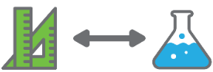 | Our families and their babies  Students participate in a range of mathematical and scientific investigations of their rice babies and the materials they will use for their protective devices.
Build and test
Students design and construct a device to keep their baby safe using a range of materials, considering a variety of physical properties. They follow the design process to develop and improve their ideas.
Evaluate and share
Students record oral reflections using a digital device, share their creations with the class and, where possible, an audience beyond the classroom.

Background
Expected learning | Students will be able to:  - Orally recount a story using everyday language and correctly sequence the order of events.  - Count with one-to-one correspondence by ones and skip count by twos, fives or tens.  - Identify the problem and generate ideas for potential solutions.  - List some external features of babies.  - Group rice babies based on specified criteria, count numbers in each group and, with support, represent the data graphically.  - Compare lengths, capacities and mass using uniform informal units.  - Identify the needs of babies and baby animals.  - Observe, describe and compare the properties of materials.  - Develop a design and document their design as a drawing.  - Safely use given materials to make simple solutions.  - Evaluate their solution, explaining what they would keep the same or change.
Vocabulary | This module uses subject-specific terminology. The following vocabulary list contains terms that need to be understood, either before the module commences or developed as they are used:  absorbent, after, before, big, bigger, biggest, category, compare, construct, data, design, evaluate, first, group, hard, heavier, heaviest, heavy, investigate, large, larger, largest, light, lighter, lightest, materials, next, plan, property, safe, second, small, smaller, smallest, soft, strong, third, type.
Timing | There is no prescribed duration for this module. The module is designed to be flexible enough for teachers to adapt. Activities do not equate to lessons; one activity may require more than one lesson to implement.
Consumable materials | A Materials list is provided for this module. The list outlines materials outside of normal classroom equipment that will be needed to complete the activities.
Safety notes | There are potential hazards inherent in these activities and with the equipment being used, and a plan to mitigate any risks will be required.  Potential hazards specific to this module include but are not limited to:  - Possible exposure to cyber bullying, privacy violations and uninvited solicitations when using the internet  - Slipping on rice spills  - Injuries from construction tools.
Assessment | The STEM modules have been developed to provide students with learning experiences to solve authentic real-world problems using science, technology, engineering and mathematics capabilities. While working through the module, the following assessment opportunities will arise:  - Anecdotal notes from observations  - Justification of final solutions with reference to the design, materials, including shape and properties, as well as student reflections.  Appendix 1 indicates how the activities are linked to the Western Australian Curriculum.  Evidence of learning from journaling, presentations and anecdotal notes from this module can contribute towards the larger body of evidence gathered throughout a teaching period and can be used to make on-balance judgements about the quality of learning demonstrated by the students in the science, technologies and mathematics learning areas.  Students can further develop the general capabilities of Information and communication technology capability, Critical and creative thinking and Personal and social capability. Continuums for these are included in the General capabilities continuums but are not intended to be for assessment purposes.

Activity 1: Rice baby
Activity focus | To capture students’ interest, they listen to the story Ten little fingers and ten little toes by Mem Fox. They share their knowledge about babies and how to care for them and identify the needs of young babies and some devices used to keep them safe.
Background information | In this activity, songs and rhymes are used to engage students with counting, babies and awareness of their bodies.  Studies suggest that music and movement:  - Nourish the brain while affecting all areas of development  - Strengthen listening, motor skills, language, problem solving, spatial-temporal performance and literacy  - Help develop critical listening skills  - Create space for emotional well-being  - Provide opportunities to practice social skills  - Support phonemic awareness  - Instill acts of kindness and cooperation  - Calm and focus the mind  - Encourage interaction in non-threatening ways.  (Stein, 2009)
Instructional procedures | This activity may work best during small group rotation activities, enabling teachers to work with groups of three to four students. Social group skills such as listening and taking turns when talking could be a focus.  The think–pair–share cooperative strategy can be incorporated in the activities to develop the students’ social skills, increase student participation and provide an environment for higher levels of reasoning. Further explanations of this strategy can be found in Teacher resource sheet 1.2: Cooperative learning – Think Pair, Share.  Throughout the activities, record student ideas and conversations for reflection and to share with a wider audience in Activity 4. Choose a method of recording conversations, such as written anecdotal notes or video or audio recordings using software such as Voice Record Pro. Decide on the platforms (eg Connect, Seesaw) that will be used to share learning with the wider audience.
Expected learning | Students will be able to:  - List some external features of babies (Science).  - Orally recount a story using everyday language and correctly sequence the order of events (Technology).  - Count with one-to-one correspondence by ones and skip count by twos, fives or tens (Mathematics).
Equipment required | For the class:  Ten little fingers and ten little toes by Mem Fox
For the students:
Cards or pictures photocopied from the story for the sequencing activity
Device with apps for digital options
A small mirror to share in small groups
Preparation | Prepare an area in the classroom for the rice baby nursery. In Activity 3 students will construct a device to keep their rice baby safe and there needs to be enough room in the nursery to house all the devices. Make a space in the nursery for a word wall for vocabulary the students will be introduced to as they work through the module.  It is suggested that a letter be sent to parents informing them about the Rice baby STEM activity. The letter should explain the duration of the activities, the resources and materials that will be required and the times when parent help will be required. See Teacher resource sheet 1.3: Sample parent letter and instructions for making a rice baby.  Decide whether you will ask parents to make the baby, as per the instruction sheet, with arms, legs and fingers (which provides for more active involvement of the ‘baby’ in the class activities) or a simpler form by filling a stocking with rice, tying it off and covering the body with baby clothes and wrapping in a blanket. This simple form could be created with help from a Year 6 buddy class instead of parents.  The apps suggested in this activity will need to be explored to assess the best options for the class.
Activity parts | Part 1: Rice babies  With assistance, students make a rice baby to reflect their own mass at birth. These can be made at home with the support of parents or at school with assistance from a year six buddy class (see Teacher resource sheet 1.3: Sample parent letter and instructions for making a rice baby).
Part 2: Ten little fingers and ten little toes
Students sit on the mat holding their rice babies while they listen to a story. Suggestions include:
- Ten little fingers and ten little toes by Mem Fox
- Hello Baby by Mem Fox
- Whoever you are by Mem Fox.
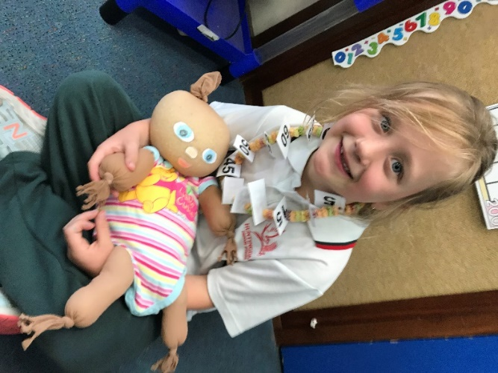
Before opening the book, look at the front page together to identify familiar images and use them to make predictions about the story. Use questioning prompts such as why and because and practise wait time to encourage higher order thinking and reasoning.
Talk about the illustrations and ask questions in ways that relate to the students (eg ‘This little baby has lots of lovely orange hair just like you. What can you tell me about this baby? What do all the babies have?’).
STEM Consortium
Sequencing the story
To focus on sequencing, read and map out a story of your choice about family. Copies of the main illustrations from the story can be used to complete the sequenced steps, acting as an introduction to step-by-step coding instructions.
Model the use of ordinals when helping the students sequence the pictures (eg first, second, third) as well as everyday language of time (eg before, after, next). See Digital resources for supporting resources.
In small groups, students act out scenes from the story.
Give each group a different sequencing card or picture from the story and encourage them to work together to act out the scene from that card. When students have had adequate time to work on this, come back together as a class and ask students to share their performances in chronological order.
Buddy up: Same but different
- Students sit on the floor, opposite one another with their baby in their lap.
- Students point and wave to their partner and their baby and say hello to them. Can they say hello in a different language?
- Encourage students to talk about their buddy’s body parts: What colour are their eyes? And their hair? What shape is their nose? Do they have freckles? Are these things the same as when they were babies?
- Students could use a small mirror to look at their reflection as their buddy describes their features.
- Reinforce the idea that even though we are all different we are the same in many ways.
Counting
Question the class:
- How many fingers do you have? How many toes do you have?
- How many fingers and toes do you have altogether?
- How many fingers and toes do you and your partner have?
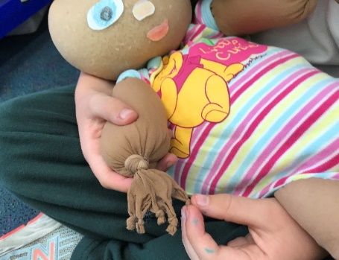
- How many fingers and toes do you and your baby have?
- How could we count how many fingers and toes the class has? How can we check our answer?
- Is there a way we can count our fingers and toes faster? Introduce skip counting, counting by twos counting by fives or counting by tens.
STEM Consortium
Students sing the song This Little Piggy to their rice babies. They use their baby’s toes or take off their shoes and socks and use their own toes. See Digital resources for a link to a video of The Wiggles singing this song.
Sing more finger play songs with the students including Where is Thumbkin? Two Little Dickie birds, Five little ducks and Ten little fingers. These songs help with the development of fine motor skills. See Digital resources for links.
Part 3: Class brainstorm
Ask students to think of ways they have seen their parents, friends or other family members look after babies.
Show snippets of videos showing a day in the life of a two-month-old baby to help students who may not have experienced living with a baby and to focus further on the range of devices for keeping babies safe. See Digital resources for links to several videos mothers have made.
Ask the students:
- Why do babies need to be protected?
- How do parents keep babies safe while they sleep?
- How do parents keep babies safe when they travel?
- How do parents keep babies safe when they are feeding?
- What do they use? How does that help? Why?
Embrace diversity and encourage students to understand that all families are different, and this is what makes us special and unique. Record student ideas as a class brainstorm for reference in Activity 2 and 3.
Additional learning opportunity: Links to the Health and Physical Education curriculum
This module presents cross-curriculum opportunities to link to the Western Australian Curriculum: Health and Physical Education. Facilitate a class discussion about foods needed to help bodies grow and stay strong, good sleeping habits, exercise that keeps us healthy, and how easily germs are spread if we do not wash our hands properly or cover our mouths when coughing. Students can share personal experiences of how their families have taught them to look after their bodies.

Part 4: Reflection and journaling
Ask students to reflect on what has been discussed in Activity 1. Suitable focus questions could include:
- In what ways are all babies the same?
- How do babies differ from each other?
- Why do babies need to be protected?
- What sorts of things are made to keep babies safe?
Keep a class reflective journal about the students’ learning experiences. A large floor book such as an A3 spiral bound book displayed somewhere central for parents to view during pick-up and drop-off times could be useful. Photos and student quotes will enhance the journal. A digital journal could also be created and shared via a platform such as Seesaw or Connect (see Reflective journal for more information).
Resource sheets | Reflective journal  Teacher resource sheet 1.1: Cooperative learning – Roles  Teacher resource sheet 1.2: Cooperative learning – Think, Pair, Share  Teacher resource sheet 1.3: Sample parent letter and instructions for making a rice baby
Digital resources | The benefits of using music with young children (Gari Stein, 2009)  www.songsforteaching.com/teachingtips/benefitsofmusicwithyoungchildren.htm
Singing to children may help development of language skills (The Guardian, 2011)
www.theguardian.com/lifeandstyle/2011/may/08/singing-children-development-language-skills
Mem Fox – 10 little fingers and 10 little toes (slackmase, 2009)
youtu.be/t3A2BBegr7U
Ten little fingers ten little toes read along (Little Readers, 2016)
youtu.be/23BD43s7iFA

Ten little fingers, Ten little toes (song) (BarneyClassics, 2015)
youtu.be/FQN4IQXEjKE
Mem Fox reads from Hello baby! (Simon & Schuster, 2009)
youtu.be/E4Q9V2Cvb98
Whoever you are by Mem Fox (Rebecca TeachingLearningConnect, 2018)
youtu.be/MugWfjAyoiw
The Wiggles - This little piggy went to market (feat. Lee Hawkins)(The Wiggles, 2014)
youtu.be/AMsAHD5_TOg
Where is thumbkin song | Nursery rhymes for children by Hooplakidz (HooplaKidz – Official Nursery Rhymes Channel, 2014)
youtu.be/bRNDu3O2VQY
Nursery rhymes: 2 little dickie birds (essortment, 2009)
youtu.be/uAgJlafhBow
The Wiggles – Five little ducks (Blackout Streamz, 2017)
youtu.be/epHTVGVNGKA
Videos of 24 hours with two-month-old babies and a range of equipment for keeping them safe.
24 hours with a two-month-old baby (Christina Holt, 2019)
youtu.be/E1lmW4ZPvsI
24 hours with a two-month-old (Deru Crew Vlog, 2018)
youtu.be/p_UnC-ZXiCM
Day in the life | With a 2-3 month old infant (Jessica Braun, 2018)
youtu.be/2Yo7P3GVjUs
Voice Record Pro
itunes.apple.com/au/app/voice-record-pro/id546983235?mt=8
Literary resources | Ten little fingers and ten little toes by Mem Fox
 | Hello baby by Mem Fox
 | Whoever you are by Mem Fox

Activity 2: Our families and their babies
Activity focus | Students participate in a range of mathematical and scientific investigations of their rice babies and the materials they will use for their protective devices.
Instructional procedures | When graphing, assist students to recognise the need to use a common baseline and space objects evenly so they can see at a glance which category has more.  Rather than filling in spaces on provided grids, give students the opportunity to make their own displays using their rice babies and drawings of their data. Help students make the transition from displaying actual rice babies (physical graph) to representing these with pictures of the data (pictograph) and then with crosses (block graph). Students learn that only the relative quantities in each category are of interest in a graph and that knowing who belongs to which individual piece of data is no longer represented.  Through exploring their displays, students will begin to develop understandings about the purpose of graphs.  Ordering several objects is much more difficult than comparing two objects. It is not expected that students will be able to do this independently until Year 3, but it is important students have opportunities to explore comparative mass and the use of balance scales in the previous years.  Literacy resources reinforcing mass concepts:  - Mighty Maddie by Stuart J. Murphy. The main character turns into Mighty Maddie, a caped super-hero able to sort toys in a flash by their mass.  - Read-aloud of the book Fishy Scales: A story about weight by Calvin Irons and Marina McAllen (Bridie Turpeinen, 2017)  youtu.be/zmMkfH3WcoI  Students at this level typically have the misconception that mass is about size and their concepts of heavy things and light things are also likely to be in an absolute sense. Students may think that small things are all ‘light’ and big things are all ‘heavy’, and therefore suggest, for example, that a large sponge would be heavier than a full pencil-pot.  They often struggle with the idea that the same object can be both ‘lighter’ and ‘heavier’ at the same time, when compared to other objects. Students should be provided with opportunities to explore, compare and say, for example, my book is lighter than Katie’s book but it is heavier than Andrew’s book.  Student ideas and photos from the lesson should be recorded in the class reflective journal.
Expected learning | Students will be able to:  - Group rice babies based on specified criteria, count the number in each group and, with support, represent the numbers graphically (Mathematics).  - Identify the needs of babies and baby animals (Science).  - Participate in a guided investigation and explain how a test is made fair (Science).  - Observe, describe and compare the properties of materials (Science).  - Compare mass by hefting (Mathematics).
Equipment required | For the class:  Interactive whiteboard
For the students:
Drawing materials
Materials for construction as outlined in the Materials list
Balance scales
Rice babies
Masking tape to secure test materials
Preparation | Some of the parts in this activity may work well in small group rotations. The room will need to be arranged to accommodate this strategy.
Activity parts | Part 1: Grouping and graphing  Students will be grouping the rice babies into categories and then representing them as a simple display. Examples of categories are size, gender, eye colour, hair colour and place of birth.  What are we like?  Model the posing of simple questions to students:  - Do you think most of the class has brown eyes? How could we find out?  - Where were most of us born? How could we find out?  - How many different hair colours do we have? How could we find out?  - Do you think the answers will be the same in the class next door? How could we find out?  Explain that these are questions that could be answered by collecting information or data and using numbers.  Prompt students to find questions they can answer by collecting data:  - What do you wonder about our families?  - Which of these things could we write a question about?  - Which of these questions could be answered by counting and comparing numbers?  Together, make up a question that could be answered by collecting information from the class (eg ‘What is the most common eye colour?’). Support students to decide on the categories to use to collect information (eg brown, grey, blue and hazel for eye colour).  What are our rice babies like?  Explain that we can answer many of the questions we have about the world by referring to data.  Using the question students selected, support students to collect data about the babies.  Find a space large enough to accommodate the rice babies (eg outside, undercover area, wet area) and ask students to sit their rice babies on the floor in groups corresponding to the categories used before (eg eye colour types). Initially, allow students to place babies in groups without lining them up.  Ask the students:  - How can we see which group has the most babies?  - Is there a way we can make it easier to see which group has more babies without having to count them?  Lead students to see that lining up the babies in each group and putting them next to each other can make it easier to see which group has more babies without having  to count how many are in each group. Masking tape could be used to create a baseline for a physical graph.  Take a photo of the display, before returning to the classroom.  Encourage students to make general statements about the grouping and display of their data:  - Did we organise the data so that we didn’t miss any babies, or count them twice? How do you know?  Looking at the photo, assist students to make the transition from displaying actual rice babies to representing these with pictures.  Ask students:  - Can you tell from our photograph which eye colour has the most babies? The least? How?  - How do we know what each group is about?  Introduce students to developing a pictograph to represent data, with categories shown by drawings of the different data types.  Have each student draw their data on a sticky note (eg blue eyes or brown eyes), then place the notes on a chart, lining them up in columns along the baseline.  Ask the following questions:  - How can you tell from our display which eye colour is the most common for our babies? The least? How?  - Compare the data display to the photo of the rice babies. Which one is easier to read? Why?  - How does this display make it easier to see what the different groups are about?  Draw out the need for the sticky notes to be placed one above the other without leaving spaces so it is easy to see at a glance which category has more than another.  Ask each child to remove their note and put a cross in its place, to produce a simpler representation.  Ask students the following questions:  - What have we changed and what have we left the same?  - Can you see which is your baby now? Why not?  - Can you see what the categories are about? Why not?  Draw out the following important points:  - The different categories now need to be labelled so we know what each group of data means. We can no longer see what the groups are about by looking at the pictures.  - In a graph we are only interested in how many are in each category, so it doesn’t matter which bit of data belongs to which baby. The graph summarises our data so we can compare how many in each category.  Invite students to make some statements about the data using more formal, comparative language, for example:  - There are more babies with blue eyes than with green eyes.  - There are the same number of babies with brown eyes as with green eyes.
Additional learning opportunity: Links to the Health and Physical Education curriculum
This is a good opportunity to talk about differences in families. Discuss positive wellbeing and the feelings and emotions students have about their family members. The conversation could also lead into developing students’ understanding of protective behaviours. A story that reinforces family and relationships is Monkey Puzzle by Julia Donaldson.
Students may be able to give examples of other animals that display these behaviours.
Prompt student thinking by asking:
- How does a mother duck take care of her babies?
- Why do the baby ducks need to be protected?
- How does the mother duck protect the baby ducks?
Extend this questioning to consider other familiar animals and their babies.
Part 2: Which is heavier? Which is lighter?
Challenge students to find a rice baby with a greater mass and lesser mass than their rice baby. Care needs to be taken when comparing the masses of the rice babies so students focus on mass rather than size. This part of the activity will help students to develop mass concepts.

Working in pairs, ask students to choose two objects from the classroom they think have the same mass, without touching the objects.
Ask students:
- Why is it hard to know which is heavier just by looking?
- How could you decide which object is heavier?
Invite students to then pick up and heft their two objects to decide if they were correct and then use hefting to compare new objects.
Once each pair of students have at least two objects that they believe weigh the same, balance scales can be introduced. Place the objects on the scales and demonstrate to students how to interpret the balance scales.
Ask students:
- What do we need to look at to know if the two objects have the same mass?
- How do we know which one is heavier?
- How do we know which one is lighter?
Select two objects that are very different in size, with the larger item having the least mass, and use the balance scales to emphasise the difference between the attribute of mass and the attribute of size (ie volume).
Ask students:
- Which object is bigger? Which object is heavier? How do you know?
- When can you use size to help you know which object is heavier or lighter?
- When does size not help you know which object is heavier or lighter?
Help students understand that size can only help if two objects are made with the same material and are similar in shape.
Ask:
- Would looking at the rice babies help you know which rice baby is heavier than another? Why? Why not?
Organise students in small groups and ask them to try and put their rice babies in a row from lightest to heaviest. They can try this first by hefting and then testing by using balance scales. Ask each group to tell the class how they decided on their final order.
Part 3: Exploring the strength of materials
Having explored the mass of their rice babies, introduce the students to the task they will be undertaking in Activity 3 to solve the problem: How can we make a device to keep our baby safe? Review the brainstorm from Activity 1 and draw out the range of devices that are used to keep babies safe.
Encourage students to explore the range of materials available for use in Activity 3 and ask students what the items are made from. Make sure to include some materials unsuitable for construction.
Encourage students to suggest ways to test the different materials to see if they would be suitable to make their baby protection devices. They will likely need guidance to develop an appropriate test, for example, the base of a cot or a pram needs to be strong enough to hold a baby without bending or breaking, so which materials will be suitable for this purpose.
If no helpful ideas are put forward, the following can be suggested, drawing attention to what should be kept the same and what should change in a scientific experiment. The idea of a ‘fair test’ may be introduced.
The following investigation could be used to test a range of materials for their ability to hold the mass of a baby without bending or breaking.
- Place pairs of chairs or desks an agreed distance apart, (about 30 cm is a good distance).
- Have students use masking tape to secure similar sized sheets of different materials across the space between the chairs or desks.
- Place a baby on each material over the gap to test its ability to hold the mass.
Materials could include a sheet of paper, a sheet of plastic from a shopping bag, a piece of cloth or cardboard.
When setting up the experiment ask questions such as:
- Why make the gap the same for each pair of chairs?
- Why should the materials we are testing be about the same size?
- Which baby should we choose? Why?
- Why not use a different baby for each test?

Draw out that if the gaps and the materials were a different size it would be difficult to know if it was the size of the gap or the type of material that made a difference. Likewise, it would not be a fair test if one type of material was tested using the lightest baby and another was tested using the heaviest baby.
Record on a class chart the type of materials that have been used and add the students’ observations.
Other properties of materials could also be investigated with simple experiments.
Inform students that the results of the experiment will help them later when they will make a device to keep their baby safe.
Part 4: Reflection and journaling – Class floor book
Review and reflect on the students’ learning, by discussing these focus questions:
- What differences are there between babies?
- What differences are there between families?
- How do we find out about these differences?
- Which types of materials will be best for making devices to keep babies safe? Why would they be suitable? …because…
- Update the class reflective journal with work samples or pictures taken during the lesson.
Digital resources | Natural world – bringing up baby (2009)(Part 1/6) (AthiestPlanet2, 2010)  youtu.be/YTowxCtnH30
Natural world – bringing up baby (2009)(Part 2/6) (AthiestPlanet2, 2010)
youtu.be/2RJ7hKavDtc
How hippos manage their young – cute baby animals – BBC wildlife (BBC Studios, 2008)
youtu.be/0pH1ieIkZRM
Shapes in everyday life (OnlnLe2010, 2010)
youtu.be/dNIuP-nHIgk
Shapes and patterns in everyday life (EDUC W200, 2010)
youtu.be/AMnFFlnv4nc
Literary resources | Monkey Puzzle by Julia Donaldson
 | My five senses by Aliki Branderberg

Activity 3: Create, build and test
Activity focus | Students design and construct a device to keep their baby safe using a range of materials, considering a variety of physical properties. They follow the design process to develop and improve their ideas.
Background information | The design process is a series of steps that guide the development of a solution. The core steps in the process include:  - Define the problem: What is the need?  - Research: Gather information.  - Analysis: What have we learned from the gathered information?  - Ideation: Generate ideas and pick the best idea. How will it work? Draw a diagram, what materials or tools will be needed?  - Development and production: Build the solution and test it out.  - Evaluation: What works, what doesn’t, what could work better? Repeat the cycle.  Further detail is provided in the Design process guide.  This activity provides an opportunity to link with Aboriginal culture. For example, a coolamon (or yandi) is a carrying vessel traditionally used by Aboriginal women to carry water, fruits, and nuts, as well as to cradle babies. It is a multipurpose shallow dish with curved sides, ranging in length from 30 to 70 cm and often lined with paperbark when used as a cradle for newborns.
Instructional procedures | Students will need assistance from a buddy class or parent help with cutting and joining skills. See Teacher resource sheet 3.2 Construction skills for more information on construction techniques.
Expected learning | Students will be able to:  - Identify a problem and generate ideas for potential solutions (Technologies).  - Informally compare lengths and capacities (Mathematics).  - Develop a design and document their design as a drawing (Technologies).  - Select materials for their solution based on their physical properties and shapes (Science and Mathematics).  - Safely use given materials to make simple solutions (Technologies).
Equipment required | For the class:  Teacher resource sheet 3.1: Prototype troubleshooting  Teacher resource sheet 3.2: Construction skills
For the students:
Variety of used materials of different shapes, colours, sizes and textures
Construction materials as outlined in the Materials list
Preparation | Organise parent help or buddy class support.  Organise workspaces for students to create solutions, ensuring easy access to construction materials. Small group rotation activities may be the best way to accommodate this, with one adult at each table of three to four students.  Teacher resource sheet 3.2: Construction skills provides a scaffold for developing construction skills which should be displayed in an area accessible to students.  Organise students into pairs to work together for the remainder of the module.
Activity parts | Part 1: Idea creation – Protecting our babies  Re-introduce the problem to the students: How can we make a device to keep our babies safe?  Engage students in a discussion to generate ideas. Remind them of their investigations into the properties of materials in Activity 2.  Ask students the following questions to prompt thinking:  - Why do we need to keep babies safe?  - What things do parents use to keep babies safe?  - Are these things strong or weak? Hard or soft? Easy to wash? Why?  - What could we build to keep our rice babies safe?  Show a range of examples of devices that keep babies safe. See Digital resources for links to websites with advertisements showing a range of baby furniture and carrying devices.  Record ideas as a brainstorm on the whiteboard or on an app such as Popplet. Add these to the ideas about keeping babies safe from Activity 1.  Present students with the range of materials they could use to construct a device to protect their babies (eg cardboard boxes, newspaper, belts or rope for handles and fabric). Before they begin construction, encourage students to sort the materials and further explore their properties and shapes.  Questioning can be used to guide students through the process:  - What shapes are the items? What parts do they have in common (eg edge, face, number and length of sides)? Could this help us group them?  - Are there some items that belong in two categories?  - Which shapes will be good for building a device to keep our babies safe? Why?  Encourage students to handle the materials and describe their properties (ie it’s rough, slippery, strong, bendy, waterproof). This may work best in a small group rotation activity. Add the vocabulary to the word wall from Activity 1.  Prompt student thinking by asking:  - What does it look like?  - What does it feel like?  - Is there sound when two surfaces are rubbed together?  - Could we use this to make something to keep our rice babies safe? Why? Why not? How?  Engage students in a think-pair-share activity (Teacher resource sheet 1.2: Cooperative learning – Think, Pair, Share) to generate ideas about what device they will make for their rice babies and how they will use selected materials in their designs.  Support the students to develop a set of criteria for their rice baby device to meet by asking:  - What does the device need to do? How will it do this?  - What materials will you use?  - Will the materials need to be soft or hard, stiff or bendy, strong or weak? Why? …because…  In Activity 4 students evaluate the success of their device against these criteria.  Encourage students to draw their ideas and, with assistance, annotate their designs. Alternatively, students could use a digital option such as Kids Doodle.
Part 2: Prototype building
Student pairs construct their design using the selection of materials provided.
Encourage students to make decisions about selecting appropriate materials. Use this opportunity to assist students to compare lengths and capacities, using direct comparison, go-betweens such as string or tape, and informal, uniform units, to ensure their babies will fit into their devices. Display the materials investigation from Activity 2 to remind students about the need for strength.
Prompt questions could include:
- What materials have you chosen? Why did you choose that? What part of your design will you use it for?
- Why will that material be suitable?
- What shapes have you used? Why have you chosen that shape?
- What colours have you used? Why did you use that colour? Will you change the colour?
- Will your baby will fit inside? How do you know?
- What can you do to be sure these two … are the same length?
- How can you check your … is long/wide/deep enough?
- How will it keep your baby safe?
- Is there anything more you could add to make it bigger, stronger or safer?
Students are encouraged to follow the Design process guide throughout their work, seeking and applying feedback at any stage to change or enhance their device. These refinements could be captured on a digital device along with student justifications, and anecdotal notes can be recorded using Teacher resource sheet 3.1: Prototype troubleshooting.
Question prompts could assist students in seeking feedback:
- What do you like about my design?
- What would you change?
- Do you think my design will help keep my baby safe? Why? Why not?
Students do not have to apply the change but should be given the opportunity to seek feedback and make informed decisions.
Part 3: Making connections
Read the book My new baby by Rachel Fuller to the students and use the following prompt questions to explore student thinking:
- What did you think the story would be about? Why?
- What did the characters use to protect the new babies?
- Were the devices similar or different to those you made? Why?
Part 4: Reasoning
Students take turns to show their work and justify their design choices about materials and shapes used. This could take the form of a gallery walk where half the class exhibit their works and explain them, while the other half walk around looking and listening, then swap roles.
While sharing, encourage the development of cooperative skills such as listening and taking turns to talk. Discuss whole body listening and how it is important to show respect when others are talking. See Teaching children the skills for whole body listening in the Digital resources section for more information.
Provide students again with the opportunity to make changes to their designs based on feedback.
Part 5: Testing
Students gently manipulate and move their devices to test its ability to keep their rice baby safe. Use questioning to guide students to evaluate the success of their device:
- What is your device designed to do?
- How and why did you use those materials?
- Will your device keep your baby safe? How?
Practise wait time and encourage deeper thinking and reasoning, using because and why as prompts. Asking these questions will give students an opportunity to critically analyse their work and engage further with the design process.
Part 6: Reflection and journaling
Encourage students to reflect on their learning:
- Why do we need to protect babies?
- What things do we use to keep babies safe?
- What did you learn about making something to keep a baby safe?
Update the class journal with work samples or pictures taken during the lesson.
Additional learning opportunity: Writing
A photograph could be taken of each student and their rice baby. A Then and Now writing assignment could be completed as the students explore the ways they have grown and changed from when they were a baby.
Resource sheets | Design process guide  Teacher resource sheet 3.1: Prototype troubleshooting  Teacher resource sheet 3.2: Construction skills
Digital resources | Top 10 Best Baby Carriers Every Parent Should Have (Top Ten Zone, 2017)  youtu.be/1OS01pTSkbM
37 Unique Baby Cribs For Adorable Baby Room (Sweet Home, 2018)
Five minute video showing visuals of baby cots.
youtu.be/QYu4ZYTp7d8
 | Search ‘Baby furniture’ to find online stores with images of a wide range of devices for keeping babies safe.
Literary resources | My new baby by Rachel Fuller

Activity 4: Evaluate and share
Activity focus | Students record oral reflections using a digital device, share their creations with the class and, where possible, an audience beyond the classroom.
Instructional procedures | Students will need support and scaffolding to prepare for their oral reflections.  The reflections will provide a rich opportunity for assessing student understanding about the technology, science and mathematics principles and processes.  Photographs and videos taken throughout the design process could be used in reflections.  Digital options for the reflections could include creating an eBook, Keynote, poster in Pages, PuppetPal presentation or simple iMovie which can then be shared through a digital platform such as Connect, Seesaw or Class Dojo. Students will require explicit instruction and teacher support when using these apps.  Potential theatrical context  Instruct students to pretend they’re making a television advertisement to promote their device and will need to explain the details and benefits of their device. Students could dress up and the presentations could be recorded. A green screen would add value to the videos and develop students Information and Communication Technology capabilities.
Expected learning | Students will be able to:  - Explain how their design will keep baby safe (Science and Technology).  - Evaluate their solution, explaining what they would keep the same or change (Technologies).
Equipment required | For the class:  Digital devices
For the students:
Devices constructed in Activity 3
Student activity sheet 4.1: Reflection
Preparation | Ensure digital devices are charged and loaded with appropriate apps, photos and videos from Activities 1–3.  Alter Student activity sheet 4.1: Reflection to reflect the criteria the students agreed on in Activity 3 if necessary.
Activity parts | Part 1: Justifying thinking  Reflect on Activity 3. Discuss the problems students encountered and how they solved those problems (eg making modifications for size or shape or changing the type of material used). Revisit vocabulary from Activity 1 and add any new vocabulary to the word wall.  Student pairs reflect orally on the baby protection device they have constructed. If students are familiar with using the video app on their digital device, they could record these responses as a video. Prompts to help students describe and justify their design could include:  - We made … because…  - We made it this way (ordinals – what did you do first, second, third etc.).  - We used … to make it because…  - We changed our … by … because…  - Can you explain the ICT tools you used?  - Can you demonstrate how your device works?  Record this footage as photographs or videos and add to existing data in preparation to upload to a platform such as Connect or Seesaw to share with the parent community.
Part 2: Evaluate design
Students reflect on their baby protection device and decide whether it meets the specified criteria developed in Activity 3.
Students complete Student activity sheet 4.1: Reflection with yes or no responses and draw a face to indicate how they feel about the design. This is an opportunity to assess students’ ability to evaluate the success of their design.

Ask students if they encountered a problem and what they did to fix it. Record answers in the class reflective journal. Prompt questions could include:
- What part of your design worked?
- What part of your design didn’t work? Why?
- Is there anything you would change? Why or why not?
Add responses to the class reflective journal.
Part 3: Sharing with family
Students present their learning as an oral reflection to an authentic audience such as their buddy class, carers, parents or grandparents.
The learning journey can also be uploaded to a digital platform such as Seesaw or Connect to allow parents who were unable to attend the presentation the opportunity to view the learning experience.
Part 4: Reflection and journaling
Review the module and record responses in the class reflective journal. Begin by asking the class:
- What have you learnt about keeping your babies safe?
- How do different materials (soft, strong, easy to wash) improve the designs?
- How can we find more ideas to improve our designs?
- What have you enjoyed about this module?
Resource sheets | Student activity sheet 4.1: Reflection
Digital resources | Keynote  www.apple.com/au/keynote/
Pages
www.apple.com/au/pages
PuppetPal
itunes.apple.com/au/app/puppet-pals-hd/id342076546?mt=8
iMovie
www.apple.com/au/imovie
Class Dojo
www.classdojo.com

Appendix 1: Links to the Western Australian Curriculum
The Rice baby module provides opportunities for developing students’ knowledge and understandings in science, technologies and mathematics. The table below shows how this module aligns to the content of the Year 1 Western Australian Curriculum and can be used by teachers for planning and monitoring.

RICE BABY | ACTIVITY
 | 1 | 2 | 3 | 4
SCIENCE
SCIENCE UNDERSTANDING
Biological sciences: Living things live in different places where their needs are met (ACSSU211) | ●
Biological sciences: Living things have a variety of external features (ACSSU017) | ●
SCIENCE INQUIRY SKILLS
Planning and conducting: Participate in guided investigations to explore and answer questions (ACSIS025) |  | ●
DESIGN AND TECHNOLOGIES
PROCESSES AND PRODUCTION SKILLS
Designing: Develop and communicate design ideas through describing, drawing, modelling and/or a sequence of written or spoken steps (WATPPS07) |  |  | ●
Producing and implementing: Use given components and equipment to safely make solutions (WATPPS08) |  |  | ●
Evaluating: Use personal preferences to evaluate the success of design processes (WATPPS09) |  |  |  | ●
KNOWLEDGE AND UNDERSTANDING
Technologies and society: People produce familiar products and services to meet personal and community needs (ACTDEK001) | ●
Technologies contexts: Materials and technologies specialisations Characteristics and behaviours of individual materials used in products (ACTDEK004) |  | ● | ●
RICE BABY | ACTIVITY
 | 1 | 2 | 3 | 4
MATHEMATICS
MEASUREMENT AND GEOMETRY
Using units of measurement: Measure and compare the lengths and capacities of pairs of objects using uniform formal units (ACMMG019)  Use direct and indirect comparisons to decide which is longer, heavier or holds more, and explain reasoning in everyday language (Pre-primary - ACMMG006) |  | ● | ●
STATISTICS AND PROBABILITY
Data representation and interpretation: Choose simple questions and gather responses and make simple inferences (ACMSP262) |  | ●
Data representation and interpretation: Represent data with objects and drawings where one object or drawing represents one data value. Describe the displays (ACMSP263) |  | ●
NUMBER AND ALGEBRA
Number and place value: Develop confidence with number sequences to and from 100 by ones from any starting point. Skip count by twos, fives and tens starting from zero (ACMNA012) | ●
Further information about assessment and reporting in the Western Australian Curriculum can be found at: k10outline.scsa.wa.edu.au/home.

Appendix 1B: Mathematics proficiency strands
Key ideas
In Mathematics, the key ideas are the proficiency strands of understanding, fluency, problem-solving and reasoning. The proficiency strands describe the actions in which students can engage when learning and using the content. While not all proficiency strands apply to every content description, they indicate the breadth of mathematical actions that teachers can emphasise.
Understanding
Students build a robust knowledge of adaptable and transferable mathematical concepts. They make connections between related concepts and progressively apply the familiar to develop new ideas. They develop an understanding of the relationship between the ‘why’ and the ‘how’ of mathematics. Students build understanding when they connect related ideas, when they represent concepts in different ways, when they identify commonalities and differences between aspects of content, when they describe their thinking mathematically and when they interpret mathematical information.
Fluency
Students develop skills in choosing appropriate procedures; carrying out procedures flexibly, accurately, efficiently and appropriately; and recalling factual knowledge and concepts readily. Students are fluent when they calculate answers efficiently, when they recognise robust ways of answering questions, when they choose appropriate methods and approximations, when they recall definitions and regularly use facts, and when they can manipulate expressions and equations to find solutions.
Problem-solving
Students develop the ability to make choices, interpret, formulate, model and investigate problem situations, and communicate solutions effectively. Students formulate and solve problems when they use mathematics to represent unfamiliar or meaningful situations, when they design investigations and plan their approaches, when they apply their existing strategies to seek solutions, and when they verify that their answers are reasonable.
Reasoning
Students develop an increasingly sophisticated capacity for logical thought and actions, such as analysing, proving, evaluating, explaining, inferring, justifying and generalising. Students are reasoning mathematically when they explain their thinking, when they deduce and justify strategies used and conclusions reached, when they adapt the known to the unknown, when they transfer learning from one context to another, when they prove that something is true or false, and when they compare and contrast related ideas and explain their choices.

Source: ACARA – www.australiancurriculum.edu.au/f-10-curriculum/mathematics/key-ideas/?searchTerm=key+ideas#dimension-content

Appendix 2: General capabilities continuums
The general capabilities continuums shown here are designed to enable teachers to understand the progression students should make with reference to each of the elements. There is no intention for them to be used for assessment.
Information and communication technology (ICT) capability learning continuum
Sub-element | Typically by the end of Foundation Year | Typically by the end of Year 2 | Typically by the end of Year 4
Create with ICT  Generate ideas, plans and processes | use ICT to follow or contribute to a simple plan for a solution | use ICT to prepare simple plans to find solutions or answers to questions | use ICT to generate ideas and plan solutions
Create with ICT  Generate solutions to challenges and learning area tasks | use ICT as a creative tool to generate simple solutions, modifications or data representations for personal or school purposes | experiment with ICT as a creative tool to generate simple solutions, modifications or data representations for particular audiences or purposes | create and modify simple digital solutions, creative outputs or data representation/ transformation for particular purposes
Communicating with ICT  Collaborate, share and exchange | use purposefully selected ICT tools safely to view information shared by trusted adults | use purposefully selected ICT tools safely to share and exchange information with appropriate local audiences | use appropriate ICT tools safely to share and exchange information with appropriate known audiences

Critical and creative thinking learning continuum
Sub-element | Typically by the end of Foundation Year | Typically by the end of Year 2 | Typically by the end of Year 4
Inquiring – identifying, exploring and organising information and ideas  Organise and process information | gather similar information or depictions from given sources | organise information based on similar or relevant ideas from several sources | collect, compare and categorise facts and opinions found in a widening range of sources
Generating ideas, possibilities and actions  Imagine possibilities and connect ideas | use imagination to view or create things in new ways and connect two things that seem different | build on what they know to create ideas and possibilities in ways that are new to them | expand on known ideas to create new and imaginative combinations
Generating ideas, possibilities and actions  Seek solutions and put ideas into action | predict what might happen in a given situation and when putting ideas into action | investigate options and predict possible outcomes when putting ideas into action | experiment with a range of options when seeking solutions and putting ideas into action
Reflecting on thinking and processes  Transfer knowledge into new contexts | connect information from one setting to another | use information from a previous experience to inform a new idea | transfer and apply information in one setting to enrich another

Personal and social capability learning continuum
Sub-element | Typically by the end of Foundation Year | Typically by the end of Year 2 | Typically by the end of Year 4
Social management  Work collaboratively | share experiences of cooperation in play and group activities | identify cooperative behaviours in a range of group activities | describe characteristics of cooperative behaviour and identify evidence of these in group activities
Social management  Negotiate and resolve conflict | listen to others’ ideas, and recognise that others may see things differently from them | practise solving simple interpersonal problems, recognising there are many ways to solve conflict | identify a range of conflict resolution strategies to negotiate positive outcomes to problems
Social management  Develop leadership skills | identify ways to take responsibility for familiar tasks at home and school | discuss ways in which they can take responsibility for their own actions | discuss the concept of leadership and identify situations where it is appropriate to adopt this role
Further information about general capabilities is available at:
k10outline.scsa.wa.edu.au/home/p-10-curriculum/general-capabilities-over/general-capabilities-overview/general-capabilities-in-the-australian-curriculum

Appendix 3: Materials list
The following materials are required to complete this module.
A range of recyclable items, including:
- Newspaper
- Cardboard from boxes
- Cans
- Plastic bottles
- Ice-cream containers
- Shoe boxes
- Plastic wrapping
- Bubble wrap
- Foil
- Fabric
- Rope
- Egg cartons.

A selection of cutting and construction tools such as:
- Tape
- Scissors
- Glue sticks
- PVA glue
- Paint brushes
- Tacks
- Cable ties
- String.
- Balance scales.

Appendix 4: Design process guide
Safe production of the final design or multiple copies of the final design.
Fine tuning the production process, such as division of labour for batch or mass production.
Use of intended materials and appropriate tools to safely make the solution to the design problem.
Reflection on the process taken and the success of the design.
Evaluation can lead to further development or improvement of the design and can be a final stage of the design process before a conclusion is reached.
Could be formal or informal and verbal or written.
Ideation
Development
Development of the design ideas. Improvements, refinements, adding detail, making it better.
Activities such as detailed drawings, modelling, prototyping, market research, gaining feedback from intended user, further research – if needed – to solve an issue with the design, testing different tools or equipment, trialling production processes, measuring or working out dimensions, testing of prototypes and further refinement.
Idea generation – turning ideas into tangible forms so they can be organised, ordered and communicated to others.
Activities such as brainstorming, mind mapping, sketching, drawing diagrams and plans, collecting colour samples and/or material samples and talking through these ideas can help to generate more creative ideas.
Using the SCAMPER model can assist with this: www.mindtools.com/pages/article/newCT_02.htm
www.designorate.com/a-guide-to-the-scamper-technique-for- creative-thinking
Analysis
Finding useful and helpful information about the design problem.
Gathering information, conducting surveys, finding examples of existing solutions, testing properties of materials, practical testing.
Understanding the meaning of the research findings.
Analysing what the information means, summarising the surveys, judging the value of existing solutions, understanding test results.
Research
Production
Evaluation

Appendix 5: Reflective journal
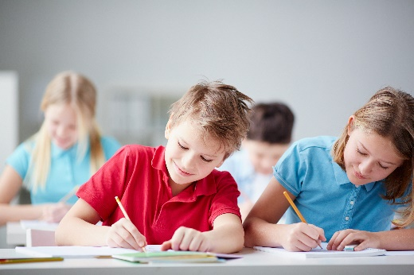
When students reflect on learning and analyse their own ideas and feelings, they self-evaluate, thereby improving their metacognitive skills. When students self-monitor or reflect, the most powerful learning happens.
Journaling may take the form of a written or digital journal, a portfolio or a digital portfolio. Early childhood classrooms may use a class reflective floor book with pictures of the learning experience and scribed conversations.
istockphoto.com
Teachers can model the journaling process by thinking aloud and showing students how they can express learning and thoughts in a variety of ways including diagrams, pictures and writing.
Journals are a useful tool that gives teachers additional insight into how students value their own learning and progress, as well as demonstrating their individual achievements.
The following links provide background information and useful apps for journaling.
Kidblog – digital portfolios and blogging
kidblog.org/home
Edmodo – for consolidating and storing class notes and learning materials
www.edmodo.com
Explain Everything™ – a screen casting, video and presentation tool all in one
explaineverything.com
Popplet – allows you to jot down your ideas and then sort them visually
popplet.com
Seesaw – for capturing work completed by students in class, using a digital device’s camera function
web.seesaw.me
Connect – the Department of Education’s integrated, online environment
connect.det.wa.edu.au
Evernote (a digital portfolio app)
evernote.com
Digital portfolios for students (Cool tools for school)
cooltoolsforschool.wordpress.com/digital-student-portfolios

Appendix 6: Teacher resource sheet 1.1: Cooperative learning – Roles
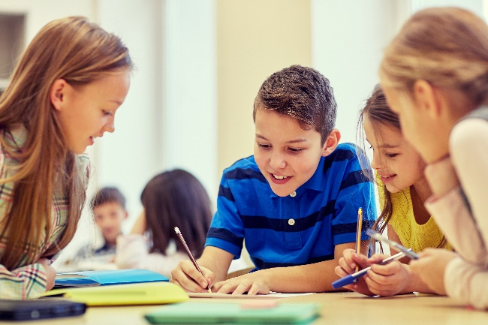
Cooperative learning frameworks create opportunities for groups of students to work together, generally to a single purpose.
As well as having the potential to increase learning for all students involved, using these frameworks can help students develop personal and social capability.
When students are working in groups, positive interdependence can be fostered by assigning roles to group members.
istockphoto.com
These roles could include:
- Working roles such as Reader, Writer, Summariser, Time-keeper
- Social roles such as Encourager, Observer, Noise monitor, Energiser.
Teachers using the Primary Connections roles of Director, Manager and Speaker for their science teaching may find it effective to also use these roles for STEM learning.
Further to this, specific roles can be delineated for specific activities that the group is completing.
It can help students if some background to the purpose of group roles is made clear to them before they start, but at no time should the roles get in the way of the learning. Teachers should decide when or where roles are appropriate to given tasks.
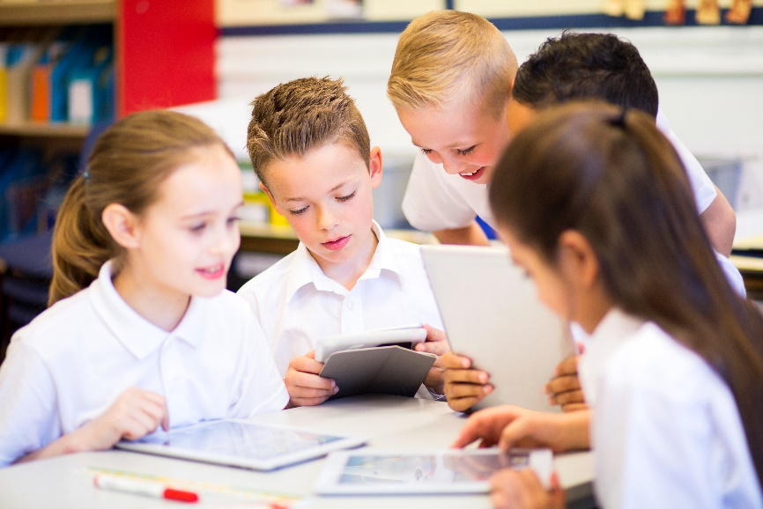
istockphoto.com

Appendix 7: Teacher resource sheet 1.2: Cooperative learning – Think, Pair, Share
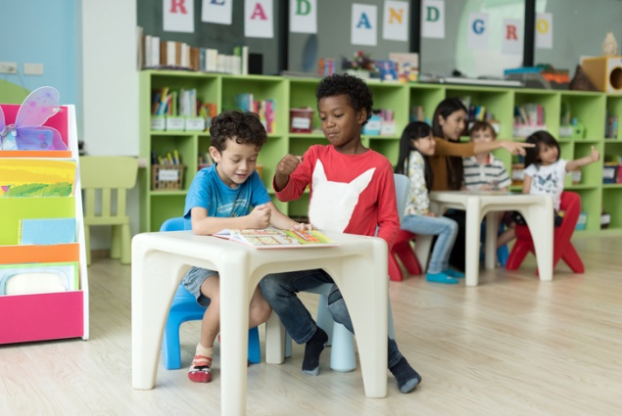
Cooperative learning frameworks create opportunities for groups of students to work together, generally to a single purpose.
As well as having the potential to increase learning for all students involved, using these frameworks can help students develop personal and social capability.
In the 'think' stage, each student thinks silently about a question asked by the teacher.
istockphoto.com
In the 'pair' stage, students discuss their thoughts and answers to the question in pairs.
In the 'share' stage, the students share their answer, their partner’s answer or what they decided together. This sharing may be with other pairs or with the whole class. It is important also to let students 'pass'. This is a key element of making the strategy safe for students.
Think–pair–share increases student participation and provides an environment for higher levels of thinking and questioning.
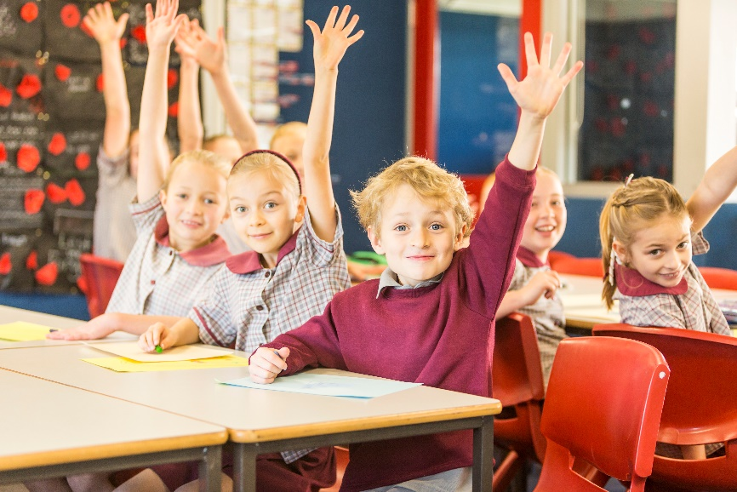
istockphoto.com

Appendix 8: Teacher resource sheet 1.3: Sample parent letter and instructions for making a rice baby
(School details and letterhead)
(Date)

Dear parents and caregivers,

RE: Rice baby STEM project

This term, our class is undertaking a STEM (Science, Technology, Engineering and Mathematics) project called Rice baby. The Rice baby project uses an integrated learning experience to relate the students to the world around them. Students cultivate a sense of empathy through encouragement to care for others and experience different perspectives.
For this project students will need their own rice baby, which is made by filling a stocking with rice until the weight of the rice approximates the weight of a given child at birth.
Please help your child make their rice baby and bring it to school before XXX. The attached sheet provides detailed instructions for creating a rice baby with arms, legs, fingers, toes and face.
This project also focuses on repurposing items (ie shoe boxes, soft materials, different sized cardboard boxes) to create devices that can protect the rice baby in different situations. I would appreciate if you could please collect clean, used items from your home and send them to school with your child. Please do not include any glass containers or toilet rolls.
We will be starting the project on (date) and would like the items to be delivered to the classroom before then.
We will require adult assistance during the construction phase of the project, please let me know if you are available to help.

Thank you in advance,
(Classroom teacher)

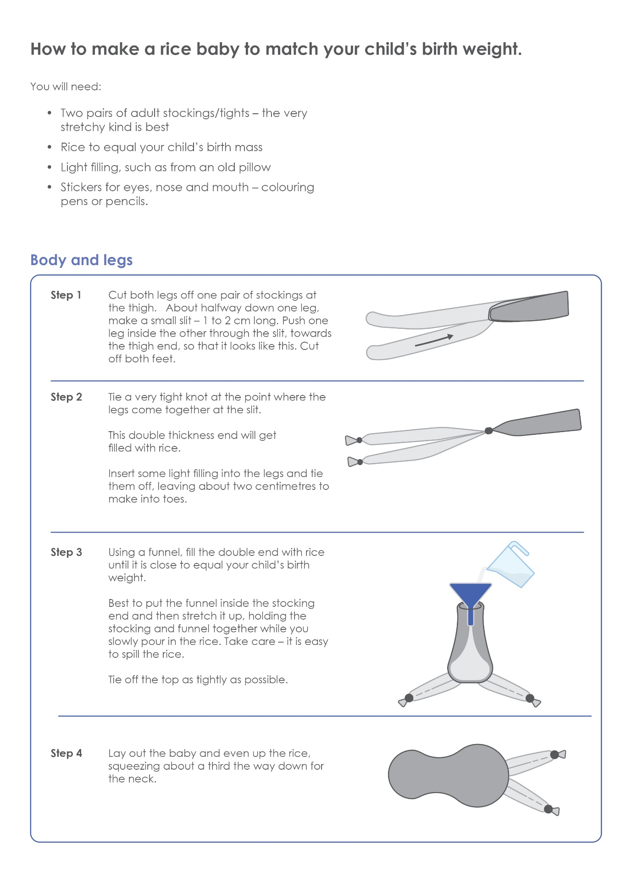
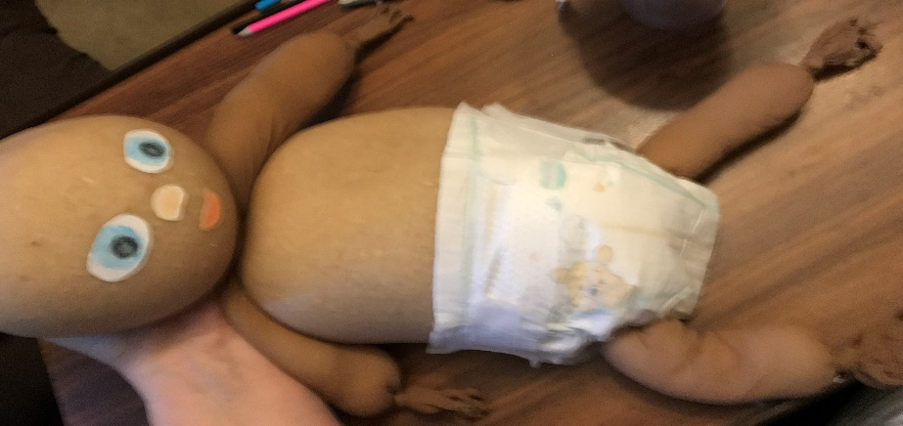
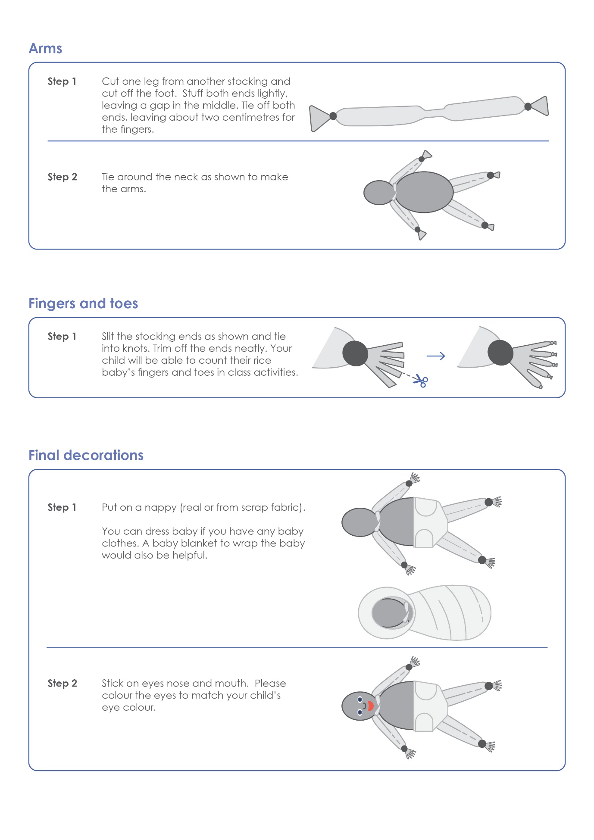

Appendix 9: Teacher resource sheet 3.1: Prototype troubleshooting
Problem | Reason for the problem | Possible changes to your design to solve the problem

Appendix 10: Teacher resource sheet 3.2: Construction skills
Construction skills help students to generate and produce solutions for real-world problems. This resource develops students' skills in design and technologies.
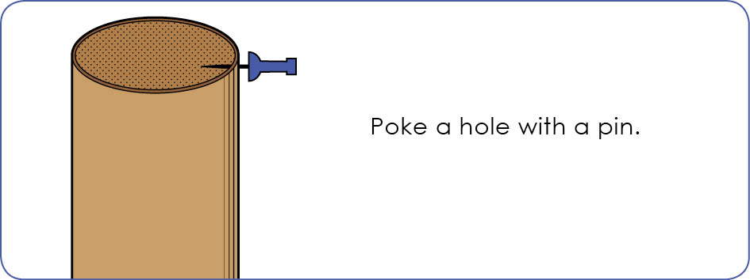
This resource can be used as a visual stimulus to prompt students to develop solutions to design problems. The cards can be printed out to create stations.
Poke a hole with a pin.

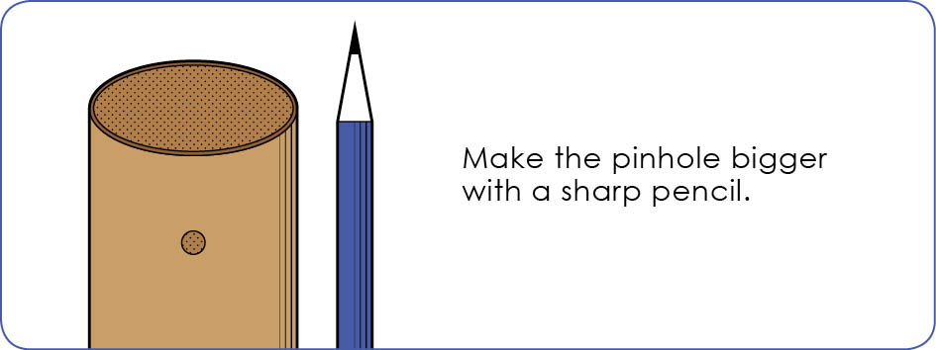
STEM Learning Project
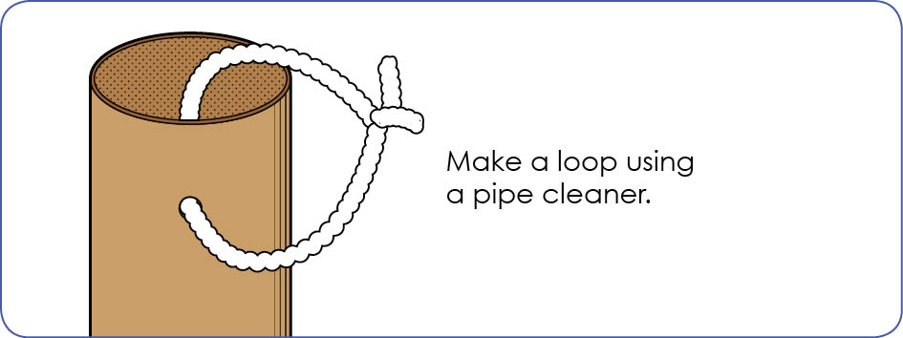

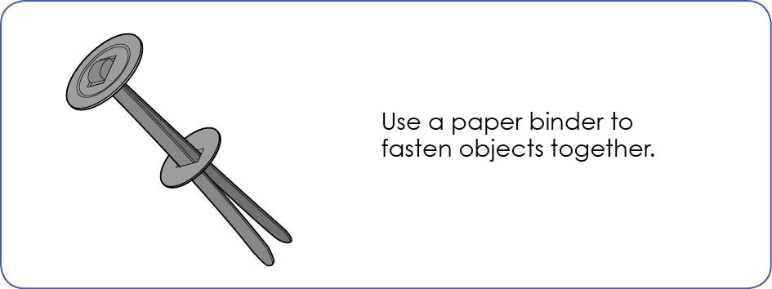

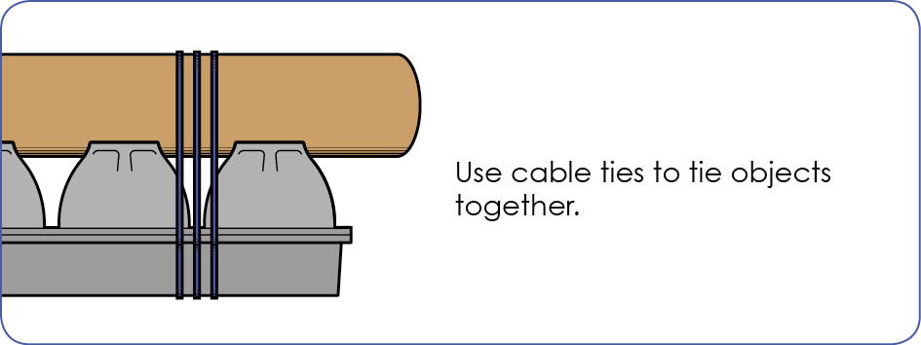
STEM Learning Project
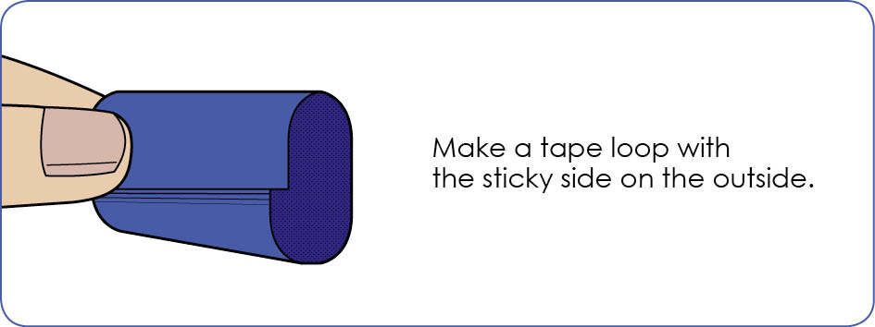

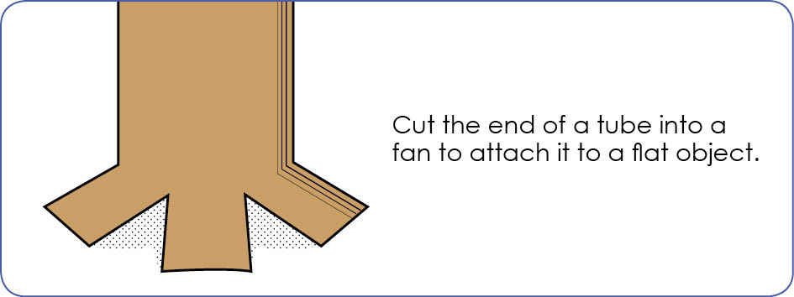

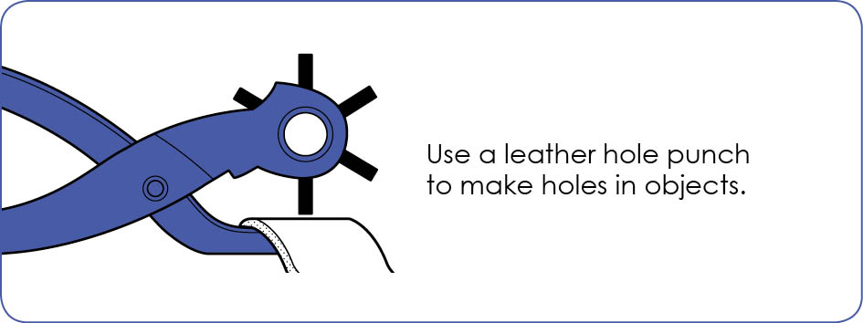
STEM Learning Project
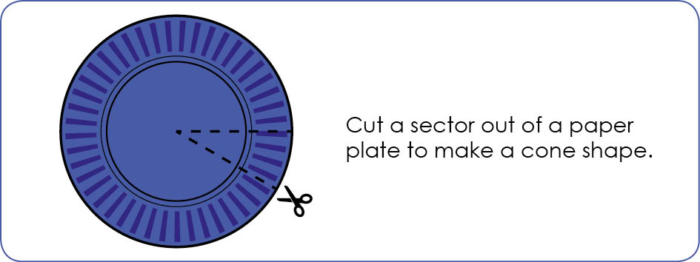

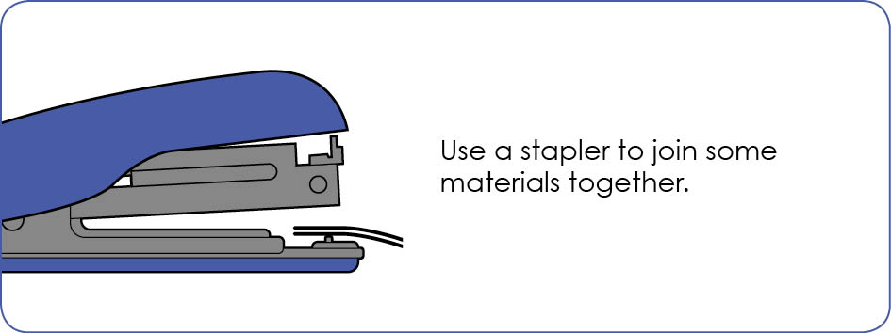

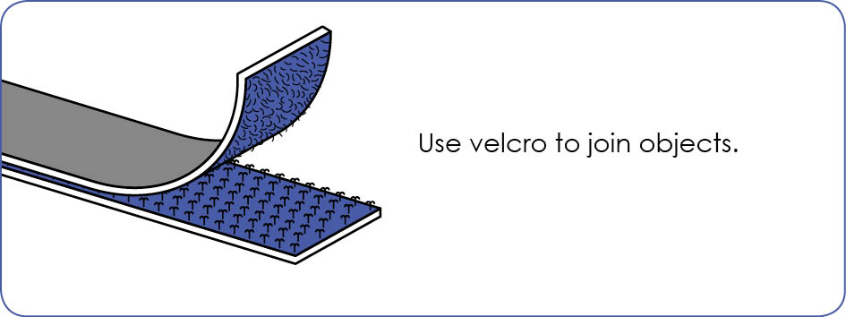

STEM Learning Project

Appendix 11: Student activity sheet 4.1: Reflection

My baby protection device is made from ________________________
________________________________________________________________

I used these materials because _________________________________
________________________________________________________________

My baby protector …
Yes/No
… is strong.
… is soft.
… is easy to wash.
… is the right size.
…keeps my baby safe.

Notes
________________________________________________________________________________________________________________________________________________________________________________________________________________________________________________________________________________________________________________________________________________________________________________________________________________________________________________________________________________________________________________________________________________________________________________________________________________________________________________________________________________________________________________________________________________________________________________________________________________________________________________________________________________________________________________________________________________________________________________________________________________________________________________________________________________________________________________________________________________________________________________________________________________________________________________________________________________________________________________________________________________________________________________________________________________________________________________________________________________________________________________________________________________________________________________________________________________________________

